The Open Source Audit
Mozilla Firefox
A Capstone Project for OSS NGMC Course
Course: Open Source Software | Unit Coverage: 1 - 5
Student Name: Archana Santhosh
Registration Number: 24BAI10840
Software Chosen: Mozilla Firefox
Date of Submission: 30/03/2026
Slot:A11

Part A — Origin and Philosophy

A1. The Problem Firefox Was Created to Solve
In the late 1990s, the internet was growing rapidly, but there was a serious problem — one company controlled how the entire world browsed the web. Microsoft's Internet Explorer had captured over 95% of the browser market by bundling it for free with every copy of Windows. This was not a fair competition. People did not choose Internet Explorer because it was the best browser — they used it simply because it was already there when they turned on their computers.
Microsoft, having essentially won the browser war, had little incentive to improve Internet Explorer. Internet Explorer 6, released in 2001, received almost no meaningful updates for five full years. During this time, it was riddled with security vulnerabilities, did not follow open web standards, and forced web developers to write code specifically designed around its bugs and quirks. Building a website meant testing it endlessly in Internet Explorer and hoping it worked. The web was effectively locked inside one company's product.
Netscape, which had been Internet Explorer's main competitor, was losing ground rapidly. In 1998, Netscape made a historic decision — they open sourced their browser code, creating the Mozilla project. The idea was that if a community of developers around the world could contribute to the browser, it could survive and compete. However, the Mozilla Suite that emerged from this effort became large, bloated, and slow. It was trying to be too many things at once — a browser, an email client, a web page editor — and it was losing focus.
In 2002, a small group of developers inside Mozilla, including Blake Ross, Dave Hyatt, and Joe Hewitt, decided to start a side project. They wanted to strip everything back and build a browser that did one thing and did it well — browse the web, fast and cleanly. This project went through several names — Phoenix, then Firebird — before finally being named Firefox.
Firefox 1.0 was released on November 9, 2004. What happened next was remarkable. The community raised $250,000 to take out a two-page advertisement in the New York Times announcing the launch. In its first year alone, Firefox was downloaded over 100 million times. People were hungry for an alternative, and Firefox gave them one.
The reason Firefox was built as open source was not accidental — it was the entire point. The Mozilla Foundation, which controls Firefox, is a nonprofit organisation. There are no shareholders demanding profit, no advertising revenue tied to which websites you visit. The source code is publicly available for anyone to read, audit, and contribute to. This means that anyone in the world can check whether Firefox is respecting their privacy, can suggest improvements, and can hold the project accountable. Firefox was created to solve a problem that was as much philosophical as it was technical — one corporation had taken control of the gateway through which billions of people accessed information. Firefox existed to prove that the web belonged to everyone.

A2. The License — What It Actually Says
Firefox is released under the Mozilla Public License 2.0 (MPL 2.0). To understand what this means, it is important to first understand the four freedoms of free software as defined by Richard Stallman and the GNU Project.
The Four Freedoms of Free Software:
- Freedom 0 — The freedom to run the program for any purpose
- Freedom 1 — The freedom to study how the program works and modify it
- Freedom 2 — The freedom to redistribute copies
- Freedom 3 — The freedom to distribute modified versions to others
Firefox's MPL 2.0 license grants all four of these freedoms. Anyone can download Firefox, study its source code, modify it, and redistribute their modified version. This is what makes it genuinely free software — not free as in price, but free as in freedom.
Can a company modify Firefox and sell it without sharing changes?
This is where the MPL 2.0 is interesting. Unlike the GPL, which requires that the entire project remain open source, the MPL 2.0 is a file-level copyleft license. This means that if a company modifies an MPL-licensed file, they must share those specific file changes under the MPL. However, they can combine MPL code with proprietary code in the same project, as long as they keep the files separate. This makes MPL 2.0 a middle ground between permissive licenses like MIT and strong copyleft licenses like GPL.
The difference between GPL and MIT licensing:
The GPL (GNU General Public License) is a strong copyleft license — if you use GPL code in your project and distribute it, your entire project must also be released under the GPL. This ensures that all derivatives remain open source forever. The MIT license, on the other hand, is extremely permissive — you can take MIT-licensed code, modify it, and release your product as proprietary software without sharing any of your changes. If I were building something I wanted to keep completely open and ensure could never be made proprietary, I would choose GPL. If I wanted maximum adoption and did not mind companies using my code in closed products, I would choose MIT.
Free as in free beer vs free as in freedom:
'Free as in free beer' means you can have it at no cost — like a free sample. 'Free as in freedom' means you have the rights to do what you want with it. Firefox is free in both senses — you can download it for nothing, and you have the freedom to modify and redistribute it. A good example of the difference: Internet Explorer was also free to download (free as in beer), but its source code was closed, so you had no freedom to study or modify it. Firefox gives you both.

A3. The Ethics of Open Source
Should all software be open source?
There is a strong argument that all software should be open source. Software increasingly controls critical parts of our lives — our medical records, our financial transactions, our communications, our elections. When this software is proprietary, we have no way to verify that it is working honestly, that it is not collecting our data without consent, or that it has no hidden vulnerabilities. Open source allows public scrutiny, which generally leads to more secure and trustworthy software. Firefox is a perfect example — because its code is public, security researchers around the world can and do find vulnerabilities and report them, making the browser safer for everyone.
However, there is also a reasonable argument against requiring all software to be open source. Building software is expensive. Companies need revenue to pay developers, run servers, and provide support. Some software, particularly in specialised industries like medical devices or financial systems, may need to remain proprietary to protect competitive investment. My conclusion is that software that controls public infrastructure, handles personal data, or acts as a gateway to information — like browsers, operating systems, and communication platforms — should be open source.
Is it ethical for companies to profit from free community labor?
Companies like Red Hat, Google, and Meta have built enormously profitable businesses on top of Linux and other open source projects that were built by volunteer communities. Red Hat charges enterprises for support and services around Linux. Google's Android is built on the Linux kernel. Meta runs its entire infrastructure on open source software. This is genuinely complicated. On one hand, these companies often contribute back to the projects they use — Google employs full-time Linux kernel developers. On the other hand, the financial benefits flow overwhelmingly to the companies, while many of the individual contributors who built the foundation receive nothing. The ethical path is for companies that profit heavily from open source to contribute meaningfully back — through code, funding, and developer time.
Standing on the shoulders of giants:
The phrase means that every new achievement builds on the work of those who came before. In software, this is especially true. Every web application today runs on top of Linux, Apache, MySQL, Python, and dozens of other open source tools built over decades by thousands of contributors. Firefox itself stands on the shoulders of the original Netscape engineers who chose to open source their code in 1998 rather than let it die. Open source enables this kind of cumulative innovation — each generation of developers can build on the last, rather than reinventing everything from scratch.

Part B — Linux Footprint
Firefox is one of the most widely available open source applications on Linux. On Fedora and RHEL-based systems, it can be installed using the DNF package manager with the command 'sudo dnf install firefox'. On Debian and Ubuntu-based systems, the equivalent command is 'sudo apt install firefox'. For users who need the absolute latest version, Firefox can also be compiled from source by downloading the source code from Mozilla's official repository.

Installation Method
Firefox is available through all major Linux package managers. On RPM-based systems (Fedora, CentOS, RHEL), it is installed via DNF or YUM. On Debian-based systems, it is installed via APT. This means that Firefox integrates into the system's standard update mechanism, receiving security patches automatically alongside other system updates.
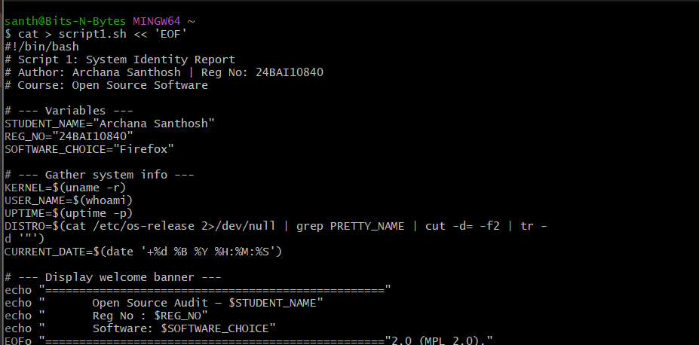

Key Directories
- /usr/bin/firefox — the main executable that launches the browser
- /usr/lib/firefox/ — core application files, libraries, and resources
- ~/.mozilla/firefox/ — each user's personal profile, bookmarks, settings, and extensions
- /etc/firefox/ — system-wide configuration files
- 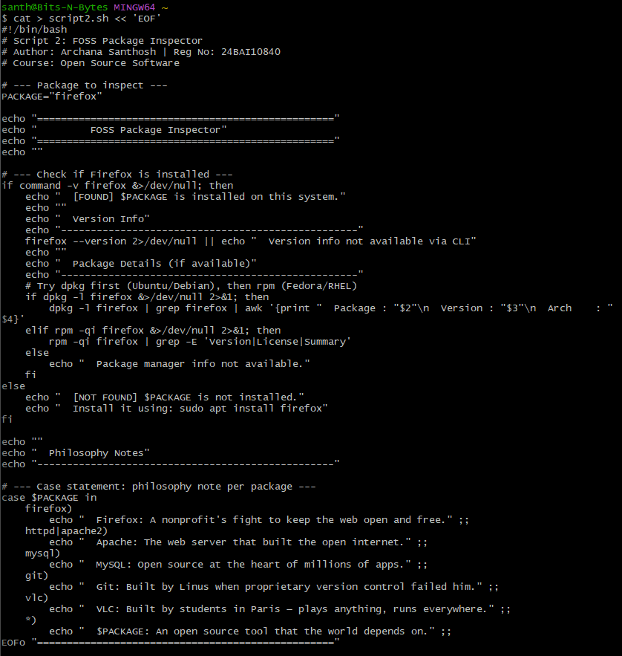

User and Group
Firefox runs under the privileges of the currently logged-in user — it does not require root access and does not run as a system service. This is an important security design decision. By running as a regular user, Firefox limits the damage that a compromised browser can do. Even if an attacker exploits a vulnerability in Firefox, they only gain the privileges of the normal user, not root access to the entire system.
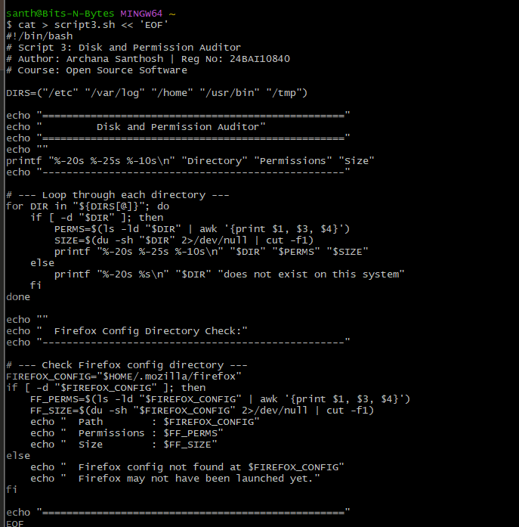

Service Management
Firefox is a desktop application, not a system service, so it is not managed with systemctl. It is launched directly by the user. On systems where Firefox is deployed as a managed browser in enterprise environments, administrators can use policies via /etc/firefox/policies/policies.json to control browser behaviour across all users.

Update Model
On Linux, Firefox updates are delivered through the distribution's package manager. When Mozilla releases a security patch, it is packaged by the distribution's maintainers and pushed to users through the standard update mechanism. The commands 'sudo dnf update' or 'sudo apt update && sudo apt upgrade' will update Firefox along with all other system packages. Firefox also has a built-in update checker that notifies users when a new version is available.
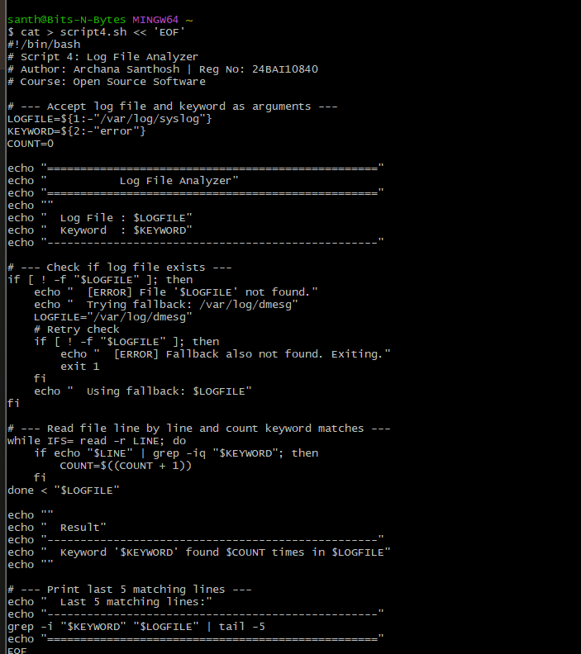

Part C — The FOSS Ecosystem
Firefox does not exist in isolation — it is part of a rich ecosystem of open source tools and depends on many of them to function.

Dependencies
Firefox is built on several major open source components. The Gecko rendering engine, developed by Mozilla, is responsible for displaying web pages. SpiderMonkey is Mozilla's open source JavaScript engine, which executes the JavaScript code that powers modern websites. Firefox also depends on system libraries like GTK (for the graphical interface on Linux), NSS (Network Security Services, for SSL/TLS encryption), and libpng and libjpeg for image rendering.

What Firefox Has Enabled
Firefox's success inspired an entire generation of open source browsers. More significantly, Firefox proved that an open source project could compete with and beat a well-funded corporate product — paving the way for the broader acceptance of open source software in consumer markets. Firefox also pioneered the modern browser extension ecosystem, which was later adopted by Chrome and Edge.

Forks and Spin-offs
Several browsers have been built on Firefox's codebase. Tor Browser is the most notable — it uses Firefox as its base and adds layers of privacy and anonymity tools. LibreWolf is another fork focused on privacy. Waterfox targets users who want a Firefox-based browser without Mozilla's telemetry. Each of these projects demonstrates the value of open source — the ability to take an existing tool and adapt it for a specific need.

Community and Governance
Firefox is governed by the Mozilla Foundation, a nonprofit, and its commercial subsidiary Mozilla Corporation. The community communicates through Mozilla's forums, mailing lists, and the Bugzilla bug tracking system. Mozilla holds an annual developer event called MozFest. Contributions to Firefox go through a formal review process on Mozilla's Phabricator code review platform.

Relation to the Web Stack
Firefox is the client-side component of the web stack. While it does not directly participate in the LAMP stack (Linux, Apache, MySQL, PHP), it is the tool through which users interact with everything the LAMP stack serves. Without open source browsers like Firefox, the open source web server ecosystem would have no open source client to match it. Firefox is therefore an essential part of the broader open source web infrastructure.

Part D — Open Source vs Proprietary Comparison
The closest proprietary alternative to Firefox is Google Chrome. Below is a structured comparison across key dimensions.

Dimension | Firefox (Open Source / MPL 2.0) | Google Chrome (Proprietary)
Cost | Completely free to download and use | Free to download but monetises user data for advertising
Security | Source code is public — anyone can audit it for vulnerabilities | Closed source — security relies on Google's internal teams only
Support | Community forums, Mozilla support, extensive documentation | Google support, large community, enterprise support available
Freedom to Modify | Full freedom — source code available, forks permitted | No freedom — cannot modify or redistribute
Control | Controlled by Mozilla Foundation nonprofit | Controlled entirely by Google Corporation
Privacy | Strong privacy focus, no built-in ad tracking | Deeply integrated with Google's advertising ecosystem

Overall Verdict
Firefox is the stronger choice for any deployment where privacy, transparency, and freedom matter. Its open source nature means that its security can be independently verified — not just trusted on the word of its creator. The Mozilla Foundation's nonprofit structure means that its incentives are aligned with users rather than advertisers.
However, Chrome has real advantages in raw performance on certain benchmarks, tighter integration with Google's ecosystem, and a larger extension library. For a user who is already deeply invested in Google's services, Chrome may offer a smoother experience in practice. For a privacy-conscious individual, an educational institution, or any organisation that values digital sovereignty, I would recommend Firefox without hesitation. I would also consider contributing to Firefox — Mozilla has a well-documented contribution guide, an active developer community, and genuine impact on the future of the open web.

Conclusion
This audit of Mozilla Firefox has been a genuine education in what open source means beyond just 'free software.' Firefox exists because a group of developers believed that the web should belong to everyone — not to Microsoft, not to Google, not to any single corporation. The MPL 2.0 license it uses reflects a careful balance between openness and practicality. Its Linux footprint demonstrates the elegant simplicity of Unix design philosophy. And its ecosystem shows how one open source project can inspire dozens of others.
Every time someone uses Firefox, they are participating in a 25-year experiment in whether community-driven, nonprofit software can hold its own against some of the most powerful technology companies in the world. The answer, so far, is yes. Understanding why Firefox was built the way it was — openly, freely, and cooperatively — is not just a lesson in software licensing. It is a lesson in how technology can be shaped by values, not just by market forces.
