NATURAL LANGUAGE PROCESSING - LAB

(COURSE CODE: 23UPCSC4E17)

A Laboratory record Submitted to Periyar University,
Salem. In partial fulfillment of the Requirements for the
Degree of

MASTER OF SCIENCE IN
DATA SCIENCE

BY
ARCHANA M

REG NO: U23PG507DTS005



DEPARTMENT OF COMPUTER SCIENCE
PERIYAR UNIVERSITY
PERIYAR PALKALAI NAGAR,
SALEM – 636011

CERTIFICATE

This is to certify that the Programming Laboratory entitled “NATURAL LANGUAGE PROCESSING LAB” (23UPCSC4E17) is a bonafide record work done by MS. ARCHANA Register No. U23PG507DTS005 as partial fulfillment of the requirements degree of MASTER OF SCIENCE IN DATA SCIENCE in the Department of Computer Science, Periyar University, Salem, during the year 2023 – 2025.

Faculty In-Charge Head of the Department

Submitted for the practical examination held on ……. /……. /………………

Marks Obtained

Internal Examiner External Examiner

SL.NO | DATE | TITLE | PAGE NO | SIGNATURE
1 | 03/07/2024 | Fundamentals of NLP I  Tokenization &  Lemmatization
2 | 09/07/2024 | Fundamentals of NLP II  Stemming & Sentence  Segmentation
3 | 16/07/2024 | NLP Using Scikit Library
4 | 23/07/2024 | NLP using Spacy library
5 | 30/07/2024 | Working with TF-IDF
6 | 06/08/2024 | Naïve Bayes Classifier
7 | 20/08/2024 | Word cloud using python
8 | 27/08/2024 | Python key word extraction
9 | 31/08/2024 | Named entity recognition
10 | 10/09/2024 | LATENT semantic analysis
11 | 18/09/2024 | Determine optimum number of topics in a document
12 | 25/09/2024 | Fundamental of topic modelling

Ex.No: 1 | FUNDAMENTAL OF NLP I: TOKENIZATION & LEMMATIZATION
Date: 03/07/2024 | FUNDAMENTAL OF NLP I: TOKENIZATION & LEMMATIZATION

AIM:
To create a tokenization and lemmatization program.

THEORY:
Tokenization:
Tokenization is a common task in Natural Language Processing
(NLP). Tokens are the building blocks of Natural Language. Tokenization is a way of separating a piece of text into smaller units called tokens. Here, tokens can be either words, characters, or sub words.

Lemmatization:
Lemmatization is one of the most common text pre-processing techniques used in Natural Language Processing (NLP) and machine learning in general. If you’ve already read my post about stemming of words in NLP, you’ll already know that lemmatization is not that much different. Both in stemming and in lemmatization, we try to reduce a given word to its root word. The root word is called a stem in the stemming process, and it is called a lemma in the lemmatization process.

PROCEDURE:
• Import necessary library.
• Tokenization.
• Lemmatization

PROGRAM:

TOKENIZATION

Word Tokenizer:

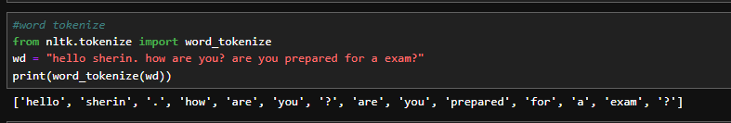

Sentence Tokenizer:

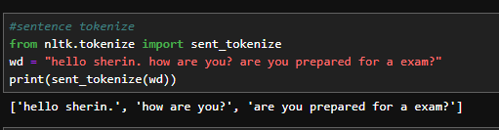

LEMMATIZATION:

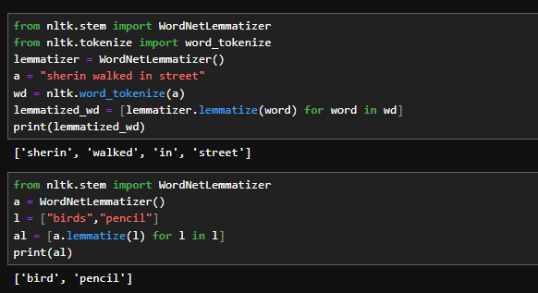

RESULT:

Thus, the tokenization and lemmatization were Completed successfully

.
Ex.No: 2 | FUNDAMENTALS OF NLP II STEMMING & SENTENCE SEGMENTATION
Date:09/07/2024 | FUNDAMENTALS OF NLP II STEMMING & SENTENCE SEGMENTATION

AIM:
To implement the process of stemming & sentence segmentation.
THEORY:
Stemming:
Stemming is the process of reducing a word to its word stem that affixes to suffixes and prefixes or to the roots of words known as a lemma. Stemming is important in natural language understanding (NLU) and natural language processing (NLP).

Sentence Segmentation:
The process of deciding from where the sentences actually start or end in NLP or we can simply say that here we are dividing a paragraph based on sentences. This process is known as Sentence Segmentation. In Python, we implement this part of NLP using the spacy library.

PROCEDURE:

- Stemming.
- Sentence Segmentation.

PROGRAM:

STEMMING:

PorterStemmer:

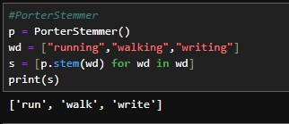

Snowball Stemmer:

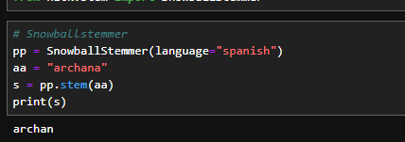

Regexp Stemmer:

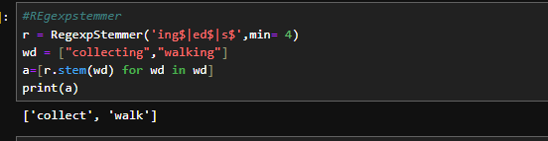

SENTENCE SEGMENTATION:

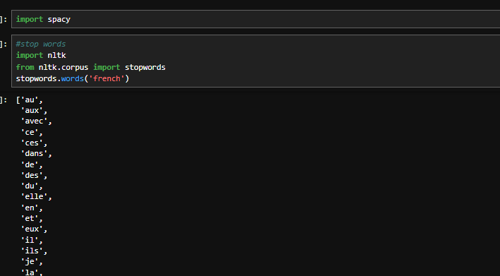

Removing Stop Words:
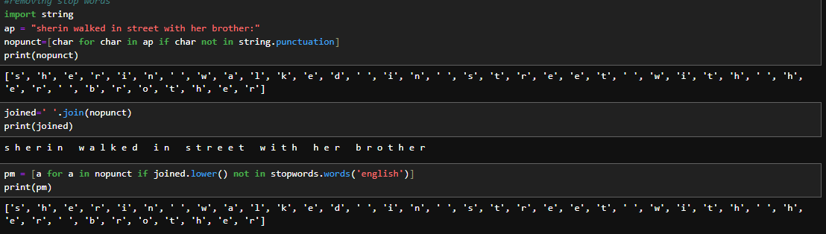

RESULT:

Thus, the stemming & sentence segmentation was Completed successfully

Ex.No: 3 | NLP USING SCIKIT LIBRARY
Date: 16/07/2024 | NLP USING SCIKIT LIBRARY

AIM:
To Create a Program for NLP Using Sckit-Learn.

THEORY:

Natural language processing (NLP) refers to the branch of computer science— and more specifically, the branch of artificial intelligence or AI—concerned with giving computers the ability to understand text and spoken words in much the same way human beings can.
Random forests or random decision forests are an ensemble learning method for classification, regression and other tasks that operates by constructing a multitude of decision trees at training time. For classification tasks, the output of the random forest is the class selected by most trees.

PROCEDURE:
- Importing Libraries.
- Loading Training and Testing Texts.
- Preprocessing.
- Model Building.
- Model Selection.
- Classifying Report.
- Visualization.

PROGRAM:

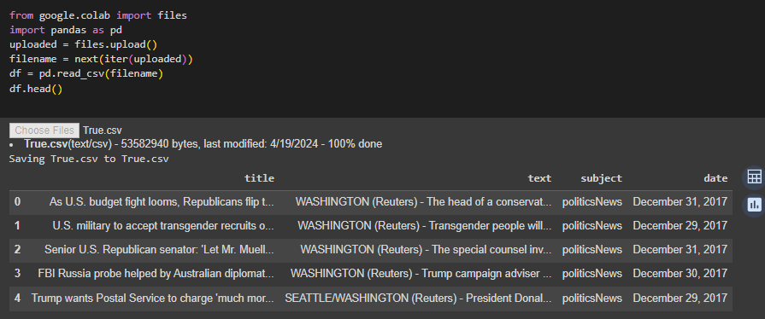
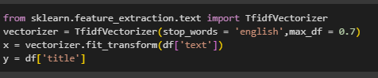
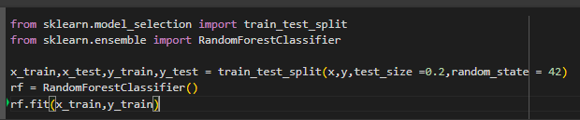
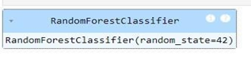

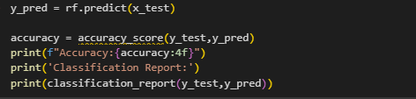
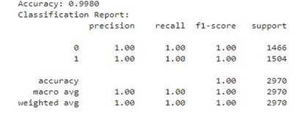

RESULT:
Thus, the NLP using scikit library has been completed successfully

AIM:
To create a program for spacy library

Ex.No: 4 | NLP USING SPACY LIBRARY
Date: 23/07/2024 | NLP USING SPACY LIBRARY
THEORY:
Spacy is an open-source software library for advanced natural language processing, written in the programming languages Python and Cython. The library is published under the MIT license and its main developers are Matthew Honnibal and Ines Montani, the founders of the software company Explosion.

PROCEDURE:

  - Stop Words.
  - Sentence Detection
  - Part-of-speech Tagging.
  - Word Frequency.

PROGRAM:

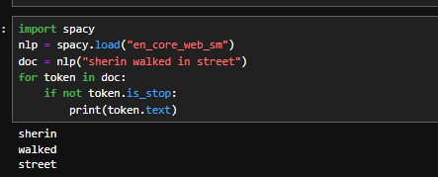

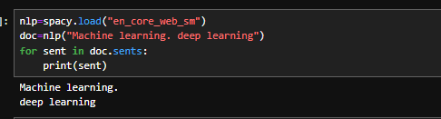

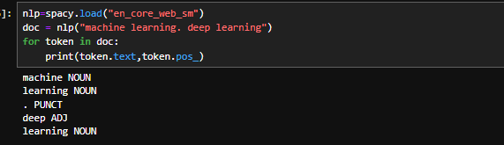
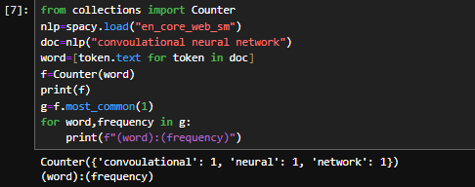

RESULT:
Thus, the NLP using Spacy library has been Completed successfully.

Ex.No: 5 | WORKING WITH TF-IDF
Date:30/07/2024 | WORKING WITH TF-IDF

AIM:

To Program for working with TF-IDF

THEORY:

TF-IDF or (Term Frequency (TF) — Inverse Dense Frequency (IDF)) is a technique which is used to find meaning of sentences consisting of words and cancels out the incapabilities of Bag of Words technique which is good for text classification or for helping a machine read words in numbers. However, it just blows up in your face when you ask it to understand the meaning of the sentence or the document.

PROCEDURE:

- Importing Libraries.
- Defining Sample Documents
- Creating TF-IDF Vectorizer
- Fitting and Transforming Documents
- Printing TF-IDF Matrix and Feature Names

PROGRAM:

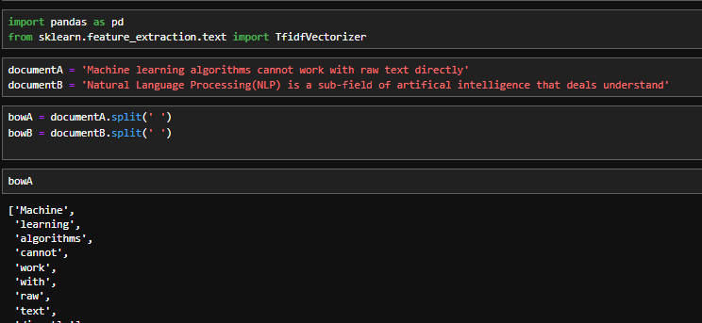

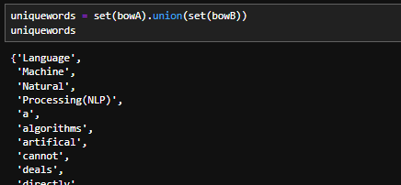

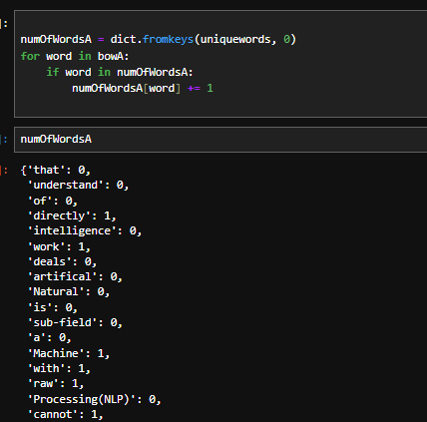
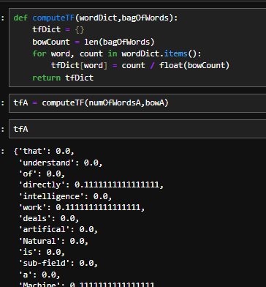

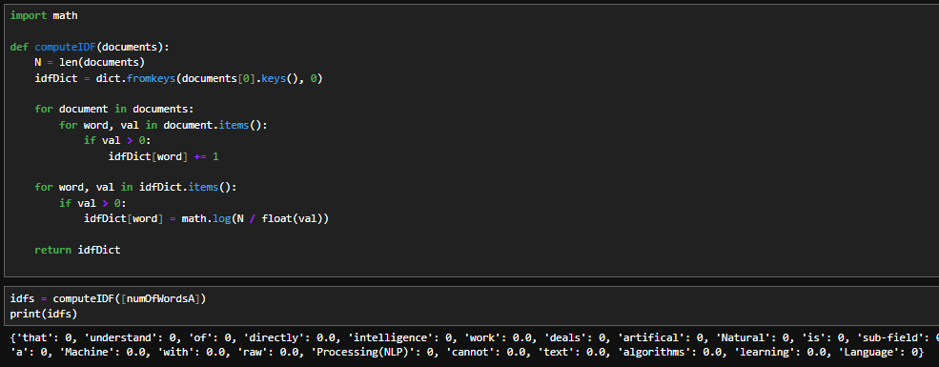

RESULT:
Thus, the NLP using TF-IDF has been Completed successfully.

Ex.No: 6 | NAÏVE BAYES CLASSIFIER
Date:06/08/2024 | NAÏVE BAYES CLASSIFIER

AIM:
Program Naive Bayes Classifier.

THEORY:
Naive Bayes classifiers are a collection of classification algorithms based on Bayes’ Theorem. It is not a single algorithm but a family of algorithms where all of them share a common principle, i.e. every pair of features being classified is independent of each other.
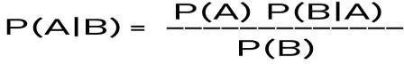
P(A|B) – is called as a posterior probability. P(B|A) – is the conditional probability of B given A. P(A) – is the Prior probability of event A.
P(B) – is the probability of event B to occur.

PROCEDURE:
- Importing libraries
- Load the Data.
- Preprocessing.
- Build the Model.
- Predict the Accuracy.

PROGRAM:

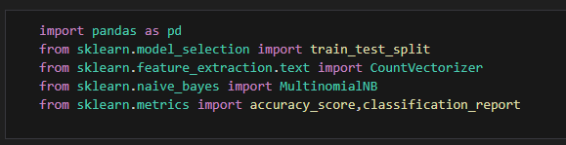

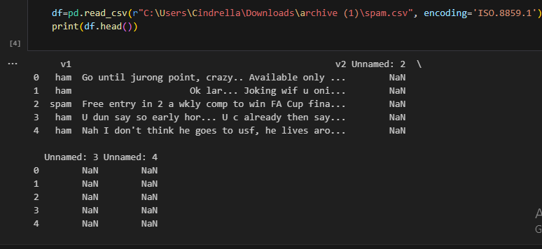

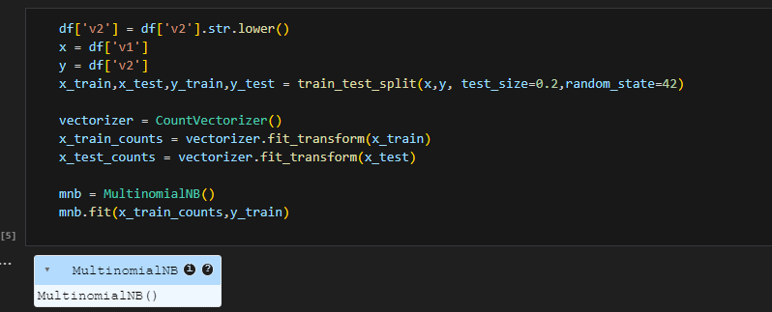

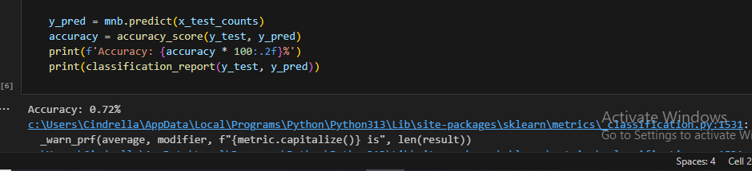

RESULT:
Thus, the multinomial naïve bayes has been Completed successfully.

Ex.No: 7 | WORD CLOUD USING PYTHON
Date: 27/08/2024 | WORD CLOUD USING PYTHON

AIM:
To Create a Program For word cloud.

THEORY:
Word Cloud is a data visualization technique used for representing text data in which the size of each word indicates its frequency or importance. Significant textual data points can be highlighted using a word cloud. Word clouds are widely used for
analysing data from social network websites.

PROCEDURE:
- Importing Libraries.
- Reading a Dataset.
- To create a Text Variable.
- Generate Word Cloud.
- Visualize the Word Cloud

PROGRAM:

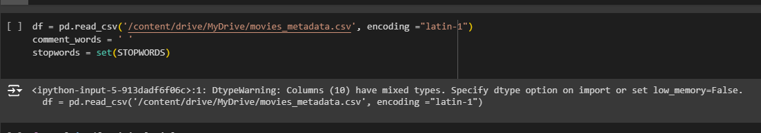

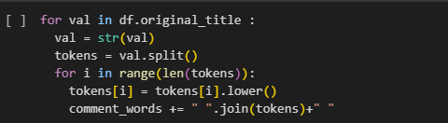

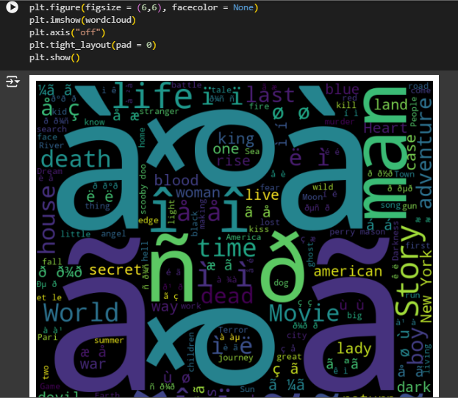

RESULT:
Thus, the word cloud using python has been Completed successfully.

Ex.No: 8 | PYTHON KEY WORD EXTRACTION
Date: 31/08/2024 | PYTHON KEY WORD EXTRACTION
AIM:
To implement the process of python keyword extraction

THEORY:
It is a text analysis technique. We can obtain important insights into the topic within a short span of time. It helps concise the text and obtain relevant keywords. It saves the time of going through the entire
document.

PROCEDURE:
- Importing Libraries.
- Reading a Text.
- Extract the Hot Words.
- Output.

PROGRAM:
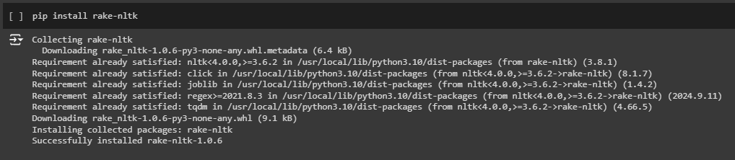

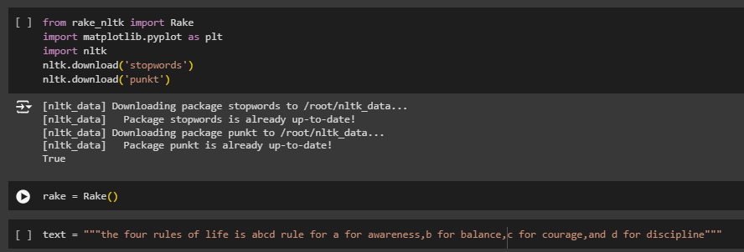

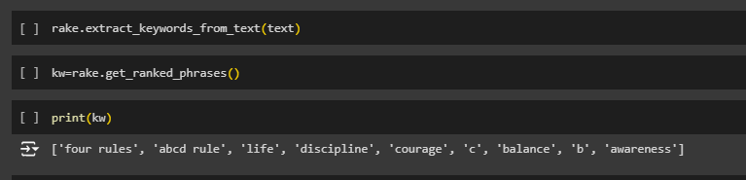

RESULT:

Thus, the key word extraction using python has been Completed .

Ex.No: 9 | NAMED ENTITY RECOGNITION
Date: 31/08/2024 | NAMED ENTITY RECOGNITION

AIM:
To implement Named entity recognition in NLP

THEORY:
Named entity recognition is a natural language processing technique that can
automatically scan entire articles and pull out some fundamental entities in a text and classify them into predefined categories. Generally, Entity Detection algorithms are ensemble models of:

- Rule-based Parsing, python
- Dictionary lookups,
- POS Tagging
- Dependency Parsing.

PROCEDURE:

- Importing Libraries.
- Loading Text.
- Output

PROGRAM:

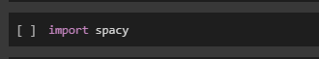

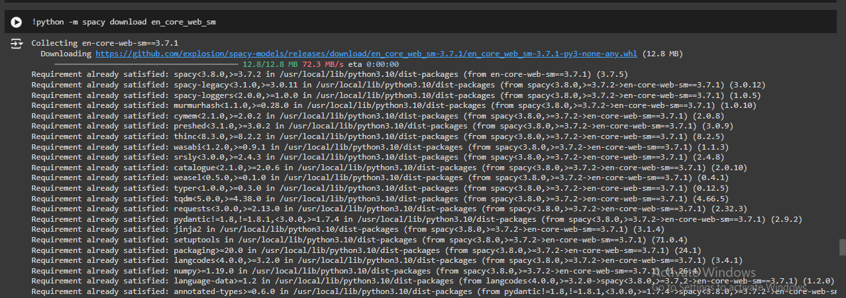

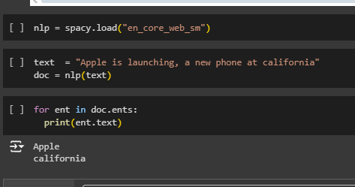

RESULT:

Thus, the named entity recognition using nltk has been Completed successfully

Ex.No: 10 | LATENT SEMANTIC ANALYSIS
Date: 10/09/2024 | LATENT SEMANTIC ANALYSIS

AIM:

To implement latent semantic analysis.

THEORY:
Latent semantic analysis is a technique in natural language processing, in particular distributional semantics, of analysing relationships between a set of documents and the terms they contain by producing a set of concepts related to the documents and terms.

PROCEDURE:
- Import Libraries
- Apply Truncated SVD Model
- Calculate Cosine Similarities
- Output the Results.

PROGRAM:

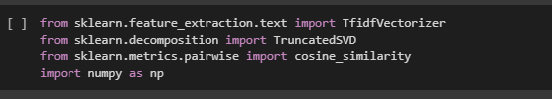

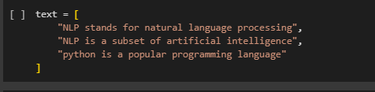

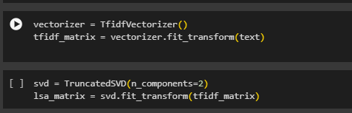

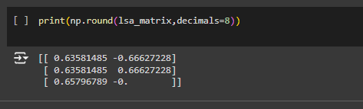

RESULT:

Thus, the latent semantic analysis using python has been Completed successfully.

Ex.No: 11 | DETERMINE OPTIMUM NUMBER OF TOPICS IN A DOCUMENT
Date: 18/09/2024 | DETERMINE OPTIMUM NUMBER OF TOPICS IN A DOCUMENT

AIM:
Program to determine optimum number of topics in a document.

THEORY:
In machine learning and natural language processing, a topic model is a type of statistical model for discovering the abstract "topics" that occur in a collection of documents. Topic modelling is a frequently used text-mining tool for discovery of hidden semantic structures in a text body. Topic modelling refers to the task of identifying topics that best describes a set of documents.

PROCEDURE:
  - Importing Libraries.
  - Loading the Data.
  - Preprocessing.
  - Bag of words.
  - Applying LDA.
  - Testing Model.

PROGRAM:

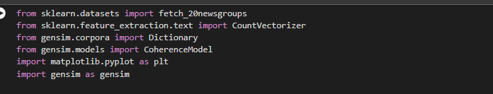

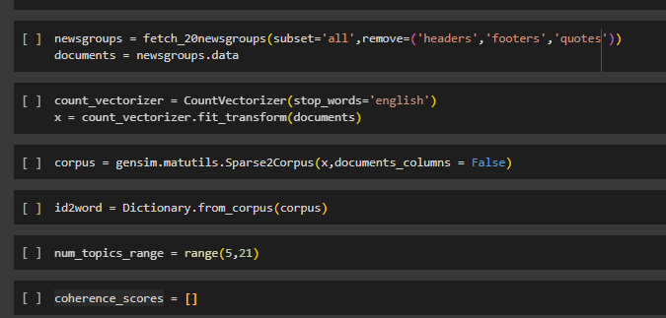

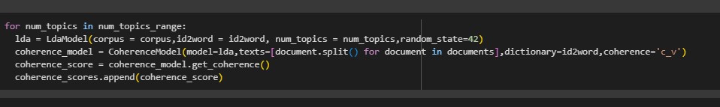
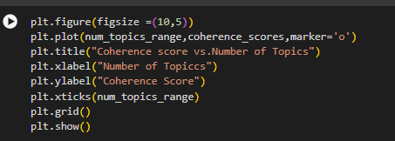
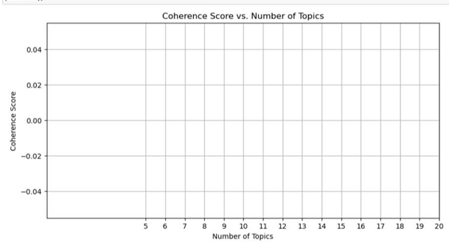

RESULT:
Thus, determining optimum number of topics in a document using python has been Completed successfully.

Ex. No: 12 | FUNDAMENTAL OF TOPIC MODELLING
Date: 25/09/2024 | FUNDAMENTAL OF TOPIC MODELLING

Aim:
Program for Fundamentals of topic modelling

THEORY:
Topic modelling refers to the task of identifying topics that best describes a set of documents. These topics will only emerge during the topic modelling process (therefore called latent). And one popular topic modelling technique is known as Latent Dirichlet Allocation (LDA).

PROCEDURE:
  - Import libraries.
  - Loading data.
  - Creating Bigram and Trigram models.
  - Building topic model.
  - Visualize the topic model.

PROGRAM:



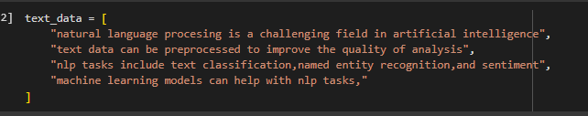
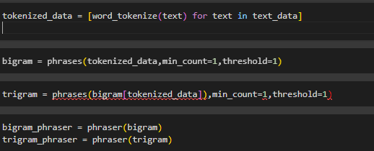
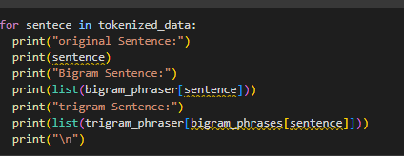
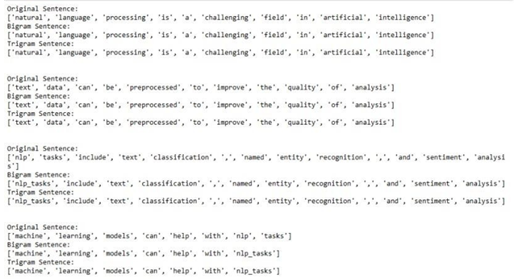

RESULT:
Thus, the fundamentals of topic modelling using python has been

Completed successfully

