**git config**

Usage: git config –global user.name “[name]”

Usage: git config –global user.email “[email address]”

This command sets the author name and email address respectively to be used with your commits.

Git Config Command - Git Commands - Edureka

**git init**

Usage: git init [repository name]

This command is used to start a new repository.

GitInit Command - Git Commands - Edureka

**git clone**

Usage: git clone [url]

This command is used to obtain a repository from an existing URL.

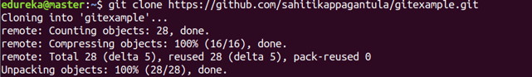

**git add**

Usage: git add [file]

This command adds a file to the staging area.

Git Add Command - Git Commands - Edureka

Usage: git add *

This command adds one or more to the staging area.

Git Add Command - Git Commands - Edureka

**git commit**

Usage: git commit -m “[ Type in the commit message]”

This command records or snapshots the file permanently in the version history.

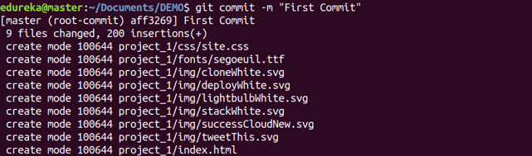

Usage: git commit -a