InterviewGapAI
3-Day Architecture Options: Plan A and Plan B
Deterministic where it matters. Agentic + RAG where reasoning and grounding add value.

Executive Recommendation
Build Plan A as the guaranteed MVP, then extend the same core engine into Plan B only after the end-to-end candidate flow is stable. Both plans use the same AI architecture: resume-informed pre-interview analysis, a structured interview plan, a bounded Interview Agent using Question RAG, a fixed 10-question one-at-a-time interview, and an Evaluation Agent grounded by Evaluation RAG. Adaptive interviewing, long-term agent memory, complex authentication, and real-time evaluation are intentionally excluded from the 3-day MVP.
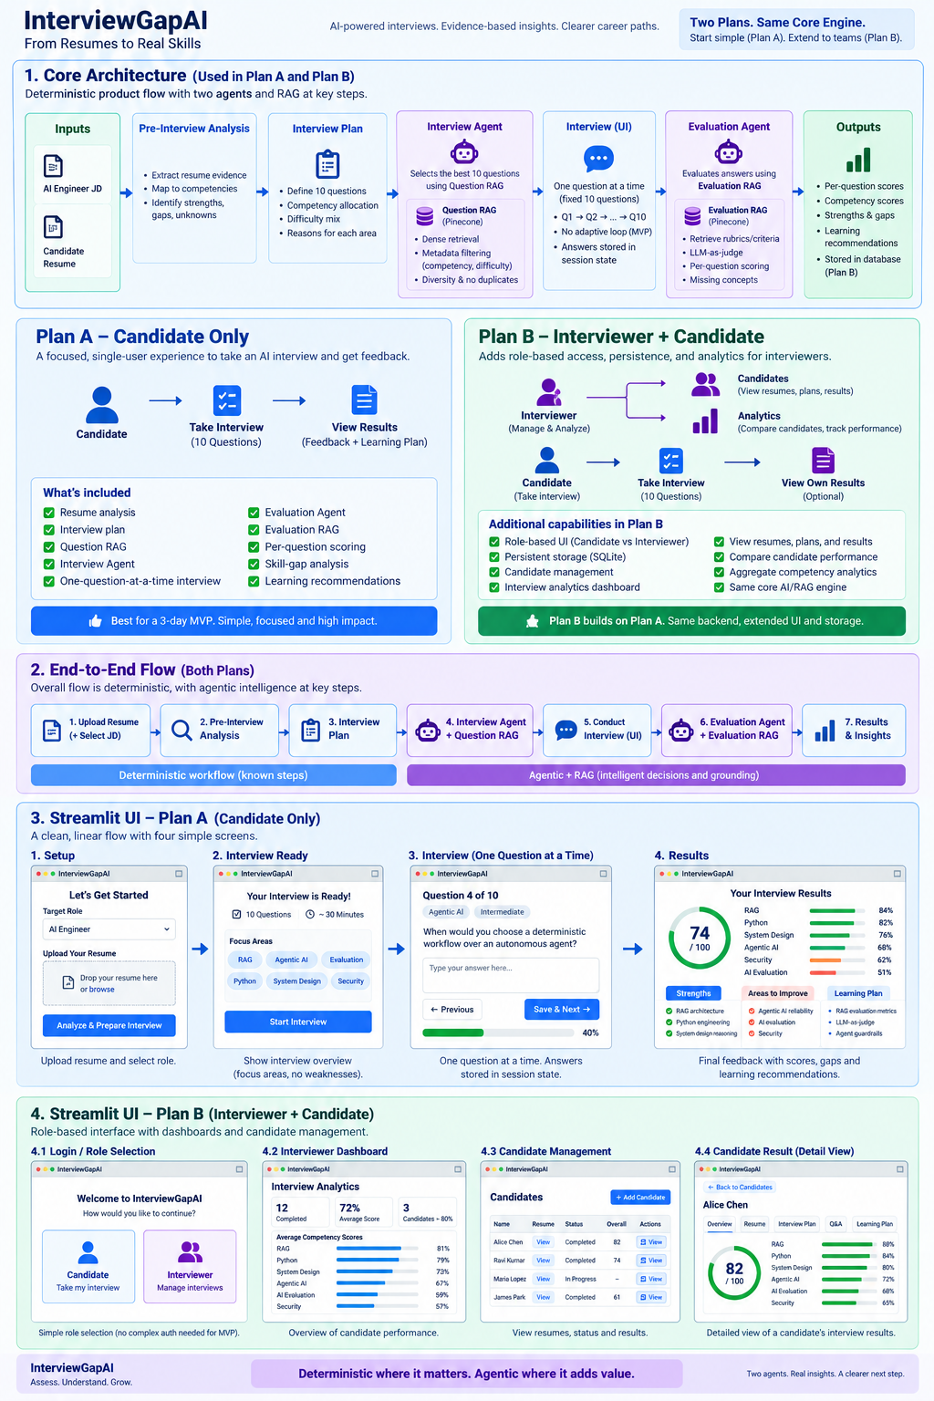
Figure 1. InterviewGapAI core architecture, Plan A/Plan B distinction, end-to-end flow, and Streamlit UI.

1. Shared Core Architecture
The product workflow is intentionally deterministic: Resume → Pre-Interview Analysis → Interview Plan → Interview → Evaluation → Results. The intelligent components are bounded inside that flow. The Interview Agent has a clear goal—construct a balanced 10-question interview satisfying the plan—and uses Question RAG as its retrieval tool. The Evaluation Agent has a separate goal—assess demonstrated competency from candidate answers—and uses Evaluation RAG to retrieve grading criteria and expected concepts.
Stage | Implementation | AI/RAG Role | MVP State
Resume analysis | Structured/LLM-assisted extraction | Identify evidence, strengths and unknown/probe areas | Required
Interview plan | Deterministic plan generation | Defines competency counts and difficulty mix | Required
Question selection | Interview Agent | Question RAG retrieves grounded questions; agent satisfies coverage/diversity constraints | Required
Interview UI | Streamlit + session state | One question at a time; no adaptive question generation | Required
Answer evaluation | Evaluation Agent | Evaluation RAG + LLM judge produces grounded scores and missing concepts | Required
Aggregation | Deterministic calculations | Per-question → competency → overall profile | Required
Learning recommendation | Evaluation output / simple mapping | Recommendations from identified gaps | Required
Analytics/history | SQLite + Streamlit dashboard | Structured persistence; not agent memory | Plan B

2. Interview Plan and Question Selection
The Interview Plan is the contract given to the Interview Agent. It describes what must be tested rather than containing the questions themselves. A typical 10-question AI Engineer plan allocates questions across RAG, Agentic AI, AI Evaluation, Python/Software Engineering, AI System Design and AI Security, with a predominantly intermediate difficulty mix. Resume evidence influences what needs validation or probing, but absence from the resume is treated as UNKNOWN—not as a weakness.
The Interview Agent uses realistic planner metadata such as competency and difficulty to query Question RAG. Question RAG then retrieves suitable questions from the curated 112-question corpus. The selected 10 questions are frozen before the candidate starts, preventing interview drift and keeping the MVP predictable.

3. State and Memory
For the live interview, Streamlit session state is sufficient. Store the interview plan, selected questions, current question index, candidate answers, status and evaluation results. This is application state, not long-term agent memory. Plan B additionally persists completed interview results in SQLite so interviewer analytics survive browser sessions and can be aggregated across candidates.

4. Plan A — Candidate-Only MVP
Plan A is the safest 3-day delivery target. The user uploads a resume, receives a personalized fixed interview, answers 10 questions one at a time, submits once, and receives final feedback. There is no role management, authentication, historical dashboard or candidate comparison.
Streamlit Screen | Purpose | Key Elements
1. Setup | Collect candidate context | Role/JD, resume upload, Analyze & Prepare Interview
2. Interview Ready | Set expectations without biasing candidate | 10 questions, estimated time, focus areas, Start Interview
3. Interview | Conduct fixed interview | Question N/10, competency/difficulty label, answer box, Save & Next, progress
4. Results | Return actionable feedback | Overall score, competency bars, strengths, gaps, learning recommendations

5. Plan B — Interviewer + Candidate Product
Plan B keeps the entire Plan A AI/RAG engine and adds product capabilities around it: role-based navigation, persistent candidate/interview history, interviewer-only analytics and candidate comparison. For the 3-day demo, use a simple Candidate/Interviewer role selector rather than building production authentication. Interviewer views should still be gated by the selected role in the application.
Persona / Screen | Purpose | Key Elements
Role Selection | Route user experience | Candidate / Interviewer
Candidate — My Interview | Same Plan A interview UI | Fixed 10 questions, one at a time
Candidate — My Results | Optional self-feedback | Own scores, strengths, gaps, learning plan
Interviewer — Dashboard | Portfolio-level analytics | Completed interviews, average score, competency averages, candidate comparison
Interviewer — Candidates | Manage/view interview records | Resume, analysis, plan, status, score
Interviewer — Result Detail | Inspect one candidate | Question-by-question evaluation, competency scores, strengths, gaps, learning plan

6. Plan A vs Plan B
Capability | Plan A | Plan B
Resume analysis | Yes | Yes
Interview plan | Yes | Yes
Question RAG | Yes | Yes
Interview Agent | Yes | Yes
One-question-at-a-time interview | Yes | Yes
Evaluation Agent + Evaluation RAG | Yes | Yes
Skill-gap analysis | Yes | Yes
Learning recommendations | Yes | Yes
Role distinction | No | Candidate + Interviewer
Persistent history | No / optional | SQLite
Analytics dashboard | No | Interviewer only
Candidate comparison | No | Yes
Delivery risk | Low | Medium

7. Evaluation Flow
Evaluation happens after the candidate submits all 10 answers. For each question, the Evaluation Agent retrieves relevant grading knowledge, evaluates demonstrated and missing concepts, and returns structured output. Deterministic aggregation then converts question scores into competency scores and an overall profile. This prevents the resume from becoming the final judgment: resume evidence guides what to test; interview evidence determines demonstrated competency.
Suggested structured per-question output:
question_id: AGENT-FUND-INT-001
score: 7/10
strengths: predictable workflows, auditability
missing_concepts: cost, failure predictability
confidence: 0.84

8. 3-Day Delivery Plan
Day | Goal | Definition of Done
Day 1 | Core backend | Resume analysis → interview plan → Question RAG → freeze 10 questions
Day 2 | Complete Plan A | One-question UI → submit → Evaluation Agent/RAG → competency/gap report
Day 3 | Stabilize, then extend | Test/polish Plan A first; if stable, add SQLite, role selector and interviewer dashboard

9. Explicitly Deferred
Adaptive next-question selection; per-answer real-time evaluation; dynamic difficulty; multi-agent supervisor; Mem0/vector memory; production OAuth/SSO; complex RBAC; semantic analytics over historical candidates; dedicated Learning Agent.

10. Final Recommendation
Treat Plan A as the guaranteed deliverable and Plan B as a productization layer. The core project story remains strong in both: deterministic orchestration for known business steps, bounded agents for reasoning tasks, RAG for grounding, structured evaluation for reproducibility, and a clear path from resume evidence to demonstrated skills and actionable learning gaps.

