# ENTITY

 When an object becomes uniquely identifiable we can call it an entity.

If we cannot distinguish it from others then it is an object but not an entity. An entity can be of two types:

***Tangible Entity:***Tangible Entities are those entities which exist in the real world physically. ***Example:*** Person, car, etc.

***Intangible Entity:*** Intangible Entities are those entities which exist only logically and have no physical existence. ***Example:*** Bank Account, etc.

## ENTITY TYPE

The entity type is a collection of the entity having similar attributes. **So, an entity type in an ER diagram is defined by a name(here, STUDENT) and a set of attributes(here, Roll_no, Student_name, Age, Mobile_no).**

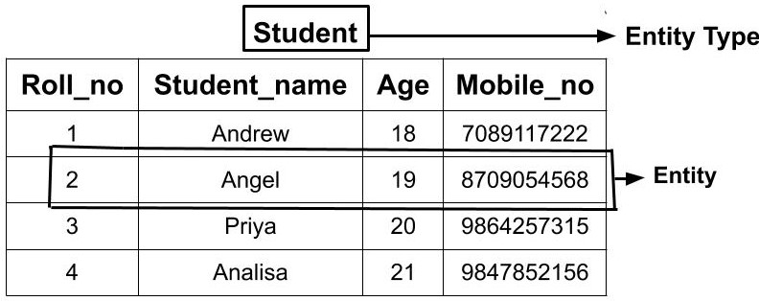

## Types of Entity type

* Strong Entity Type
* Weak Entity Type

Strong Entity Type***:*** Strong entities are those entity types which has a key attribute. The primary key helps in identifying each entity uniquely. It is represented by a rectangle. In the above example, Roll_no identifies each element of the table uniquely and hence, we can say that STUDENT is a strong entity type.

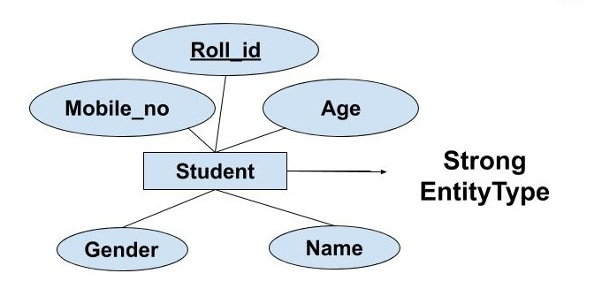

Weak Entity Type: Weak entity type doesn't have a key attribute. Weak entity type can't be identified on its own. It depends upon some other strong entity for its distinct identity. This can be understood with a real-life example. There can be children only if the parent exits.

 A weak entity is represented by a double outlined rectangle. The relationship between a weak entity type and strong entity type is called an identifying relationship and shown with a double outlined diamond instead of a single outlined diamond. This representation can be seen in the diagram below.

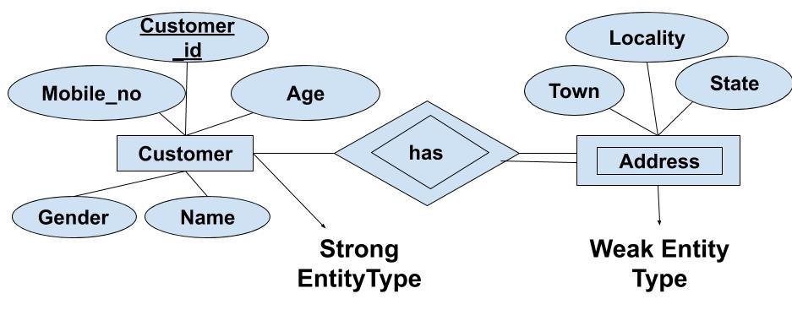

## Entity Set

Entity Set is a collection of entities of the same entity type. **We can say that entity type is a superset of the entity set as all the entities are included in the entity type.**

