**Hypothesis#1:**

**H0: Distance travelled by tornadoes of magnitude 3 and 4 are the same**

**Ha: Distance travelled by tornadoes of magnitude 3 is more than that of 4**

**Distribution in box plot:**

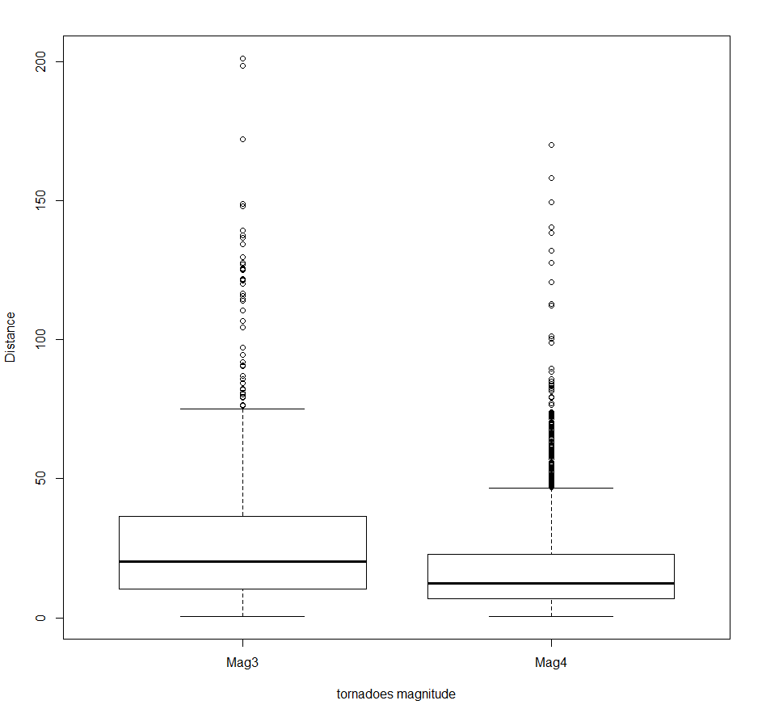

**Box plot without outliers:**

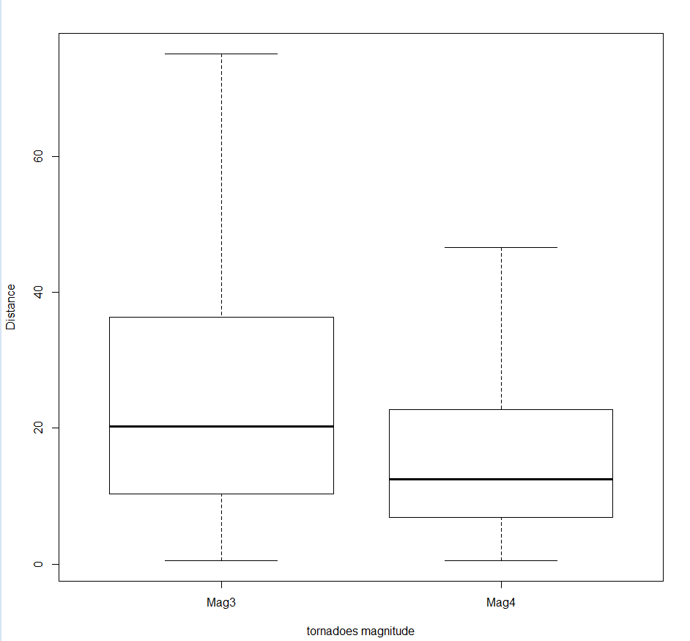

**Z test: two sample – independent one tailed test**

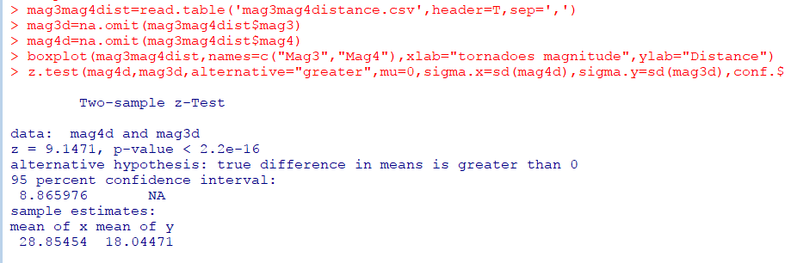

**Hypothesis#2:**

**H0: Alabama and Texas have the same number of injuries list caused by tornadoes**

**Ha: Alabama and Texas injuries list is not the same**

**Box plot to view the distribution**

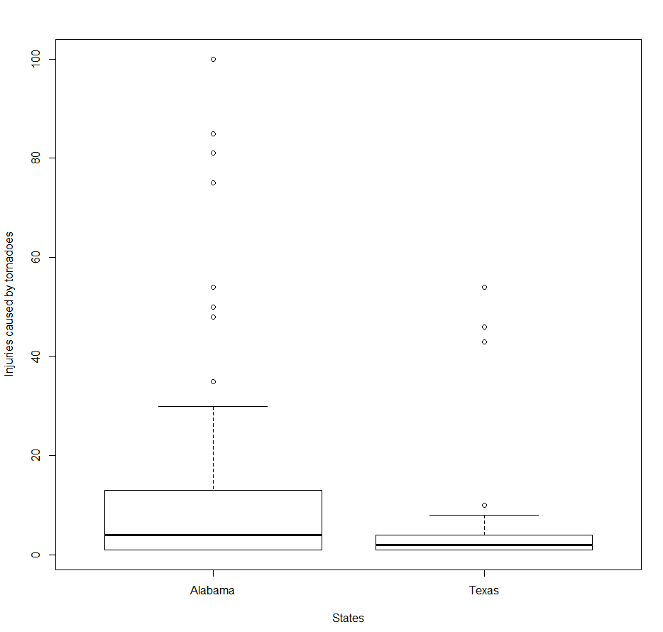

**Box plot without outliers**

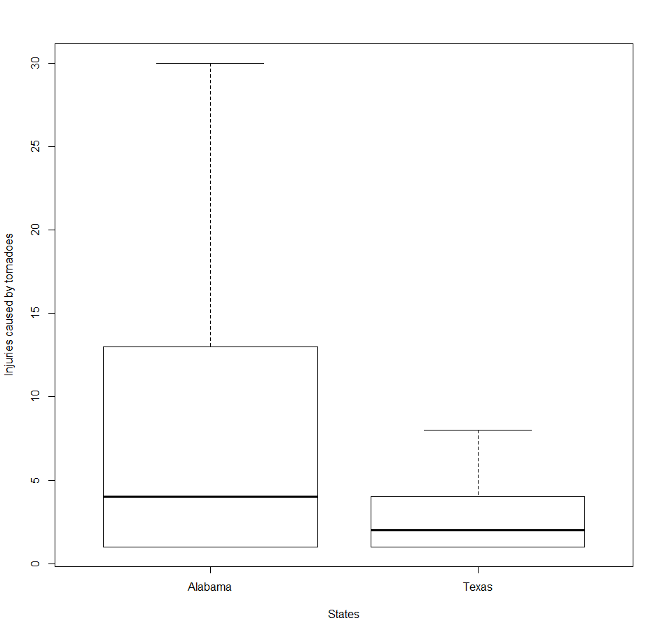

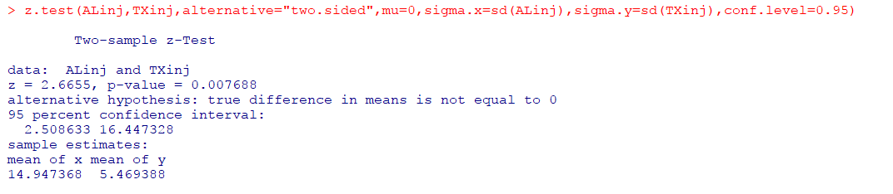

**Here, the p-value is < 0.05 and the z-stat falls within the rejection region (Zc: +1.96 🡺 Zstat > Zc). Hence, we do not have enough evidence to accept the null hypothesis. Hence at 95% confidence level, we conclude that the number of people injured by tornadoes in states Texas and Alabama are not the same and that they are different**

**Hypothesis#3:**

**H0: No of states affected by tornado of magnitudes 0 to 3 is 3**

**Ha: No of states affected by tornado of magnitude less than 3 is less than 3**

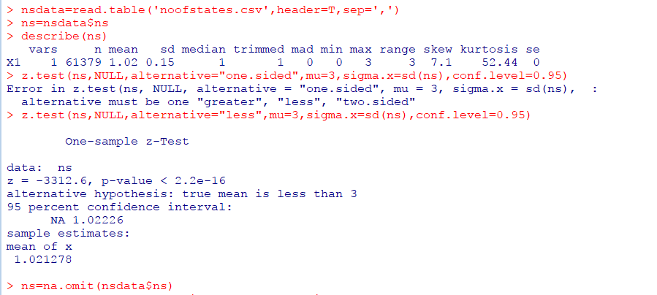

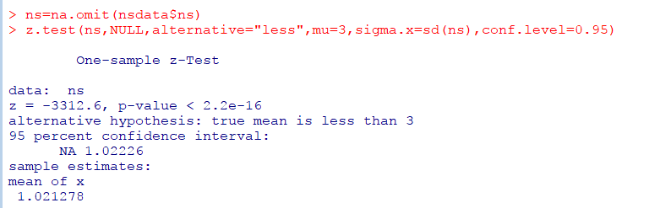

Here, the z-stat falls within the rejection region and the p-value is also less than 0.05. Hence, we do not have enough evidence to accept the null hypothesis at 95% confidence level which in turn favors the alternate hypothesis. Hence, it can be concluded that **the no of states affected by tornado of magnitudes 0 to 3 are less than 3**

**Hypothesis#4:**

**H0: Average number of fatalities caused by tornadoes is 4**

**Ha: Average number of fatalities caused by tornadoes is not 4**

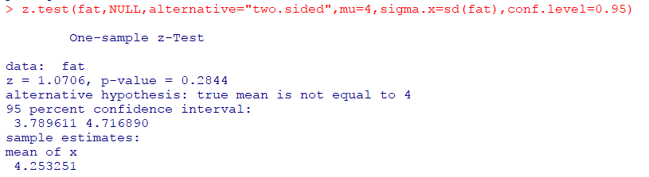

**p-value > 0.05 🡺 accept null hypothesis thereby concluding that the average number of fatalities caused by tornadoes is 4**