Healthcare Management: Patient Readmission Prediction

GOOGLE COLAB
Step 1 :
import pandas as pd

Step 2 : upload the file
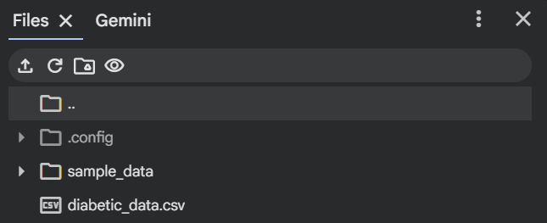

Step 3 :
df = pd.read_csv("/content/diabetic_data.csv")
df.shape

Step 4 :
for i in df.columns:
if df[i].dtype == "object":
df[i] = df[i].str.strip().replace('?',None)

Step 5 :
df.to_csv("diabetic_data_cleaned.csv")
download the file cleaned one –
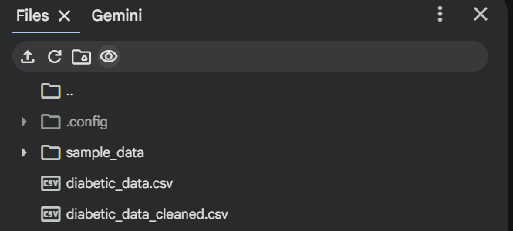

Step 6 :
for i in df.columns:
if df[i].dtype == "object":
print(i, df[i].unique())

Step 7 :
for i in df.columns:
if df[i].dtype == "object":
print(i, df[i].unique())

Excel Tasks:
- Data Exploration:
• Make a statistical summary of pertinent features like the number of lab procedures, procedures, drugs, and furthermore.
EXCEL
Step 8 :
Open diabetic_data_cleaned.csv file -> click on file -> options ->
Add-ins -> manage (Excel add-ins) ->
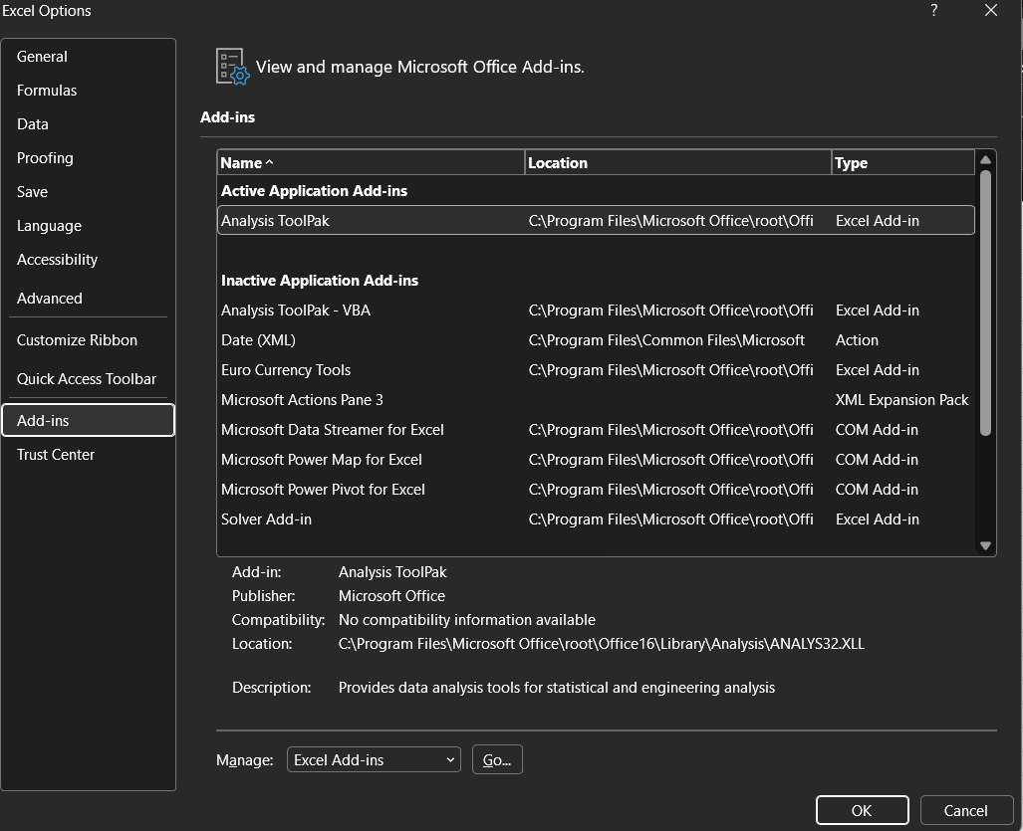

click on go -> analusis ToolPak -> ok
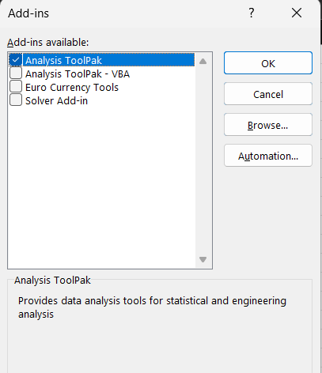
Click on data analysis ->
Select descriptive statistics -> ok
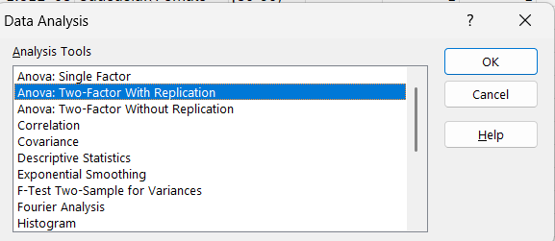
Select the column which you want in input range i.e.num_lab_procedure ->num-
Lab…->
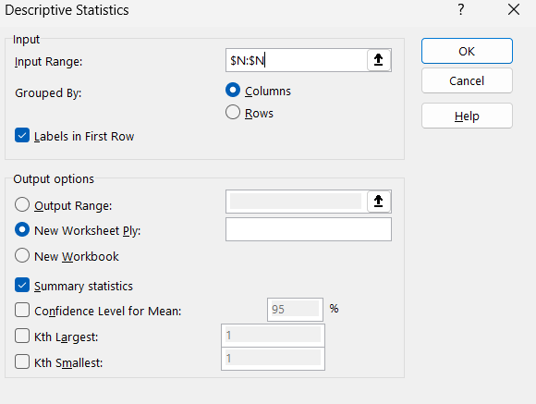
In input range section go to end of that particular column -> check labels in first row and summary statistics -> OK
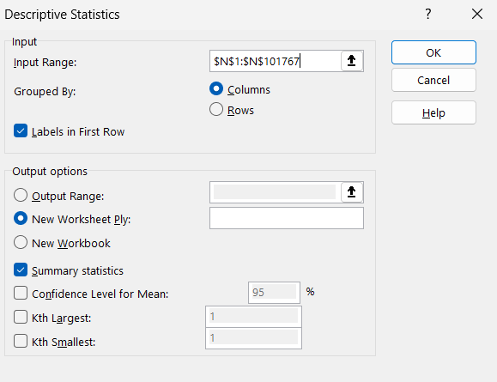

Output : Lab Procedure
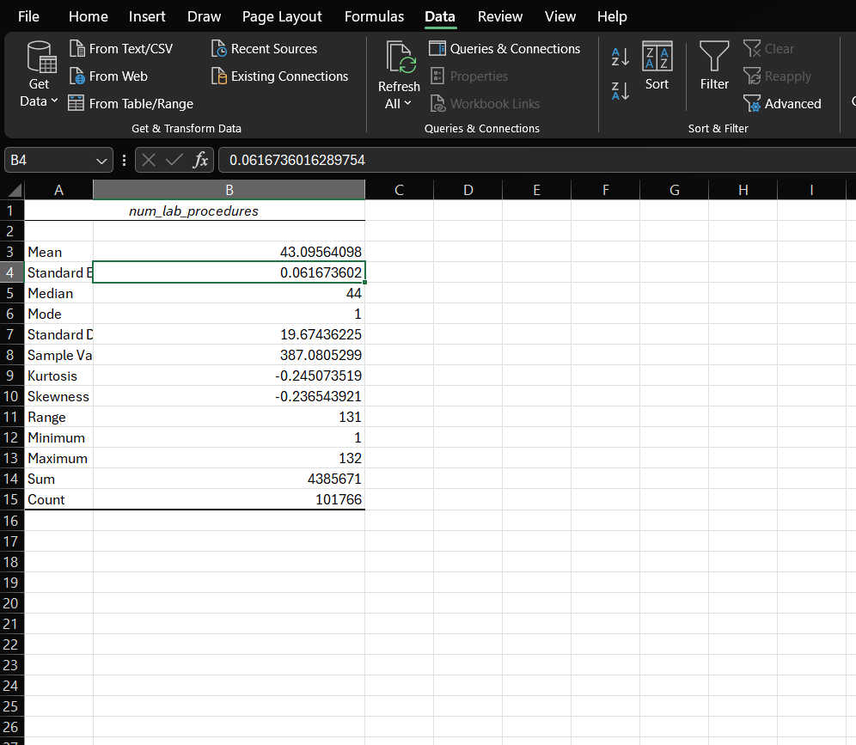

Now, Procedure –
Select the column which you want in input range i.e.num_procedure ->
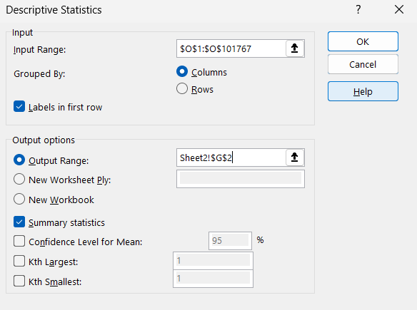
Output : on same sheet 2
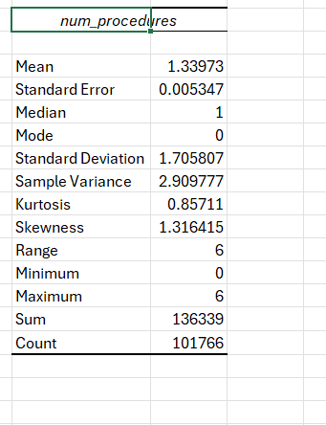

• Create a report showing the number of readmissions by gender and age group
Step 9 :
Go to diabetic_data_cleaned.csv and then go to insert tab ->
Click on pivot table -> select from table/range -> OK
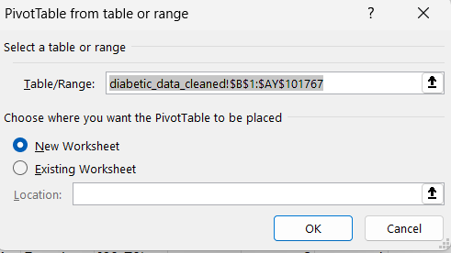
Next page ->
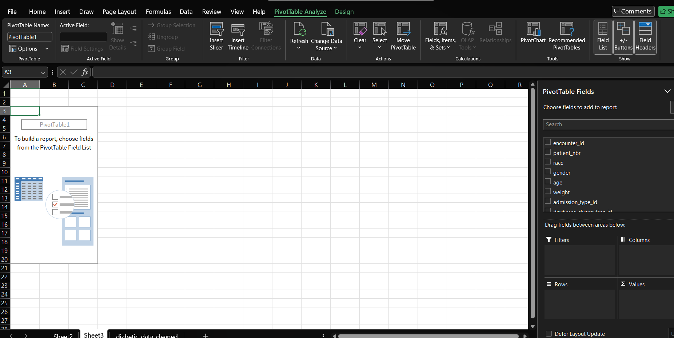
Now drag down the readmitted to values ->
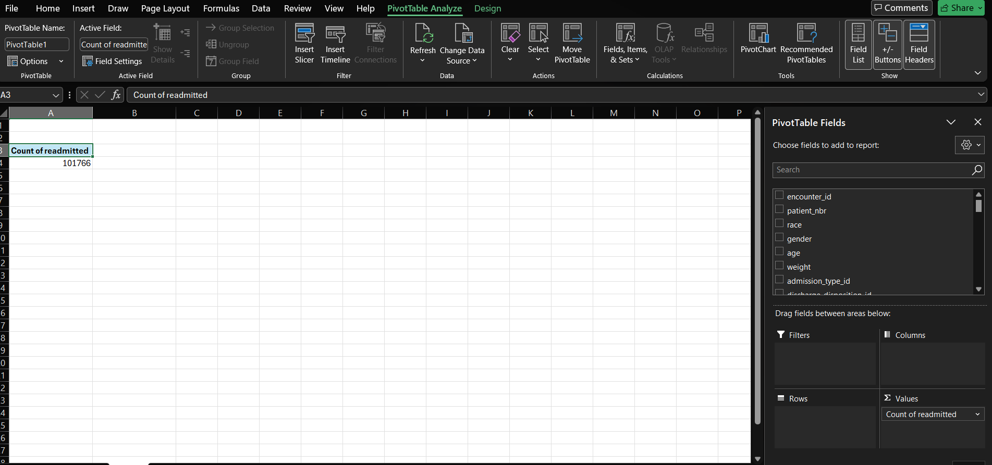
Drag down gender and age in rows ->
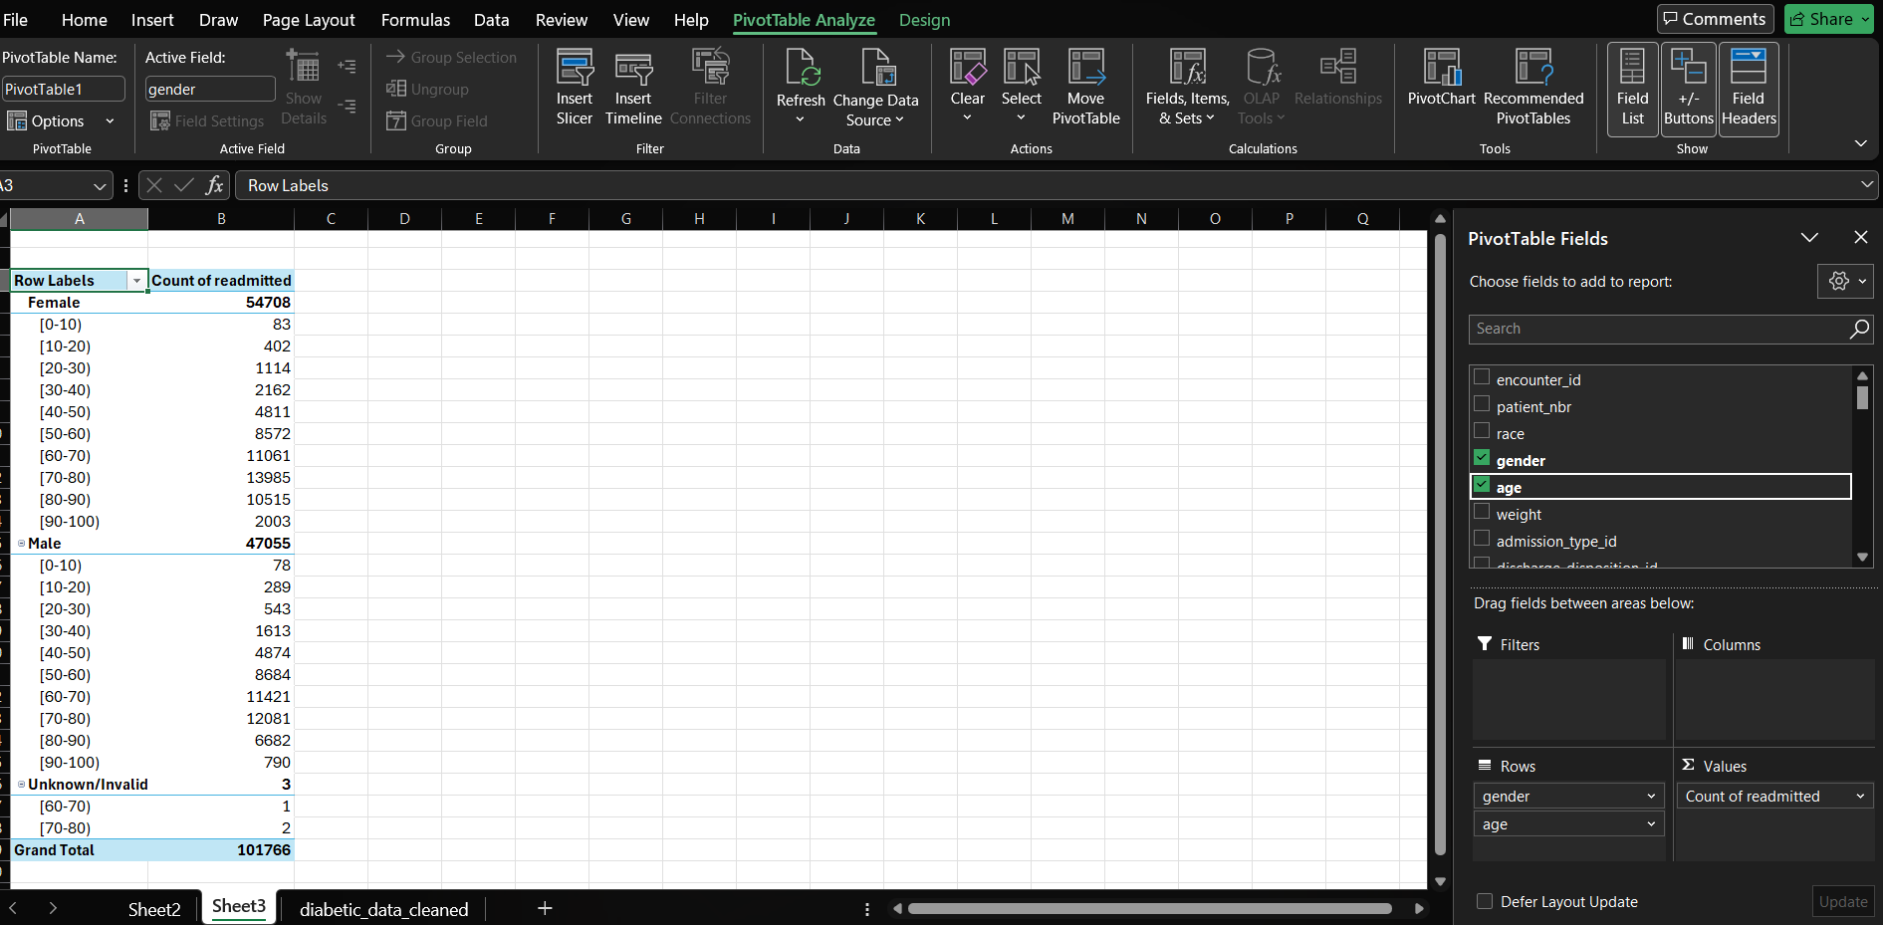

• Show race distribution in a chart –
Bring the arrow to race cell ->
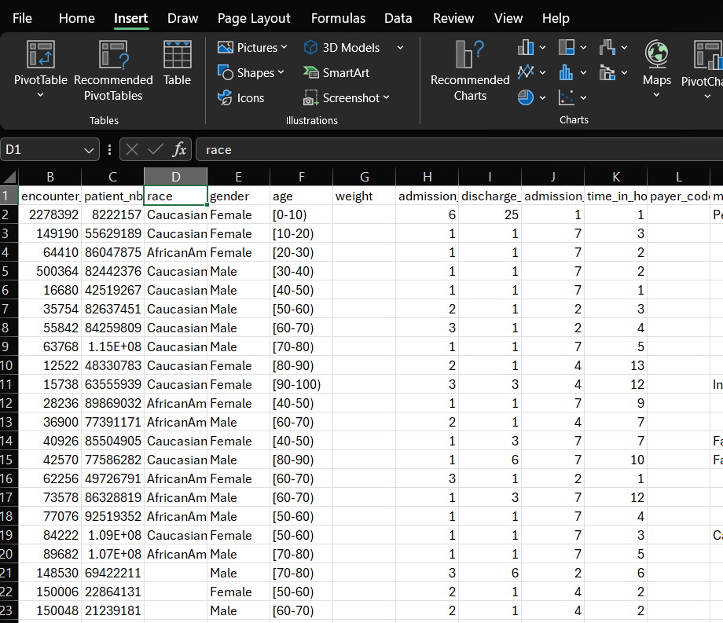
Go to insert tab -> click on pivot table -> select from table/range -> OK
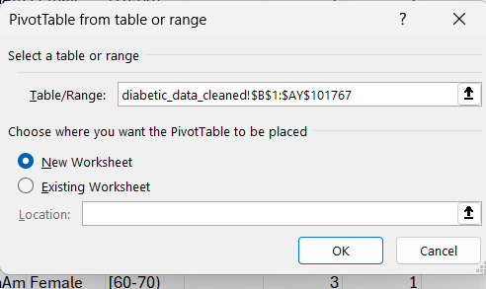
Drag down the race to row box and patient_nbr to value box ->
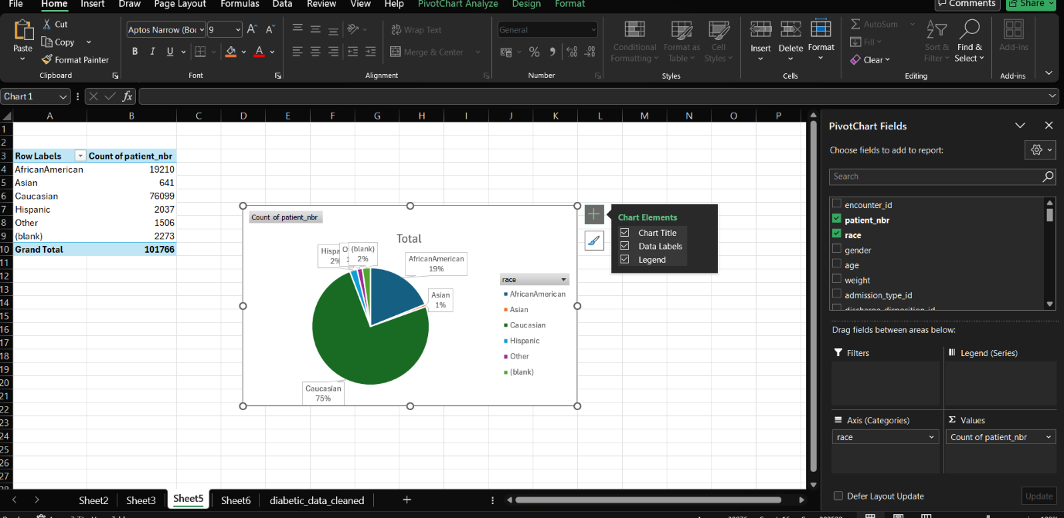
• Plot count of patients for each category of readmitted
Drag the encounter_id column into the Rows area and drag the patient_nbr into the value area -> click in patient_nbr in value box -> click on value field settings ->change patient_nbr to encounter_id
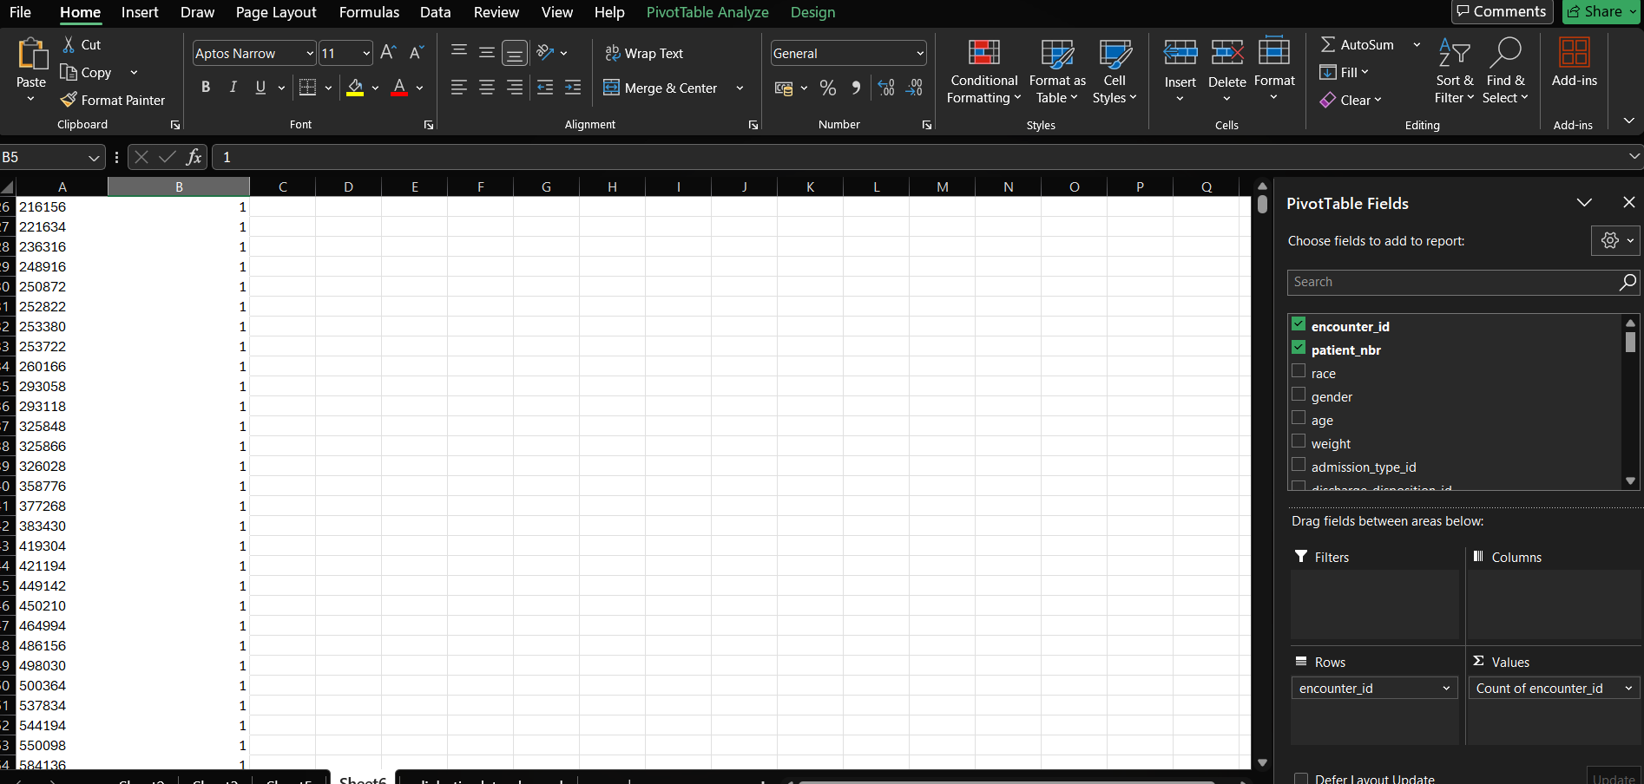

SQL Tasks:
MYSQL
- Data Loading:
• Create a schema named healthcare, set it as the default schema, and create tables using diabetic_data.csv
Open MySQL -> create schema -> name as healthcare ->click on apply -> pop-up will appear as above snapshot -> apply -> finish
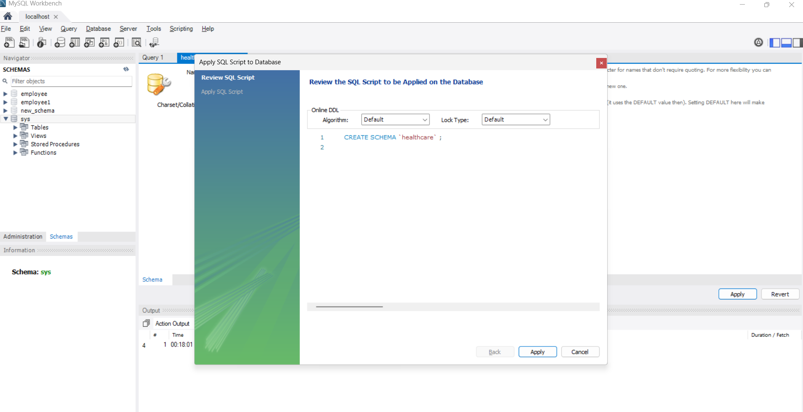
Now, in left side panel there we can see healthcare section in that double click we can see table in that right click -> table data import wizard -> select the path by browsing and next
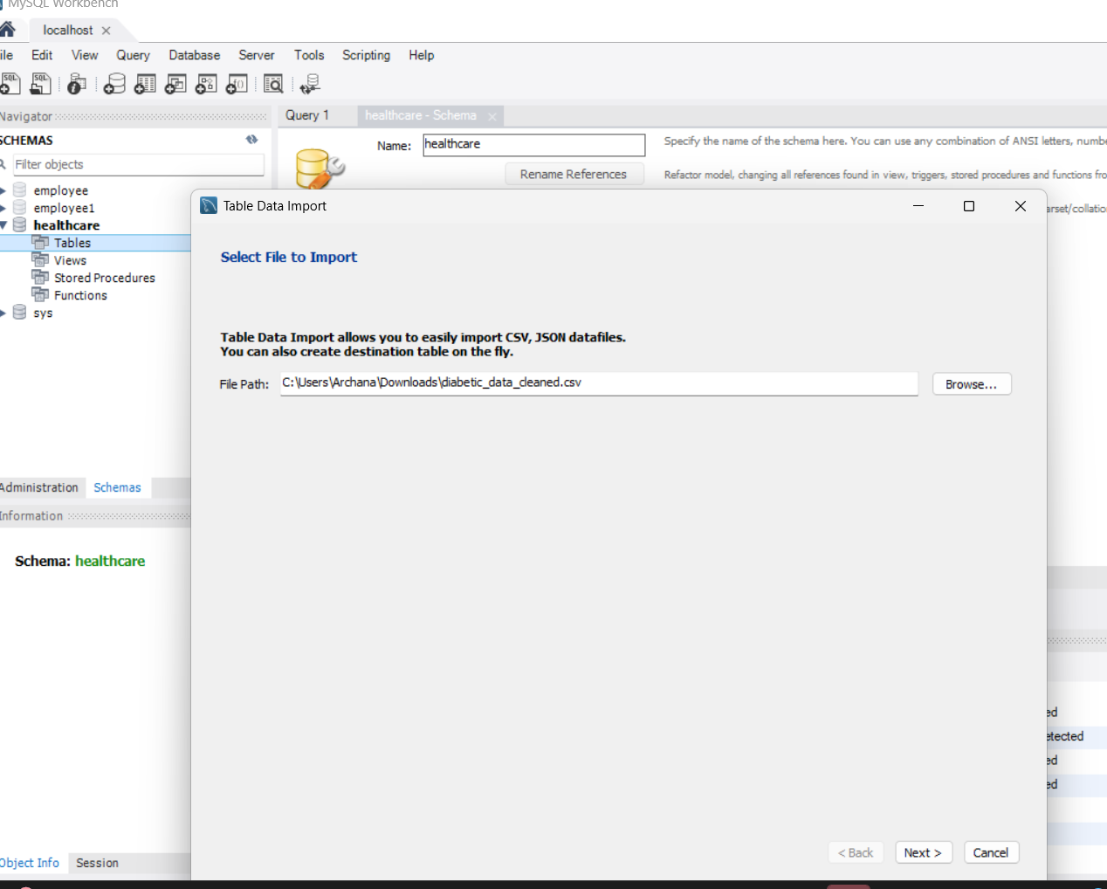
name the file as in task give above -> next
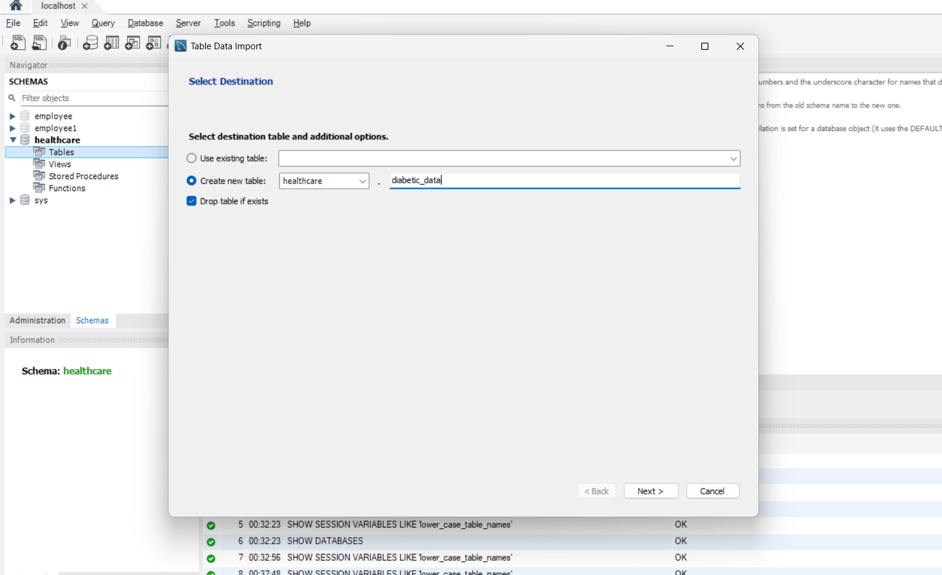
Click on next again ->
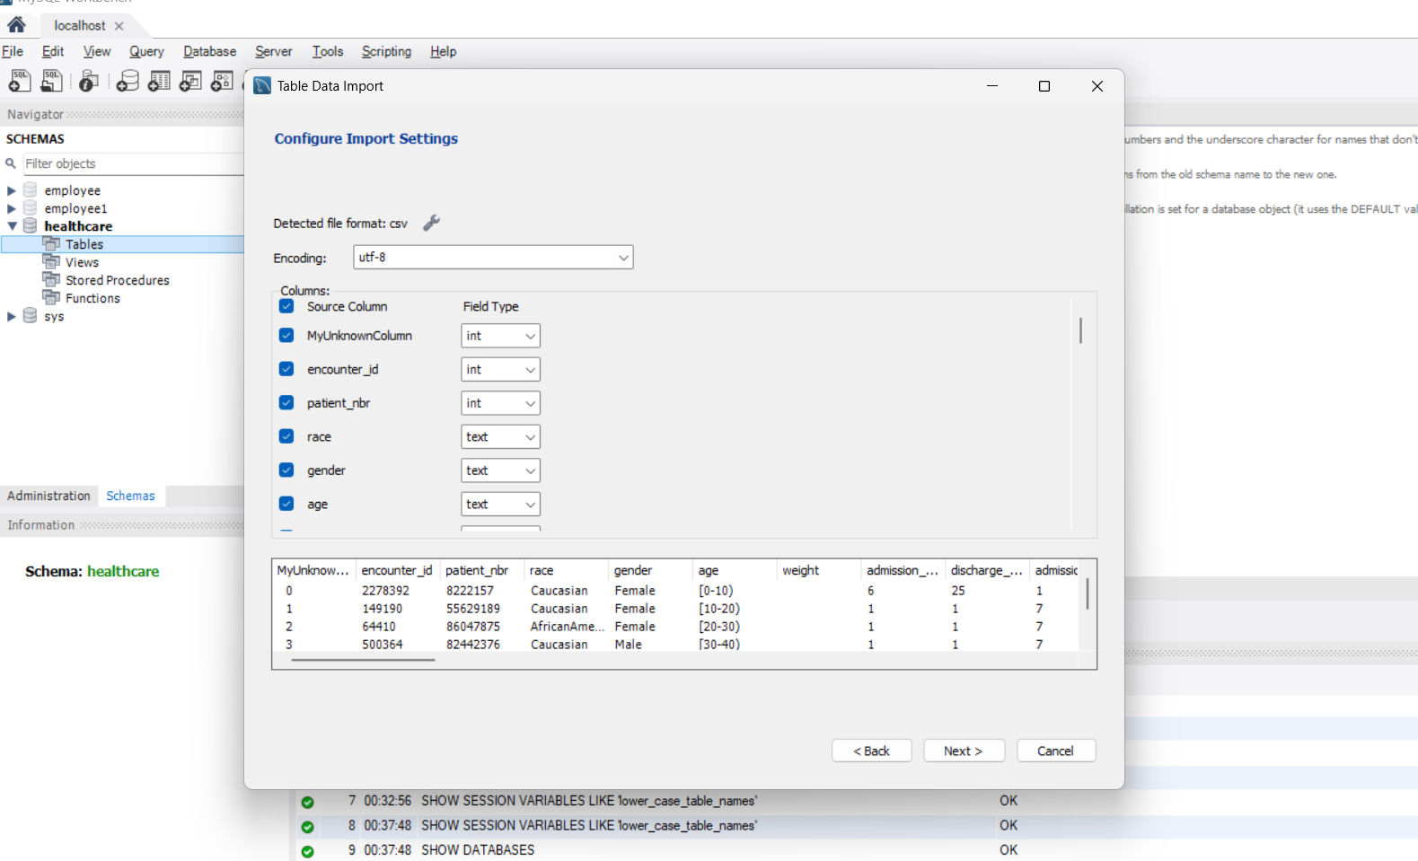

Click on next ->
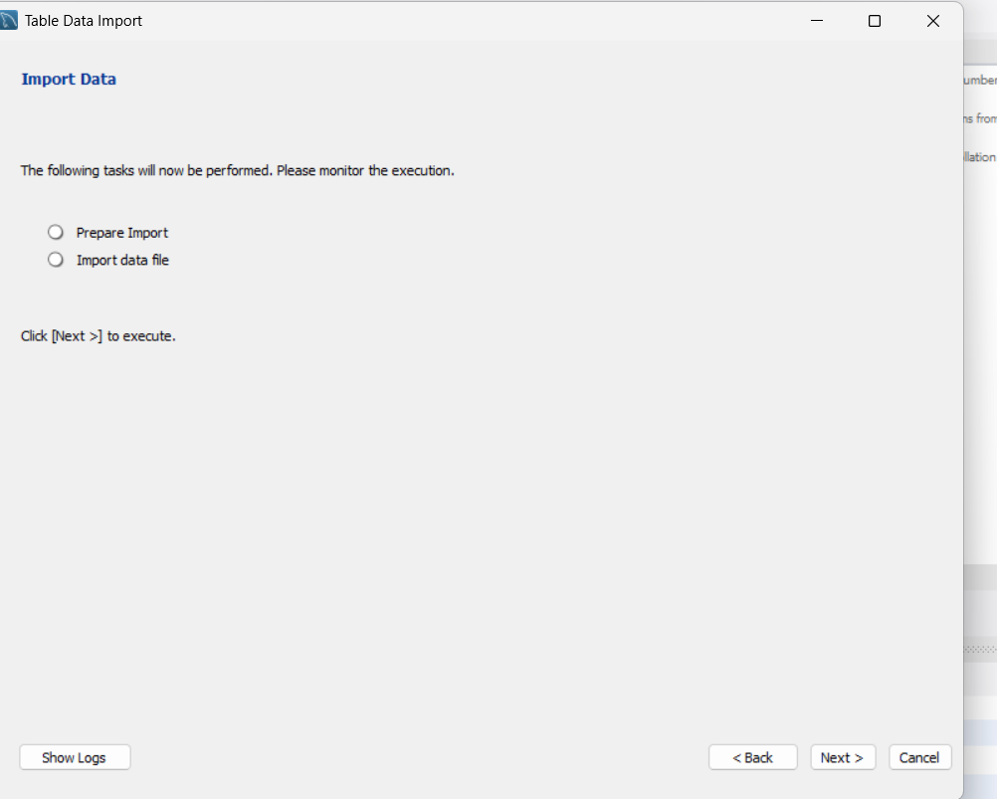
• Identify the distribution of readmission rates across different payer codes
SELECT payer_code,
COUNT(CASE WHEN readmitted != 'No' THEN 1 END) AS readmitted_count,
COUNT(*) AS total_encounters,
(COUNT(CASE WHEN readmitted != 'No' THEN 1 END) * 100.0 / COUNT(*)) AS readmission_rate_percentage
FROM healthcare.diabetic_data
GROUP BY payer_code
ORDER BY readmission_rate_percentage DESC;
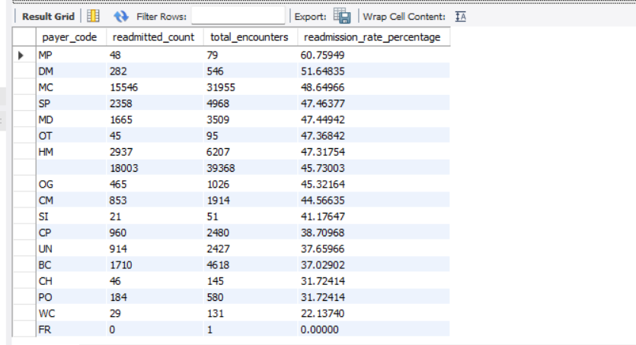
• Calculate the average number of medications prescribed for patients in each age group
SELECT age, AVG(num_medications) AS avg_medications
FROM healthcare.diabetic_data
GROUP BY age
ORDER BY age;
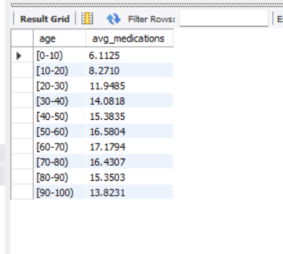
• Identify the most common procedures performed during patient encounters
SELECT num_procedures, COUNT(*) AS procedure_count
FROM healthcare.diabetic_data
GROUP BY num_procedures
ORDER BY num_procedures DESC
LIMIT 10;
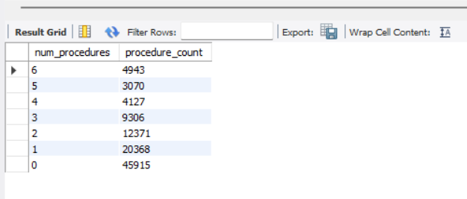
• Identify the age distribution of patients
SELECT age, COUNT(*) AS patient_count
FROM healthcare.diabetic_data
GROUP BY age
ORDER BY age;
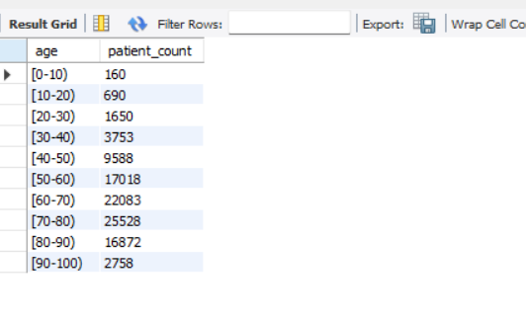
• Determine the number of readmitted patients and the percentage of total encounters that they represent
SELECT
COUNT(*) AS readmitted_count,
(COUNT(*) * 100.0 / (SELECT COUNT(*) FROM healthcare.diabetic_data)) AS readmitted_percentage
FROM healthcare.diabetic_data
WHERE readmitted != 'No';
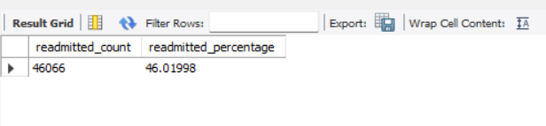
• Calculate the average length of hospital stay for each admission type
SELECT admission_type_id, AVG(time_in_hospital) AS avg_length_of_stay
FROM healthcare.diabetic_data
GROUP BY admission_type_id;
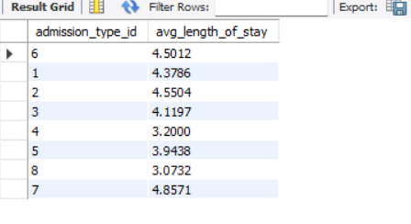
• Identify the top 10 most frequent diagnoses in the dataset
SELECT diag_1, COUNT(*) AS diagnosis_count
FROM healthcare.diabetic_data
GROUP BY diag_1
ORDER BY diagnosis_count DESC
LIMIT 10;
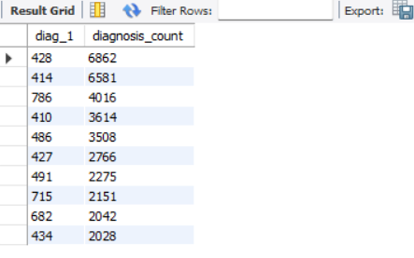
• Calculate the total number of patient encounters in the healthcare dataset
SELECT COUNT(DISTINCT encounter_id) AS total_encounters
FROM healthcare.diabetic_data;
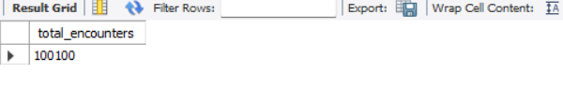

Tableau Tasks:
- Interactive Dashboard Design in Tableau:
- Show the distribution of readmitted counts of diagnoses and emergency cases through bar graphs
  - Choose the Text file in the Connect pane and upload the diabetic_data.csv dataset
  - Open a new worksheet
  - Drag Number Diagnoses and Number Emergency into Columns and Readmitted to Rows
  - Drag Readmitted to Label
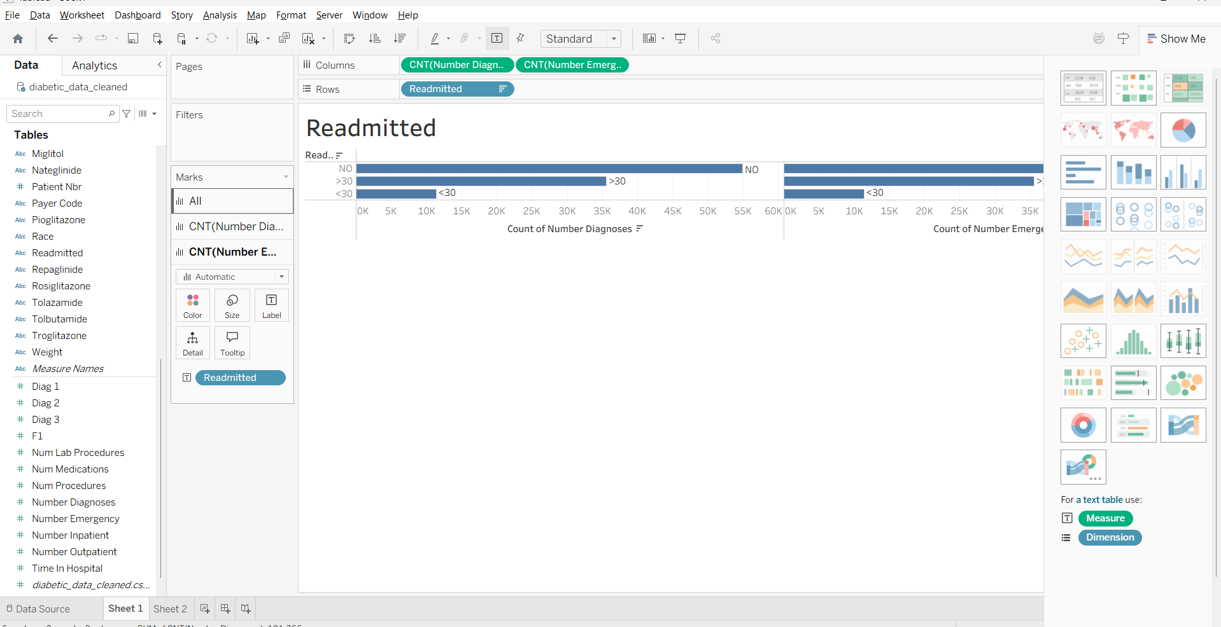

• Create a visual capturing age bucket count by readmitted
- Open a new worksheet, click on Analysis, and choose Create Calculated Field o Name the calculated field as Age Numeric, and use the formula: INT([Age]), and click on Apply and OK
- Again, click on Analysis and choose Create Calculated Field o Name the calculated field as Age Bucket, use this formula: IF [Age Numeric] <= 10 THEN "0-10" ELSEIF [Age Numeric] <= 20 THEN "11-20" ELSEIF [Age Numeric] <= 30 THEN "21-30" ELSEIF [Age Numeric] <= 40 THEN "31-40" ELSEIF [Age Numeric] <= 50 THEN "41-50" ELSE "51+" END and click on Apply and OK
- Drag Age Bucket to Columns and Readmitted and Number Inpatient to Rows o Right-click on Number Inpatient and change the measure from sum to count
- Drag Number Inpatient to Color and Label
Steps :– go to analytics -> create calculated fields… -> rename as Age Numeric.
Again go to analytics -> create calculated fields… -> rename as Age Bucket.
Drag readmitted and numeric inpatient to column and drag age bucket to row box.
Drag numeric inpatient to color and label.
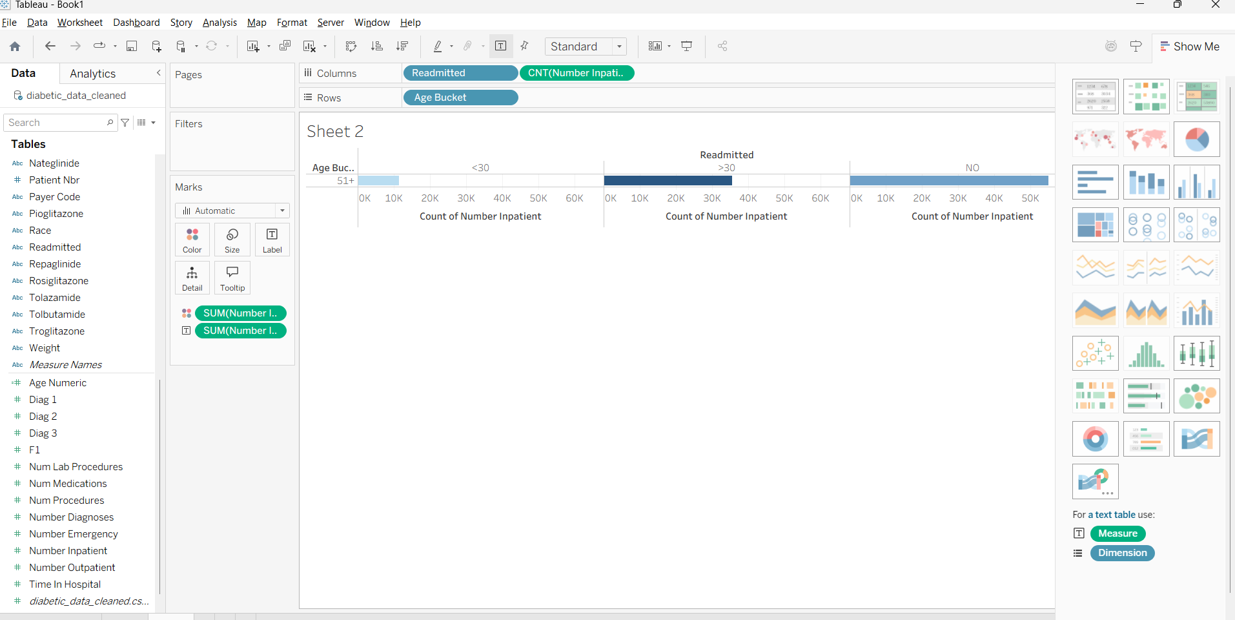

Renaming of the sheet
Step :- double click on sheet 2 and type age bucket -> apply -> OK

• Visualize the number of medications, procedures, diagnoses, emergencies, time in the hospital by readmitted
  - Drag Readmitted to Columns and Num Medications, Num Procedures, Number Diagnoses, Number Emergency and Time In Hospital to Rows
  - Select the stacked bar chart from show me
  - Interchange the rows and columns for a better visualization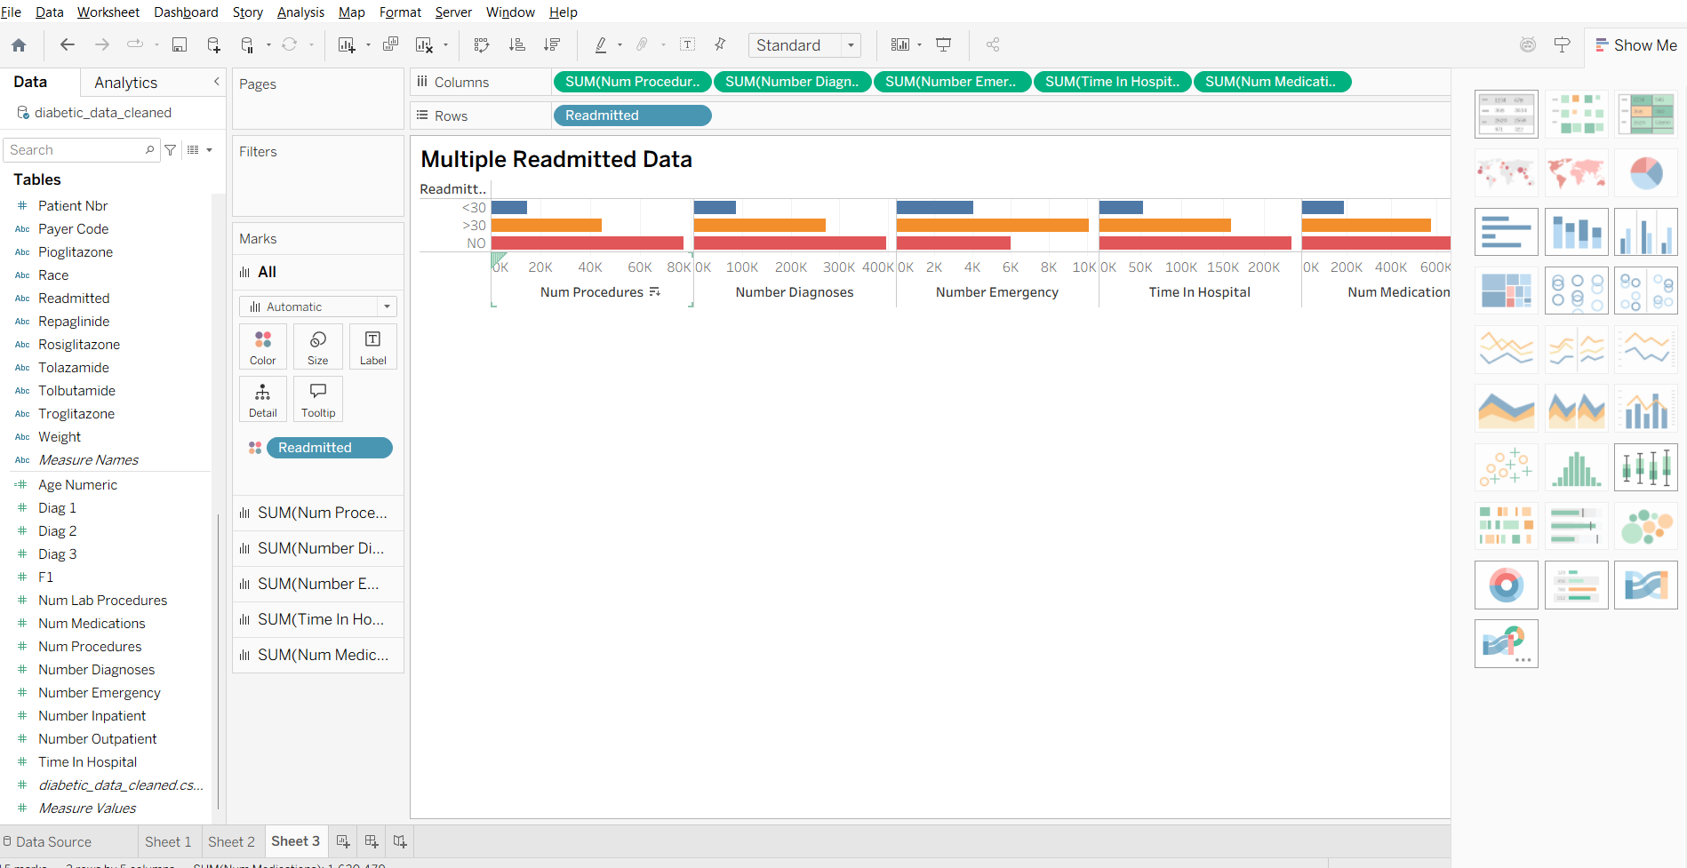

• Create a bubble chart showing the number of medications, Lab procedures and Diagnoses and use Readmitted as color code
  - Drag Num Medications to Columns and Num Lab Procedures to Rows
  - Drag Number Diagnoses to Size
  - Drag Readmitted to Color
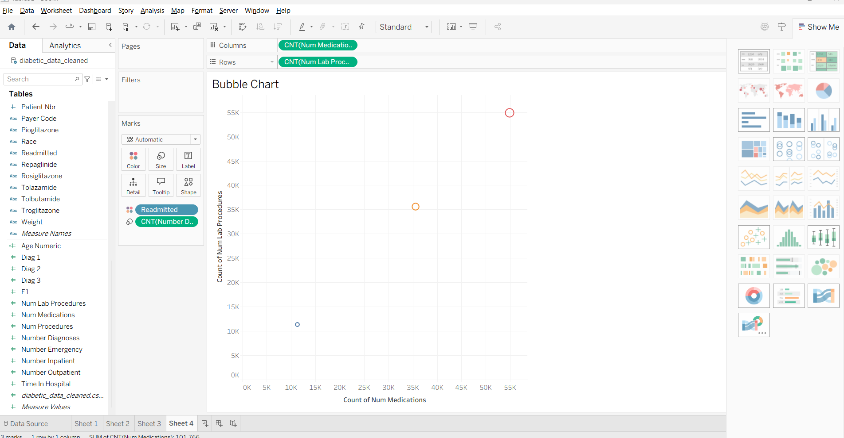
• Create a dashboard with all the visualizations
  - Click on the dashboard icon at the bottom
  - Drag Readmitted, Age Bucket, Multiple Readmitted Data, and Bubble Chart to the dashboard area
