/*For this challenge you need to PIVOT data. You have two tables, products and details. Your task is to pivot the rows in products to produce a table of products which have rows of their detail. Group and Order by the name of the Product.

**Tables and relationship below:**

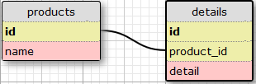

You must use the CROSSTAB statement to create a table that has the schema as below:

CROSSTAB table.

* name
* good
* ok
* bad

Compare your table to the expected table to view the expected results.

[more info can be found here](https://www.postgresql.org/docs/9.2/static/tablefunc.html)

*/

CREATE EXTENSION tablefunc;

SELECT *

FROM crosstab(

'SELECT p.name, detail, COUNT(d.id)

FROM products p

JOIN details d

ON p.id = d.product_id

GROUP BY p.name, d.detail

ORDER BY 1,2')

AS ct (name text, bad bigint, good bigint, ok bigint)