/*

For this challenge you need to create a VIEW. This VIEW is used by a sales store to give out vouches to members who have spent over $1000 in departments that have brought in more than $10000 total ordered by the members id. The VIEW must be called members_approved_for_voucher then you must create a SELECT query using the view.

**Tables and relationship below:**

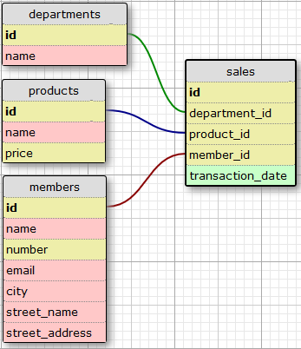

**resultant table schema**

* id
* name
* email
* total_spending

*/

create or replace view members_approved_for_voucher as

select m.id,m.name,m.email,sum(p.price) as total_spending from sales s

inner join products p on p.id = s.product_id

inner join members m on m.id = s.member_id where s.department_id in

(select s.department_id from sales s

inner join products p on p.id = s.product_id

group by s.department_id

having sum(p.price) > 10000)

group by m.id

having sum(p.price) > 1000

order by m.id;

select id,name,email,total_spending from members_approved_for_voucher;