For this challenge you need to create a simple SELECT statement. Your task is to calculate the MIN, MEDIAN and MAX scores of the students from the results table.

**Tables and relationship below:**

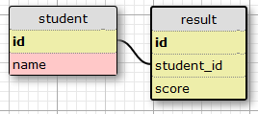

**Resultant table:**

* min
* median
* max

select min(score), percentile_cont(0.5) within group (order by score::float) as median,

max(score) from result;