**Linear Algebra**

**Data Structure for Algebra**

**Tensor:** arrays of numbers, Tensors are machine learning generalization of vectors and matrices to any number of dimensions

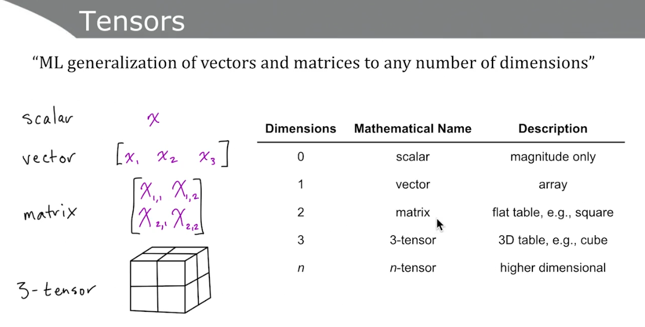

**Scalars:**

* No dimensions
* Single number
* Denoted in lowercase, italics e.g.: *x*
* Should be typed, like all other sensors: e.g.: int, float32

**Vectors:**

* One dimensional array
* Denoted in lowercase, italics and bold e.g.: ***x***
* Elements are arranged in order and each element is accessed by index. Elements are scalars so not bold. Eg.: ***X*** = [*x1, x2*] – noticed elements x1, x2 are italic, lowercase but not bold.
* Represent point in space:
  + Vector of length two represents location in 2D matrix
  + Vector of length three represents location in 3D matrix
  + Vector of length n represents location in n-dimensional matrix

**Vector Transposition:**

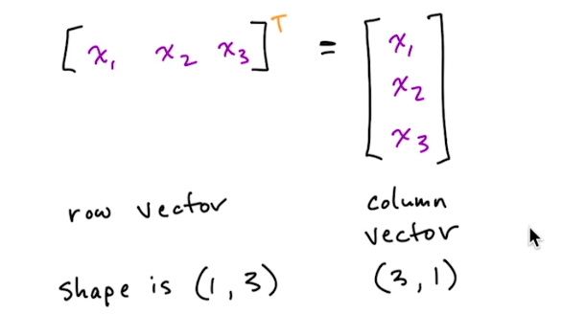

**Norms:** Norms are functions that quantify vector magnitude

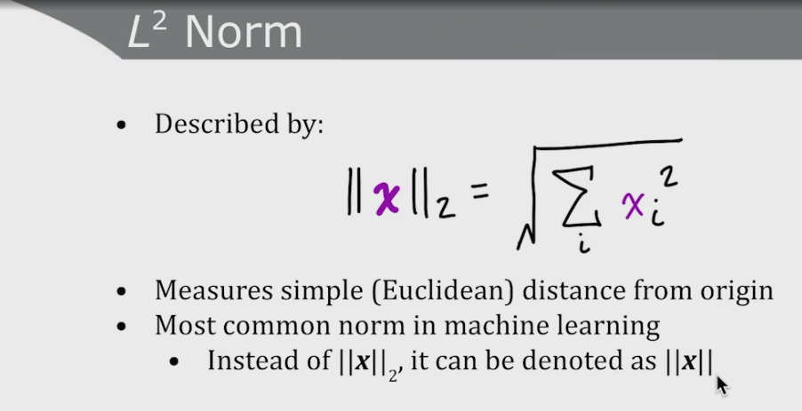

L2 Norm measures simple distance (Euclidean) from origin

**Numpy function:** np.linalg.norm(x)

**Unit Vectors:**

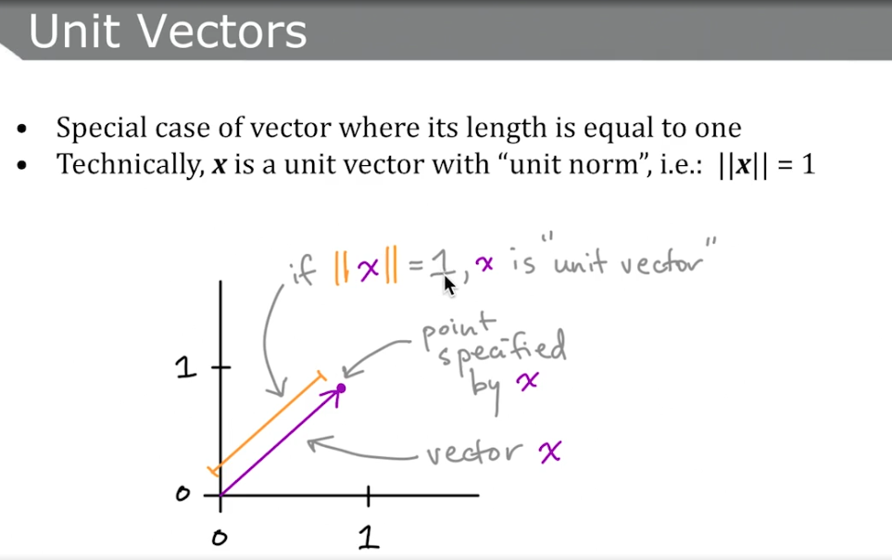

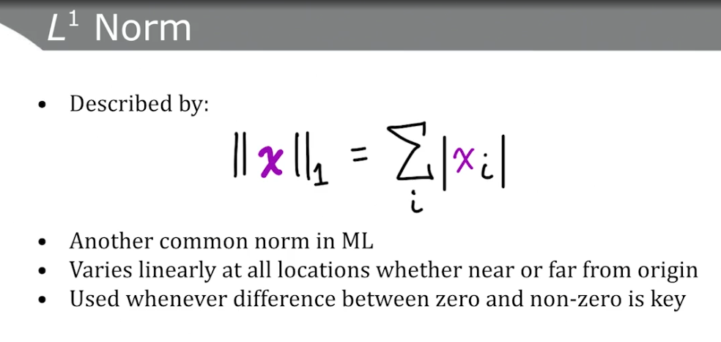

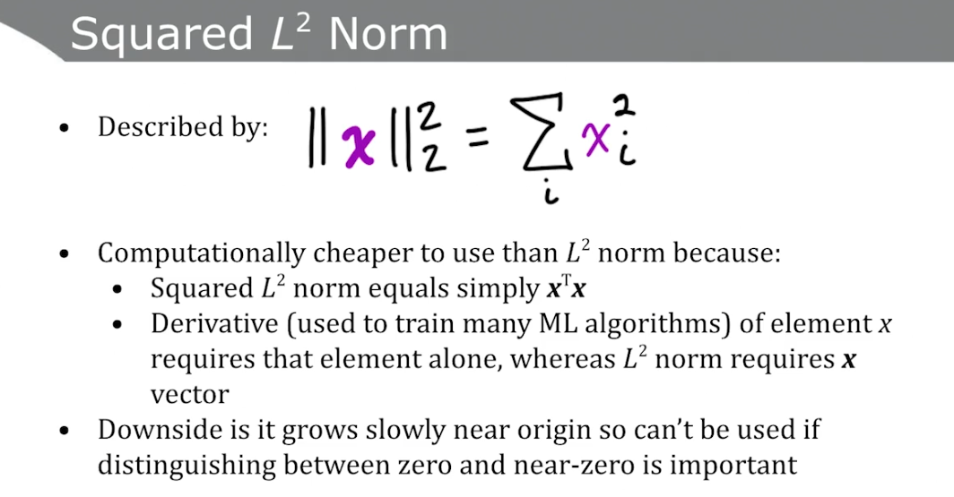

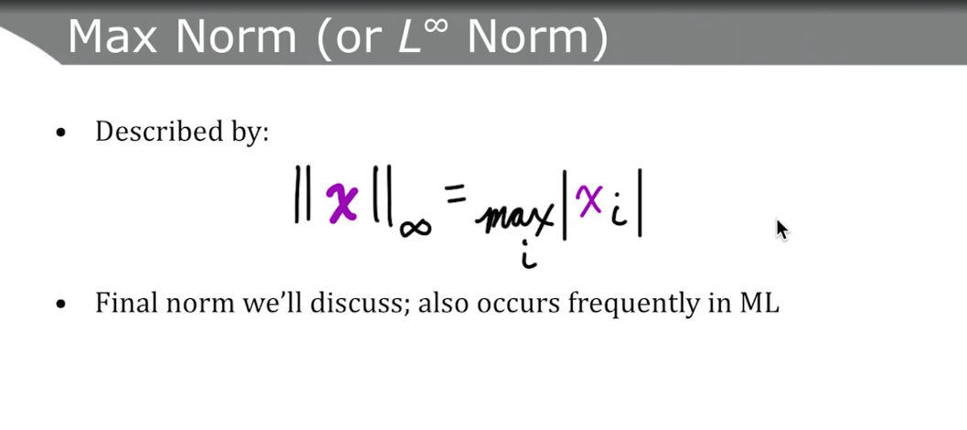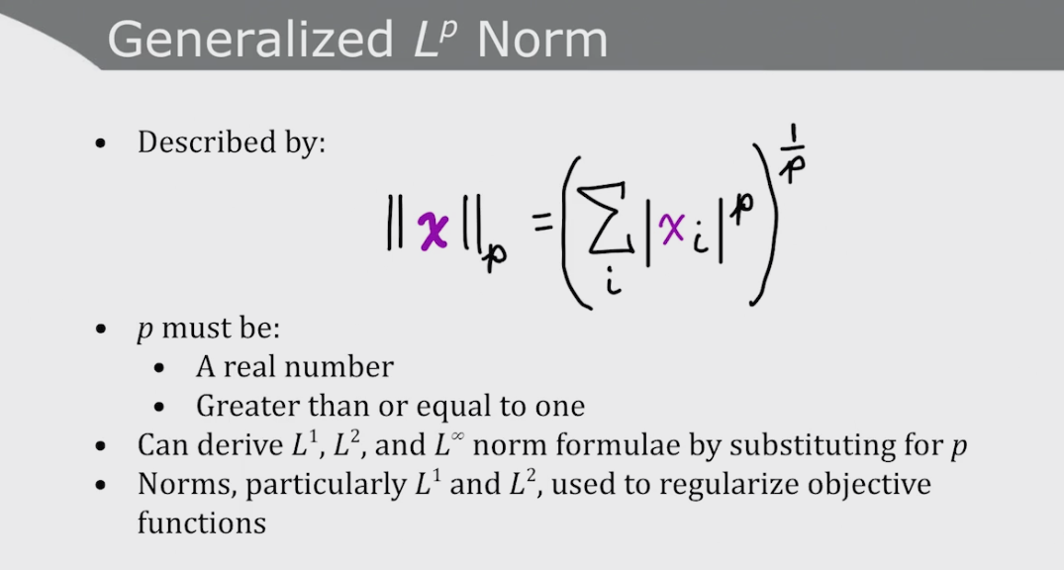

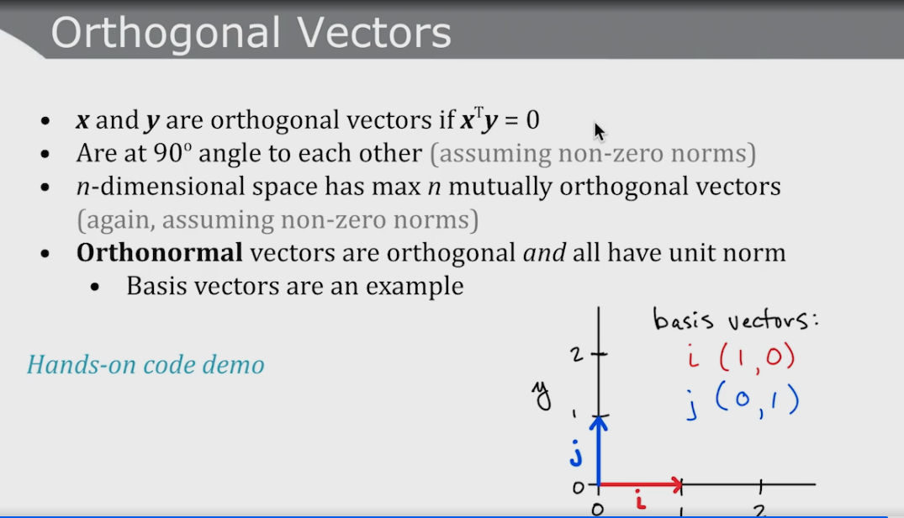

**Matrices:** matrix tensors are two dimensional arrays of numbers

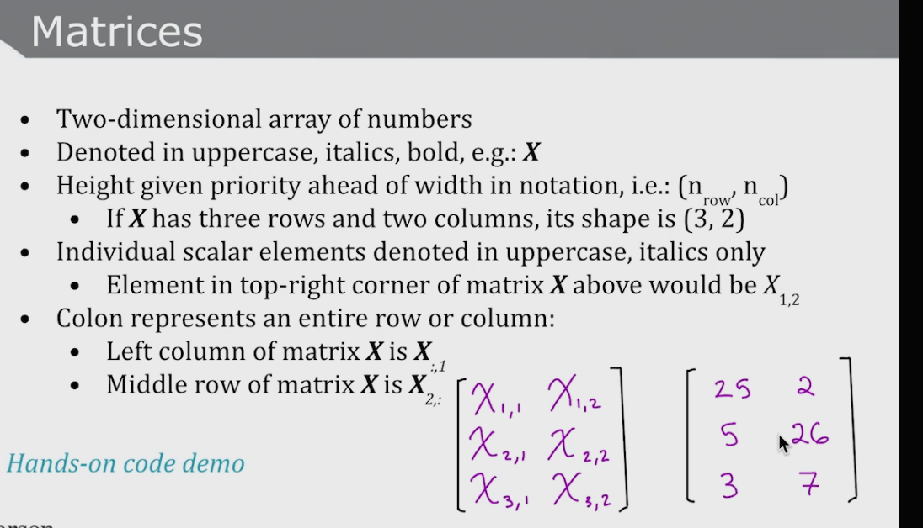

**Generic Tensor Notation**

