Story
Date | 30 july 2026
Team ID | Archana kumari
Project Name | Food ordering behaviour and consumer trends
Maximum Marks | 5 Marks

Activity 1: Story Design:
FOOD ORDERING BEHAVIOUR AND CONSUMER TRENDS
This story presents a comprehensive analysis of customer food ordering behavior using Tableau. The analysis focuses on order value, ordering patterns, meal preferences, cuisine performance, and city-wise revenue contribution. Through interactive visualizations, the story identifies key business insights that can help improve customer satisfaction, optimize operations, and support data-driven decision-making in the food delivery industry.
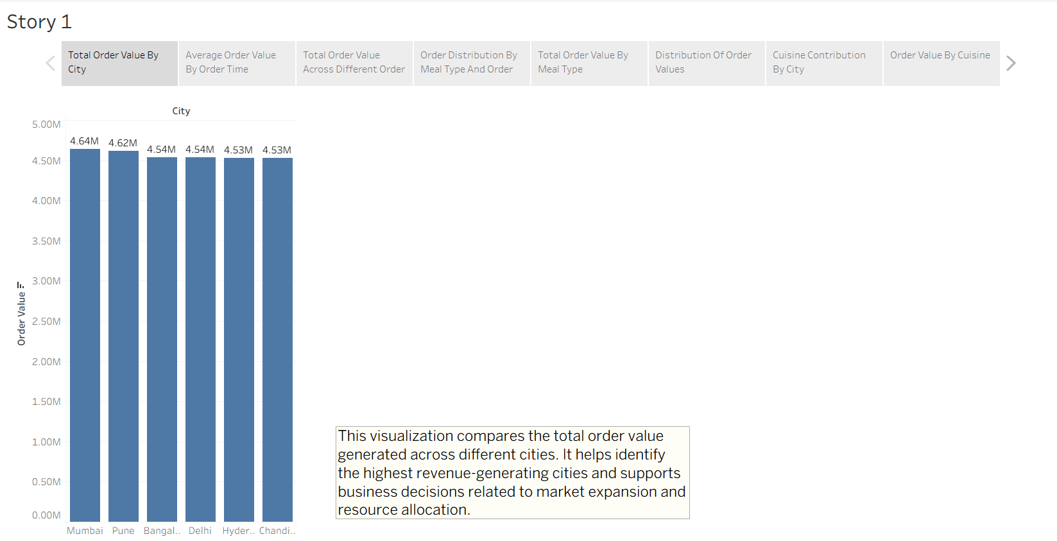
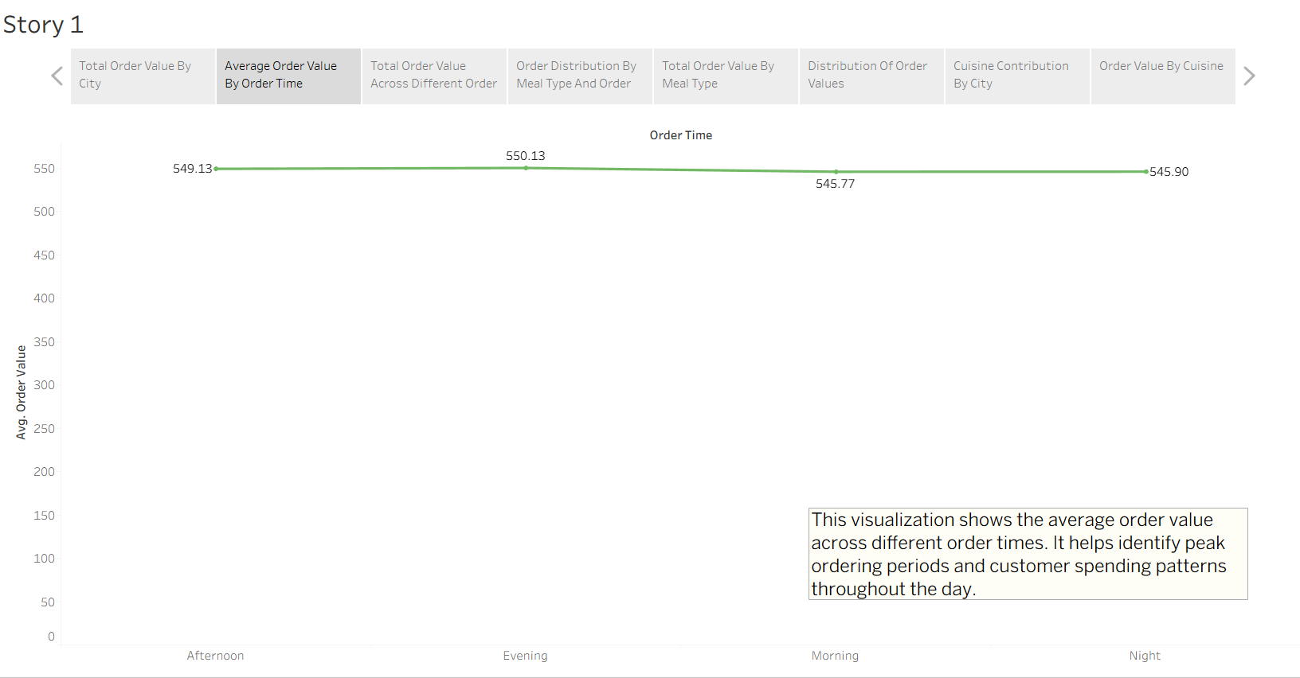
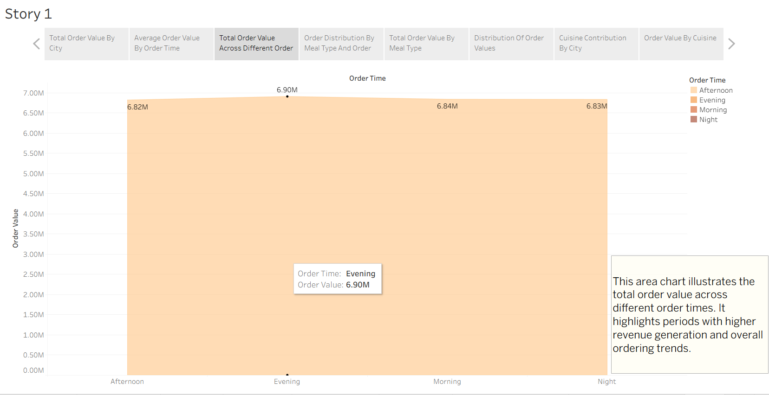
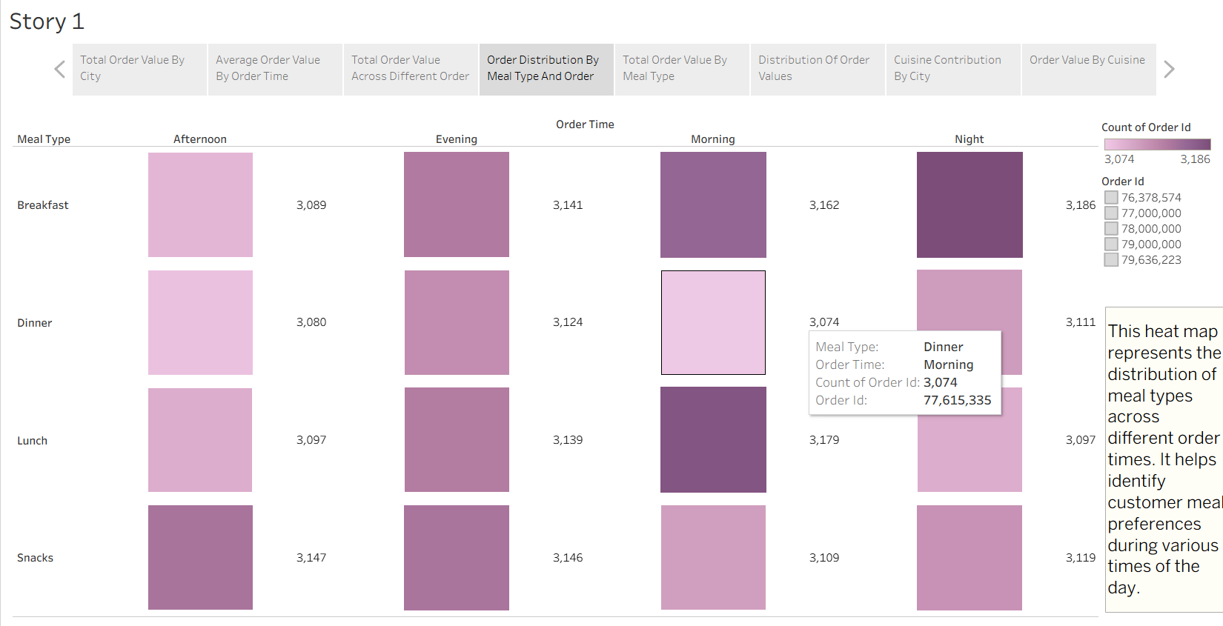
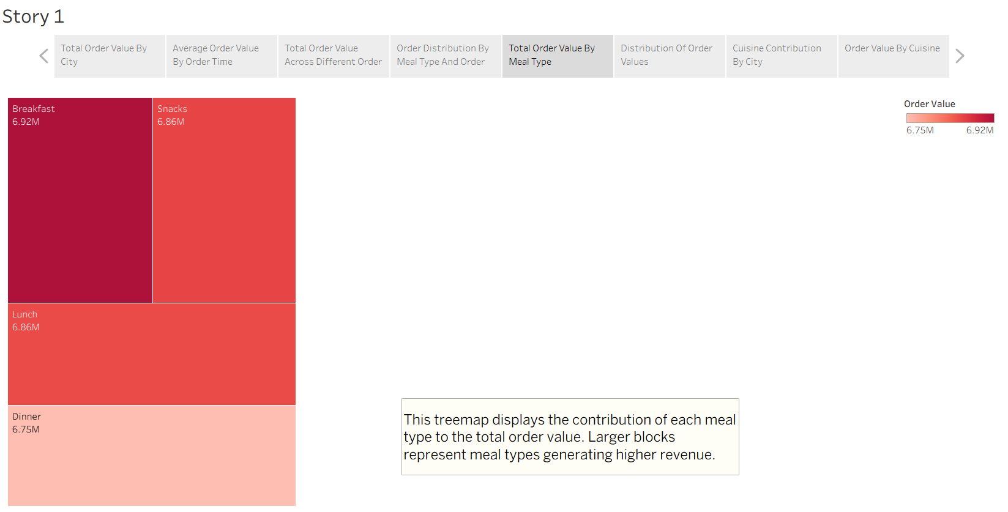
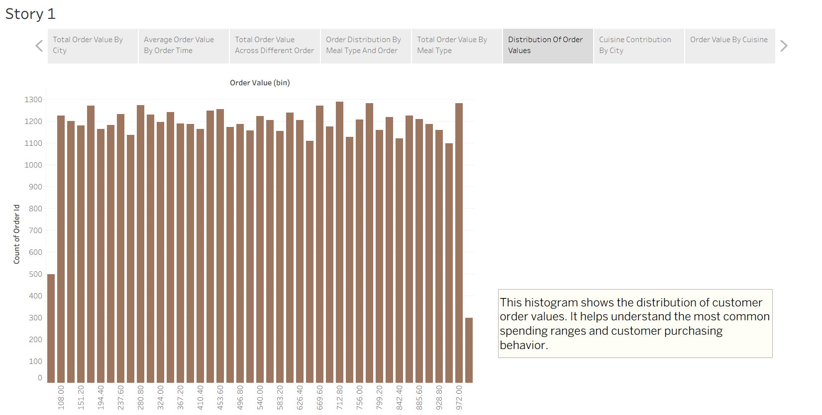
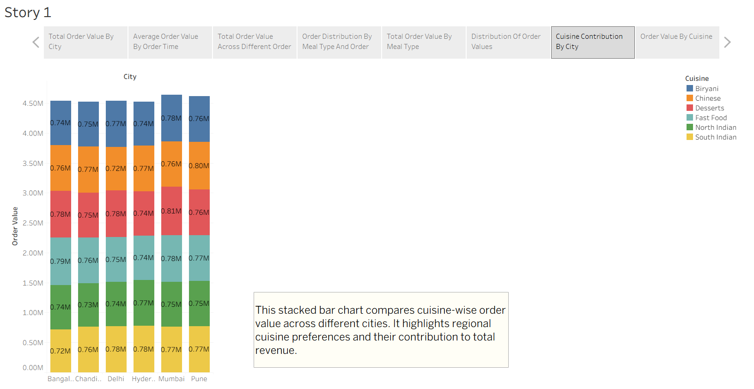
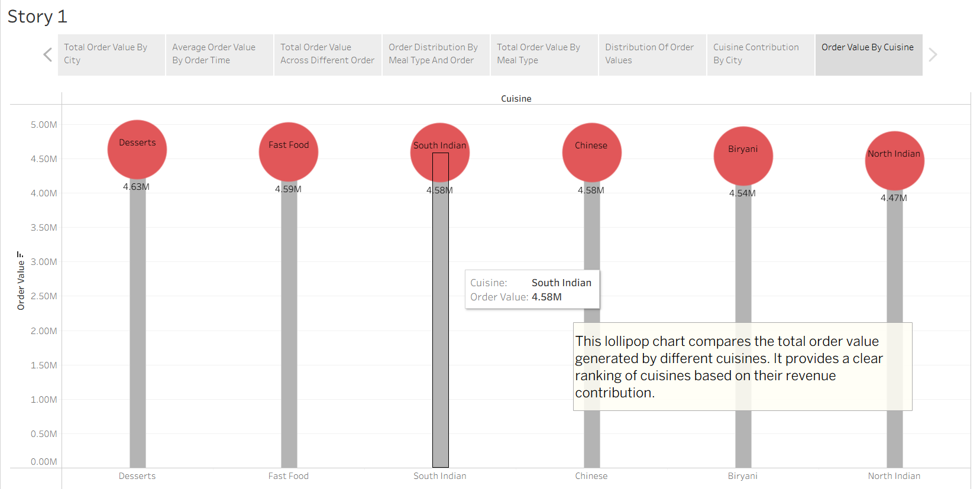
Tableau Story Narrative & Observations
By leveraging the sequential story point structure in Tableau, the Food Ordering Behavior analytical presentation guides the viewer through a logical progression of revenue patterns, customer ordering behavior, meal preferences, spending distribution, and cuisine performance. The visualizations transform raw food-ordering data into a cohesive business-oriented narrative.
Based on the interactive story points, the following are the core observations:
City-wise Revenue Performance (Q1): The Total Order Value by City bar chart provides a comparative view of revenue contribution across different cities. The visualization helps identify relatively stronger-performing markets and provides useful direction for business expansion, targeted marketing activities, and city-level resource allocation.
Time-based Ordering Behavior (Q2 & Q3): The Average Order Value line chart and Total Order Value area chart illustrate customer spending and revenue patterns across Morning, Afternoon, Evening, and Night. Although the differences between time periods are relatively small, the visualizations provide a clear comparison of customer ordering behavior throughout the day and can support time-specific promotional and operational planning.
Meal Preference and Order-time Patterns (Q4): The Meal Type and Order Time heat map provides a combined view of customer ordering activity across different meal categories and times of day. The visualization highlights the relative concentration of orders within each combination and supports decisions related to inventory planning, staffing, and meal-specific promotions.
Meal-wise Revenue Contribution (Q5): The Total Order Value by Meal Type treemap compares the revenue contribution of different meal categories. The visualization makes the relative contribution of each meal type easy to identify and helps businesses evaluate which meal categories should receive greater attention in menu planning and promotional strategies.
Customer Spending Distribution (Q6): The Order Value histogram presents the frequency distribution of customer spending across different order-value ranges. It helps identify the commonly occurring spending levels and provides a broader understanding of customer purchasing behavior, which can support pricing, promotional, and customer-segmentation decisions.
Cuisine Contribution Across Cities (Q7): The stacked bar chart compares total order value across cities while simultaneously showing the contribution of different cuisines. This provides a combined city-and-cuisine perspective, helping identify regional cuisine preferences and supporting localized menu, partnership, and marketing strategies.
Cuisine-wise Revenue Comparison (Q8): The Order Value by Cuisine lollipop chart ranks cuisines according to their total order value. The visualization provides a clear comparison between cuisine categories and helps identify relatively higher- and lower-performing cuisines for strategic promotional and menu decisions.

Activity 2:
Tableau Public Story Link:
https://public.tableau.com/views/food_ordering_behaviourstory/Story1?:language=en-US&publish=yes&:sid=&:redirect=auth&:display_count=n&:origin=viz_share_link

