1. Login page: Login and create an account text is cut at the top.(below image)

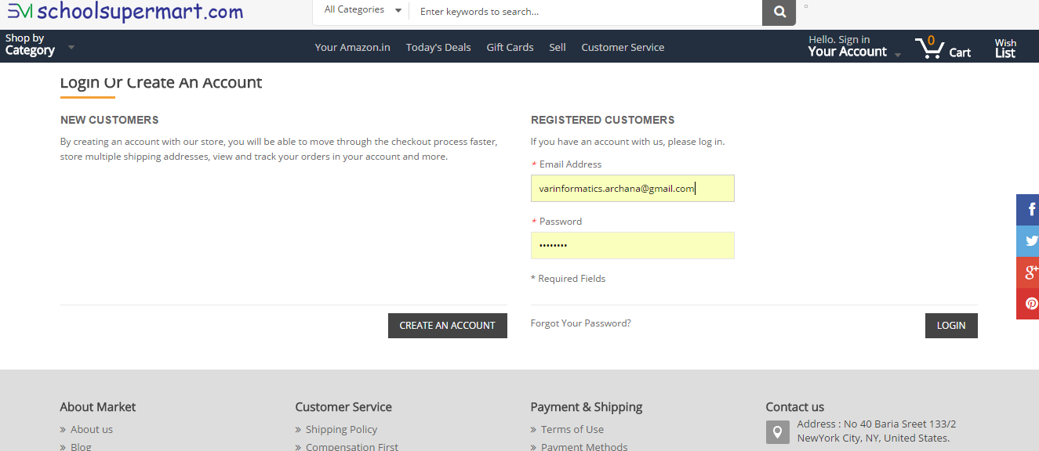

1. For new user (before registration): When the user clicks on sign in button the default username and password is displaying in the login page.(above image)