HireFlow Recruitment Management System

1.Abstract:
HireFlow is a full-stack web-based Recruitment Management System designed to streamline and automate the hiring process within organizations. The application provides role-based access for Admin, Recruiter, and Candidate, enabling secure and structured interactions across the platform.
Candidates can register, create profiles, upload resumes, search job listings, and apply for positions, while recruiters can post jobs, manage applications, and track candidate progress. The system supports a complete recruitment workflow including application submission, shortlisting, selection, rejection, and interview scheduling with real-time status updates.
It also integrates automated email notifications to keep candidates informed throughout the hiring process. A resume-based match scoring mechanism is implemented to assist recruiters in identifying suitable candidates efficiently.
The platform includes dashboards and analytics to provide insights into recruitment activities. Built using Spring Boot for the backend and React for the frontend, the system ensures scalability, performance, and usability. Overall, HireFlow simplifies recruitment operations, enhances decision-making, and improves the overall hiring experience.

2.Introduction:
The rapid growth of digital recruitment has created a need for efficient and centralized hiring systems that can streamline the entire recruitment lifecycle. Traditional hiring processes are often manual, time-consuming, and lack proper tracking and communication mechanisms.
To address these challenges, HireFlow is developed as a full-stack Recruitment Management System that automates job posting, candidate application, and hiring workflows. The system enables candidates to search and apply for jobs, while recruiters can manage applications, shortlist candidates, and schedule interviews through a unified platform.
It incorporates role-based access control, ensuring secure and organized interactions for Admin, Recruiter, and Candidate users. Additionally, the platform integrates resume management and automated email notifications to enhance user experience and communication. Overall, HireFlow aims to improve hiring efficiency, reduce manual effort, and provide a scalable solution for modern recruitment needs.
3.Architecture
The system follows a three-tier architecture with React as the frontend, Spring Boot as the backend, and MySQL as the database. The backend is designed using a layered approach with controllers, services, and repositories. REST APIs handle communication between frontend and backend. The system also integrates file handling for resumes, email services for notifications, and a structured recruitment workflow including application tracking and interview management.”
HireFlow follows a 3-Tier Architecture:
- Frontend Layer (React)
- Backend Layer (Spring Boot)
- Database Layer (MySQL)
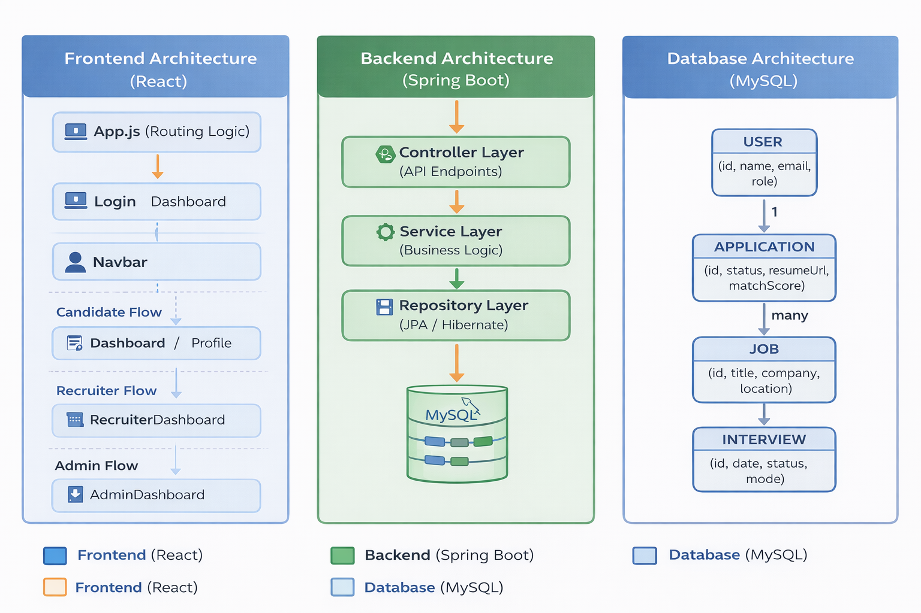
PROJECT FLOW (END-TO-END WORKING)
The HireFlow system follows a structured flow that connects the frontend, backend, and database to manage the complete recruitment lifecycle efficiently.
🧩 1. USER AUTHENTICATION FLOW
- User opens the application (React frontend).
- Enters email and password on the login page.
- Request is sent to:POST /api/users/login
- Backend (Spring Boot):
  - Validates credentials using BCrypt
  - Generates JWT token
- Response sent to frontend with:
  - User ID
  - Role (Admin / Recruiter / Candidate)
- Frontend stores data in localStorage and redirects to dashboard.
💼 2. JOB MANAGEMENT FLOW (RECRUITER)
- Recruiter logs in.
- Clicks Post Job.
- Enters job details (title, company, location, etc.).
- Request sent to:POST /api/jobs
- Backend:
  - Saves job in database
- Job becomes visible to all candidates.
👉 Recruiter can also:
- Update job → PUT /api/jobs/{id}
- Delete job → DELETE /api/jobs/{id}

🔍 3. JOB SEARCH & FILTER FLOW (CANDIDATE)
- Candidate opens dashboard.
- Applies filters:
  - Role
  - Location
  - Company
  - Experience
- Request sent to:GET /api/jobs/search
- Backend filters jobs dynamically.
- Filtered results displayed on UI.
📄 4. JOB APPLICATION FLOW
- Candidate clicks Apply.
- Uploads resume (file input).
- Request sent as multipart/form-data:POST /api/applications/apply
- Backend (ApplicationService):
  - Validates user & job
  - Prevents duplicate applications
  - Saves resume in /uploads/
  - Stores file path in DB
  - Generates match score
  - Saves application with status = APPLIED
- Email notification sent:
  - “Application Submitted”
🤖 5. MATCH SCORING FLOW
- Job description is analyzed.
- Resume filename & keywords checked.
- Score calculated based on:
  - Java, Spring, SQL, React, etc.
- Score stored in database (0–100).
- Displayed in:
  - Candidate dashboard
  - Recruiter dashboard
📊 6. APPLICATION TRACKING FLOW
- Candidate opens My Applications.
- Request sent to:
GET /api/applications/candidate/{id}
- Backend fetches applications.
- UI shows:
  - Job details
  - Status (APPLIED, SHORTLISTED, etc.)
  - Match score
🧑‍💼 7. RECRUITER WORKFLOW
- Recruiter opens dashboard.
- Fetches all applications:
GET /api/applications/all
Actions:
✔ Shortlist
PUT /api/applications/{id}/shortlist
✔ Select
PUT /api/applications/{id}/select
✔ Reject
PUT /api/applications/{id}/reject
Backend:
- Updates status
- Sends email notification
📅 8. INTERVIEW SCHEDULING FLOW
- Recruiter clicks Schedule Interview.
- Enters:
  - Date
  - Time
  - Message
- Request sent:
PUT /api/applications/{id}/schedule
- Backend:
  - Updates interview details
  - Changes status
  - Sends email to candidate
📂 9. RESUME VIEW FLOW
- Recruiter clicks View Resume.
- Request sent:GET /api/applications/resume?path=...
- Backend:
  - Fetches file from /uploads/
  - Returns file
- Resume opens in browser (PDF inline).
📊 10. DASHBOARD & ANALYTICS FLOW
- Dashboard API:GET /api/dashboard
- Backend calculates:
  - Total jobs
  - Total applications
  - Shortlisted count
  - Selected count
- Data displayed in UI.
🛠️ 11. ADMIN FLOW
- Admin logs in.
- Views all users:
GET /api/admin/users
- Views all jobs:
GET /api/admin/jobs
- Can delete:
  - Users
  - Jobs

Functionalities:
🔐 1. User Authentication & Authorization
- User registration with secure password encryption (BCrypt)
- Login with email and password
- JWT-based authentication (token generation)
- Role-based access control:
  - Admin
  - Recruiter
  - Candidate
👤 2. Candidate Profile Management
- Create and manage user profile
- Update personal details (name, email)
- Upload and manage resume
- Store resume path in database
💼 3. Job Management
- Recruiters can:
  - Create job postings
  - Update job details
  - Delete jobs
  - View all job listings
- Jobs include title, company, location, description, experience, and salary
🔍 4. Job Search and Filtering
- Candidates can search jobs using filters:
  - Job title (role)
  - Location
  - Company
  - Experience
- Dynamic filtering through backend APIs
- Reset search functionality
📄 5. Job Application System
- Candidates can apply to jobs
- Resume upload during application
- Prevent duplicate applications
- Store application details:
  - Candidate
  - Job
  - Resume
  - Application date
🤖 6. Resume-Based Match Scoring
- Automatic match score generation (0–100)
- Based on:
  - Job description keywords
  - Resume file name hints
- Helps recruiters identify suitable candidates quickly
📊 7. Application Tracking
- Candidates can view:
  - Applied jobs
  - Application status:
    - APPLIED
    - SHORTLISTED
    - REJECTED
    - SELECTED
- Display of match score for each application
🧑‍💼 8. Recruiter Dashboard
- View all applications
- Access candidate details and resumes
- Perform actions:
  - Shortlist candidates
  - Select candidates
  - Reject candidates
📅 9. Interview Management
- Schedule interviews with:
  - Date
  - Time
  - Message
- Update interview status:
  - SCHEDULED
  - COMPLETED
  - CANCELLED
- Integrated with application workflow
📩 10. Email Notification System
- Automated email notifications for:
  - Application submission
  - Shortlisting
  - Selection
  - Rejection
  - Interview scheduling
- Enhances communication with candidates
📂 11. Resume Management System
- Upload resumes (file handling)
- Store files in server directory (/uploads)
- Save file path in database
- Recruiters can view/download resumes
📊 12. Dashboard & Analytics
- Display key recruitment metrics:
  - Total jobs
  - Total applications
  - Shortlisted candidates
  - Selected candidates
- Helps in decision-making
🧑‍💻 13. Admin Management
- View all users
- Delete users
- View all jobs
- Delete job listings
- Monitor system activities
⚠️ 14. Exception Handling
- Centralized error handling using Global Exception Handler
- Handles:
  - Resource not found
  - Duplicate entries
  - Invalid credentials
  - Server errors
- Returns structured API responses
🔗 15. RESTful API Integration
- Backend exposes REST APIs for all operations
- Supports:
  - GET, POST, PUT, DELETE methods
- Seamless communication between frontend and backend

SOFTWARE REQUIREMENTS
💻 Operating System
- Windows 10 / 11
⚙️ Backend Technologies
- Java (JDK 17 or above)
- Spring Boot (3.x / 4.x)
- Hibernate (JPA)
- Maven (Build Tool)
- Apache Tomcat (Embedded Server)
🎨 Frontend Technologies
- React.js
- HTML5, CSS3, JavaScript (ES6)
- Node.js & npm
🗄️ Database
- MySQL Server (8.0 or above)
- MySQL Workbench (optional GUI tool)
🔐 Security & Authentication
- Spring Security
- JWT (JSON Web Token)
- BCrypt Password Encoder
📩 Additional Libraries / Tools
- JavaMailSender (Email Service)
- Multipart File Handling (Spring Boot)
- REST APIs (JSON-based communication)
🛠️ Development Tools
- VS Code / IntelliJ IDEA / Eclipse
- Postman (API Testing)
- Git (Version Control)
HARDWARE REQUIREMENTS
The system does not require high-end hardware and can run on standard machines.
💻 Minimum Requirements
- Processor: Intel i3 or above
- RAM: 4 GB
- Storage: 10 GB free space
- Internet connection (for dependencies & APIs)
🚀 Recommended Requirements
- Processor: Intel i5 or above
- RAM: 8 GB or more
- Storage: SSD with 20 GB free space
- Stable internet connection
ADVANTAGES OF THE SYSTEM
The HireFlow Recruitment Management System offers several advantages that improve the efficiency and effectiveness of the hiring process:
🔹 1. End-to-End Recruitment Automation
- Covers the complete hiring lifecycle from job posting to candidate selection
- Reduces manual effort and paperwork
🔹 2. Role-Based Access Control
- Separate dashboards for Admin, Recruiter, and Candidate
- Ensures secure and organized system usage
🔹 3. Centralized Data Management
- All recruitment data stored in one system
- Easy access to candidate profiles, applications, and job details
🔹 4. Efficient Job Search & Application
- Advanced filtering options for candidates
- Quick and easy job application process with resume upload
🔹 5. Resume Management System
- Upload and store resumes securely
- Recruiters can view and download resumes directly
🔹 6. Automated Email Notifications
- Real-time updates to candidates for:
  - Application submission
  - Shortlisting
  - Rejection/Selection
  - Interview scheduling
- Improves communication and transparency
🔹 7. Smart Match Scoring
- Automatically evaluates candidate suitability
- Helps recruiters quickly identify potential candidates
🔹 8. Interview Scheduling System
- Easy scheduling with date, time, and message
- Organized interview workflow
🔹 9. Dashboard & Analytics
- Provides insights such as:
  - Total applications
  - Shortlisted candidates
  - Selected candidates
- Supports better decision-making
🔹 10. Scalable & Flexible Architecture
- Built using modern technologies (React, Spring Boot, MySQL)
- Can be extended to microservices or cloud deployment
🔹 11. Secure System
- Password encryption using BCrypt
- JWT-based authentication support
- Structured exception handling
🔹 12. User-Friendly Interface
- Simple and intuitive UI
- Easy navigation for all user roles

🧾 CONCLUSION
The HireFlow Recruitment Management System successfully addresses the challenges of traditional hiring processes by providing a centralized, automated, and efficient platform for managing recruitment activities. The system enables candidates to easily search and apply for jobs, while recruiters can effectively manage applications, shortlist candidates, and schedule interviews through a structured workflow. The integration of features such as resume management, automated email notifications, and match scoring enhances the overall hiring experience and improves decision-making.
Built using modern technologies like React, Spring Boot, and MySQL, the system ensures scalability, performance, and maintainability. The role-based access control and secure authentication mechanisms provide a reliable and organized environment for different users. Overall, HireFlow simplifies recruitment operations, reduces manual effort, and increases efficiency, making it a valuable solution for organizations seeking to modernize their hiring process. Future enhancements such as advanced analytics, Email notifications, and stronger security enforcement can further improve the system’s capabilities.

