**what is ratelimiting in circuit breaker ?**

In the context of a circuit breaker pattern, "rate limiting" refers to a mechanism where the circuit breaker not only prevents further requests to a failing service but also actively controls the frequency of retry attempts, essentially limiting the number of requests that can be made to the failing service within a specific timeframe, preventing overwhelming the service further while it tries to recover; essentially acting like a traffic cop to manage the flow of retry attempts.

Key points about rate limiting in a circuit breaker:

* **Purpose:**

To prevent cascading failures by controlling the rate of retry attempts when a service is experiencing issues, allowing the service time to recover without being bombarded with too many requests simultaneously.

* **How it works:**

The circuit breaker monitors the failure rate of requests to a service; if the failure rate exceeds a threshold, the circuit breaker "trips" and starts to limit the number of retry attempts per unit time.

* **Benefits:**
  + **Protects failing services:** By limiting the number of requests, it helps prevent further strain on a failing service, allowing it to recover faster.
  + **Maintains system stability:** Prevents cascading failures by preventing too many retry attempts to a failing service, which can further overload the system.

Distinction from "Circuit Breaker" functionality:

* **Circuit breaker:**

Primarily focuses on quickly failing over to a fallback mechanism when a service is experiencing failures, preventing further requests until a timeout period has passed.

* **Rate limiting within a circuit breaker:**

Adds an extra layer of control by regulating the frequency of retry attempts during the "open" state of the circuit breaker.

* Circuit Breaker vs Throttling vs Rate Limiting - Medium

13 Mar 2024 — It is like an electrical circuit breaker that cuts off the current to prevent damages when a fault is detected. ... It ...

Medium ·

Merwan Chinta

* Understanding Rate Limiting: An Essential Tool for System Stability

30 Jun 2023 — Rate Limiting vs Circuit Breakers As we've discussed, rate limiting is a technique used to control the number of reques...

Medium ·

Arindam Paul

* Rate Limiter Pattern With Spring Boot - Vinsguru

12 Oct 2023 — Rate Limiter Pattern might sound same as Circuit Breaker in some cases. However there is an important difference! Rate ...

Vinsguru

* Show all

Generative AI is experimental.

Export

**Featured snippet from the web**

मराठी मध्ये

In English

Rate Limiting is similar to Throttling but focuses on limiting the number of requests a user can make to a service within a specific timeframe. It's used to maintain the quality of service and ensure availability.13 Mar 2024

*@RestController  
public class* CircuitBreakerController {  
 *static int* counter=1;  
 *private* Logger logger = LoggerFactory.getLogger(CircuitBreakerController.*class*);  
 *@GetMapping*("/sample-api")  
 *//@Retry(name = "sample-api",fallbackMethod = "hardcodedResponse")  
 //@CircuitBreaker(name = "sample-api",fallbackMethod = "hardcodedResponse")  
 @RateLimiter*(name = "default")  
 *//10s =>10000 calls to the sampleapi we are setting it by ratelimiting  
 public* String sampleApi(){  
*// logger.info("sample api call received call no " + counter++ );  
//// ResponseEntity<String> forEntity = new RestTemplate()  
//// .getForEntity("http://localhost:8080/some-dummy-url", String.class);  
//// return forEntity.getBody();  
 return* "sample-api";  
 }  
 *public* String hardcodedResponse(Exception ex){  
 *return* "hardcoded response";  
 }  
}

**Run below command in powershell**

for ($i=1; $i -le 20; $i++) {curl http://localhost:8002/sample-api}



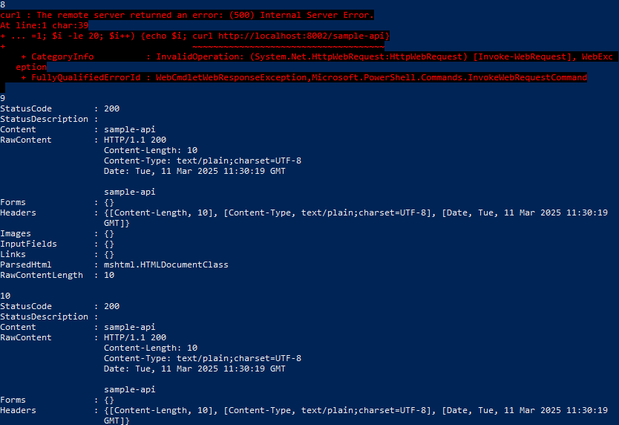

In addition to rate limiter we can also configure how many concurrent calls can be configured that is called bulkheads.