# What is Spring Framework?

* Spring is the most popular application development framework for enterprise Java. Millions of developers around the world use Spring Framework to create high performing, easily testable, and reusable code.
* Spring framework is an open source Java platform. It was initially written by Rod Johnson and was first released under the Apache 2.0 license in June 2003.
* Spring is lightweight when it comes to size and transparency. The basic version of Spring framework is around 2MB.
* The core features of the Spring Framework can be used in developing any Java application, but there are extensions for building web applications on top of the Java EE platform. Spring framework targets to make J2EE development easier to use and promotes good programming practices by enabling a POJO-based programming model.

# Benefits of Using the Spring Framework

* Following is the list of few of the great benefits of using Spring Framework
* Benefits of Using the Spring Framework
* Following is the list of few of the great benefits of using Spring Framework −
* Spring enables developers to develop enterprise-class applications using POJOs. The benefit of using only POJOs is that you do not need an EJB container product such as an application server but you have the option of using only a robust servlet container such as Tomcat or some commercial product.
* Spring is organized in a modular fashion. Even though the number of packages and classes are substantial, you have to worry only about the ones you need and ignore the rest.
* Spring does not reinvent the wheel, instead it truly makes use of some of the existing technologies like several ORM frameworks, logging frameworks, JEE, Quartz and JDK timers, and other view technologies.
* Testing an application written with Spring is simple because environment-dependent code is moved into this framework. Furthermore, by using JavaBeanstyle POJOs, it becomes easier to use dependency injection for injecting test data.
* Spring's web framework is a well-designed web MVC framework, which provides a great alternative to web frameworks such as Struts or other over-engineered or less popular web frameworks.
* Spring provides a convenient API to translate technology-specific exceptions (thrown by JDBC, Hibernate, or JDO, for example) into consistent, unchecked exceptions.
* Lightweight IoC containers tend to be lightweight, especially when compared to EJB containers, for example. This is beneficial for developing and deploying applications on computers with limited memory and CPU resources.
* Spring provides a consistent transaction management interface that can scale down to a local transaction (using a single database, for example) and scale up to global transactions (using JTA, for example).

# Spring Framework – Architecture

The Spring Framework provides about 20 modules which can be used based on an application requirement

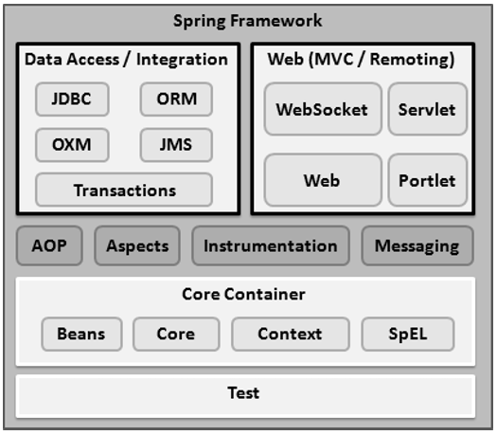

## **Core Container**

The Core Container consists of the Core, Beans, Context, and Expression Language modules the details of which are as follows −

* The **Core** module provides the fundamental parts of the framework, including the IoC and Dependency Injection features.
* The **Bean** module provides BeanFactory, which is a sophisticated implementation of the factory pattern.
* The **Context** module builds on the solid base provided by the Core and Beans modules and it is a medium to access any objects defined and configured. The ApplicationContext interface is the focal point of the Context module.
* The **SpEL** module provides a powerful expression language for querying and manipulating an object graph at runtime.

## **Data Access/Integration**

The Data Access/Integration layer consists of the JDBC, ORM, OXM, JMS and Transaction modules whose detail is as follows −

* The **JDBC** module provides a JDBC-abstraction layer that removes the need for tedious JDBC related coding.
* The **ORM** module provides integration layers for popular object-relational mapping APIs, including JPA, JDO, Hibernate, and iBatis.
* The **OXM** module provides an abstraction layer that supports Object/XML mapping implementations for JAXB, Castor, XMLBeans, JiBX and XStream.
* The Java Messaging Service **JMS** module contains features for producing and consuming messages.
* The **Transaction** module supports programmatic and declarative transaction management for classes that implement special interfaces and for all your POJOs.

## **Web**

The Web layer consists of the Web, Web-MVC, Web-Socket, and Web-Portlet modules the details of which are as follows −

* The **Web** module provides basic web-oriented integration features such as multipart file-upload functionality and the initialization of the IoC container using servlet listeners and a web-oriented application context.
* The **Web-MVC** module contains Spring's Model-View-Controller (MVC) implementation for web applications.
* The **Web-Socket** module provides support for WebSocket-based, two-way communication between the client and the server in web applications.
* The **Web-Portlet** module provides the MVC implementation to be used in a portlet environment and mirrors the functionality of Web-Servlet module.

## **Miscellaneous**

There are few other important modules like AOP, Aspects, Instrumentation, Web and Test modules the details of which are as follows −

* The **AOP** module provides an aspect-oriented programming implementation allowing you to define method-interceptors and pointcuts to cleanly decouple code that implements functionality that should be separated.
* The **Aspects** module provides integration with AspectJ, which is again a powerful and mature AOP framework.
* The **Instrumentation** module provides class instrumentation support and class loader implementations to be used in certain application servers.
* The **Messaging** module provides support for STOMP as the WebSocket sub-protocol to use in applications. It also supports an annotation programming model for routing and processing STOMP messages from WebSocket clients.
* The **Test** module supports the testing of Spring components with JUnit or TestNG frameworks.