**Background :**

This is a Java report publisher primarily created to publish cucumber reports on the extent report using cucumber framework , RESTAssured API and Maven build tool.

It publishes detailed extent report with screenshots showing the results of cucumber runs for each test step executed in path userdir\target\Reports\Extent_Automation_Report.html

Another simpler pretty HTML reports are available in userdir /target/cucumber-reports/report.html

Generated report has no dependency so can be viewed offline.

**Install:**

Dependencies are available in POM.xml file.

**Usage:**

Package had been configured for chrome browser to make testing the scripts quicker.

**Extent Report Sample :**

**Pass Screenshot at the bottom of each page report:**

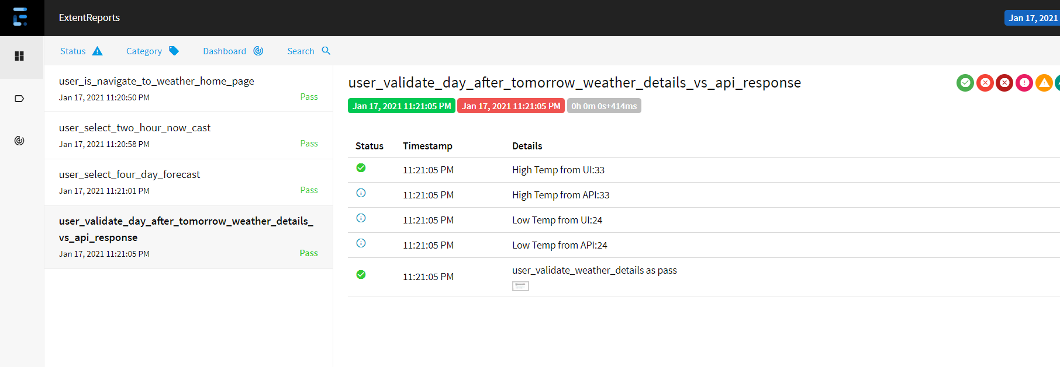

**Fail Screenshot at the bottom of each page report. API value does not match with web value :**

