**Docker three-tier archiecture**

First get into the folder where source code is present



create the network first and attach the MySQL container at startup.



Start a MySQL container and attach it to the network. We’re also going to define a few environment variables that the database will use to initialize the database

To get list of images

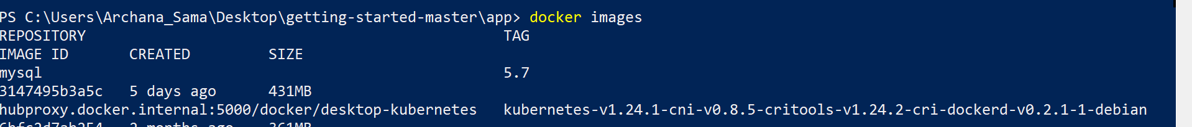

To confirm we have the database up and running, connect to the database and verify it connects. Copy the id from >docker container ps -a

* After executing the command will get into database with password secret
* Show databases where we can see tables

Start a new container using the nicolaka/netshoot image. Make sure to connect it to the same network.

$ dig mysql



**Note**: for MySQL versions 8.0 and higher, make sure to include the following commands in mysql.

We’ll specify each of the environment variables above, as well as connect the container to our app network.

1. Open the app in your browser and add a few items to your todo list.

Open the app in your browser and add a few items to your todo list.

And in the mysql shell, run the following:

If you take a quick look at the Docker Dashboard, you’ll see that we have two app containers running.

Again run the command and make changes to it and see the result



After makings changes we see result

