**What is Terraform?**

HashiCorp Terraform is an infrastructure as code tool that lets you define both cloud and on-prem resources in human-readable configuration files that you can version, reuse, and share. You can then use a consistent workflow to provision and manage all of your infrastructure throughout its lifecycle. Terraform can manage low-level components like compute, storage, and networking resources, as well as high-level components like DNS entries and SaaS features.

## How does Terraform work?

Terraform creates and manages resources on cloud platforms and other services through their application programming interfaces (APIs). Providers enable Terraform to work with virtually any platform or service with an accessible API.

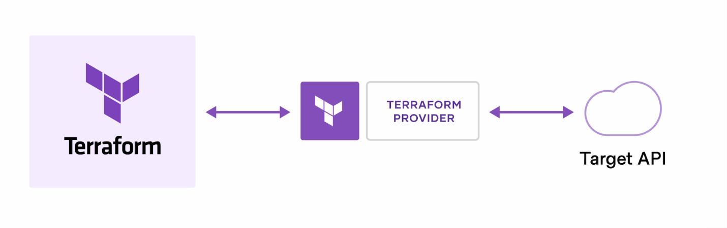

The core Terraform workflow consists of three stages:

* **Write:** You define resources, which may be across multiple cloud providers and services. For example, you might create a configuration to deploy an application on virtual machines in a Virtual Private Cloud (VPC) network with security groups and a load balancer.
* **Plan:** Terraform creates an execution plan describing the infrastructure it will create, update, or destroy based on the existing infrastructure and your configuration.
* **Apply:** On approval, Terraform performs the proposed operations in the correct order, respecting any resource dependencies. For example, if you update the properties of a VPC and change the number of virtual machines in that VPC, Terraform will recreate the VPC before scaling the virtual machines.

Now we create the folder by name terraform-vpc-module

In that we create dev folder

Modules folder

EC2

Instance.tf

Vars.tf

Vpc

Main.tf

Var.tf

Here you see some of the screen shots of it

Now first do change into directory

Run the command terraform init

Terraform plan

Next terraform apply

We can see the in aws console where our in ec2 instance and vpc is created

