
SMARTMEET AI : AN INTELLIGENT VIDEO
CONFERENCING PLATFORM
A MINI PROJECT REPORT
Submitted by
ARCHANA SATHEESH
MLM25MCA-2022
TO
the APJ Abdul Kalam Technological University in Partial fulfillment of the requirements for the award of the degree
of
MASTER OF COMPUTER APPLICATIONS
Under the Guidance of
Ms. ASHWANI VIJAYACHANDRAN
(Assistant Professor, Department of Computer Applications)

DEPARTMENT OF COMPUTER APPLICATIONS

MANGALAM COLLEGE OF ENGINEERING, ETTUMANOOR

(Affiliated to APJ Abdul Kalam Technological University)
OCTOBER 2026
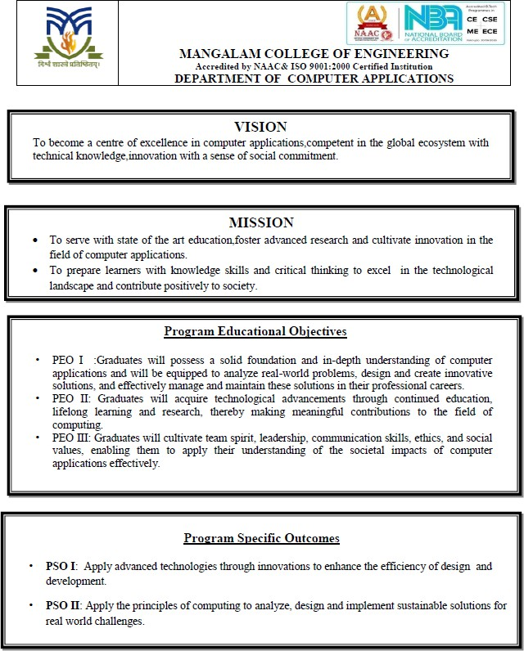

MAPPING OF PO-PSO-SDG
1.MAPPING WITH PROGRAM OUTCOMES (POs): -
SL.NO | POs ADDRESSED | RELEVANCE TO PROJECT
1 | PO1 | Applied programming, database, web development, and software engineering knowledge to develop the SmartMeet AI meeting platform.
2 | PO2 | Analyzed the limitations of conventional meeting systems and identified the need for automatic meeting recording, transcription, translation, and summarization.
3 | PO3 | Designed and developed SmartMeet AI with features such as user authentication, WebRTC-based meetings, audio/video recording, transcription, translation, summarization, and downloadable reports.
4 | PO4 | Investigated and evaluated technologies such as WebRTC, Whisper speech recognition, FFmpeg, natural language processing, and translation techniques to implement the proposed system.
5 | PO5 | Utilized modern tools and technologies including Django, WebRTC, JavaScript, Bootstrap, Whisper, FFmpeg, NLP libraries, and ReportLab in developing the application.
6 | PO7 | Considered efficient digital meeting and documentation practices by reducing dependence on physical meeting records and enabling digital storage of meeting transcripts and summaries.

LIST OF PROGRAM OUTCOMES (POs):
PO1 (Foundation Knowledge): Apply knowledge of mathematics, programming logic and coding fundamentals for solution architecture and problem solving.
PO2 (Problem Analysis): Identify, review, formulate and analyze problems for primarily focusing on customer requirements using critical thinking frameworks.
PO3 (Development of Solutions): Design, develop and investigate problems with as an innovative approach for solutions incorporating ESG/SDG goals.
PO4 (Modern Tool Usage): Select, adapt and apply modern computational tools such as development of algorithms with an understanding of the limitations including human biases.
PO5 (Individual and Teamwork): Function and communicate effectively as an individual or a team leader in diverse and multidisciplinary groups. Use methodologies such as agile.
PO6 (Project Management and Finance): Use the principles of project management such as scheduling, work breakdown structure and be conversant with the principles of Finance for profitable project management.
PO7 (Ethics): Commit to professional ethics in managing software projects with financial aspects. Learn to use new technologies for cyber security and insulate customers from malware.
PO8 (Life-long learning): Change management skills and the ability to learn, keep up with contemporary technologies and ways of working.

SL.NO | PSOs ADDRESSED | RELEVANCE TO PROJECT
1 | PSO1 | Applied computer programming, database, web technologies, and AI-related concepts to develop an intelligent meeting management system.
2 | PSO2 | Integrated emerging technologies such as WebRTC, speech recognition, natural language processing, translation, and AI-based summarization to solve a real-world communication problem.
2.MAPPING WITH PROGRAM SPECIFIC OUTCOMES (PSOs):

LIST OF PROGRAM SPECIFIC OUTCOMES (PSOs):
PSO 1:Apply advanced technologies through innovations to enhance the efficiency of design development.
PSO 2: Apply the principles of computing to analyze, design and implement sustainable solutions for real world challenges.
SDG NO | SDGs ADDRESSED | RELEVANCE TO PROJECT
SDG 4 | Quality Education | SmartMeet AI supports learning and knowledge sharing by providing recorded meeting transcripts, summaries, translations, and downloadable study or meeting materials.
SDG 8 | Decent Work and Economic Growth | The system improves workplace productivity by automatically recording meetings, generating transcripts and summaries, and reducing the time required for manual meeting documentation.
SDG 9 | Industry, Innovation, and Infrastructure | The project uses modern technologies such as Django, WebRTC, Artificial Intelligence, speech recognition, NLP, and automated translation to develop an innovative digital meeting platform.
SDG 10 | Reduced Inequalities | The translation and transcription features help reduce language and communication barriers by making meeting content available in multiple languages and accessible as text.

3.MAPPING WITH SUSTAINABLE DEVELOPMENT GOALS (SDGs):
SUSTAINABLE DEVLOPMENT GOALS (SDGs):
SDG 1 – No Poverty-End poverty in all its forms everywhere.
SDG 2 – Zero Hunger-End hunger, achieve food security and improved nutrition, and promote sustainable agriculture.
SDG 3 – Good Health and Well-Being-Ensure healthy lives and promote well-being for all at all ages.
SDG 4 – Quality Education-Ensure inclusive and equitable quality education and promote lifelong learning opportunities for all.
SDG 5 – Gender Equality-Achieve gender equality and empower all women and girls.
SDG 6 – Clean Water and Sanitation-Ensure availability and sustainable management of water and sanitation for all.
SDG 7 – Affordable and Clean Energy-Ensure access to affordable, reliable, sustainable, and modern energy for all.
SDG 8 – Decent Work and Economic Growth-Promote sustained, inclusive, and sustainable economic growth, full and productive employment, and decent work for all.
SDG 9 – Industry, Innovation, and Infrastructure-Build resilient infrastructure, promote inclusive and sustainable industrialization, and foster innovation.
SDG 10 – Reduced Inequality-Reduce inequality within and among countries.
SDG 11 – Sustainable Cities and Communities-Make cities and human settlements inclusive, safe, resilient, and sustainable.
SDG 12 – Responsible Consumption and Production-Ensure sustainable consumption and production patterns.
SDG 13 – Climate Action-Take urgent action to combat climate change and its impacts.
SDG 14 – Life Below Water-Conserve and sustainably use the oceans, seas, and marine resources.
SDG 15 – Life on Land -Protect, restore, and promote sustainable use of terrestrial ecosystems, manage forests sustainably, combat desertification, halt and reverse land degradation, and halt biodiversity loss.
SDG 16 – Peace, Justice, and Strong Institutions- Promote peaceful and inclusive societies, provide access to justice for all, and build effective, accountable, and inclusive institutions.
SDG 17 – Partnerships for the Goals -Strengthen the means of implementation and revitalize the global partnership for sustainable development.

MANGALAM COLLEGE OF ENGINEERING, ETTUMANOOR
DEPARTMENT OF COMPUTER APLLICATION
OCTOBER 2026


DECLARATION
I hereby certify that the work which is being presented in the project entitled “SMARTMEET AI : AN INTELLIGENT VIDEO CONFERENCING PLATFORM” submitted in the DEPARTMENT OF COMPUTER APPLICATIONS is an authentic record of my own work carried under the supervision of MS.ASHWANI VIJAYACHANDRAN, ASSISTANT PROFESSOR. This study has not been submitted to any other institution or university for the award of any other degree. This report has been checked for plagiarism by the college and the similarity index is within permissible limits set by the college.

Date: Name & Signature of Student
Place: ARCHANA SATHEESH
MANGALAM COLLEGE OF ENGINEERING, ETTUMANOOR
DEPARTMENT OF COMPUTER APLLICATION
OCTOBER 2026

CERTIFICATE
Certified that the report entitled “SMARTMEET AI: An Intelligent Video Conferencing Platform” submitted by “Archana Satheesh MLM25MCA-2022” to the APJ Abdul Kalam Technological University in partial fulfillment of the requirements for the award of the DEGREE OF MASTER OF COMPUTER APPLICATIONS by APJ ABDUL KALAM TECHNOLOGICAL UNIVERSITY is a bonafide record of the MINI PROJECT work carried out by him / her under our guidance and supervision during the academic year 2025-27.

PROJECT GUIDE  Ms. Ashwani Vijayachandran  Assistant Professor  Department Of Computer Application | PROJECT COORDINATOR  Ms.Athira R Kurup  Assistant Professor  Department of Computer Applications
HEAD OF THE DEPARTMENT  Ms. Divya S B Associate Professor  Department of Computer Applications | INTERNAL EXAMINER

ACKNOWLEDGEMENT

I am greatly indebted to the authorities of Mangalam College of Engineering for providing the necessary facilities to successfully complete my Project on the topic “SMARTMEET AI : An Intelligent Video Conferencing Platform”.
I express my sincere thanks to Dr. Vinodh P Vijayan, Principal, Mangalam College of Engineering for providing the facilities to complete my Project successfully.
I thank and express my solicit gratitude to Ms. Divya S B, HOD, Department of Computer Applications, Mangalam College of Engineering, for her invaluable help and support which helped me a lot in successfully completing this Project work.
I express my gratitude to my Internal Guide, Ms. Ashwani Vijayachandran ,Assistant professor, Department of Computer Applications for the suggestions and encouragement which helped in the successful completion of my Project.
Furthermore, I would like to acknowledge with much appreciation the crucial role of the faculties especially Project coordinator, Ms. Athira R Kurup, Department of Computer Applications, Mangalam College of Engineering, who gave the permission to use all the required equipment and the necessary resources to complete the presentation & report.
Finally, I would like to express my heartfelt thanks to my parents who were very supportive both financially and mentally and for their encouragement to achieve my goal.

ARCHANA SATHEESH
(MLM25MCA-2022)
ABSTRACT
Meetings and online discussions often generate important information that can be difficult to record, organize, and review manually. Participants may miss important points during discussions, while manually preparing meeting transcripts and summaries can be time-consuming. Language differences can also create communication barriers when meeting content needs to be understood by users from different linguistic backgrounds. Artificial intelligence and real-time communication technologies provide an effective approach for developing systems that can automate meeting documentation and improve accessibility.
SmartMeet AI is an AI-enabled web-based meeting platform designed to provide real-time online meetings along with automated recording, transcription, translation, and summarization of meeting content. The system allows users to participate in meetings through WebRTC-based audio and video communication and record the meeting for later processing. After the meeting, the recorded audio is processed using the Whisper speech recognition model to generate a transcript. The system can translate the transcript into selected languages and generate a concise summary of the important information discussed during the meeting.
Additional features of the system include user authentication, meeting management, recorded meeting storage, downloadable transcripts and summaries, and PDF generation for convenient documentation. The application is developed using Django, HTML, CSS, JavaScript, and Bootstrap, with technologies such as WebRTC, Whisper, FFmpeg, natural language processing, translation services, and ReportLab integrated into the system. SmartMeet AI aims to provide an efficient and accessible solution for managing meeting communication and automatically converting recorded discussions into useful digital documentation.
Keywords: SmartMeet AI, WebRTC, meeting platform, automatic transcription, speech recognition, meeting summarization, artificial intelligence, translation, natural language processing, meeting recording
Mapping with Sustainable  Development Goals | SDG 4 – Quality Education  SDG 8 – Decent Work and Economic Growth SDG 9 – Industry, Innovation, and Infrastructure SDG 10 – Reduced Inequalities

CONTENT

Contents Page No.
ACKNOWLEDGEMET I ABSTRACT II
LIST OF FIGURES V
LIST OF ABBREVIATIONS VI
Chapter 1 | INTRODUCTION | 1
1.1 | Background | 1
1.2 | Motivation | 2
1.3 | Scope & Objectives | 2
1.4 | Problem Statement | 3
Chapter 2 | REQUIREMENT AND ANALYSIS | 4
2.1 | Existing System & Problem Statement | 4
2.2 | Solution Overview | 5
2.3 | Feasibility Study | 5
Chapter 3 | LITERATURE REVIEW | 8
3.1 | AI-Meeting Summarizer | 8
3.2 | AI-Powered Meeting Assistant for Transcription, Summarization and Action Extraction | 9
3.3 | NPUsper: Eliminating Redundant Computation for Real-Time Whisper on Mobile NPUs | 10
3.4 | From Text Metrics to Model Internals: A Study of Whisper ASR Hallucination Detection | 11
3.5 | Grounding Spoken LLMs in Multi-Speaker Audio via Diarization Conditioning | 12
3.6 | TellWhisper: Tell Whisper Who Speaks When | 13
3.7 | Murmur: An Efficient Inference System for Long-Form ASR | 14
3.8 | AI-Driven Meeting Transcriber & Summarizer: An Intelligent System for Automated Meeting | 15
3.9 | AutoNote AI: Real-Time Transcription and Automated PDF Generation for Live Meetings | 16
3.10 | Adapting Diarization-Conditioned Whisper for End-to-End Multi-Talker Speech Recognition | 17
Chapter 4 | DIAGRAMS | 19
4.1 | Data Flow Diagram (DFD) | 19
4.1.1 | DFD Level 0 | 19
4.1.2 | DFD Level 1 | 20
4.2 | Use Case Diagram | 22
4.3 | Class Diagram | 23
4.4 | State Diagram | 25
4.5 | Activity Diagram | 26
4.6 | Sequence Diagram | 27
Chapter 5 | METHODOLOGY | 29
5.1 | Module Descriptions | 29
5.2 | Algorithms | 37
5.3 | Architecture | 38
5.4 | Case Study | 40
Chapter 6 | IMPLEMENTATION DETAILS | 41
6.1 | Implementation Procedures | 41
6.2 | Testing Methods and Results | 43
Chapter 7 | ADVANTAGES & DISADVANTAGES | 46
7.1 | Advantages | 46
7.2 | Disadvantages | 47
Chapter 8 | RESULT & DISCUSSION | 48
8.1 | Analysis | 48
Chapter 9 | CONCLUSION | 50
9.1 | Summary | 50
9.2 | Limitations | 50
9.3 | Future Scope | 51
9.4 | Applications | 52
Chapter 10 | APPENDICES | 54
10.1 | Sample Code | 54
Chapter 11 | REFERENCES | 56

LIST OF FIGURE
FIGURE NO. | TITLE | PAGE NO.
4.1 | Data Flow Diagram (Level 0) | 20
4.1.1 | User data flow diagram | 21
4.1.2 | Admin data flow diagram | 22
4.2 | Use Case Diagram | 23
4.3 | Class Diagram | 24
4.4 | State Diagram | 25
4.5 | Activity Diagram | 26
4.6 | Sequence Diagram | 27
5.1.1 | Login Interface | 29
5.1.2 | Register Interface | 31
5.1.3 | Dashboard | 32
5.1.4 | Meeting Interface | 33
5.1.5 | Recording Interface | 34
5.1.6 | Transcription Interface | 35
5.1.7 | Translation and pdf Report Interface | 36
5.3 | Architecture of SmartMeet AI | 39
10.1 | Sample code | 55

LIST OF ABBREVIATIONS
ABBREVIATION | FULL FORM
AI | Artificial Intelligence
ASR | Automatic Speech Recognition
API | Application Programming Interface
Django | Django Web Framework
FFmpeg | Fast Forward Moving Picture Experts Group
NLP | Natural Language Processing
PDF | Portable Document Format
SDG | Sustainable Development Goal
UI | User Interface
URL | Uniform Resource Locator
WebRTC | Web Real-Time Communication
WER | Word Error Rate
ML | Machine Learning
LLM | Large Language Model
DP | Display Picture
GPS | Global Positioning System

CHAPTER 1
INTRODUCTION
1.1 Background
Meetings have become an important part of education, business, professional collaboration, and online communication. With the increasing use of virtual and hybrid meetings, a large amount of valuable information is exchanged through audio and video discussions. However, remembering all the information discussed during a meeting and manually preparing detailed meeting records can be difficult and time-consuming. Participants may miss important points, decisions, or tasks, especially during long discussions.
The development of web-based communication technologies has made it possible to conduct meetings through computers and other internet-connected devices. Technologies such as WebRTC enable real-time audio and video communication directly through web browsers without requiring complex additional software. Although online meeting platforms provide effective communication, many systems primarily focus on conducting the meeting and may require users to manually record and organize the information discussed.
Artificial Intelligence (AI) and Natural Language Processing (NLP) provide new possibilities for automating meeting documentation. Speech recognition technologies can convert spoken conversations into text, while NLP techniques can identify important information and generate concise summaries. Translation technologies can further improve accessibility by allowing meeting content to be understood in different languages. These capabilities can reduce the effort required to manually prepare meeting records and make important discussions easier to review.
SmartMeet AI is developed as an AI-enabled web-based meeting platform that combines real-time communication with automated meeting documentation. The system allows users to participate in meetings, record the complete meeting, and process the recorded audio after the meeting. The recorded content can be converted into a transcript using speech recognition, translated into selected languages, summarized using AI-based processing, and generated as a downloadable PDF document. By integrating communication and AI-based documentation features into a single platform, SmartMeet AI aims to provide an efficient and accessible solution for managing meeting information.

1.2 Motivation
The motivation for developing SmartMeet AI arises from the increasing need for efficient management of information generated during meetings. Meetings often contain important discussions, decisions, explanations, and assigned tasks, but participants may not remember every detail after the meeting. Manually writing notes or preparing transcripts requires additional time and effort and may result in important information being missed.
Another motivation is the limitation of conventional meeting platforms in automatically converting recorded discussions into useful and organized information. Although users can record online meetings, the resulting audio or video may require users to listen to the entire recording to find specific information. This can be particularly inconvenient for lengthy meetings where participants need to review only the important points.
The availability of AI-based speech recognition and NLP technologies provides an opportunity to address these limitations. Automatic speech recognition can convert meeting conversations into text, while AI-based summarization can extract the important points from lengthy transcripts. Translation features can also help users understand meeting content in their preferred language. These technologies can reduce manual documentation effort and make recorded meeting content easier to access and review.
The motivation behind SmartMeet AI is therefore to develop a practical meeting platform that combines real-time communication, recording, automatic transcription, translation, and summarization. The system is intended to help users efficiently preserve and review meeting information while reducing the effort required for manual documentation.
1.3 Scope and Objectives
The scope of SmartMeet AI focuses on providing a web-based meeting platform with integrated AI-powered meeting documentation features. The system enables users to participate in online meetings through real-time audio and video communication and record the meeting for processing after the session. The application combines meeting management and AI-based processing within a single platform.
The meeting functionality is implemented using WebRTC, which enables real-time communication between participants through a web browser. Users can access the meeting environment and communicate using audio and video. The recording feature captures the meeting so that the recorded content can be processed after the meeting has ended.An important component of the system is automatic transcription. The recorded meeting audio is processed using the Whisper speech recognition model to generate a textual transcript of the conversation. The system can also translate the generated transcript into a selected language. This helps users access meeting information in different languages and reduces communication barriers.
The system also provides meeting summarization functionality. The generated transcript is processed to produce a concise representation of the important information discussed during the meeting. Users can review the transcript and summary and generate downloadable PDF documentation for future reference. The main objectives of SmartMeet AI include providing real-time online communication, recording complete meetings, automatically generating transcripts, supporting multilingual translation, producing concise meeting summaries, and providing convenient digital documentation.
1.4 Problem Statement
Online and hybrid meetings generate a significant amount of information through spoken discussions, decisions, explanations, and interactions between participants. However, manually recording and organizing this information is time-consuming and can lead to incomplete or inaccurate meeting records. Participants who miss a meeting or need to review a specific discussion may have to listen to the entire recording to locate the required information.
Another major challenge is that conventional meeting systems generally separate communication from meeting documentation. Although meeting recordings can preserve the conversation, users still need to manually listen to the recording, prepare notes, and identify important information. This becomes increasingly difficult as the duration and number of meetings increase.
Language differences can also make meeting content difficult to understand for some participants. A transcript generated in one language may not be easily accessible to users who prefer another language. In addition, raw transcripts can be lengthy and may not provide a concise representation of the most important points discussed during a meeting.
The problem addressed by this project is the need for an integrated meeting platform that can provide real-time communication while automatically converting recorded meeting conversations into useful digital information. The system should be capable of recording meetings, generating speech-to-text transcripts, translating the content into selected languages, producing concise summaries, and providing downloadable documentation.

CHAPTER 2
REQUIREMENT AND ANALYSIS
2.1 Existing System and Problem Statement
Online meeting and video communication platforms have become increasingly common with the growth of internet connectivity and web-based communication technologies. Several platforms provide features such as real-time audio and video communication, meeting creation, screen sharing, and meeting recording. These systems allow users to communicate remotely for educational, professional, and personal purposes.
Although existing meeting platforms provide effective communication facilities, they often require users to manually record and document the information discussed during meetings. In many cases, participants need to take notes while simultaneously participating in the discussion. This can result in important information, decisions, or tasks being missed. Reviewing a complete meeting recording later can also be time-consuming, particularly when meetings are lengthy.
Another limitation is that recorded meeting videos generally contain the complete conversation without automatically providing a structured transcript or concise summary. Users may need to listen to the entire recording to find a particular discussion or manually convert the conversation into notes. This creates additional effort and makes it difficult to quickly review important meeting information.
The major problem identified in existing systems is the lack of an integrated platform that combines online meeting communication with automated meeting documentation. Therefore, there is a need for a system that can conduct meetings, record the complete session, convert recorded speech into text, translate the transcript into selected languages, and generate a concise summary. SmartMeet AI is proposed to address these limitations by integrating real-time meeting communication with AI-based transcription, translation, summarization, and downloadable meeting documentation.
2.2 Solution Overview
The proposed solution to address the identified limitations is the development of the SmartMeet AI web application. The system is designed as an AI-enabled meeting platform that combines real-time audio and video communication with automated meeting processing. The application aims to provide users with a convenient platform for conducting meetings and converting meeting discussions into useful digital documentation.SmartMeet AI allows users to register and log into the system using authentication features. After logging in, users can access the meeting environment and participate in online meetings using audio and video communication. The system uses WebRTC technology to support real-time communication between participants through the web browser.
One of the important features of the system is meeting recording. The complete meeting can be recorded so that the conversation can be processed after the meeting. The recorded audio is extracted and processed using speech recognition technology. The Whisper model is used to convert the spoken conversation into a textual transcript. This allows users to review the meeting without having to listen to the complete recording again.
The system also provides translation functionality. Users can select a supported language and translate the generated transcript into the required language. This feature helps improve accessibility for users who may prefer to read meeting content in a different language.
Another important feature is AI-based meeting summarization. The generated transcript is processed to identify the important information discussed during the meeting and produce a concise summary. This allows users to quickly understand the main points of a lengthy meeting. The system also provides PDF generation so that transcripts and summaries can be saved as convenient digital documents.
Overall, SmartMeet AI integrates multiple features into a single web-based platform. By combining WebRTC-based communication, meeting recording, speech-to-text transcription, translation, AI-based summarization, and PDF generation, the system aims to reduce manual meeting documentation and make meeting information easier to review and preserve.
2.3 Feasibility Study
A feasibility study is conducted to evaluate whether the proposed SmartMeet AI system can be successfully developed, implemented, and used in a practical environment. It helps determine whether the proposed solution is achievable using the available technologies, software tools, and development resources. Conducting a feasibility study is an important part of system development because it helps identify possible technical, economic, and operational challenges before implementation begins.
The feasibility analysis also helps determine whether the proposed system can provide meaningful benefits while remaining practical to develop and maintain. For SmartMeet AI, the feasibility study focuses on evaluating whether the required web technologies, real-time communication technologies, speech recognition tools, natural language processing techniques, and supporting libraries can be integrated successfully. The feasibility analysis considers three major factors: technical feasibility, economic feasibility, and operational feasibility. These factors help determine whether SmartMeet AI is technologically achievable, financially practical, and easy for users to operate.
Technical Feasibility
Technical feasibility refers to the availability of technologies and resources required to develop and implement the system. SmartMeet AI is developed as a web-based application using Django as the backend framework along with HTML, CSS, JavaScript, and Bootstrap for the web interface. WebRTC is used to provide real-time audio and video communication between meeting participants.
The system uses speech recognition technology to process recorded meeting audio and generate transcripts. The Whisper model is used for automatic speech recognition. FFmpeg is used for audio and video processing, including extracting audio from recorded meeting content for transcription. Natural language processing techniques are used to process the generated transcript and support meeting summarization. The application also integrates translation functionality to convert transcripts into selected languages. ReportLab is used to generate downloadable PDF documents containing meeting information. These technologies and development tools are available and can be integrated into a Django-based web application, making the technical implementation of SmartMeet AI feasible.
Another important technical requirement is the processing of recorded meeting audio. The system must handle the recorded content and convert it into an appropriate audio format before sending it for transcription. The availability of audio-processing tools such as FFmpeg and speech-recognition models makes this process technically achievable.
Therefore, from a technical perspective, SmartMeet AI is feasible because the required development frameworks, communication technologies, AI models, and supporting libraries are available and can be integrated into a single web application.
Economic Feasibility
Economic feasibility evaluates the costs involved in developing and maintaining the proposed system. SmartMeet AI is primarily developed using software frameworks, libraries, and tools that are freely available or provide suitable options for academic development. Django, HTML, CSS, JavaScript, Bootstrap, WebRTC, FFmpeg, and several supporting Python libraries can be used without requiring expensive proprietary development software.
The project does not require specialized hardware for basic development and testing. A standard computer with internet connectivity, a microphone, and a camera is sufficient for developing and testing the meeting platform. This reduces the initial infrastructure requirements.
The use of locally available speech-processing and NLP technologies can also reduce dependence on costly external services for core processing. Translation services may be used when required, depending on the implementation and service limitations .Since the system is developed as a web application, users can access the platform through supported web browsers without installing a separate desktop application. This reduces deployment complexity and additional software requirements. Overall, SmartMeet AI is economically feasible for academic implementation because it can be developed using widely available development tools and does not require expensive specialized infrastructure.
Operational Feasibility
Operational feasibility examines whether the proposed system will be useful and easy for users to operate in real-world conditions. SmartMeet AI is designed with a user-friendly web interface that allows users to access meeting, recording, transcription, translation, and summarization features through an organized platform.Users can log into the system, participate in online meetings, and record the meeting without requiring advanced technical knowledge. After the meeting, the recorded content can be processed to generate a transcript and summary. This reduces the need for users to manually prepare meeting notes.
The transcription and summarization features are particularly useful for participants who need to review important information after a meeting. Instead of listening to the entire recording, users can refer to the generated transcript and summary. The translation feature also provides additional accessibility by allowing meeting content to be viewed in a selected language.
The system is designed to integrate the major meeting and documentation functions into a single platform. This reduces the need to use separate applications for conducting meetings, recording conversations, preparing transcripts, translating content, and generating documentation.
Based on the technical, economic, and operational analysis, the SmartMeet AI system is feasible for development and implementation. The availability of required technologies, relatively low development requirements, and practical usefulness of automated meeting documentation support the feasibility of the proposed system.

CHAPTER 3
LITERATURE REVIEW
3.1 AI-Meeting Summarizer
[Authors: N. Bhavana et al. (2026)]
The study AI-Meeting Summarizer by N. Bhavana et al. (2026) focuses on the development of an artificial intelligence-based system for automatically processing meeting conversations. The research addresses the difficulties associated with manually recording and reviewing lengthy meetings. The proposed approach combines speech recognition, speaker identification, and artificial intelligence-based summarization to transform meeting conversations into structured information.
The system makes use of WhisperX for speech transcription, enabling spoken meeting content to be converted into textual form. Accurate transcription is an important stage because the generated transcript acts as the basis for subsequent meeting analysis. The study also incorporates Pyannote for speaker diarization, allowing different speakers in a meeting conversation to be identified and separated.
Another major component of the system is the use of LLaMA 3.1 for generating meeting summaries. After the conversation has been converted into text and speakers have been identified, the language model processes the content to produce concise summaries and important highlights. This helps users understand the main points of a meeting without having to read or listen to the complete recording.
The study evaluates the transcription and summarization process using measures such as Word Error Rate (WER) and summary quality. The combination of transcription, speaker diarization, and language-model-based summarization demonstrates how multiple AI technologies can work together for automated meeting documentation.
Overall, the research demonstrates the usefulness of integrating speech recognition, speaker diarization, and large language models for meeting analysis. The concepts presented in this study are relevant to SmartMeet AI, particularly for automatic transcription and generation of meaningful meeting summaries.
Key Aspects
• Automatic meeting speech transcription
• Use of WhisperX for speech recognition
• Speaker diarization using Pyannote
• Identification of different meeting participants
• Use of LLaMA 3.1 for summarization
• Automatic extraction of important meeting information
• Generation of structured meeting summaries
• Evaluation using Word Error Rate
• Reduction of manual meeting documentation
• Improved accessibility of recorded meeting information
The study demonstrates that combining speech recognition, speaker diarization, and AI-based summarization can improve the process of meeting documentation. These concepts provide important background for the transcription and summarization features implemented in SmartMeet AI.
3.2 AI-Powered Meeting Assistant for Transcription, Summarization and Action Extraction
[Authors: Dr. Rupali Mishra (2026)]
The study AI-Powered Meeting Assistant for Transcription, Summarization and Action Extraction by Dr. Rupali Mishra (2026) presents an AI-powered approach for automating meeting documentation. The research identifies manual note-taking as a time-consuming and error-prone process and proposes an automated system that converts meeting recordings into structured and useful information.
The proposed system, AutoScribe, uses OpenAI's Whisper API for speech recognition and GPT-4-based models for natural language processing. The meeting audio is first converted into a textual transcript, after which the generated transcript is processed to create concise summaries and extract important action items.
A significant feature of the research is its ability to identify action items from meeting conversations. Meeting discussions frequently contain tasks, responsibilities, and follow-up activities that may be difficult to remember when relying only on manual notes. Automatically extracting these items provides a more structured representation of the meeting.
The study evaluates the system using 50 real-world meeting recordings. The reported evaluation includes a Word Error Rate of 6.3%, a ROUGE-L F1 score of 0.71 for summarization, and an action extraction F1 score of 85.4%. These results demonstrate the potential of combining speech recognition and NLP models for automated meeting documentation.
The research also presents a full-stack architecture using React, FastAPI, and MongoDB. Although SmartMeet AI uses a different technology stack, the underlying concepts of speech transcription, NLP-based summarization, and structured meeting documentation are closely related to the proposed system.
Key Aspects
• AI-based meeting transcription
• OpenAI Whisper API for speech recognition
• GPT-4-based natural language processing
• Automatic generation of meeting summaries
• Extraction of meeting action items
• Structured representation of meeting information
• Evaluation using Word Error Rate
• Evaluation using ROUGE-L F1 score
• Evaluation of action extraction using F1 score
• Automated meeting documentation
The study demonstrates how AI can transform raw meeting recordings into transcripts, summaries, and actionable information. Its approach provides relevant technical background for the transcription and summarization functions of SmartMeet AI.
3.3 NPUsper: Eliminating Redundant Computation for Real-Time Whisper on Mobile NPUs
[Authors: Sihyeon Lee et al. (2026)]
The study NPUsper: Eliminating Redundant Computation for Real-Time Whisper on Mobile NPUs by Sihyeon Lee et al. (2026) focuses on improving the efficiency of Whisper-based automatic speech recognition. The research addresses the computational requirements associated with real-time speech processing and investigates methods for reducing unnecessary computation.
Whisper is capable of converting spoken language into text, but continuous real-time processing can require considerable computational resources. The study therefore focuses on optimization techniques that can improve the efficiency of Whisper when executed on mobile Neural Processing Units.
The research considers important performance factors such as latency, Time-to-First-Token, and power consumption. These measurements are useful for determining how quickly a speech recognition system can begin producing results and how efficiently it uses computational resources.
The proposed optimization approach aims to eliminate redundant computation while maintaining comparable speech recognition performance. This is particularly relevant for applications that require frequent or continuous speech processing where computational efficiency and response time are important.
Overall, the study highlights the importance of optimizing AI-based speech recognition systems for efficient processing. Although its primary focus is mobile NPU environments, the research provides useful background for understanding the performance considerations involved in Whisper-based transcription.
Key Aspects
• Whisper-based automatic speech recognition
• Real-time speech processing
• Optimization of computational operations
• Use of Neural Processing Units
• Reduction of redundant computation
• Reduction of processing latency
• Time-to-First-Token measurement
• Evaluation of power consumption
• Efficient speech recognition processing
• Support for real-time AI applications
The study demonstrates that computational optimization is an important consideration when implementing real-time Whisper-based speech recognition. These findings are relevant to SmartMeet AI, where recorded meeting audio is processed for automatic transcription.
3.4 From Text Metrics to Model Internals: A Study of Whisper ASR Hallucination Detection
[Authors: Jan Jasiński et al. (2026)]
The study From Text Metrics to Model Internals: A Study of Whisper ASR Hallucination Detection by Jan Jasiński et al. (2026) investigates the reliability of automatic speech recognition systems, particularly the problem of hallucinated or incorrect transcription outputs. The research focuses on Whisper-based automatic speech recognition and methods for detecting errors in generated transcripts.
Whisper-based systems can produce inaccurate text when the input audio contains difficult acoustic conditions, unclear speech, or other challenging characteristics. Such errors can become significant when the generated transcript is subsequently used for summarization or other language-processing tasks.
The research examines Whisper Large V3 and investigates the use of language-model-based techniques for detecting potentially incorrect transcription results. Identifying such errors can help improve the reliability of automatically generated transcripts.
The study evaluates hallucination detection using measures including precision, recall, and F1-score. These evaluation measures provide information about how effectively incorrect transcription outputs can be identified.
The research is particularly relevant to automated meeting systems because transcription accuracy directly affects subsequent processing. If incorrect information is included in a meeting transcript, it can influence the quality and reliability of the generated summary.
Key Aspects
• Whisper Large V3 speech recognition
• Investigation of ASR hallucinations
• Detection of incorrect transcription outputs
• Use of language-model-based error detection
• Analysis of transcription reliability
• Evaluation using precision
• Evaluation using recall
• Evaluation using F1-score
• Importance of accurate meeting transcripts
• Relationship between transcription and summarization quality
The study emphasizes the importance of reliable automatic speech recognition for AI-based applications. Its findings are relevant to SmartMeet AI, where accurate transcription is required before generating translations and meeting summaries.
3.5 Grounding Spoken LLMs in Multi-Speaker Audio via Diarization Conditioning
[Authors: Alexander Polok et al. (2026)]
The study Grounding Spoken LLMs in Multi-Speaker Audio via Diarization Conditioning by Alexander Polok et al. (2026) focuses on improving the processing of multi-speaker audio using speaker diarization and spoken language models. Multi-speaker conversations are particularly important in meeting environments because multiple participants contribute to the discussion.
The research investigates the use of diarization-conditioned Whisper together with a Spoken Large Language Model. Speaker diarization allows the system to distinguish between different speakers and associate sections of the audio with the appropriate participant.
Speaker-aware transcription can provide additional context compared with a transcript that contains only the spoken words. Identifying who participated in particular parts of a discussion can make meeting transcripts more organized and useful for later analysis.
The study evaluates its approach using measures such as cpWER and question-answering accuracy. These metrics are used to assess the quality of speaker-attributed transcription and the system's ability to understand information contained in multi-speaker audio.
The research demonstrates that speaker diarization can play an important role in improving the processing of meeting conversations. The approach provides useful technical background for systems that need to process conversations involving multiple participants.
Key Aspects
• Processing of multi-speaker meeting audio
• Speaker diarization
• Diarization-conditioned Whisper
• Spoken Large Language Models
• Speaker-attributed transcription
• Identification of different participants
• Improved contextual understanding of conversations
• Evaluation using cpWER
• Question-answering accuracy evaluation
• Application to multi-participant discussions.
3.6 TellWhisper: Tell Whisper Who Speaks When
[Authors: Yifan Hu et al. (2026), ACL]
The study TellWhisper: Tell Whisper Who Speaks When (2026) by Yifan Hu et al. focuses on improving multi-speaker automatic speech recognition and speaker attribution. The research addresses an important challenge in meeting environments, where several participants may speak during the same conversation and the transcription system must determine not only what was said but also who said it.
The proposed approach integrates temporal and speaker information directly into the Whisper encoder. It introduces TS-RoPE (Time-Speaker Rotary Positional Encoding) together with Hyper-SD to provide the speech recognition model with information about the timing and identity of speakers.
A major focus of the study is handling rapid speaker changes. In real-world meetings, participants may frequently change turns or speak in quick succession. Such situations can make speaker attribution difficult for conventional speech recognition systems. The proposed approach incorporates speaker activity information to improve the handling of these challenging speaker transitions.
The system is evaluated using CP-WER, TCP-WER, ORC-WER, and DER, which measure different aspects of transcription and speaker-attribution performance. These evaluation measures help assess both speech recognition accuracy and the ability of the system to correctly associate spoken content with individual speakers.
Overall, the research demonstrates the value of incorporating speaker and temporal information directly into an ASR model. The approach is particularly relevant to meeting applications such as SmartMeet AI, where accurate multi-speaker transcription can improve the organization and usefulness of recorded meeting conversations.
Key Aspects
• Multi-speaker automatic speech recognition
• Speaker attribution
• Whisper-based speech recognition
• TS-RoPE temporal and speaker encoding
• Hyper-SD speaker information
• Handling rapid speaker turns
• Integration of speaker activity into the Whisper encoder
• Evaluation using CP-WER
• Evaluation using TCP-WER and ORC-WER
• Evaluation using Diarization Error Rate
The study demonstrates that incorporating temporal and speaker information into Whisper can improve the processing of multi-speaker conversations. This provides useful technical background for developing more organized and speaker-aware transcription functionality in SmartMeet AI.
3.7 Murmur: An Efficient Inference System for Long-Form ASR
[Authors: Research Team (2026), arXiv]
The study Murmur: An Efficient Inference System for Long-Form ASR (2026) focuses on improving the efficiency of automatic speech recognition for long-form audio. Long meetings can generate large amounts of continuous speech, requiring ASR systems to process lengthy audio streams while maintaining reasonable memory usage and inference speed.
The research investigates an efficient approach for processing long-context speech using sliding-window Key-Value (KV) cache optimization. Autoregressive speech recognition systems maintain previously processed information in a KV cache during decoding. As the audio becomes longer, retaining unnecessary speech tokens can increase memory requirements and processing overhead.
The proposed approach addresses this issue by identifying and removing redundant speech tokens from the KV cache during autoregressive decoding. This allows the system to maintain the information necessary for continued transcription while reducing unnecessary computational and memory requirements.
The study evaluates the approach using inference latency, memory footprint, and Word Error Rate (WER). These measures are important for long-form meeting transcription because a system must balance transcription accuracy with processing efficiency.
Overall, the research highlights the importance of efficient inference for long-duration speech recognition. The concepts are relevant to SmartMeet AI, where complete meeting recordings may need to be processed after a meeting and converted into textual transcripts.
Key Aspects
• Long-form automatic speech recognition
• Continuous audio transcription
• Long-context ASR processing
• Sliding-window processing
• Key-Value cache optimization
• Removal of redundant speech tokens
• Reduction of memory requirements
• Improvement of inference efficiency
• Evaluation using inference latency
• Evaluation using memory footprint and WER
The study demonstrates that efficient inference techniques can improve the processing of long-form speech while considering both computational requirements and transcription accuracy. These concepts are relevant to the processing of lengthy recorded meetings in SmartMeet AI.
3.8 AI-Driven Meeting Transcriber & Summarizer: An Intelligent System for Automated Meeting Documentation
[Authors: International Journal of Computer Information Systems (2026)]
The study AI-Driven Meeting Transcriber & Summarizer: An Intelligent System for Automated Meeting Documentation (2026) focuses on developing an intelligent system for automatically converting meeting conversations into structured documentation. The research addresses the difficulty of manually recording meeting discussions, decisions, and important outcomes.
The system uses OpenAI Whisper for speech-to-text conversion and combines it with Large Language Models (LLMs) and Natural Language Processing APIs. The speech recognition component converts the recorded conversation into text, while the language-processing components analyze the transcript to identify relevant meeting information.
A major functional area of the proposed system is automated decision tracking. Meeting discussions can contain important decisions and outcomes that may be difficult to identify from a complete transcript. AI-based processing can organize these details into a more structured representation of the meeting.
The research also focuses on workspace integration, allowing the generated meeting information to be incorporated into a broader working environment. The system is evaluated using measures including ROUGE-L, word accuracy, and action-item precision and recall.
Overall, the study demonstrates how Whisper, NLP, and LLM technologies can be integrated to automate meeting documentation. The approach is relevant to SmartMeet AI, particularly its automatic transcription, summarization, and structured meeting-record generation features.
Key Aspects
• Automatic meeting transcription
• OpenAI Whisper speech recognition
• Large Language Models
• Natural Language Processing APIs
• Automated meeting documentation
• Decision tracking
• Action-item extraction
• Workspace integration
• Evaluation using ROUGE-L
• Evaluation using word accuracy and precision/recall
The study demonstrates that combining speech recognition with NLP and LLM technologies can transform raw meeting conversations into structured documentation. These concepts support the development of the automated documentation features of SmartMeet AI.
3.9 AutoNote AI: Real-Time Transcription and Automated PDF Generation for Live Meetings
[Authors: IJERT (2026)]
The study AutoNote AI: Real-Time Transcription and Automated PDF Generation for Live Meetings (2026) presents an intelligent meeting system designed to automate transcription and meeting-document generation. The research focuses on reducing the effort involved in manually recording meeting discussions and preparing formal meeting documents.
The proposed system combines Whisper, Google Speech-to-Text, FastAPI, and NLP-based summarization. These technologies are used to process meeting audio, convert speech into text, and generate summarized meeting information.
An important feature of the system is its focus on real-time meeting transcription. The system also incorporates noise reduction to improve the quality of audio processing. Background noise can negatively affect speech recognition, so audio preprocessing is an important component of an automated transcription platform.
The system also includes speaker diarization and automated PDF generation. After processing the meeting content, the platform can generate a clean PDF report containing the resulting meeting information. This provides users with a convenient document that can be stored or reviewed later.
The system is evaluated using processing delay, transcription word accuracy, and summary relevance. These measures assess the efficiency and usefulness of the complete meeting-processing workflow.
Key Aspects
• Real-time meeting transcription
• Whisper-based speech recognition
• Google Speech-to-Text
• FastAPI-based system architecture
• NLP-based meeting summarization
• Background noise reduction
• Speaker diarization
• Automated PDF generation
• Processing-delay evaluation
• Evaluation of transcription accuracy and summary relevance
The study demonstrates the integration of real-time transcription, audio preprocessing, summarization, and document generation within a single meeting platform. These concepts are closely related to SmartMeet AI, particularly its transcription, summarization, and PDF generation functions.
3.10 Adapting Diarization-Conditioned Whisper for End-to-End Multi-Talker Speech Recognition
[Authors: Martin Kocour et al. (2025), arXiv]
The study Adapting Diarization-Conditioned Whisper for End-to-End Multi-Talker Speech Recognition (2025) by Martin Kocour et al. investigates the adaptation of Whisper for recognizing speech from multiple simultaneous or overlapping speakers. Multi-talker speech is a significant challenge for meeting transcription because participants may interrupt each other or speak at the same time.
The research uses Diarization-Conditioned Whisper (DiCoW) to incorporate speaker information into the speech recognition process. The approach uses frame-level diarization-dependent transformation layers to provide Whisper with information about which speaker is active at different points in the audio.
The use of speaker conditioning is particularly important for meeting environments where overlapping speech can reduce transcription accuracy. By providing diarization information to the recognition model, the system can better associate speech segments with the appropriate speakers.
The study evaluates the approach using cpWER and Match Error Rate (MER). These metrics are useful for measuring the quality of multi-speaker speech recognition and speaker-related transcription performance.
Overall, the research demonstrates how diarization information can be integrated with Whisper to improve end-to-end multi-talker speech recognition. The approach provides relevant technical insights for SmartMeet AI, particularly for improving transcription when multiple participants speak during a meeting.
Key Aspects
• End-to-end multi-talker speech recognition
• Diarization-Conditioned Whisper
• Speaker-conditioned speech recognition
• Frame-level diarization information
• Processing of overlapping speech
• Multi-speaker meeting transcription
• Improved speaker attribution
• Evaluation using cpWER
• Evaluation using Match Error Rate
• Integration of diarization with Whisper

The literature reviewed in this chapter highlights the growing importance of artificial intelligence, speech recognition, and intelligent communication technologies in improving online meeting and documentation systems. Several research studies have focused on developing AI-based solutions that assist users in automatically transcribing, analyzing, summarizing, and organizing meeting conversations. These studies demonstrate how technologies such as WebRTC, automatic speech recognition, Whisper, speaker diarization, natural language processing, large language models, and automated document generation can be integrated to create efficient meeting management systems.
Many of the reviewed works emphasize the use of speech recognition technologies to convert spoken meeting conversations into textual information. Whisper and related ASR systems provide an effective approach for automatically generating meeting transcripts, while diarization techniques help identify different speakers in multi-participant conversations. Some studies also explore advanced approaches such as diarization-conditioned Whisper, temporal and speaker encoding, and efficient long-form ASR processing to improve transcription accuracy, speaker attribution, and processing efficiency. These approaches are particularly useful for meetings where multiple participants may speak or where conversations contain overlapping speech.
In addition to transcription, several research efforts highlight the importance of automatically analyzing meeting content using natural language processing and large language models. AI-based summarization systems can identify important information, decisions, action items, and key discussion points from lengthy transcripts.

CHAPTER 4
DIAGRAMS
4.1 Data Flow Diagram
A Data Flow Diagram (DFD) is used to represent the flow of data within a system. It shows how information moves between different processes, data stores, and external entities involved in the application. In the SmartMeet AI system, the DFD illustrates how user inputs such as registration details, meeting requests, participant information, and recording commands are processed by the application. It also shows how meeting data, recorded files, transcripts, translated content, summaries, and generated PDF reports are stored, retrieved, and delivered to users. The diagram helps in understanding how different components of the system interact with each other.
The DFD of SmartMeet AI represents the flow of information between users, the meeting platform, and the different processing modules. It explains how users provide meeting-related inputs, how the system manages real-time communication, and how recorded meeting data is processed using artificial intelligence techniques. The diagram also shows the movement of audio data through speech recognition, transcription, translation, summarization, and report-generation processes. Overall, the DFD provides a clear representation of how data enters the SmartMeet AI system, how it is processed, and how the resulting information is delivered to users.
4.1.1 DFD LEVEL 0
The Level 0 Data Flow Diagram, also known as the context diagram, provides a high-level overview of the entire SmartMeet AI system. It represents the system as a single main process and shows how it interacts with external entities such as users and meeting participants. The diagram illustrates the major inputs and outputs of the system, including registration details, login information, meeting requests, participant data, audio and video streams, recording commands, and meeting documents. It helps in understanding the overall functionality of the application without showing detailed internal processes.
Additionally, the diagram highlights how users provide inputs such as account details, meeting information, joining requests, and recording controls to the system. The SmartMeet AI platform processes these inputs and establishes real-time meetings using WebRTC technology. During or after the meeting, the recorded audio and video data are processed to generate transcripts using Whisper speech recognition. The system may further translate the transcript into the selected language, prepare an AI-generated summary, and create a downloadable PDF report. These outputs are delivered to the respective users for reviewing, storing, and sharing meeting information.
The context diagram also represents the exchange of meeting-related information between the users and the application. Users can access meeting records, transcripts, translated content, summaries, and generated reports through the platform. The diagram provides a simplified view of how data enters the system, how the system processes meeting information, and how the results are delivered to external entities. Overall, the Level 0 DFD presents a clear and concise representation of the major data flows and interactions of the SmartMeet AI system.

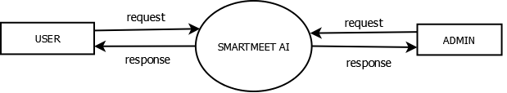
Figure 4.1.1 DFD Level 0
4.1.2 DFD LEVEL 1
The Level 1 Data Flow Diagram provides a detailed view of the internal processes of the SmartMeet AI system by expanding the main process shown in Level 0 into smaller functional modules. In this diagram, the user first logs into the system, where the authentication process verifies the credentials using stored user data. After successful authentication, the user can access different system features such as creating or joining meetings, managing participants, starting or stopping meeting recordings, and accessing previous meeting records. The meeting and user information are stored in the respective data stores for future access and management.
During a meeting, the WebRTC communication process manages the exchange of audio and video data between participants. When recording is enabled, the meeting recording process captures and stores the meeting content. After the meeting is completed, the recorded audio is extracted and processed by the transcription module using Whisper speech recognition. The generated transcript is stored for later access. The translation process can convert the transcript into the language selected by the user, while the summarization process analyzes the transcript and generates a concise summary containing the important information from the meeting.
Finally, the report generation process uses the transcript, translated content, and meeting summary to generate a downloadable PDF document. These generated meeting documents are stored and made available to the user for viewing or downloading. The different processes work together to provide communication, recording, transcription, translation, summarization, and documentation functionalities within a single platform.
The diagram clearly shows how user requests are processed and how meeting-related information flows between the different modules and data stores. It also highlights the interaction between the WebRTC meeting module, recording module, AI-based transcription and summarization modules, translation service, and report generation module. Overall, the Level 1 DFD provides a detailed representation of the internal data flow and functional operations of the SmartMeet AI.

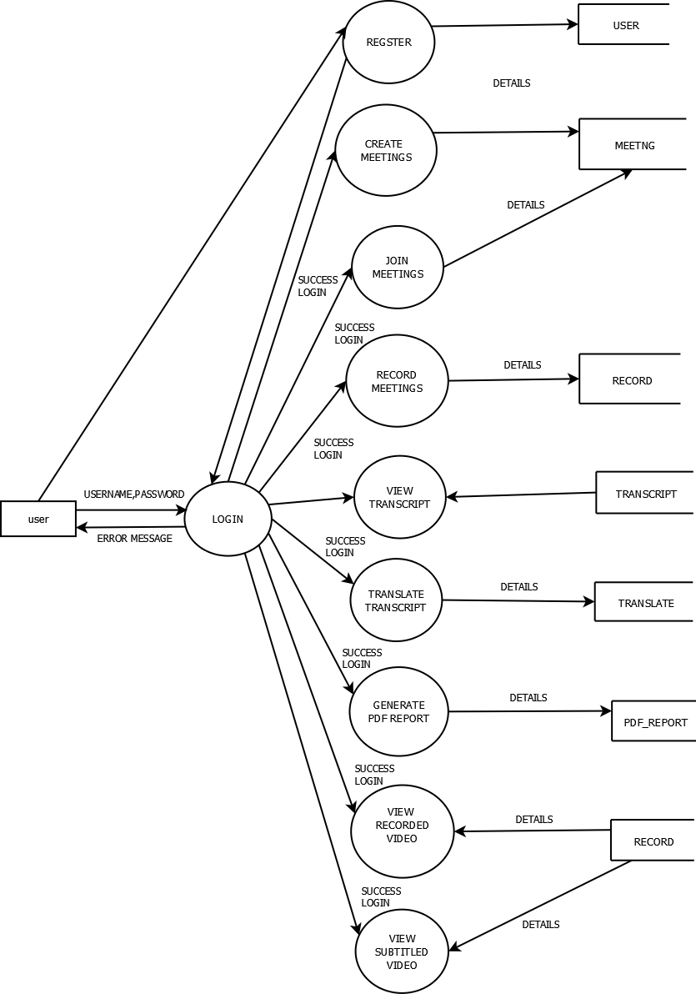
Figure 4.1.2 USER DFD Level 1

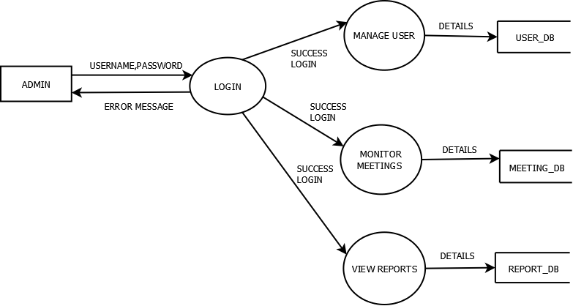
Figure 4. 1.2 ADMIN DFD Level 1

4.2 USE CASE DIAGRAM
The use case diagram represents the interaction between the users and the SmartMeet AI system. It shows the main functionalities available in the application and how different actors interact with these features. In this system, the primary actors are the User and the System.
The user can perform actions such as register or login, manage their profile, create or join meetings, participate in video and audio communication, and enable meeting recording. During a meeting, participants can communicate through real-time audio and video using WebRTC. The system records the meeting and processes the recorded audio after the meeting to generate a transcript and summary. The user can also translate the transcript into supported languages and download the generated transcript, summary, and subtitles as a PDF. This diagram helps illustrate the overall functionality and user interaction within the SmartMeet AI.
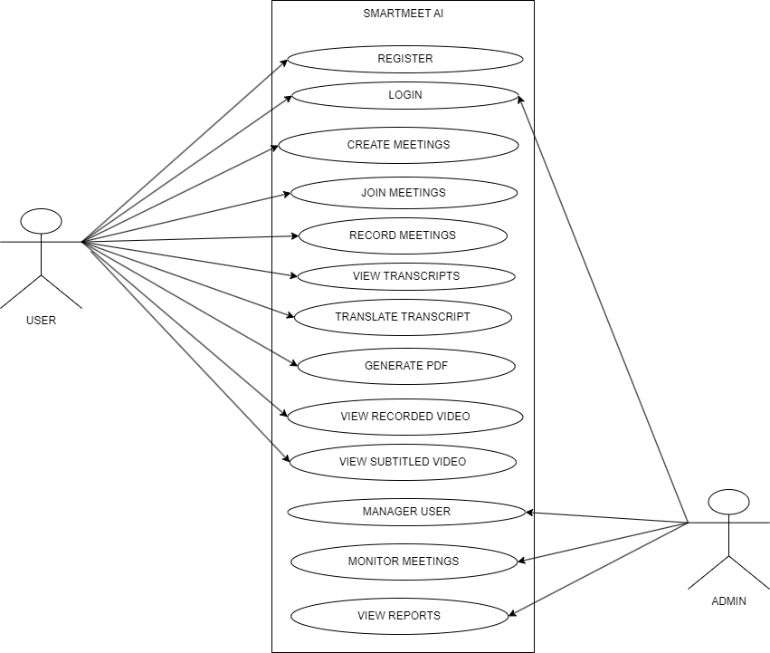
Figure 4.3 Use Case Diagram

4.3 CLASS DIAGRAM
The class diagram represents the structural design of the SmartMeet AI system by showing the main classes, their attributes, methods, and the relationships between them. The primary class is the User, which contains details such as user ID, username, email, password, and profile information. The user can perform operations such as register, login, manage profile, create meetings, join meetings, and participate in video and audio communication.
The system also includes supporting classes such as Meeting, Participant, Recording, Transcript, Summary, Translation, and PDFReport. The Meeting class manages meeting details such as meeting ID, title, host, participants, and meeting status. The Participant class manages users who join a meeting. The Recording class handles the recording of meeting audio and video, while the Transcript class stores the speech-to-text output generated from the recorded meeting. The Summary class generates a summarized version of the meeting content, and the Translation class converts the transcript or summary into supported languages such as Malayalam, Hindi, and Tamil etc. The PDFReport class generates downloadable PDF documents containing the meeting transcript, summary, and related information. Together, these classes work to manage meetings, participants, recording, transcription, summarization, translation, and report generation within the SmartMeet AI.

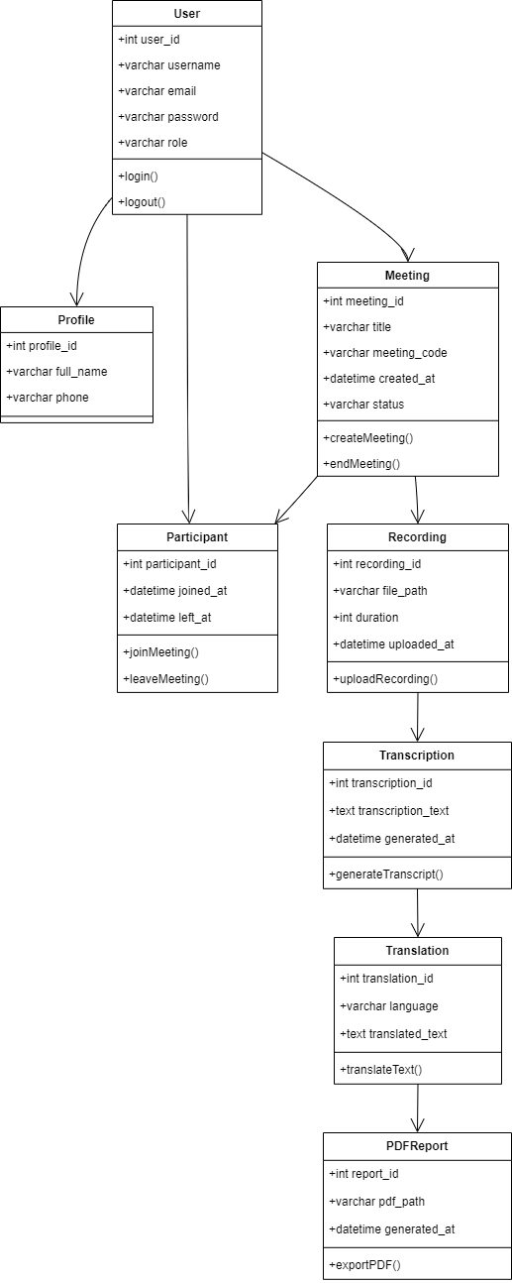
Figure 4.4 Class Diagram
4.4 STATE DIAGRAM
The state diagram represents the different states involved in the meeting and processing workflow of the SmartMeet AI system. The process begins in the Idle state and moves to the Meeting Created state when the host creates a meeting. Participants can then join the meeting, moving the system to the Meeting Active state, where users can communicate through audio and video using WebRTC. When recording is started, the system enters the Recording state and captures the meeting content. After the meeting ends, the system moves to the Processing state, where the recorded audio is processed to generate the transcript and meeting summary. The system can then perform translation into supported languages and generate a downloadable PDF report containing the transcript and summary. Finally, the process moves to the Meeting Completed state, indicating that the meeting and its related processing activities have been successfully completed.
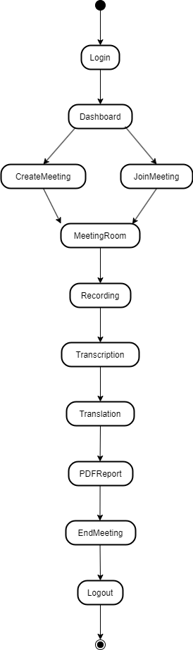
Figure 4.5 State Diagram
4.5 ACTIVITY DIAGRAM
The activity diagram illustrates the workflow of the SmartMeet AI system by showing the sequence of activities involved in conducting and processing an online meeting. It represents the step-by-step flow of actions performed by the user and the system from the beginning of the meeting to the generation of the final meeting report. The process begins when the user logs into the website and accesses the dashboard. After login, the user can create a meeting or join an existing meeting using the provided meeting details.
Once the meeting starts, participants can communicate through real-time audio and video using WebRTC. The host can start the recording, after which the system captures the meeting audio and video. During the meeting, participants can continue their discussion until the meeting is ended by the host or participants.
After the meeting ends, the recorded audio is processed by the system using the speech-to-text module to generate a transcript. The generated transcript is then processed to create a concise meeting summary. The user can also select a supported language to translate the transcript or summary. Finally, the system generates a downloadable PDF containing the meeting transcript, summary, and related information.
The activity diagram illustrates the overall workflow of the SmartMeet AI system, showing how the application manages user authentication, meeting participation, communication, recording, transcription, summarization, translation, and PDF report generation.
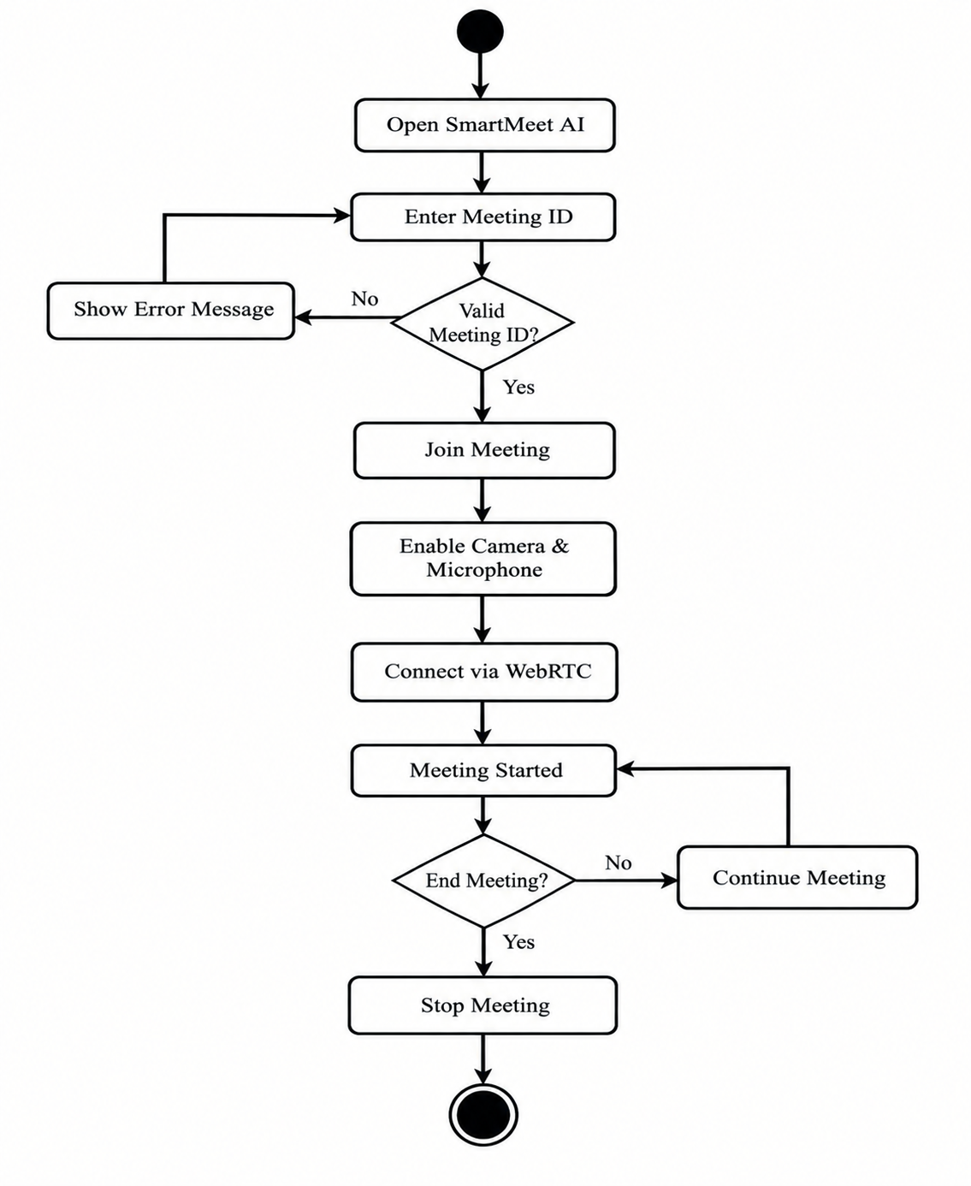
Figure 4.6 Activity Diagram
4.6 SEQUENCE DIAGRAM
The sequence diagram illustrates the interaction between the User, SmartMeet AI , Backend, WebRTC Service, and Processing Module during the meeting process. It shows the order in which messages are exchanged between the different components of the system when the user creates or joins a meeting. The sequence starts when the user logs into the SmartMeet AI and creates or joins a meeting. The application sends the meeting request to the backend, where the meeting details are processed and the participant is connected to the meeting.
Once the meeting begins, the WebRTC service establishes real-time audio and video communication between the participants. The user can start recording the meeting, and the application captures the meeting audio and video. When the meeting ends, the recorded data is sent for processing. The Processing Module extracts the audio and uses the speech-to-text process to generate the meeting transcript.
The generated transcript is then processed to create a meeting summary. If required, the user can request translation of the transcript or summary into a supported language. Finally, the system generates a PDF report containing the transcript, summary, and related meeting information, which can be downloaded by the user.
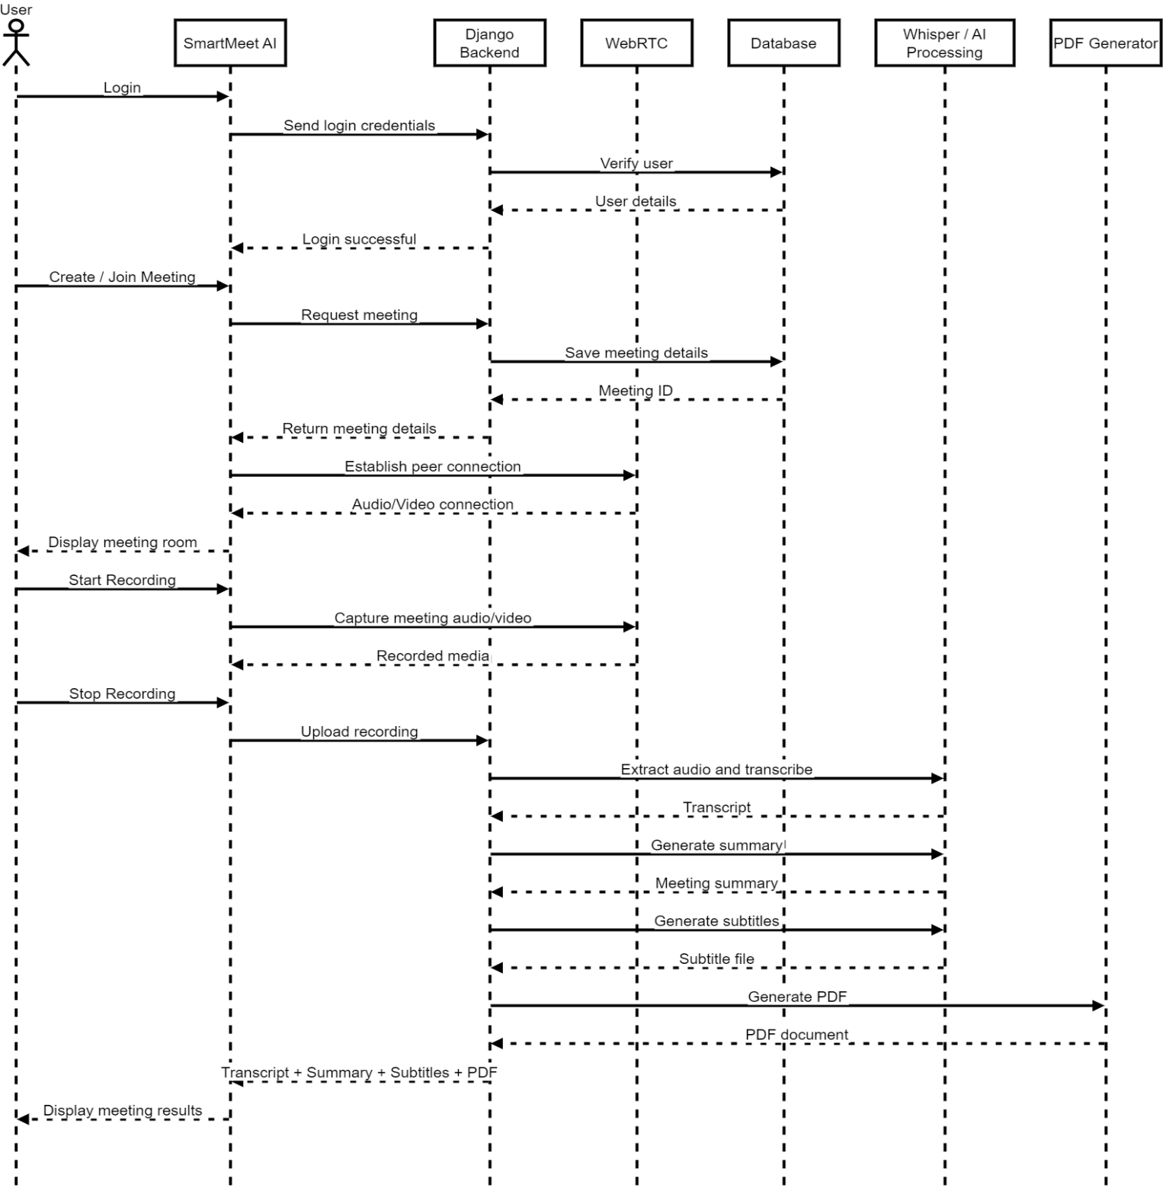
Figure 4.7 Sequence Diagram

CHAPTER 5
METHODOLOGY
5.1 Module Descriptions
The SmartMeet AI web application is designed as a modular system in which different components work together to provide an efficient online meeting and post-meeting processing platform. Each module is responsible for a specific function within the application. This modular structure helps organize the system efficiently and allows different features to operate in a coordinated manner. The main modules of the SmartMeet AI system include authentication, user profile management, meeting management, real-time communication, meeting recording, transcription, summarization, translation, and PDF report generation.
Authentication Module
The authentication module is responsible for managing user access to the SmartMeet AI. It ensures that only registered users can access the meeting and processing features of the system. When a new user accesses the website, they can create an account by providing the required details such as username, email address, and password. Once registration is completed successfully, the user can log into the system using the registered credentials.
The registration process allows new users to create an account within the system. The entered user information is stored in the website database and associated with the user's account. A unique user account is maintained for each registered user, allowing the system to identify users and manage their meeting-related activities.
The login process allows existing users to access the website using their registered username or email and password. When the user submits the login form, the entered credentials are verified by the Django authentication system. If the credentials are valid, the system grants access to the dashboard. If the credentials are incorrect, an appropriate error message is displayed and the user is requested to provide valid credentials.
The authentication module also manages user sessions and logout operations. After successful login, the authenticated user can access the available meeting features according to their account. The module helps prevent unauthorized access and provides a secure foundation for the other modules of the SmartMeet AI system.
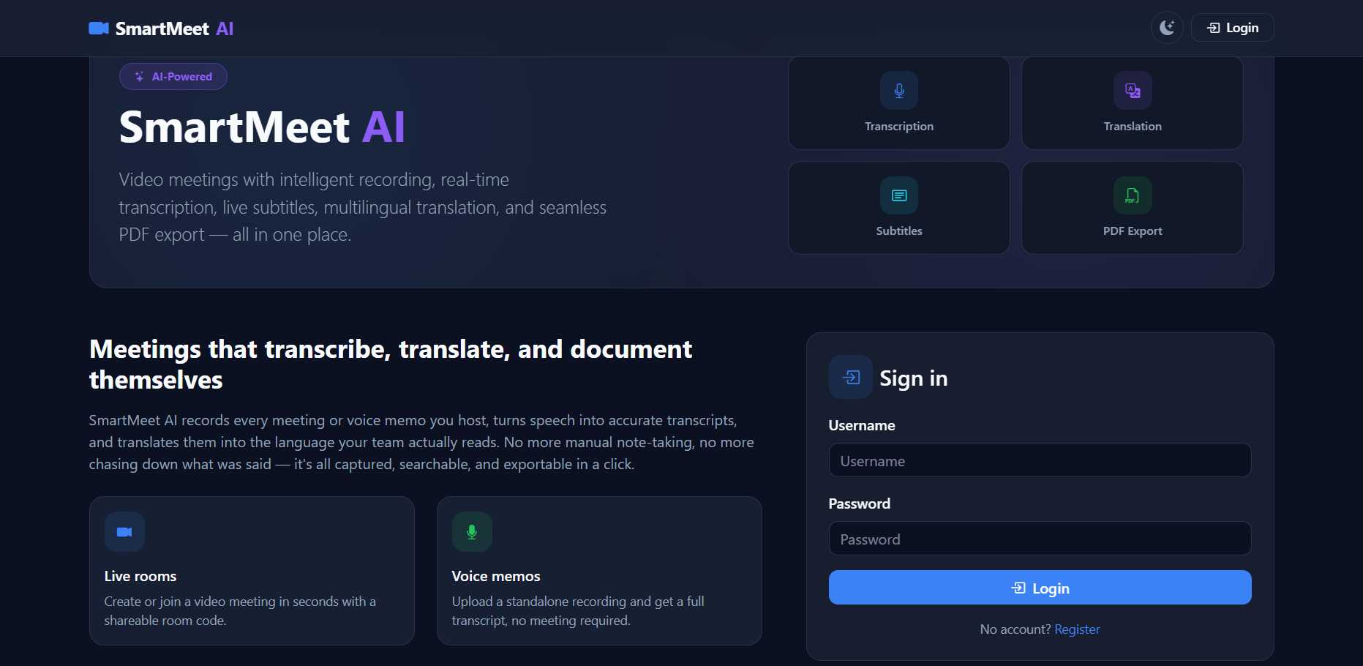
Figure 5.1.1 Login Interface

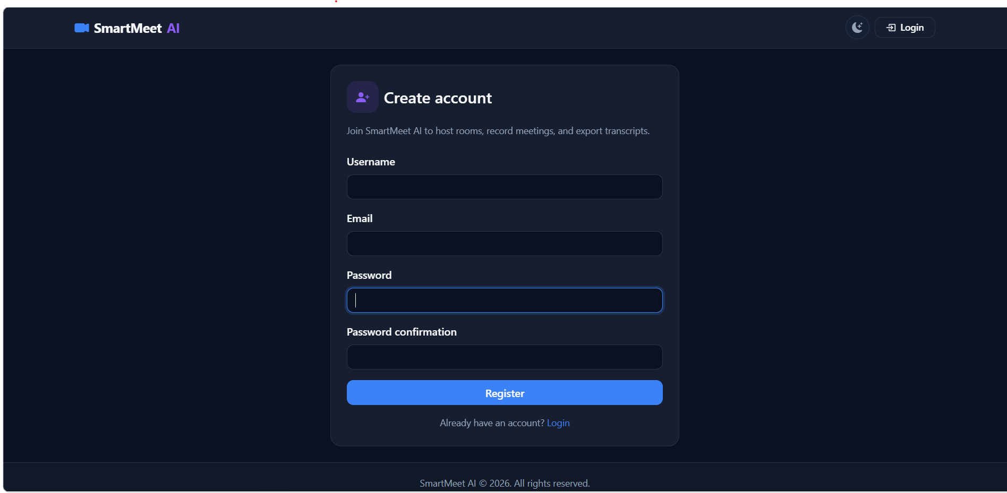
Figure 5.1.2 Register Interface
Dashboard Module
The dashboard module serves as the main interface of the SmartMeet AI and acts as the central control panel through which users can access the major features of the system. After a user successfully logs into the application, the dashboard is displayed. It provides a clear and organized interface that allows users to quickly navigate to different meeting-related functionalities. The primary purpose of the dashboard is to provide convenient access to meeting creation, joining meetings, recent meetings, and other account-related features.
The dashboard is designed with a simple and user-friendly interface so that users can easily understand and operate the application. Important functions are displayed using cards, buttons, and navigation options, allowing users to access the required feature without unnecessary steps. The interface also follows a consistent design to provide a smooth experience while using the application.
One of the main features available on the dashboard is the Create Meeting option. This allows the host to create a new meeting and obtain the required meeting information for sharing with participants. Users can also use the Join Meeting option to enter an existing meeting using the available meeting details or meeting link.
The dashboard also provides a Recent Meetings section that displays previously conducted or joined meetings. This allows users to easily access their meeting history and review the related meeting information. For a new user who has not yet created or joined any meetings, the recent meeting section remains empty and the interface focuses on the available actions such as creating or joining a meeting.
In addition to meeting-related options, the dashboard provides access to profile management through the user profile section. Users can view and update their profile information, including their profile image and account details. The navigation options also provide access to other available application functions and the logout operation.
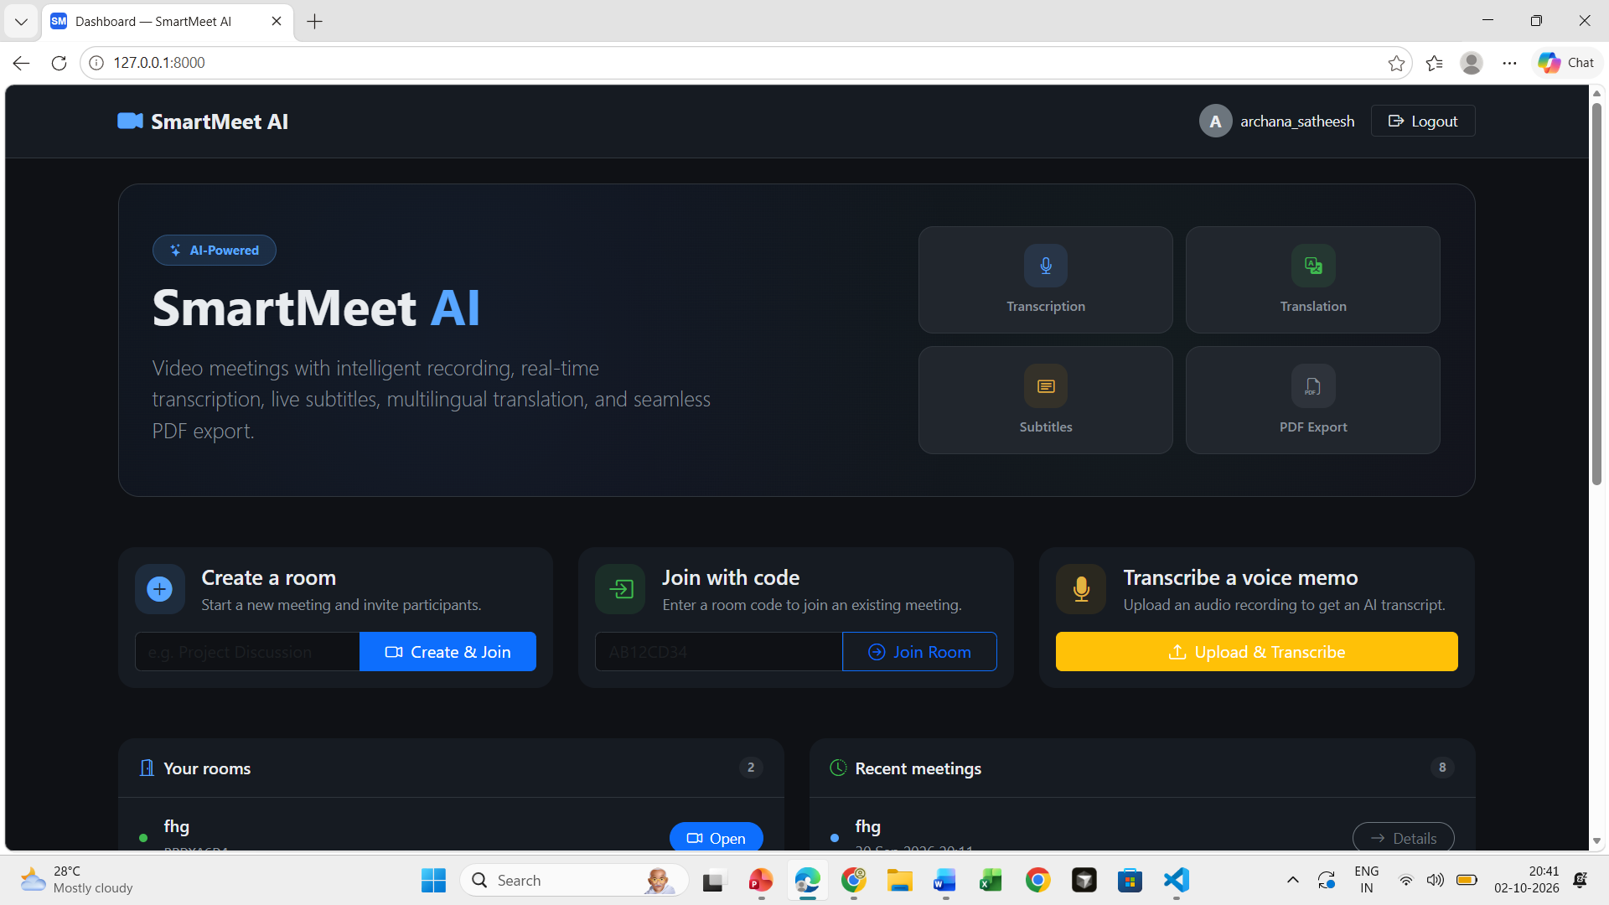
Figure 5.1.3 Dashboard
Meeting Module
The meeting module is one of the core modules of the SmartMeet AI and is responsible for creating, joining, and managing online meetings. It provides the main environment where users can communicate with other participants through real-time audio and video. The module uses WebRTC technology to establish direct communication between participants and provide an interactive meeting experience.
The meeting creation feature allows an authenticated user to create a new meeting. The system generates the required meeting details, which can be shared with other participants. Users can join an existing meeting using the available meeting link or meeting ID. Before entering the meeting, the system verifies the required meeting information and provides access to the meeting room.
Once the meeting begins, participants can communicate using their microphone and camera. The meeting interface provides controls for enabling or disabling audio and video, leaving the meeting, and managing other available meeting functions. The system displays the connected participants within the meeting room so that users can interact with each other in real time.
The meeting module also supports meeting recording. When the host starts recording, the system captures the meeting audio and video for further processing after the meeting is completed. The recording can then be processed by the transcription module to generate a text transcript of the conversation.
The meeting module also handles the joining and leaving of participants and maintains the meeting session until the meeting is ended. After the meeting is completed, the recorded content is passed to the processing modules for transcription, summarization, translation, and PDF report generation.
Thus, the meeting module provides the central communication environment of SmartMeet AI, connecting users through real-time audio and video while also supporting recording and post-meeting processing.
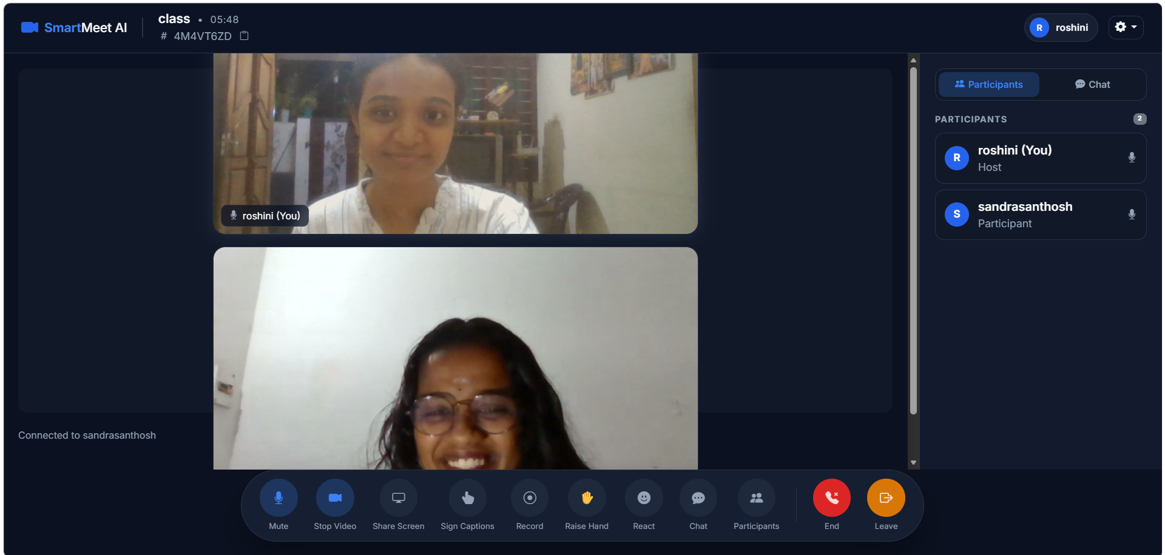
Figure 5.1.4 Meeting Interface
Recording Module
The recording module is responsible for capturing and managing the audio and video content of meetings in the SmartMeet AI. It allows the host to start and stop the recording during an active meeting. Once recording is started, the system captures the meeting content so that it can be processed after the meeting ends.
The recording feature works along with the real-time communication module to capture the audio and video streams of the meeting. The recorded data is stored temporarily and processed after the meeting is completed. The system extracts the required audio from the recording and prepares it for further processing by the transcription module.
After the recording is completed, the extracted audio is passed to the Whisper speech-to-text model to generate the meeting transcript. The recorded meeting therefore serves as the input for the subsequent transcription, summarization, translation, and PDF generation processes.
The recording module also provides controls for starting and stopping the recording and ensures that the recording process is properly terminated when the meeting ends. By integrating recording with the post-meeting processing pipeline, the module allows users to review the discussion and obtain useful meeting information after the meeting.
Thus, the recording module plays an important role in SmartMeet AI by capturing meeting content and providing the required recorded data for automatic transcription and subsequent AI-based processing.
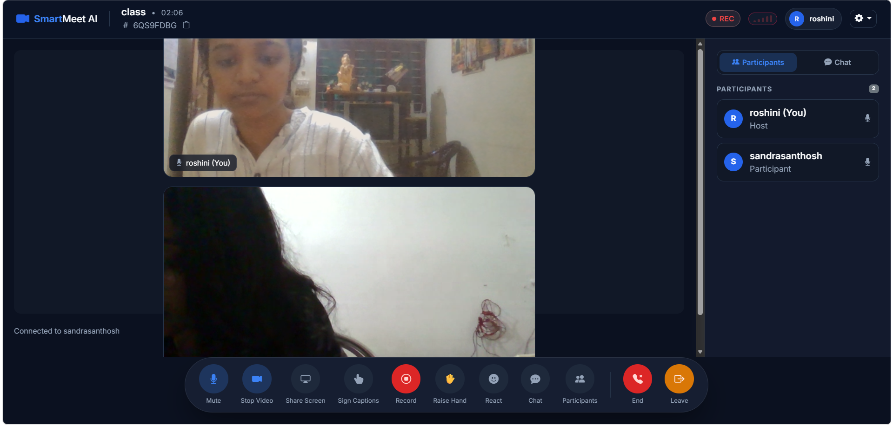
Figure 5.1.5 Recording Interface

Transcription Module
The transcription module is responsible for converting the recorded meeting audio into text in the SmartMeet AI. It processes the audio obtained from the recording module after the meeting is completed and generates a textual representation of the conversation. This module helps users review the meeting discussion without having to listen to the entire recording.
After a meeting ends, the system extracts the audio from the recorded meeting and prepares it for transcription. The processed audio is then passed to the OpenAI Whisper speech-to-text model. Whisper analyzes the audio and identifies the spoken words, converting the conversation into a text transcript.
The generated transcript contains the spoken content of the meeting and can be used for further processing. The transcript is passed to the AI Processing Module, where important information is analyzed and a concise meeting summary is generated. The transcript can also be translated into supported languages such as Malayalam, Hindi, and Tamil based on the user's selection.
The transcription module also supports the generation of subtitles that can be synchronized with the recorded meeting video. This allows users to review the recorded meeting together with its corresponding text.
Thus, the transcription module plays an important role in SmartMeet AI by automatically converting recorded meeting conversations into text and providing the required input for summarization, translation, subtitle generation, and PDF report creation.
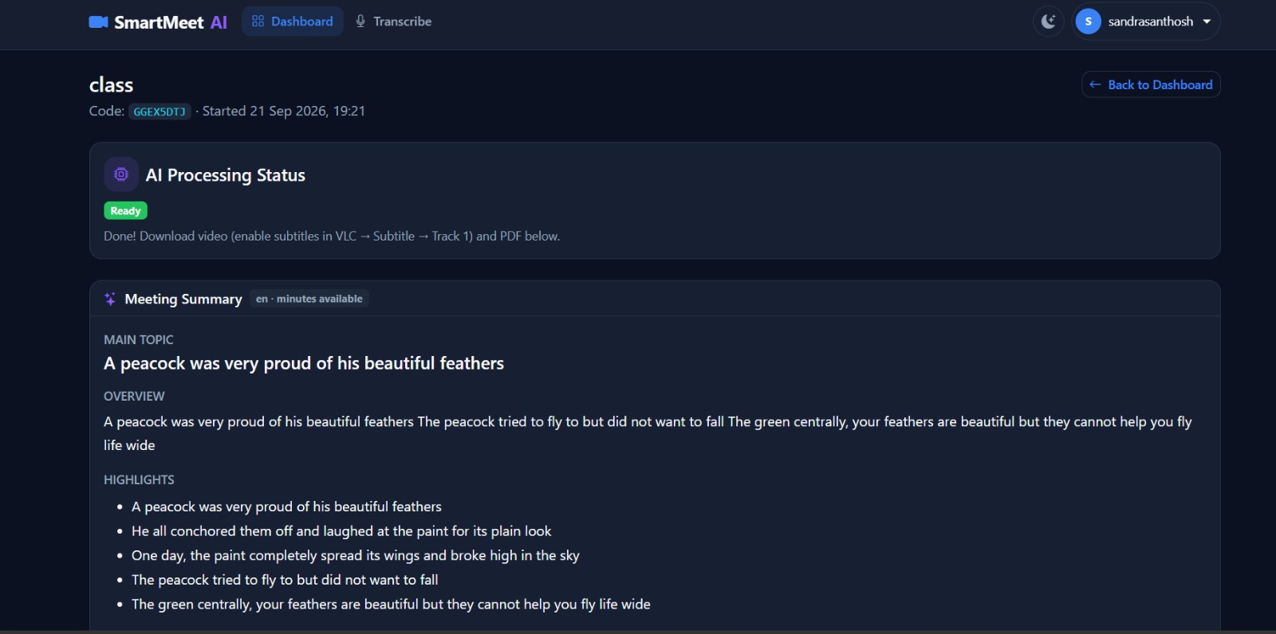
Figure 5.1.6 Transcription Interface

Translation and PDF Report Module
The Translation and PDF Report Module is responsible for translating the processed meeting content and generating downloadable reports in the SmartMeet AI application. This module works with the transcription and AI processing components to provide the meeting information in a user-selected language and present it in a structured PDF format.
After the meeting transcript and summary are generated, the user can select a supported language such as Malayalam, Hindi, or Tamil. The system processes the selected content using the translation service and generates the translated version. The original transcript and summary can also be retained so that the user can access both the original and translated content.
The PDF report feature allows the user to generate a downloadable document containing important meeting information. The report can include the meeting details, transcript, summary, and translated content based on the user's selection. The system uses the ReportLab library to format and generate the PDF document.
The generated PDF is organized in a readable format so that users can save, download, and review the meeting information after the meeting has ended. This provides a permanent record of the discussion without requiring the user to access the meeting again.
Thus, the Translation and PDF Report Module improves the accessibility and usability of SmartMeet AI by providing meeting content in multiple supported languages and allowing users to generate and download structured PDF reports.
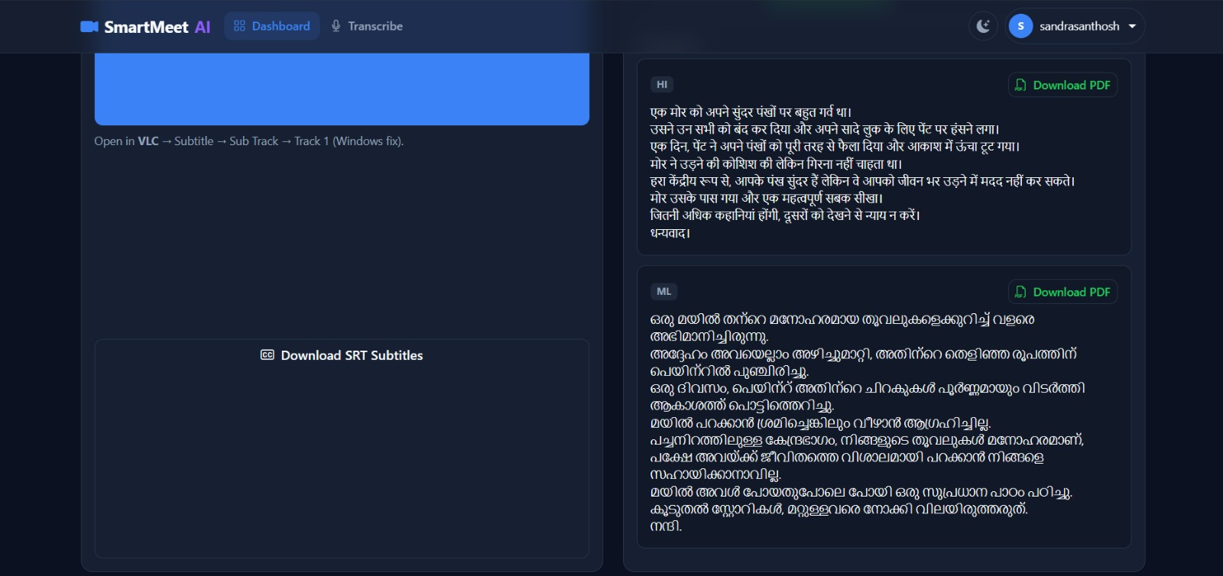
Figure 5.1.7 Translation and Pdf Report Interface

Subtitle Generation Module
The Subtitle Generation Module is responsible for creating synchronized subtitles from the recorded meeting audio in the SmartMeet AI. It allows users to view the spoken content as text while watching the recorded meeting video, improving the accessibility and readability of the recorded meeting.
After the meeting recording is completed, the system extracts the audio from the recorded video and processes it using the Whisper speech-to-text model. Along with the recognized text, the system obtains the timing information of the spoken segments. These timestamps are used to synchronize the generated subtitles with the corresponding portions of the recorded video.
The generated subtitle data is then combined with the recorded video using FFmpeg. The subtitles are embedded into the processed video so that they remain synchronized with the spoken conversation. The system can generate subtitles from the original meeting transcript without requiring real-time captioning during the meeting.
The subtitle generation process is performed after the meeting has been recorded. This allows the system to process the complete audio and produce more structured subtitles based on the recorded content. The resulting video can be reviewed with subtitles after processing.
Thus, the Subtitle Generation Module enhances the accessibility of SmartMeet AI by providing synchronized subtitles for recorded meetings and allowing users to understand the spoken content more easily while reviewing the recorded video.
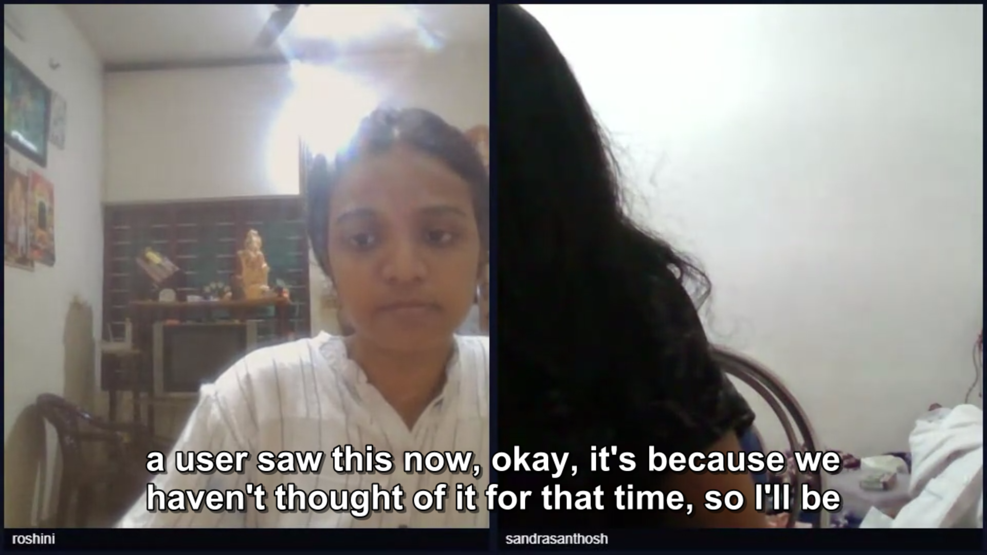
Figure 5.1.8 Subtitle Generation
5.2 Algorithms
The SmartMeet AI system uses a set of algorithms and processing procedures to manage online meetings and automatically process recorded meeting content. These procedures control important system functions such as user authentication, meeting creation and participation, audio and video communication, meeting recording, speech transcription, subtitle generation, summarization, translation, and PDF report generation. Each procedure defines a sequence of steps that the system follows to process user actions and generate the required output. By using these structured processes, the application can conduct online meetings and automatically convert recorded discussions into useful and accessible meeting information.
Steps:
- Start the SmartMeet AI application and log into the system.
- User creates a new meeting or joins an existing meeting using the meeting details.
- The system establishes the meeting connection and enables real-time audio and video communication using WebRTC.
- The host starts the meeting recording, and the system captures the meeting audio and video.
- When the meeting ends, the recorded content is processed by the system.
- The system extracts the audio from the recording and uses Whisper to generate the meeting transcript.
- The generated transcript is processed to create a concise meeting summary.
- The system generates synchronized subtitles from the transcript and associates them with the recorded video.
- The user can select a supported language, and the transcript or summary is translated accordingly.
- The system generates a downloadable PDF report containing the meeting transcript, summary, and translated content.
- End.

5.3 Architecture
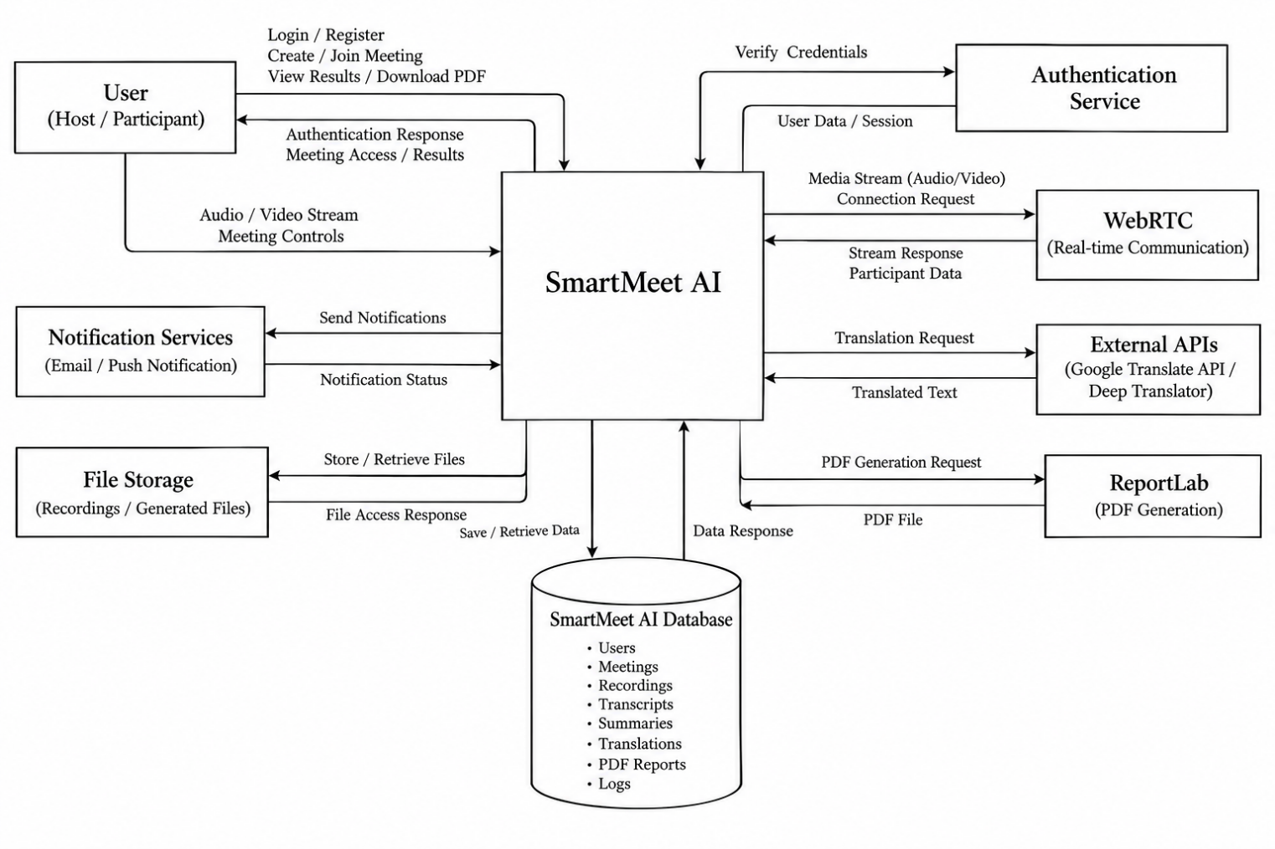
Figure 5.3 Architecture of SmartmeetAI
5.1 System Architecture
The architecture of the SmartMeet AI system is designed using a web-based client–server model in which the web browser functions as the client and the Django framework acts as the backend infrastructure. This architecture enables the application to manage user authentication, meeting sessions, real-time communication, recording, transcription, summarization, translation, and report generation efficiently. The overall design focuses on providing a responsive user interface, reliable meeting communication, secure data management, and automated post-meeting processing.
In this architecture, the web application serves as the primary interface through which users interact with the system. The application is responsible for presenting the user interface, processing user inputs, and providing access to different features such as user authentication, meeting creation, meeting joining, profile management, recording, transcription, translation, and PDF report generation.
The Django backend functions as the central application server. It manages user authentication, meeting-related requests, database operations, and communication between the different modules. When a user registers or logs into the application, Django verifies the provided credentials and manages the user's authenticated session. The backend also handles meeting creation, participant information, and other application data.
The system uses a database to store important application information such as user details, profile information, meeting records, and other required data. When users create or participate in meetings, the backend communicates with the database to store or retrieve the necessary information. This centralized data management helps maintain consistency across the application.
The architecture also includes WebRTC for real-time audio and video communication. When users join a meeting, WebRTC establishes the required peer-to-peer communication between participants. This allows participants to communicate through their microphones and cameras during the meeting. The meeting interface provides controls for managing audio, video, and other meeting functions.
Another important component is the Recording Module, which captures the meeting audio and video when recording is enabled. After the meeting ends, the recorded content is processed by the system. The audio is extracted from the recording and passed to the transcription module for further processing.
The Whisper speech-to-text model is used to convert the recorded meeting audio into text. The generated transcript is then provided to the AI processing module, which analyzes the meeting content and generates a concise summary. The system can also generate synchronized subtitles from the transcript using the timing information obtained during transcription.
The Translation Module allows users to translate the generated transcript or summary into supported languages such as Malayalam, Hindi, and Tamil. The translated content can then be displayed to the user or included in the final report.
The architecture also includes the PDF Report Module, which uses the ReportLab library to generate downloadable PDF documents. The generated report can contain meeting details, transcript, summary, subtitles-related information, and translated content according to the user's selection.
The modular architecture of SmartMeet AI allows each functional component to operate independently while communicating through the central Django application. The major modules include authentication, dashboard, profile management, meeting management, real-time communication, recording, transcription, AI processing, subtitle generation, translation, and PDF report generation. This modular structure makes the system easier to maintain and allows additional features to be integrated in the future.
Overall, the architecture integrates the web client, Django backend, database, WebRTC, Whisper, AI processing, translation services, FFmpeg, and ReportLab to provide an integrated platform for conducting online meetings and automatically processing meeting recordings.
5.2 Case Study
To evaluate the working of the SmartMeet AI system, a practical online meeting scenario can be considered. Suppose a user wants to conduct an online meeting with two or more participants. The host opens the SmartMeet AI application, logs into the system, and creates a new meeting. The system generates the required meeting details, which can be shared with the intended participants.
The participants use the provided meeting details to join the meeting. Once they enter the meeting room, the system establishes real-time audio and video communication using WebRTC. The participants can communicate with each other using their microphones and cameras.
During the meeting, the host can start the recording feature. The system captures the meeting audio and video while the discussion takes place. The participants continue their discussion until the meeting is completed. The host can then stop the recording and end the meeting.
After the meeting ends, the recorded audio is processed by the system. The audio is extracted from the recording and passed to the Whisper speech-to-text model. The model converts the spoken conversation into a text transcript. The generated transcript provides a textual record of the meeting discussion.
The transcript is then processed by the AI processing module to generate a concise meeting summary containing the important information from the discussion. The system can also generate synchronized subtitles from the recorded audio and associate them with the recorded video for later review.
If the user requires the meeting information in another language, they can select a supported language such as Malayalam, Hindi, or Tamil. The translation module processes the selected transcript or summary and produces the translated content.
Finally, the user can generate a PDF report containing the meeting details, transcript, summary, and translated content. The report can be downloaded and used as a record of the completed meeting.

CHAPTER 6
IMPLEMENTATION DETAILS
6.1 Implementation Procedures
The implementation of the SmartMeet AI web application was carried out using web development technologies and AI-based processing tools. The development process focused on creating an online meeting platform that integrates real-time communication with automatic meeting recording, transcription, summarization, subtitle generation, translation, and PDF report generation. The application was developed using Django as the primary backend framework along with HTML, CSS, JavaScript, and Bootstrap for the user interface.
The first step in the implementation process involved setting up the development environment and configuring the required software and libraries. Django was configured as the backend framework, while the required Python packages and supporting tools were installed for authentication, database management, audio processing, speech recognition, translation, and PDF generation. FFmpeg was also configured to support audio extraction and video processing.
After setting up the development environment, the next stage involved implementing the authentication system. The registration and login functionality was developed using Django's authentication system. Users can create accounts and securely log into the application using their registered credentials. User profile functionality was also implemented to allow users to manage their profile information and profile image.
The next stage involved designing and implementing the user interface. The dashboard was developed as the central interface of the application, providing access to the main features such as creating meetings, joining meetings, viewing meeting information, and managing the user profile. The meeting interface was designed to provide an organized environment for participants to communicate through audio and video.
After completing the basic interface, the meeting management module was implemented. The system allows authenticated users to create meetings and share the required meeting details with other participants. Participants can join an existing meeting using the provided meeting information. Meeting-related information is managed through the Django backend and database.
The real-time communication module was then implemented using WebRTC. This allows participants to establish audio and video communication through their web browsers. JavaScript was used to access the user's camera and microphone and manage the media streams. Meeting controls were implemented to allow users to enable or disable their microphone and camera and leave the meeting.
The recording module was implemented to capture the meeting audio and video. When the host starts recording, the system captures the available meeting media and stores the recorded content for post-meeting processing. After the recording is completed, the recorded file is passed to the processing pipeline.
The transcription module was implemented using the Whisper speech-to-text model. The audio is extracted from the recorded meeting using FFmpeg and prepared for speech recognition. Whisper processes the audio and generates a text transcript containing the spoken content of the meeting. The generated transcript is stored and made available for further processing.
The subtitle generation module was implemented using the transcript and its associated timing information. The system generates subtitle data corresponding to the spoken segments and uses FFmpeg to associate the subtitles with the recorded video. This allows users to review the recorded meeting with synchronized subtitles after the meeting has ended.
The AI processing module was then implemented to generate a concise summary from the meeting transcript. The transcript is analyzed to identify the important information discussed during the meeting and produce a summarized version. This helps users review the main points of a meeting without reading the complete transcript.
The translation module was implemented to provide multilingual access to the meeting content. Users can select supported languages such as Malayalam, Hindi, or Tamil, and the system processes the transcript or summary using the configured translation service. The translated content is then presented to the user for review.
Finally, the PDF report generation module was implemented using ReportLab. The system collects the required meeting information, transcript, summary, and translated content and formats them into a structured PDF document. The generated report can be downloaded by the user for future reference.
During the implementation process, each module was developed and tested individually before being integrated into the complete application. The authentication, meeting communication, recording, transcription, subtitle generation, summarization, translation, and PDF generation components were tested separately to identify and correct errors. After integration, the complete system was tested to verify that the modules worked together correctly.
The final stage of implementation involved improving the application's reliability, user interface, media handling, and processing workflow. Error handling and file processing were refined to ensure that recorded meeting content could be processed correctly. The completed implementation provides an integrated workflow from user authentication and meeting participation to recording, transcription, summarization, subtitle generation, translation, and PDF report generation in the SmartMeet AI application.
6.2 Testing Methods and Results
Testing Methods
Testing plays an important role in the development of the SmartMeet AI system because it ensures that the application performs according to its intended requirements. The application was evaluated using different testing techniques to verify the functionality, reliability, integration, and usability of the implemented modules. The testing process focused on validating individual modules as well as examining the complete workflow when all modules operate together.
Functional testing was performed to verify that each feature of the application worked according to its intended design. Individual modules were tested to confirm that the expected operations were performed correctly. For example, the registration and login functions were tested to verify user authentication. The meeting module was tested to confirm that users could create and join meetings, while the WebRTC communication feature was tested to verify audio and video communication between participants.
The recording module was tested to verify that meeting audio and video could be recorded and that the recorded file was available for post-meeting processing. The transcription module was tested by processing recorded meeting audio through the Whisper speech-to-text model and checking whether the generated transcript represented the spoken content correctly.
Integration testing was carried out to verify the communication between different modules. The complete workflow from meeting creation to recording, transcription, summarization, translation, subtitle generation, and PDF generation was tested. This helped verify that the output of one module was correctly passed to the next module.
Usability testing was conducted to evaluate the ease of interaction with the application. The dashboard, meeting interface, recording controls, transcript display, translation options, and PDF download functions were checked to ensure that users could access the required features without unnecessary complexity.
Scenario-based testing was performed by simulating different meeting situations, including creating a meeting, joining with multiple participants, conducting a discussion, recording the meeting, ending the meeting, and processing the recorded content.
The testing methods used for evaluating the system included:
- Functional testing to verify the correct operation of individual modules
- Integration testing to evaluate communication between different modules
- Usability testing to ensure that the interface is simple and easy to use
- Scenario-based testing to simulate different meeting situations
- System testing to evaluate the complete SmartMeet AI workflow
Results
The testing process confirmed the operation of the major SmartMeet AI modules under the tested scenarios. Each module was evaluated individually and then tested as part of the complete system workflow.
During testing of the authentication module, user registration and login operations were verified to ensure that registered users could access the application using valid credentials. The system also prevented access when invalid login information was provided.
The meeting module was tested to verify that users could create and join meetings successfully. The WebRTC communication functionality was evaluated to confirm that participants could communicate through audio and video during an active meeting.
The recording module was tested by starting and stopping the recording during an active meeting. The system successfully captured the meeting content and made the recorded data available for post-meeting processing.
The transcription module was evaluated using recorded meeting audio. The audio was processed using the Whisper speech-to-text model, and the system generated a textual transcript of the recorded conversation. The generated transcript was then used as input for further processing.
The AI processing module was tested to verify that the transcript could be processed to generate a concise meeting summary. The subtitle generation module was also tested to verify that subtitles could be generated from the transcript and synchronized with the recorded meeting video.
The translation module was tested using the supported languages, including Malayalam, Hindi, and Tamil. The system processed the selected meeting content and generated the corresponding translated text.
The PDF report module was tested to verify that meeting information, transcript, summary, and translated content could be formatted into a downloadable PDF document using ReportLab.
The results of the testing process demonstrated the following:
- User registration and login functionality operated correctly.
- Users were able to create and join meetings.
- WebRTC supported real-time audio and video communication between participants.
- Meeting recordings were captured for post-meeting processing.
- Recorded audio was processed to generate meeting transcripts using Whisper.
- Meeting transcripts were processed to generate summaries.
- Subtitles were generated from the recorded meeting transcript.
- Translation functionality supported the configured languages.
- PDF reports were generated containing the processed meeting information.
- The different modules were successfully integrated into the overall meeting workflow.
- The application interface provided access to the major meeting and processing functions.
Overall, the testing process verified the main functionality of the SmartMeet AI application across the tested scenarios. The system integrates real-time meeting communication with recording and automated post-meeting processing, allowing users to obtain transcripts, summaries, subtitles, translated content, and downloadable PDF reports from recorded meetings.

CHAPTER 7
ADVANTAGES AND DISADVANTAGES
7.1 Advantages
The SmartMeet AI provides several advantages by combining real-time web communication with artificial intelligence-based meeting processing. The system is designed to simplify online meetings by providing communication, recording, transcription, summarization, subtitle generation, translation, and PDF report generation within a single platform. By integrating these features, the application reduces the need to use separate tools for different meeting-related tasks.
The system also helps users review meeting discussions after the meeting has ended. Instead of manually listening to an entire recording, users can refer to the generated transcript and summary. The multilingual translation feature further improves accessibility by allowing meeting content to be processed in supported languages. Some of the major advantages of the proposed system are listed below.
- Provides real-time audio and video communication between participants using WebRTC.
- Allows users to create and join online meetings through a web-based interface.
- Supports meeting recording for later review and processing.
- Automatically converts recorded meeting audio into text using the Whisper speech-to-text model.
- Generates a concise summary from the meeting transcript, reducing the need to review the complete conversation.
- Generates synchronized subtitles for recorded meeting videos.
- Supports translation of meeting transcripts and summaries into languages such as Malayalam, Hindi, and Tamil.
- Generates downloadable PDF reports containing meeting information, transcripts, summaries, and translated content.
- Integrates multiple meeting-related functions into a single application instead of requiring separate applications for each task.
- Provides a user-friendly dashboard for accessing meeting and post-meeting processing features.
- Uses a modular architecture, making the system easier to maintain and extend with additional features.
- Helps users preserve important meeting discussions through recorded content, transcripts, summaries, and downloadable reports.

7.2 Disadvantages
Although the SmartMeet AI system provides several useful features, there are certain limitations associated with the current implementation. These limitations mainly arise from factors such as network connectivity, browser and device capabilities, audio quality, computational requirements, and the accuracy of AI-based speech processing. Since the application depends on real-time communication and post-meeting AI processing, the quality of the generated results can be affected by the input data and available system resources.
In addition, the current version focuses mainly on core meeting communication and post-meeting processing features. Some advanced capabilities can be introduced in future versions to improve the overall functionality and scalability of the system.
- Real-time audio and video communication depends on a stable internet connection.
- WebRTC communication performance may be affected by network quality, browser compatibility, or device limitations.
- The accuracy of the generated transcript depends on audio quality, background noise, accents, pronunciation, and overlapping speech.
- Whisper-based transcription and other AI processing may require considerable processing time for longer meeting recordings.
- The quality of the generated meeting summary depends on the accuracy and completeness of the transcript.
- Translation results may vary depending on the language, sentence structure, and quality of the original transcript.
- Subtitle synchronization may be affected when the recorded audio contains overlapping speakers or unclear speech.
- Recording and processing long meetings may require considerable storage space.
- The current system may have limitations when handling a large number of simultaneous participants or meetings.
- The webstie requires supporting software such as FFmpeg for certain audio and video processing operations.
- The current implementation may not provide advanced speaker identification and complete speaker diarization for every meeting scenario.
- The system primarily performs transcription, summarization, translation, and subtitle generation after the meeting rather than providing all AI processing in real time.

CHAPTER 8
RESULT AND DISCUSSION
8.1 Analysis
The analysis of the SmartMeet AI system was carried out to evaluate the overall functionality, performance, and usability of the web-based meeting platform. The evaluation focused on examining how the different modules operate individually and how they work together as a complete meeting and post-meeting processing system. The analysis considered real-time communication, meeting recording, transcription accuracy, summary generation, subtitle generation, translation, and PDF report generation.
One of the important aspects analysed during the system evaluation was the real-time communication module. The WebRTC-based meeting environment was tested to verify audio and video communication between participants. The system allowed users to create and join meetings and communicate using their microphones and cameras. The meeting interface also provided controls for managing audio and video during the meeting.
The recording module was analysed to verify whether meeting content could be captured and processed after the meeting. During testing, the recording feature was started during active meetings and stopped when the discussion was completed. The recorded content was then made available for further processing. This provided the required input for the transcription and subtitle generation modules.
Another important component evaluated during the analysis was the transcription module. Recorded meeting audio was extracted and processed using the Whisper speech-to-text model. The system generated a textual transcript from the recorded conversation. The quality of the transcript depended on factors such as audio clarity, background noise, pronunciation, and overlapping speech. The generated transcript was subsequently used by the summarization and translation modules.
The AI processing module was evaluated to determine whether the generated transcript could be converted into a concise meeting summary. The system processed the transcript and generated summarized meeting content containing the important information from the discussion. This feature allows users to review the main points of a meeting without going through the complete transcript.
The subtitle generation module was also analysed. The system used the transcript and timing information to generate subtitles corresponding to the recorded meeting. FFmpeg was used during the video processing stage to associate the generated subtitles with the recorded video. This allows users to review the meeting with synchronized subtitles after the meeting has been completed.
The translation module was evaluated using the supported languages, including Malayalam, Hindi, and Tamil. The system processed the selected transcript or summary and generated the corresponding translated content. This feature improves the accessibility of meeting information for users who prefer different languages.
The PDF report generation module was analysed to verify whether the processed meeting information could be converted into a structured downloadable document. The system generated PDF reports containing relevant meeting details, transcript, summary, and translated content based on the selected options. ReportLab was used to generate and format the PDF documents.
In addition to evaluating individual modules, the overall system usability was analysed. The dashboard provides access to meeting creation, meeting joining, profile management, and other available functions. The meeting interface provides controls for communication and recording, while the post-meeting interface provides access to transcripts, summaries, subtitles, translations, and PDF reports. This organization allows users to complete the meeting workflow through a single application.
The modular architecture of the system also contributed to the organized functioning of the application. Each major function was implemented as a separate module, allowing the system to process meeting information through a defined workflow. This modular structure also makes it easier to maintain the application and introduce additional features in future versions.
The key observations obtained from the analysis of the system include:
- The authentication module successfully manages user registration and login.
- Users can create and join online meetings through the website.
- WebRTC provides real-time audio and video communication between meeting participants.
- The recording module captures meeting content for post-meeting processing.
- Recorded audio can be processed using Whisper to generate meeting transcripts.
- The transcript can be processed to generate a concise meeting summary.
- The system can generate subtitles from the recorded meeting transcript.
- Meeting content can be translated into supported languages such as Malayalam, Hindi, and Tamil etc.
- The system can generate downloadable PDF reports containing processed meeting information.
- The modular architecture allows different components to interact through the overall application workflow.
- The dashboard and meeting interfaces provide access to the major functions of the system.
Overall, the analysis indicates that SmartMeet AI successfully integrates real-time online meeting communication with automated post-meeting processing. The system combines WebRTC-based communication, meeting recording, Whisper transcription, AI-based summarization, subtitle generation, multilingual translation, and PDF report generation within a single platform.
CHAPTER 9
CONCLUSION
9.1 Summary
The SmartMeet AI website was developed as an AI-powered online meeting platform designed to simplify virtual communication and automate post-meeting processing. The system provides users with an integrated environment for creating and joining online meetings, communicating through real-time audio and video, recording meetings, and processing the recorded content. The application combines WebRTC-based communication with artificial intelligence technologies to provide useful meeting-related outputs.
The system integrates several important features such as user authentication, profile management, meeting creation and joining, real-time audio and video communication, meeting recording, automatic transcription, AI-based summarization, subtitle generation, translation, and PDF report generation. These features work together to provide a complete meeting workflow, from conducting the meeting to generating useful information from the recorded content.
One of the major contributions of SmartMeet AI is the automatic processing of recorded meetings. After a meeting is completed, the recorded audio is extracted and processed using the Whisper speech recognition model to generate a text transcript. The generated transcript is then processed to create a concise summary of the meeting. This reduces the need for users to manually review lengthy meeting recordings or prepare meeting notes.
The system also provides subtitle generation and multilingual translation capabilities. Subtitles can be generated from the transcribed content and synchronized with the recorded meeting video. Users can also translate the transcript or summary into supported languages such as Malayalam, Hindi, and Tamil. The processed information can be compiled into a downloadable PDF report using ReportLab.
The results obtained during testing indicate that the system successfully performs the major functions of the proposed application, including authentication, meeting creation and joining, real-time communication, recording, transcription, summarization, subtitle generation, translation, and PDF generation. The modular design also allows individual components to be maintained and improved independently. Overall, SmartMeet AI demonstrates how WebRTC and AI technologies can be combined to provide an efficient online meeting and automated post-meeting processing solution.
9.2 Limitations
Although the SmartMeet AI application provides several useful meeting and AI-based features, the current implementation has certain limitations that may affect its performance in some situations. These limitations mainly arise from network conditions, audio quality, processing requirements, and the technologies used for speech recognition and translation.
One limitation of the system is its dependence on a stable internet connection for real-time communication. WebRTC-based audio and video communication can be affected by low bandwidth, high latency, network instability, or browser-related issues. In such situations, participants may experience interruptions or reduced audio and video quality.
Another limitation is that the accuracy of automatic transcription depends on the quality of the recorded audio. Background noise, overlapping speech, unclear pronunciation, different accents, and low microphone quality can affect the accuracy of the Whisper transcription process. When multiple participants speak at the same time, distinguishing individual speakers may also be difficult.
The AI-based summarization process also depends on the quality of the generated transcript. If the transcript contains missing or incorrect words, the resulting summary may not completely represent the actual discussion. Similarly, the quality of translated content may vary depending on the language and the accuracy of the original transcript.
Another limitation is the processing time required for longer meeting recordings. Audio extraction, transcription, summarization, subtitle generation, and PDF creation may require additional processing time, particularly for lengthy meetings or large media files. The system also requires sufficient storage for recorded videos, audio files, transcripts, and generated reports.
The current implementation may also have limitations in advanced speaker identification and diarization. Since the system mainly focuses on post-meeting transcription and processing, identifying exactly which participant spoke each sentence may not always be possible.
Despite these limitations, SmartMeet AI provides a functional platform for online meetings and automated meeting-content processing. Identifying these limitations provides opportunities for improving the system in future versions.
9.3 Future Scope
The SmartMeet AI application has several opportunities for further improvement and expansion. Future development can focus on improving communication quality, transcription accuracy, AI capabilities, multilingual support, and meeting management features.
One possible improvement is the integration of advanced speaker diarization techniques. This would allow the system to identify different participants and associate their speech with the corresponding speaker. Such a feature could improve the usefulness of meeting transcripts, especially when several participants are involved in a discussion.
Another potential enhancement is the improvement of AI-based meeting analysis. Future versions could automatically identify important topics, decisions, action items, deadlines, and key discussion points from meeting transcripts. This would provide users with more structured and useful meeting information.
The transcription system could also be enhanced to support additional languages and improve recognition of different accents and speaking styles. More advanced speech processing techniques could be incorporated to handle background noise, overlapping speech, and low-quality audio more effectively.
Future versions could also provide real-time AI assistance during meetings. Features such as real-time transcription, intelligent meeting suggestions, automatic question generation, keyword identification, and live action-item detection could be incorporated while maintaining the existing post-meeting processing functionality.
The meeting platform could also be expanded with features such as calendar integration, meeting reminders, screen sharing improvements, participant management, attendance tracking, chat functionality, and cloud-based recording storage. Integration with external storage services could provide users with easier access to their meeting recordings and generated reports.
In addition, the system could be optimized for larger meetings and improved scalability. Cloud-based processing and distributed AI services could reduce processing time for long recordings and support a larger number of simultaneous users.
9.4 Applications
The SmartMeet AI system can be applied in various real-world situations where online communication, meeting recording, and automated information processing are required. The application is particularly useful for organizations, educational institutions, teams, and individuals who regularly conduct online meetings.
One of the main applications of the system is in educational institutions. Teachers and students can use the platform for online classes, discussions, seminars, and project meetings. Recorded sessions can be transcribed and summarized, allowing students to review important information after the meeting.
The system can also be used in business and corporate environments for team meetings, project discussions, client meetings, and online conferences. Automatic transcription and summarization can help users maintain meeting records and quickly review important discussion points.
Another application is in project development and team collaboration. Project teams can record discussions, generate transcripts, identify important information, and create PDF reports for future reference. This can help maintain organized documentation throughout the project lifecycle. SmartMeet AI can also be useful for online seminars, workshops, and training programs. Participants can access recorded meeting content with subtitles and translated versions, making the information more accessible to users with different language preferences.
The platform may also be applied in remote work environments, where employees regularly communicate through online meetings. Meeting recordings, transcripts, summaries, and reports can provide a structured record of discussions and help team members who were unable to attend the meeting.
Overall, SmartMeet AI combines online meeting communication with automated AI-based post-meeting processing. By integrating real-time communication, recording, transcription, summarization, subtitles, translation, and PDF report generation into a single platform, the system provides a practical solution for managing and documenting online meetings.

CHAPTER 10
10.1 APPENDICES
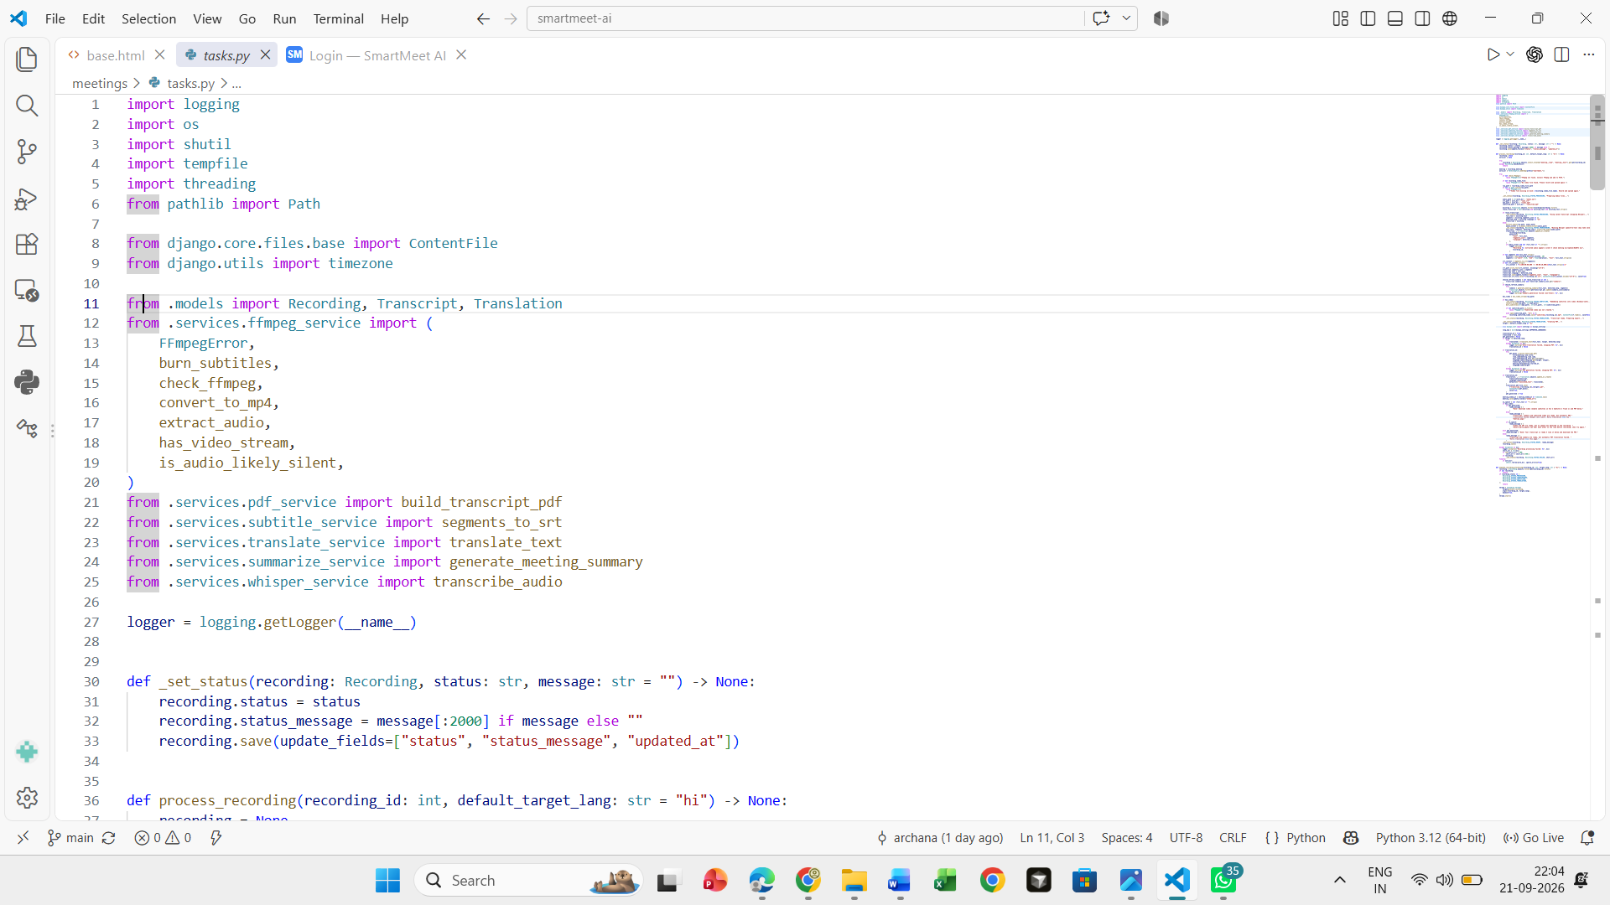
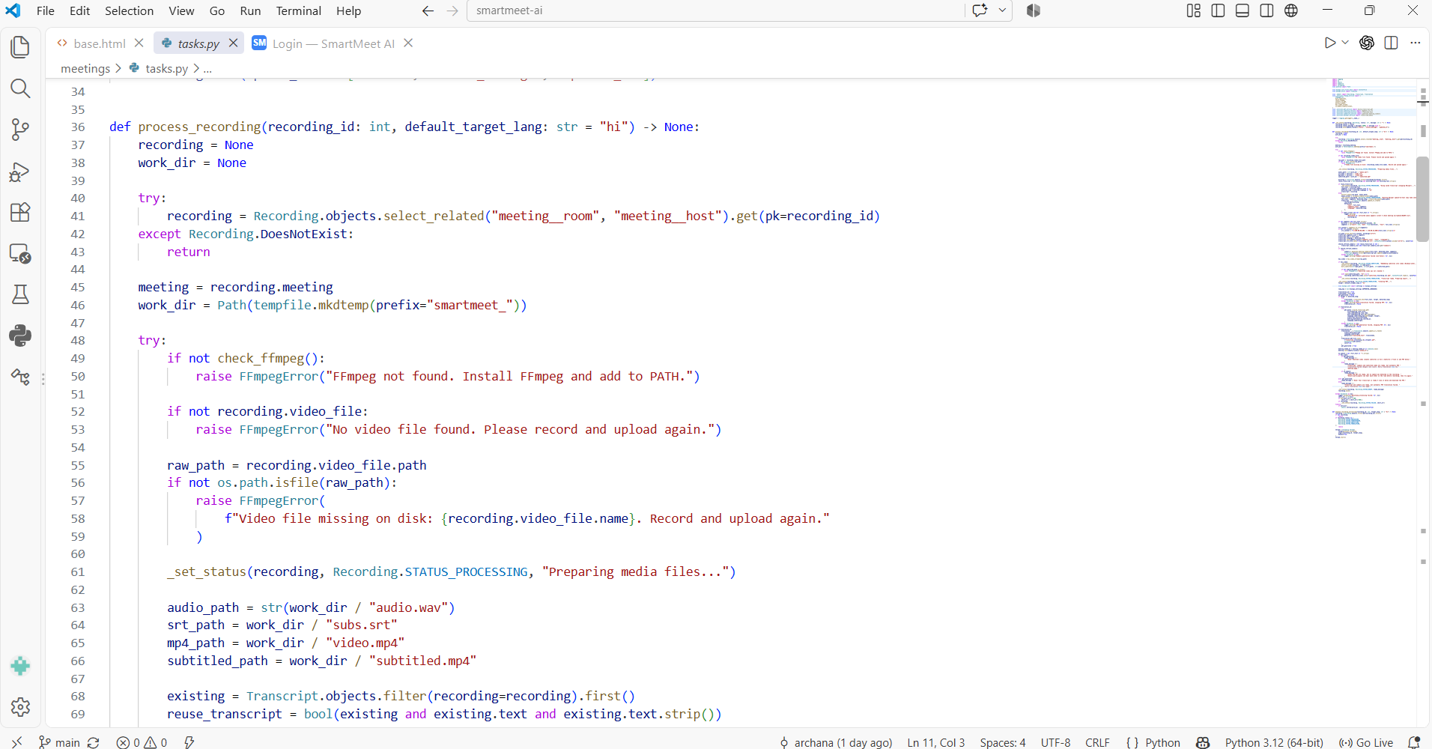

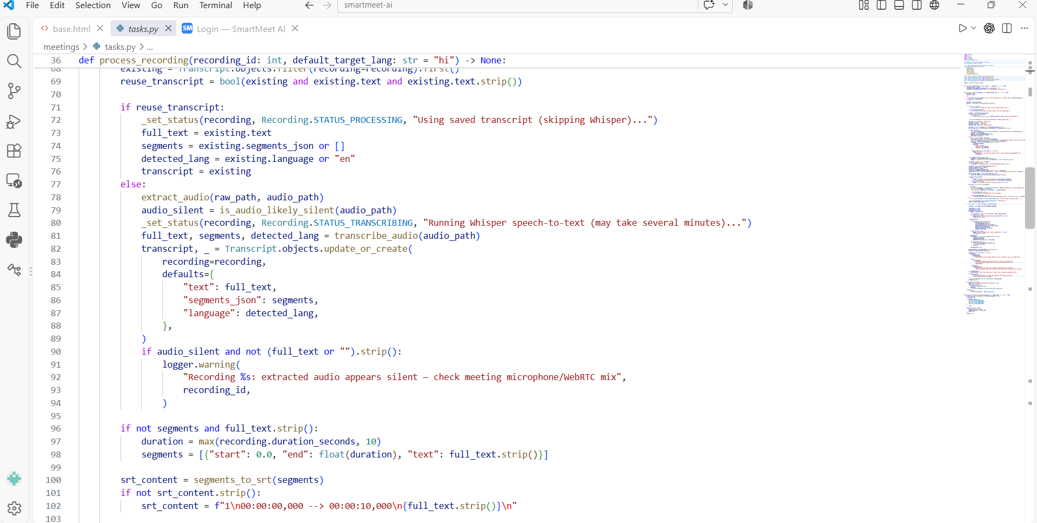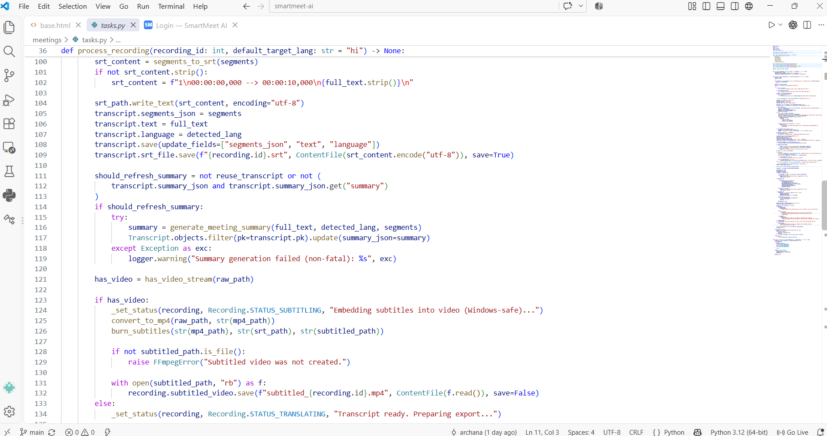

Hosted Project Link
Project Repository: https://github.com/archanasatheesh772/SMARTMEETAI/

CHAPTER 11
REFERENCES
[1] A. Johnson and M. Smith, “Generative AI and conversational intelligence in modern enterprise meeting assistants,” IEEE Transactions on Engineering Management, vol. 72, no. 4, pp. 1450–1462, 2025.
[2] S. Wang, L. Chen, and H. Zhang, “Real-time speech transcription and automated summarization using transformer models for smart meetings,” Journal of Systems and Software, Elsevier, vol. 210, pp. 111942, 2024.
[3] R. Patel, K. Gupta, and T. Baker, “SmartMeet: An AI-driven collaborative framework for multi-participant context tracking and action-item extraction,” IEEE Access, vol. 13, pp. 24510–24525, 2025.
[4] D. Martinez, A. Al-Mansoor, and E. Rossi, “Privacy-preserving speech recognition and natural language processing in cloud-based meeting assistants,” Computers & Security, Elsevier, vol. 140, pp. 103780, 2024.
[5] K. Thorne and J. Davis, “Speaker diarization and voice activity detection in intelligent conference environments,” IEEE/ACM Transactions on Audio, Speech, and Language Processing, vol. 32, pp. 890–902, 2024.
[6] Y. Liu, X. Wang, and Z. Chen, “Large language models for automated minute generation and semantic analysis in enterprise workflows,” Expert Systems with Applications, Elsevier, vol. 255, pp. 124501, 2025.
[7] M. O’Connor and B. Fitzgerald, “Adoption trends and productivity impacts of AI-powered meeting assistants in hybrid work cultures,” International Journal of Information Management, Elsevier, vol. 75, pp. 102734, 2024.
[8] C. Dubois and F. Laurent, “Multimodal sentiment analysis and participant engagement tracking in virtual meeting platforms,” IEEE Transactions on Affective Computing, vol. 16, no. 1, pp. 112–125, 2025.
[9] S. Nair and P. Deshmukh, “Edge-cloud collaborative frameworks for real-time speech processing and keyword spotting in smart meetings,” Journal of Network and Computer Applications, Elsevier, vol. 222, pp. 103765, 2023.
[10] A. Kulkarni, R. Sharma, and V. Rao, “Task automation and workflow orchestration using LLM-based agents in corporate meetings,” IEEE Intelligent Systems, vol. 40, no. 2, pp. 54–63, 2026.
[11] H. Tanaka and Y. Sato, “Context-aware semantic indexing and retrieval for enterprise meeting archives,” Information Processing & Management, Elsevier, vol. 61, no. 3, pp. 103589, 2024.
[12] E. Gomez and M. Fernandez, “Security challenges, data leakage prevention, and compliance in generative AI meeting tools,” IEEE Security & Privacy, vol. 23, no. 1, pp. 34–42, 2025.
[13] T. Nguyen and K. Le, “Real-time translation and cross-lingual summarization for global virtual conferences,” IEEE Communications Magazine, vol. 62, no. 8, pp. 78–84, 2024.
[14] P. Kumar and S. Jha, “An intelligent IoT-enabled smart room architecture with integrated AI transcription systems,” IEEE Internet of Things Journal, vol. 11, no. 6, pp. 9540–9551, 2024.
[15] L. Zhang, “Agentic workflows and automated decision-making engines in next-generation enterprise collaboration tools,” Future Generation Computer Systems, Elsevier, vol. 156, pp. 310–322, 2026.
[16] B. Miller and C. Davis, “Optimizing audio streaming pipelines for low-latency automatic speech recognition in virtual meeting systems,” IEEE Transactions on Consumer Electronics, vol. 70, no. 1, pp. 210–218, 2024.
[17] J. Rossi, K. Moretti, and L. Bianchi, “Zero-shot speaker identification and diarization using deep neural networks for corporate conferencing,” Computer Speech & Language, Elsevier, vol. 84, pp. 101590, 2024.
[18] F. Zhao and W. Chen, “Retrieval-augmented generation (RAG) frameworks for context-aware enterprise meeting query systems,” Information Systems, Elsevier, vol. 122, pp. 102340, 2024.
[19] M. Al-Hassan and N. Qureshi, “Security frameworks and access control mechanisms for AI-generated meeting minutes and transcripts,” Computers & Security, Elsevier, vol. 148, pp. 104112, 2025.
[20] S. Kapoor, V. Verma, and R. Joshi, “Multilingual speech-to-text translation models for cross-border collaborative business meetings,” IEEE/ACM Transactions on Audio, Speech, and Language Processing, vol. 33, pp. 1420–1432, 2025.
[21] D. Wright and E. Taylor, “Evaluating the hallucination rates of large language models in automated meeting action-item extraction,” Expert Systems with Applications, Elsevier, vol. 260, pp. 125310, 2025.
[22] T. O’Neill and P. Gallagher, “Human-AI collaboration in project management: Integrating automated meeting notes into corporate trackers,” International Journal of Project Management, Elsevier, vol. 43, no. 2, pp. 102645, 2025.
[23] G. Moreland and H. Vance, “Edge computing applications for real-time speech enhancement in noisy hybrid-work environments,” IEEE Internet of Things Journal, vol. 12, no. 5, pp. 4890–4901, 2025.
[24] K. Sundaram and A. Pillai, “Autonomous meeting facilitators: Using reinforcement learning and LLMs to manage meeting time and agendas,” IEEE Transactions on Cybernetics, vol. 56, no. 3, pp. 1540–1552, 2026.
[25] Y. Tanaka, S. Nakamura, and K. Endo, “Federated learning approaches for privacy-preserving acoustic model training in corporate meeting assistants,” IEEE Transactions on Information Forensics and Security, vol. 21, pp. 1230–1242, 2026.

