**Interest Free Car Loan**

The utility will get the input of loan/vehicle details from the users and generate the monthly loan summary details.

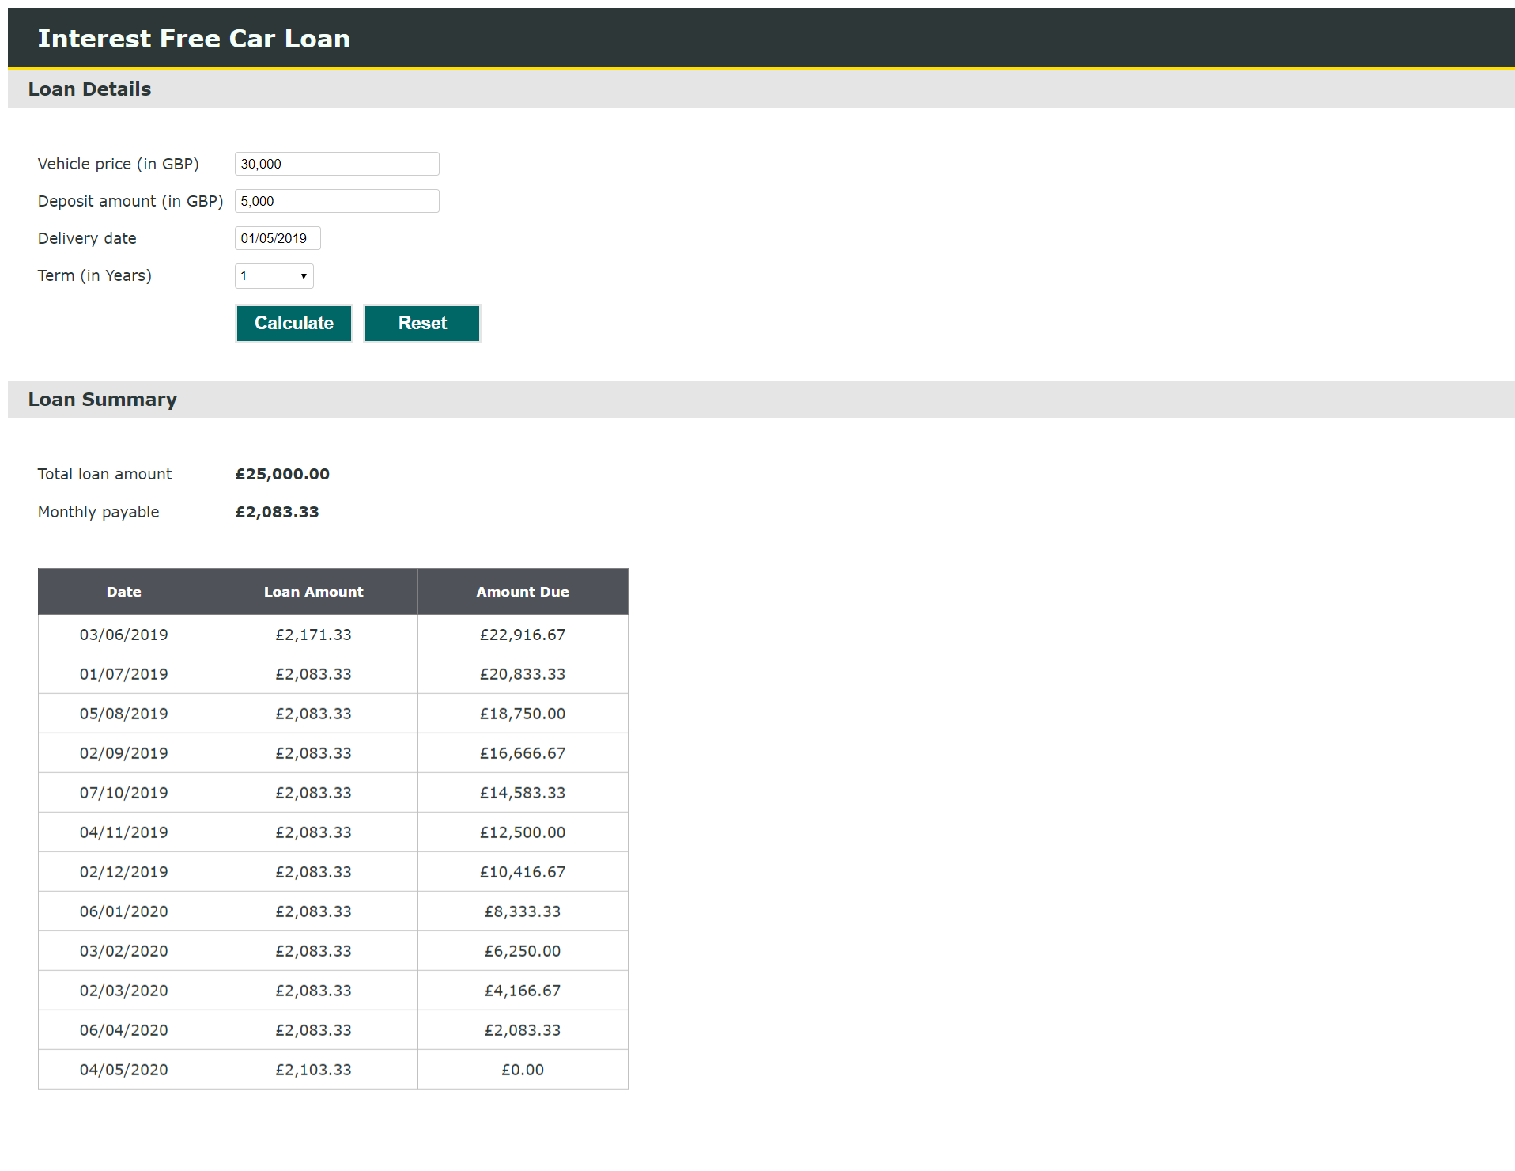

**Characteristics**

* All the fields are mandatory
* Vehicle price and Deposit amount will allow the amount value greater than £0.00
* Vehicle price and Deposit amount input field will not allow non numeric values
* Vehicle price and Deposit amount input fields will automatically displayed with comma separator while keying in.
* Deposit amount input field will allow only the value greater than 15% of the vehicle price
* Deposit amount input field will allow the value greater than the vehicle price
* Delivery date can be selected by using the calendar or can be keyed in manually with proper date format
* Reset button is provided to clear all the inputs and results.
* Total loan amount will be displayed based on the vehicle price and deposit amount
* Amount payable will be displayed based on total loan amount and term
* Monthly loan summary details will be displayed with Date, Loan amount and Amount due.
* Loan date will be the first monday of every month
* Arrangement fee will be included in the first month loan amount
* Completion fee will be included in the last month loan amount

**Error Tracking**

If there’s any error in the application, it can be tracked through the text file which will be automatically generated for every day under the Log Folder.

**Configuration Details**

The following 3 values are configured in web.config

* Arrangement fee
* Completion fee
* Error tracking files location

<appSettings>

<add key="ArrangementFee" value= "88" />

<add key="CompletionFee" value= "20" />

<add key="logFilePath" value= "Log" />

</appSettings>

**Application Screenshots**

