Infinity Wardrobe Plug-in Manual

Overview
The Infinity Wardrobe plug-in extends the ARPG Project's EntityItemManager with a third Item System management path. Besides Character Pieces and Item Renderers, equipped armor can now activate or deactivate the objects that belong to Infinity PBR “Wardrobe” groups without editing any ARPG Project file. The system is implemented on top of the plug-in framework and relies on the shared EventBus, so it stays update-safe and can be automated by other tools.

Installation

Requirements
This plugin has the following dependencies:
- ARPG Project
- Plugin System
- Infinity PBR (at least one of the character packs)
- Items configured in the Infinity PBR’s Prefab and Object Manager

Automatic Installation (recommended)
This is the normal workflow for plugins distributed as InfinityWardrobe.zip exported from the Plugin System.
- Open the Plugin System Window
  - In Unity: Menu → Tools → ANSTUDIO → Plugin System → Plugin System Window
  - The left side lists all existing plugins. The bottom toolbar contains import/export buttons.
- Import the InfinityWardrobe.zip archive
  - In the bottom toolbar click “Import Plug-in”.
  - In the file dialog select the InfinityWardrobe.zip.
  - Confirm.
- Finalize plugin setup
After import and (optional) patch application:
  - Check the plugin folder under: Assets/ANSTUDIO/PluginSystem/plugins/InfinityWardrobe
  - Open any README / manual provided by the plugin.

Manual Installation
- Copy the entire Assets/ANSTUDIO/PluginSystem/plugins/InfinityWardrobe folder into your project alongside the other plug-ins.
- Ensure the PluginManager script (already included with the plug-in system) is part of your project so the new plug-in is discovered at play mode.
Keep the provided Resources/InfinityWardrobeLibrary.asset file in your project. The runtime service auto-loads it from Resources/InfinityWardrobeLibrary when no custom library is assigned.
Enter play mode. A hidden “[Plugin] Infinity Wardrobe Service” object is created and persists across scenes while automatically wiring EntityItemManager instances.
Default Behaviour
The bundled library ships with an example rule for “Leather Armor Chest”. When that armor is worn the first entry inside Wardrobe0 is activated, while the rest of the group is turned off. Removing the armor disables the object again. Use this as a template for your own rules.

Configuring Wardrobe Rules
- Select InfinityWardrobeLibrary.asset and press “Add” in the list to create new rules. Use the search bar located above the rules list whenever you need to filter entries by item name or description — the inspector stretches with the window so you can comfortably edit long lists.
- Fill the fields (each one includes inspector tooltips for easy info when needed):
• Item Armors: list every ItemArmor asset that should execute the same rule. A single entry is still valid, but now you can drag multiple armor definitions into the list so each one enables or disables the same wardrobe objects.
• Description: optional helper text shown only in the inspector.
• Group Type: matches the groupType column inside the Prefab And Object Manager (the default “Wardrobe” type is usually enough).
• Group Name: name of the group row (for example “Wardrobe0”). Leave it empty when you prefer to target by index.
• Group Index: zero-based index used when no name is provided. The index is calculated per group type, so “0” represents the first group of the chosen type (default -1 to auto-detect).
• Clear Group Before Apply: disables every object inside the group before any custom action runs. Enable it whenever you want to guarantee that only one outfit piece remains visible at a time (it is disabled by default so you can opt in per rule).
• Clear Group On Unequip: forces the entire group to turn off when the armor is removed. Enable it when you do not want a fallback outfit to remain (also disabled by default).
• Revert On Unequip: mirrors each action when the item is removed. If disabled, the plug-in will leave the last state untouched (default = true).
• Actions: list of object toggles that target the indices shown inside the Prefab And Object Manager (the small red “X” / green “✓” controls highlighted in the provided screenshots). Each action stores one or more Object Indices, whether they should be enabled on equip, the state to apply on unequip, and an optional list of extra indices to disable whenever the action fires. Use this last field to immediately hide multiple conflicting meshes the moment a new object turns on. Pairing several indices inside a single action is perfect for outfits that need to activate multiple wardrobe entries simultaneously.
- Repeat the process for every armor piece. No scene or prefab editing is required.

Player Entity Item Manager Configuration
To avoid conflicts with the existing default item systems you need to clear the following fields and entries in the Entity Item Manager:
Item Renderers
Character pieces
Initial Visible Pieces

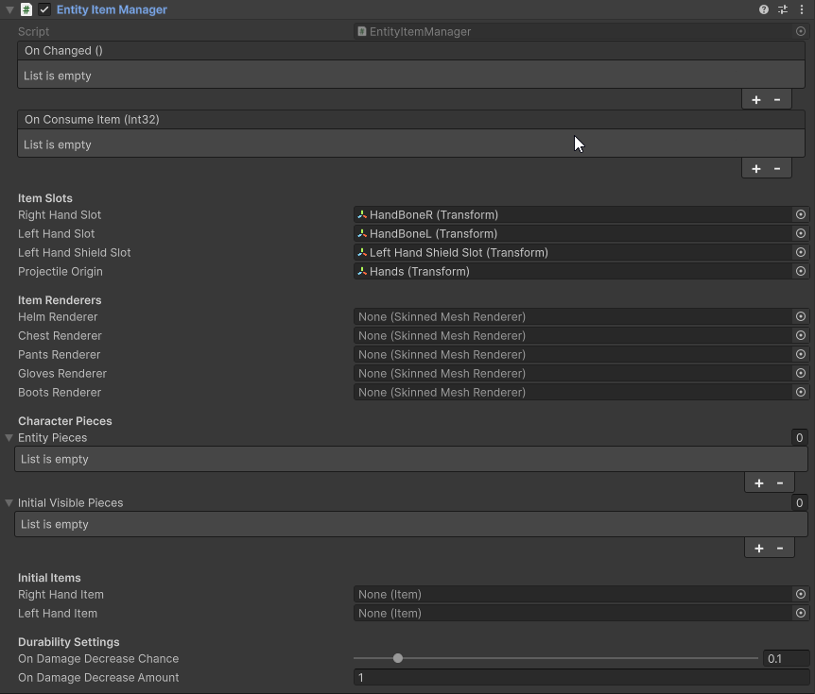

Tips for New Items
• When creating a new armor item, duplicate an existing rule and add the new ItemArmor to the Item Armors list (or create a dedicated rule). The plug-in reacts to any armor listed in a rule, so variants that share visuals can reuse the same configuration.
• Enable “Clear Group Before Apply” to automatically disable conflicting wardrobe pieces the moment a new one becomes active; leave it off when you want multiple objects from the same group to remain visible.
• Use the Description field to record which meshes are being toggled. This helps the next person who edits the library.
• Multiple armor items can now keep their wardrobe objects enabled at the same time. The binder tracks which entries are currently needed and ignores revert operations for those objects, so a belt and a cloak (for example) can share the same group without disabling each other unless you explicitly clear the group or add extra disable indices.

EventBus Hooks
The plug-in exposes two new events for automation:
EventBus.RaiseInfinityWardrobeRefresh(Entity targetEntity); // null refreshes every binder
EventBus.RaiseInfinityWardrobeApplied(Entity affectedEntity);
• InfinityWardrobeRefreshRequested: published whenever a refresh is requested (either via the helper method above or by other systems).
• InfinityWardrobeApplied: published after the binder processes the currently equipped items.
You can subscribe to EventBus.InfinityWardrobeRefreshEvent and EventBus.InfinityWardrobeAppliedEvent if you prefer the strongly typed delegates.
Usage Flow
- Equip or remove an armor item using the inventory.
- The EntityItemManager fires onChanged, which the binder listens to.
- Infinity Wardrobe compares the new inventory state with the configured rules and toggles the requested wardrobe objects. When the plug-in needs to spawn a wardrobe prefab it automatically retargets every SkinnedMeshRenderer to the character's live skeleton so the mesh follows the correct bones and the Infinity PBR “checkmark” UI mirrors the current state.
- EventBus.RaiseInfinityWardrobeApplied is called so other systems (for example gameplay buffs or analytics) can react to the visual change.

Troubleshooting
• Nothing happens at runtime: ensure the character prefab actually contains an Infinity PBR PrefabAndObjectManager component. The service only attaches binders when this component is present, so characters without it remain untouched (and the console stays clean).
• Wrong object toggled: double-check every entry in the action's object-index list against the Prefab And Object Manager inspector. Indices are zero-based and follow the same order used in the UI.
• Need to refresh manually: call EventBus.RaiseInfinityWardrobeRefresh(targetEntity) whenever you change wardrobe data via code.
• Multiple outfits stacking: enable Clear Group Before Apply and, if necessary, Clear Group On Unequip for the involved rules.
With these tools you can extend the wardrobe pipeline without touching Player Two's source files and future updates of the ARPG Project remain safe.

