Content
Introduction 3
1 Advantages of Design Patterns 4
1.1 Bridge pattern 4
1.1.1 Problem and its obvious implementation 4
1.1.2 Fixing drawbacks with the Facade pattern 6
1.2 Template method 8
1.2.1 Problem and its obvious implementation 8
1.2.2 Fixing drawbacks with the Template method pattern 10
2 Practical Research 12
2.1 Formulation of the Problem 12
2.2 Description of Entities 13
2.2.1 Student class 13
2.2.2 Achievement class 14
2.2.3 Course class 15
2.2.4 Progress class 16
2.2.5 DatabaseConnection and DatabaseInteraction classes 17
2.2.6 Graphic class 18
2.2.7 Histogram, DotPlot and PieChart classes 18
2.2.8 GraphicStrategy interface 18
2.2.9 HistogramStrategy, PieChartStrategy, DotPlotStrategy classes 18
2.3 Implementation of Design Patterns 19
2.3.1 Builder 19
2.3.2 Factory Method with Builder 21
2.3.3 Singleton 25
2.3.4 Strategy 26
2.4 Testing the Application 28
Conclusion 29
List of sources 30

Introduction
This coursework involves the using of Java programming language to create a program that uses Design Patterns. We have created an application that implements the possibilities of playing Chess in player versus player mode.
The coursework contains two chapters. The first chapter describes the benefits of design patterns. It includes descriptions of two design patterns that we did not use in the developed application. The description includes short formulation of the problem and its obvious implementation with described drawbacks, the idea of their fixing with the illustrative java code and class diagram, and achieved results.
The second chapter is divided into four parts. The first part includes a problem statement, which describes in detail the statement of the problem that we are going to solve. The second part includes a description of entities, where we describe all our classes and interfaces of the developed application and the relationships between them. The third part includes a description of the design patterns that we used in the developed application, where we need to describe their purpose, a class diagram with our entities, illustrative Java code and the results achieved. The last part includes information about testing the application. In this part, we describe the tests performed and their results.

Advantages of Design Patterns

Abstract factory pattern
The essence of the pattern
An abstract factory is a generative design pattern that allows you to create families of related objects without being tied to the specific classes of objects that you create. When used
• The system must remain independent of both the process of creating new objects and the types of objects generated. Direct use of the new expression in the application code is undesirable (more on this in the Generative Patterns section).
• You must create groups or families of related objects so that objects from different families cannot be used concurrently in the same context.
Problem
Let's imagine there is a furniture store simulator. It contains the code:
1. A family of dependent products. Let's say Armchair + Sofa + Table.
2. Several variations of this family. For example, the Armchair, Sofa and Table products are available in three different styles: Art Deco, Victorian and Modern.
You need to find a way to create product objects so that they can be combined with other products in the same family.
Also, I would not want to make changes to existing code when adding new products or families to the program.
Solution
To begin with, the Abstract Factory pattern suggests identifying common interfaces for individual products that make up a family. So, all variations of armchairs will have a common Armchair interface, all sofas will implement the Sofa interface, and so on.
Next, an abstract factory is created - a general interface that contains methods for creating all products of the family (for example, create an armchair, create a sofa and create a table). These operations should return the abstract product types represented by the interfaces we highlighted earlier — Armchairs, Sofas, and Tables. Shown in Figure 1
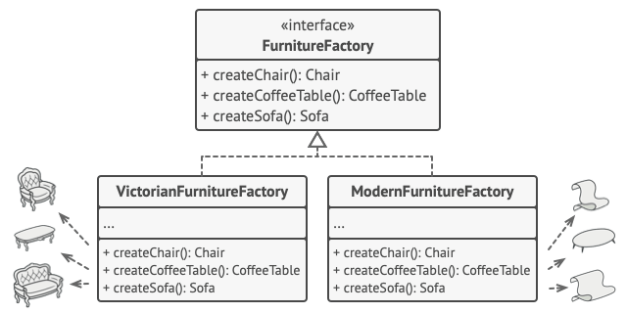
Figure 1 – Class diagram of Abstract factory pattern
Each variation of a product family needs to create its own factory by implementing an abstract interface. Factories create products of one variation.
An example of the pattern implementation

buttons/Button.java
package abstract_factory.example.buttons;

public interface Button {
void paint();
}
buttons/MacOSButton.java
package abstract_factory.example.buttons;

public class MacOSButton implements Button {

@Override
public void paint() {
System.out.println("You have created MacOSButton.");
}
}
checkboxes/Checkbox.java
package abstract_factory.example.checkboxes;

public interface Checkbox {
void paint();
}
checkboxes/MacOSCheckbox.java
package abstract_factory.example.checkboxes;

public class MacOSCheckbox implements Checkbox {

@Override
public void paint() {
System.out.println("You have created MacOSCheckbox.");
}
}
factories/GUIFactory.java:
package abstract_factory.example.factories;

import abstract_factory.example.buttons.Button;
import abstract_factory.example.checkboxes.Checkbox;

public interface GUIFactory {
Button createButton();
Checkbox createCheckbox();
}

package abstract_factory.example.factories;

import abstract_factory.example.buttons.Button;
import abstract_factory.example.buttons.MacOSButton;
import abstract_factory.example.checkboxes.Checkbox;
import abstract_factory.example.checkboxes.MacOSCheckbox;

public class MacOSFactory implements GUIFactory {

@Override
public Button createButton() {
return new MacOSButton();
}

@Override
public Checkbox createCheckbox() {
return new MacOSCheckbox();
}
}
app/Application.java:
package abstract_factory.example.app;

import abstract_factory.example.buttons.Button;
import abstract_factory.example.checkboxes.Checkbox;
import abstract_factory.example.factories.GUIFactory;

public class Application {
private Button button;
private Checkbox checkbox;

public Application(GUIFactory factory) {
button = factory.createButton();
checkbox = factory.createCheckbox();
}

public void paint() {
button.paint();
checkbox.paint();
}
}

Demo.java:
package abstract_factory.example;

import abstract_factory.example.app.Application;
import abstract_factory.example.factories.GUIFactory;
import abstract_factory.example.factories.MacOSFactory;
import abstract_factory.example.factories.WindowsFactory;

public class Demo {

private static Application configureApplication() {
Application app;
GUIFactory factory;
String osName = System.getProperty("os.name").toLowerCase();
if (osName.contains("mac")) {
factory = new MacOSFactory();
app = new Application(factory);
} else {
factory = new WindowsFactory();
app = new Application(factory);
}
return app;
}

public static void main(String[] args) {
Application app = configureApplication();
app.paint();
}
}

Singleton pattern
The essence of the pattern
Singleton design pattern is used when you want to have only one instance of a given class. Another words, Singleton is a creational design pattern that lets you ensure that a class has only one instance, while providing a global access point to this instance.
Problem
A loner solves two problems at once, violating the principle of the only responsibility of the class.
1. Ensures there is a single instance of the class. This is most often useful for accessing some kind of shared resource, such as a database. Imagine you have created an object, and after a while you are trying to create another one. In this case, I would like to get the old object instead of creating a new one. This behavior cannot be implemented using a regular constructor, because a class constructor always returns a new object.
2. Provides a global access point. This is not just a global variable through which you can access a specific object. Global variables are not write protected, so any code can override their values ​​without your knowledge. But there is another nuance. It would be nice to keep in one place the code that solves problem # 1, as well as have a simple and accessible interface to it.
Solution
All singleton implementations boil down to hiding the default constructor and creating a public static method that will control the lifecycle of the singleton object.
If you have access to the singleton class, then you will have access to this static method as well. From whatever point in the code you call it, it will always return the same object.
An example of the pattern implementation

Singleton.java:
package singleton.example.non_thread_safe;

public final class Singleton {
private static Singleton instance;
public String value;

private Singleton(String value) {
try {
Thread.sleep(1000);
} catch (InterruptedException ex) {
ex.printStackTrace();
}
this.value = value;
}

public static Singleton getInstance(String value) {
if (instance == null) {
instance = new Singleton(value);
}
return instance;
}
}
DemoSingleThread.java:
package singleton.example.non_thread_safe;

public class DemoSingleThread {
public static void main(String[] args) {
System.out.println("If you see the same value, then singleton was reused (yay!)" + "\n" +
"If you see different values, then 2 singletons were created (booo!!)" + "\n\n" +
"RESULT:" + "\n");
Singleton singleton = Singleton.getInstance("FOO");
Singleton anotherSingleton = Singleton.getInstance("BAR");
System.out.println(singleton.value);
System.out.println(anotherSingleton.value);
}
}

Practical Research

Formulation of the Problem
To begin with, when creating a game Chess in the JAVA programming language, the main advantages of this choice were the following criteria:
- Ability to implement one of the most popular and challenging games in the world for two players.
- The game itself has a huge potential for working with code and algorithms later
- The ability to transfer the game to the server and, as a result, the creation of games online player against player
- Possibility of writing a player versus computer game mode through various implementations: mathematical models, script models.
- Possibility of further training of models through machine learning and generative learning
Therefore, in order to have all of the above possibilities, it is necessary to re-create the game, which we can subsequently recycle and refine.

The application currently has a ponsol interface and a player versus player game mode. In the future, the development of the project is likely, the emergence of a server component, the emergence of a player versus computer game mode and the possibility of training models.

Description of Entities

Student class
Public class Student stores information about the student. It contains five private fields. There are integer id field, string nickname, country fields, and gender field of the Gender type. Gender is enumeration, which contains constants M and F and their string implementations. These implementations are stored by string gender field. In addition, Gender enumeration contains public constructor and toString method that has no parameters and returns string representation of student’s gender.
The id field contains the student identifier; the nickname, country fields store the student’s name and country; the gender and age fields contain the student’s gender and age.
The class content is initialized using the Builder pattern. Inner static class Builder represents this pattern. The Builder class contains private student field of the Student type that is initialized by a public constructor without parameters. In addition, class Builder contains public methods that initialize fields of the Student class instance and return the instance of the Builder class. There are setId method with integer id parameter, setNickname and setCountry methods with string nickname and country parameters, setGender method with gender parameter of the Gender type and setAge method with integer age parameter. Public build method has no parameters and returns initialized instance of the Student class.
The Student class also contains public methods that work with its private fields. These methods include getters and overridden equals, hashCode and toString methods. Getters are represented by methods getId, getNickame, getCountry, getGender, getAge that return the values of the fields. The equals and hashCode methods are used to compare instances of the Student class and return Boolean and integer values, the toString method returns string representation of the Student class as a csv-string.

Achievement class
Public class Achievement stores information about achievements that student can get for high results on control points of different courses. These achievements are common for all courses. The Achievement class contains five private fields. There are integer id field, string name field and integer requiredPoints, testNo, earnedPoints fields.
The id field contains the achievement identifier; the name field stores the name of the achievement; the requiredPoints field contains points which student should receive on the control point to get this achievement; the control point number is stored in the testNo field; the earnedPoints field contains points the student gets for the achievement.
The class content is initialized using the Builder pattern. Inner static class Builder represents this pattern. The Builder class contains private achievement field of the Achievement type that is initialized by a public constructor without parameters. In addition, class Builder contains public methods that initialize fields of the Achievement class instance and return the instance of the Builder class. There are setId method with integer id parameter, setName method with string name parameter, setRequiredPoints method with integer requiredPoints parameter, setTestNo method with integer testNo parameter and setEarnedPoints method with integer earnedPoints parameter. Public build method has no parameters and returns initialized instance of the Achievement class.
The Achievement class also contains public methods that work with its private fields. These methods include getters and overridden toString method. Getters are represented by methods getId, getName, getRequiredPoints, getTestNo, getEarnedPoints that return the values of the class fields. The toString method return string representation of the Achievement class as a csv-string.

Course class
Public abstract class Course stores information about different courses. This class contains five private fields. These fields are final. There are integer id field, string name field, integer thresholdPoints and pointsToHonors fields and achievements field of the List<Achievement> type.
The id field contains the course identifier; the name field stores name of the course; the thresholdPoints and pointsToHonors fields contain points that the student should receive to pass the course or pass with honors; the achievements field contains the list of achievements that the student can get for good results on the course.
Public constructor initializes the class content. This constructor has parameters that are equivalent to the class fields.
The Course class also contains public getters and overridden equals, hashCode, toString methods. There are getId, getName, getThresholdPoints, getPointsToHonors, getAchievements that return the values of the class fields. The equals and hashCode methods are used to compare class instances. The toString method return string representation of the Course class fields as a csv-string.
The Course class is abstract, so it does not imply creating its own instances. This class is the parent class of ProgrammingCourse, MathCourse, BiologyCourse and PhysicsCourse classes. The Course class also contains the abstract method calculateTotalPoints with integer summaryPoints and achievedPoints parameters. This method calculates the total points of the student for the course. All inherited classes will implement the calculateTotalPoints method.
The factory method will be used to create instances of course classes. There are also CourseFactory class and CourseCategories enumeration, which are used in the factory method implementation.
Public class CourseFactory is used to create instances of the courses. It contains inner class Builder. This inner class is public and static because we need to be able to call it without creating the instance of the class CourseFactory. The Builder class contains six private fields. There are fields that the Course class contains and category field of the CourseCategories type. The category field contains information about the course category.
The CourseCategories is an enumeration that contains constants of the available courses. There are PROGRAMMING, MATH, BIOLOGY, PHYSICS constants. Their implementations are stored by string field. In addition, this enumeration contains public constructor and toString method that has no parameters and returns string representation of the course category. The CourseCategories defines a createCourse method for invidual constants. This method creates an instance of the course in accordance with its category. The createCourse method gets parameters equivalent to fields of the Course class and returns the desired course instance.
The Builder class also contains public constructor with parameter of the CourseCategories type. This constructor initializes the category field. There are public setId, setName, setThresholdPoints, setPointsToHonors and setAchievements methods that initialize other fields and return the instance of the Builder class. Public method build return the course instance that returns the course instance using the createCourse method of the CourseCategories enumeration.

Progress class
Public class Progress stores information about the student’s progress on the course. The Achievement class contains three private fields. There are student field of the Student type, course field of the Course type and controlPoints that represents array of integers.
The student field contains information about the student; the course field contains information about the course; the controlPoints field contains information about the points received at the control points.
The class content is initialized using the Builder pattern. Inner static class Builder represents this pattern. The Builder class contains private progress field of the Progress type that is initialized by a public constructor without parameters. In addition, class Builder contains public methods that initialize fields of the Progress class instance and return the instance of the Builder class. There are setStudent method with student parameter of the Student type, setCourse method with course parameter of the Course type and setControlPoints parameter of the array type. Public build method has no parameters and returns initialized instance of the Progress class.
The Progress class also contains public and private methods that work with its private fields. Public methods include getters, getAveragePoint, getMinPoint, getMaxPoint, printEarnedAchievements, getTotalPoints, isPassed, isPassedWithHonors methods and overridden toString method. Private methods include getSummaryPoints and getAchievedPoints methods.
Getters are represented by methods getStudent, getCourse, getControlPoints methods that return the values of the class fields. The getAveragePoint, getMinPoint and getMaxPoint methods return average, minimum and maximum points, which the student received for the control points. These methods have no parameters and return integer value. Private getSummaryPoints and getAchievedPoints are used to calculate summary points for the control points and obtained achievements. These methods return the values that are used to calculate total points for the course. These methods has no parameters and return integer value. The getTotalPoints method return the total points that the student received for the course. The method has no parameters and returns integer value. The isPassed method returns Boolean value that indicates whether the student passed the course or not. The isPassedWithHonors method also returns Boolean value that indicates whether the student passed the course with honors or not. The printEarnedAchievements method prints names of the earned achievements and points that student received for these achievements. The toString method return string representation of the Progress class as a csv-string.
Figure 4 represents the UML-diagram of all described classes.
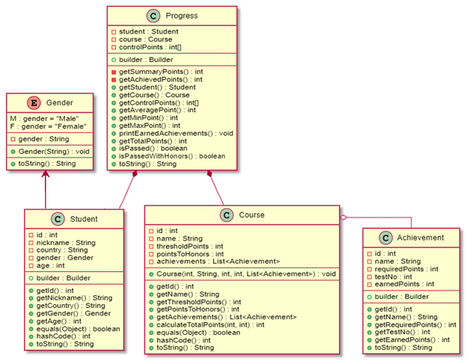
Figure 4 – Class diagram of all described classes

DatabaseConnection and DatabaseInteraction classes
Public class DatabaseConnection created a database connection. The database connection will be created once. This feature is implemented using the Singleton pattern. This pattern will be described in the next chapter. The DatabaseConnection class contains six private fields. The instance field is static. It contains the instance of the DataConnection class. The connection field of the Connection type contains the connection to the database. The string DRIVER, URL, USERNAME, PASSWORD fields are static final fields because they are constant. They contain driver name, database url, name and password of the database user.
The constructor of the DatabaseConnection class is private. It will create the database connection if the driver exists. If the driver does not exist, ClassNotFoundException will be raised. If this exception occurs, we will throw SQLException with the message “JDBC driver not found”. Further, this exception will be handled in the Main class. This method also will throw the SQLException if we have problems with connection to the database.
Public static getInstance method returns the instance of the DatabaseConnection class. It will create new instance of the DatabaseConnection class if the instance field is null or the connection was closed. This method will throw the SQLException if we have problems with the instance. The exception will be handled in the Main class. Public method getConnection returns the database connection.
Public class DatabaseInteraction reads data about students, courses, achievements and student’s progress from the database. It stores the cn field of the Connection type. The public constructor initializes this field.
This class contains four public methods for reading data from the database. There are readStudentsFromDb, readAchievementsFromDb, readCoursesFromDb and readProgressFromDb methods. They return lists of Student, Achievement, Course and Progress types. The readStudentsFromDb and readAchievementsFromDb methods has no parameters; the readCoursesFromDb method has achievements parameter of List<Achievement> type; the readProgressFromDb method has courses and students parameters of List<Course> and List<Student> types.
The DatabaseInteraction class also contains two private methods. There are getCourseById and getStudentById. These methods get parameters courses and students of List<Course> and List<Student> types and return Map<Integer, Course> and Map<Integer, Student>, which contains the instance of the Course and Student class and its identifier.

Graphic class
The public abstract class Graphic is the parent of the PieChart, Histogram, and DotPlot classes. This class, like its child classes, is part of the implementation of the Strategy pattern and is intended for plotting charts based on data from a database.
Because a class is abstract and not instantiated in the application, the class constructor is the default constructor.
The only field of the class is the protected GraphicStrategy graphicStrategy, which is intended to store the object that implements the plotting.
Public void create method is designed to create a window for the chart and display information on it. The class method applies the method of the same name to the GraphicStrategy class object.

Histogram, DotPlot and PieChart classes
These classes inherit from the Graphic class and are identical in their implementation. Each of the classes contains only a constructor that initializes the inherited graphicStrategy field. The object that is created depends on the class in which it is created. This can be DotPlotStrategy, HistogramStrategy or PieChartStrategy.

GraphicStrategy interface
This interface describes a single void create() method that uses an array of integers int[] data and a String name as arguments. This method is implemented in the DotPlotStrategy, HistogramStrategy, and PieChartStrategy classes.

HistogramStrategy, PieChartStrategy, DotPlotStrategy classes
These classes are identical in implementation and implement the graphicStrategy interface. The classes contain two integer fields X and Y that store the size of the window that is created when building graphs and histograms. These fields are constants, so there is no need to initialize them with the constructor. For this reason, all three classes use the default constructor.
The create () method is intended for graphing. Its implementation depends on the class in which this method is implemented. In general, the method uses int [] data as the data array for plotting the chart, and String name for setting the title of the chart window. Further, using the Swing and AWT libraries, the method creates a window object and draws a chart on it, the appearance of which depends on the class in which the method is implemented. After rendering, the method sets the title of the window and then exits.

Implementation of Design Patterns

Builder
Builder is a creational design pattern that helps to solve the issue with large number of optional parameters by providing a way to build the object step-by-step.
This pattern helps to create the class instances with many parameters and not confuse them especially when there are many fields of the same type in the class. The Builder pattern is also allows not filling in all the fields of the object and we do not need to create a large number of constructors for this feature. In addition, this pattern makes the code more readable.
The application includes two implementation of the Builder pattern. The first implementation creates an instance of the external class in the constructor of the Builder class. This implementation is applied in Student, Progress and Achievement classes. The second implementation used with the Factory method and contains all the fields of the Course class in the Builder class. The constructor of the Builder class initializes the category field that is responsible for the category to which the course belongs.
Figure 5 represents the UML-diagram of the Student class that implements the Builder pattern.
The code with the implementation of the Builder pattern in the Student class is presented below.

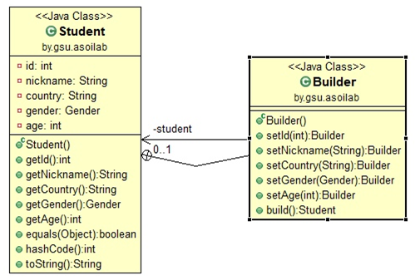
Figure 5 – Class diagram of the Builder pattern
public class Student {
private int id;
private String nickname;
private String country;
private Gender gender;
private int age;
public static class Builder {
private Student student;
public Builder() {
student = new Student();
}
public Builder setId(int id) {
student.id = id;
return this;
}
public Builder setNickname(String nickname) {
student.nickname = nickname;
return this;
}
public Builder setCountry(String country) {
student.country = country;
return this;
}
public Builder setGender(Gender gender) {
student.gender = gender;
return this;
}
public Builder setAge(int age) {
student.age = age;
return this;
}
public Student build() {
return student;
}
}
// getters and other methods
}
}
The Builder pattern made the procedure of creating an instance of a class more convenient. Now it looks like this:

Student student = new Student.Builder()
.setId(1)
.setNickname("Paul")
.setCountry("USA")
.setGender(Gender.M)
.setAge(20)
.build();

Factory Method with Builder
Factory method is a creational pattern that uses factory methods to deal with the problem of creating objects without having to specify the exact class of the object that will be created. We just create objects by calling a factory method.
The Factory Method pattern allows making the code for creating objects more flexible, without being tied to specific classes but operating only the general interface.
The application uses Factory Method to create instances of classes with different course categories.
Figure 6 represents the UML-diagram of Factory Method with Builder.
The illustrative code that implements Factory Method with Builder is shown below:

public abstract class Course {
private final int id;
private final String name;
private final int thresholdPoints;
private final int pointsToHonors;
private final List<Achievement> achievements;
// constructor, getters and equals, hashCode, toString methods
public abstract int calculateTotalPoints(int summaryPoints, int achievedPoints);
}

public class ProgrammingCourse extends Course {
// constructor
public int calculateTotalPoints(int summaryPoints, int achievedPoints) {
double result = summaryPoints + achievedPoints;
return (int)Math.round(result);
}
}

public class BiologyCourse extends Course {
// constructor
public int calculateTotalPoints(int summaryPoints, int achievedPoints) {
double result = summaryPoints + 0.75 * achievedPoints;
return (int)Math.round(result);
}
}

public class MathCourse extends Course {
// constructor
public int calculateTotalPoints(int summaryPoints, int achievedPoints) {
double result = 0.9 * summaryPoints + 0.8 * achievedPoints;
return (int)Math.round(result);
}
}

public class PhysicsCourse extends Course {
// constructor
public int calculateTotalPoints(int summaryPoints, int achievedPoints) {
double result = 0.85 * summaryPoints + achievedPoints;
return (int)Math.round(result);
}
}

public enum CourseCategories {
PROGRAMMING("Programming") {
public Course createCourse(int id, String name, int thresholdPoints, int pointsToHonors, List<Achievement> achievements) {
return new ProgrammingCourse(id, name, thresholdPoints, pointsToHonors, achievements);
}
},
MATH("Math") {
public Course createCourse(int id, String name, int thresholdPoints, int pointsToHonors, List<Achievement> achievements) {
return new MathCourse(id, name, thresholdPoints, pointsToHonors, achievements);
}
},
BIOLOGY("Biology") {
public Course createCourse(int id, String name, int thresholdPoints, int pointsToHonors, List<Achievement> achievements) {
return new BiologyCourse(id, name, thresholdPoints, pointsToHonors, achievements);
}
},
PHYSICS("Physics") {
public Course createCourse(int id, String name, int thresholdPoints, int pointsToHonors, List<Achievement> achievements) {
return new PhysicsCourse(id, name, thresholdPoints, pointsToHonors, achievements);
}
};
private String course;
CourseCategories(String course) {
this.course = course;
}
public abstract Course createCourse(int id, String name, int thresholdPoints, int pointsToHonors, List<Achievement> achievements);
@Override
public String toString() {
return course;
}
}

public class CourseFactory {
public static class Builder {
private int id;
private String name;
private int thresholdPoints;
private int pointsToHonors;
private CourseCategories category;
private List<Achievement> achievements;
public Builder(CourseCategories category) {
this.category = category;
}
public Builder setId(int id) {
this.id = id;
return this;
}
public Builder setName(String name) {
this.name = name;
return this;
}
public Builder setThresholdPoints(int thresholdPoints) {
this.thresholdPoints = thresholdPoints;
return this;
}
public Builder setPointsToHonors(int pointsToHonors) {
this.pointsToHonors = pointsToHonors;
return this;
}
public Builder setAchievements(List<Achievement> achievements) {
this.achievements = achievements;
return this;
}
public Course build() {
return category.createCourse(id, name, thresholdPoints, pointsToHonors, achievements);
}
}
}
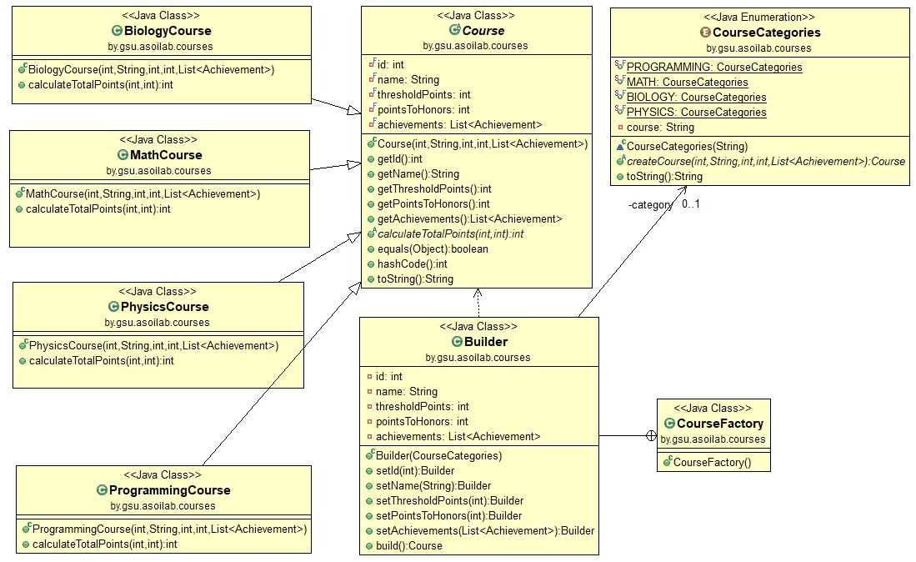
Figure 6 – Class diagram of Factory Method
Now, there is a common interface for creating instances of course classes. The instance creating process looks like this:

Course mathCourse = new CourseFactory.Builder(CourseCategories.MATH)
.setId(2)
.setName("Probability")
.setThresholdPoints(325)
.setPointsToHonors(335)
.setAchievements(achievements)
.build();

Singleton
The Singleton pattern is a design pattern that restricts the instantiation of a class to one “single” instance. This pattern is useful when exactly one object is needed to coordinate actions across the system.
The application uses the Singleton pattern to create the database connection. It helps to create a single connection for the entire program.
Figure 7 represents the UML-diagram of Singleton.
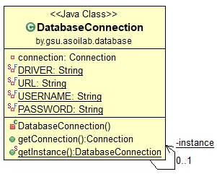
Figure 7 – Class diagram of Singleton
The code that implements the Singleton pattern is shown below:

public class DatabaseConnection {
private static DatabaseConnection instance;
private Connection connection;
private static final String DRIVER = "com.mysql.cj.jdbc.Driver";
private static final String URL = "jdbc:mysql://127.0.0.1:3306/courses_db?serverTimezone=Europe/Minsk";
private static final String USERNAME = "name";
private static final String PASSWORD = "password";
private DatabaseConnection() throws SQLException {
try {
Class.forName(DRIVER);
this.connection = DriverManager.getConnection(URL, USERNAME, PASSWORD);
} catch (ClassNotFoundException e) {
throw new SQLException("JDBC driver not found!");
}
}
public Connection getConnection() {
return connection;
}
public static DatabaseConnection getInstance() throws SQLException {
if (instance == null || instance.getConnection().isClosed()) {
instance = new DatabaseConnection();
}
return instance;
}
}

Strategy
The strategy pattern is a behavioral software design pattern that enables selecting an algorithm at runtime. Instead of implementing a single algorithm directly, code receives run-time instructions as to which in a family of algorithms to use.
Strategy lets the algorithm vary independently from clients that use it. Deferring the decision about which algorithm to use until runtime allows the calling code to be more flexible and reusable.
The application uses the Strategy for charting.
Figure 8 represents the UML-diagram of Strategy.
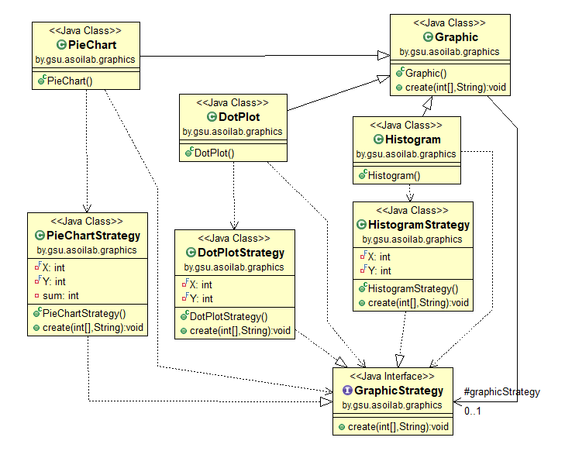
Figure 8 – Class diagram of Strategy
The code that implements the Strategy pattern is shown below:
public interface GraphicStrategy {
public void create(int[] data, String name);
}
public class DotPlotStrategy implements GraphicStrategy {
private final int X = 500;
private final int Y = 300;
@Override
public void create(int[] data, String name) {
//realization
}
}
public class HistogramStrategy implements GraphicStrategy {
private final int X = 500;
private final int Y = 300;
@Override
public void create(int[] data, String name) {
//realization
}
}
public class PieChartStrategy implements GraphicStrategy {
private final int X = 500;
private final int Y = 300;
private int sum;
@Override
public void create(int[] data, String name) {
//realization
}
}
abstract public class Graphic {
protected GraphicStrategy graphicStrategy;
public void create(int[] data, String str) {
graphicStrategy.create(data, str);
}
public class Histogram extends Graphic {
public Histogram() {
this.graphicStrategy = new HistogramStrategy();
}
}
public class DotPlot extends Graphic {
public DotPlot() {
this.graphicStrategy = new DotPlotStrategy();
}
}
public class PieChart extends Graphic {
public PieChart() {
this.graphicStrategy = new PieChartStrategy();
}
}

Testing the Application
The Student, Progress, Achievement and group of Course classes were tested using the JUnit framework. There are StudentTest, ProgressTest, AchievementTest and CourseTest classes that were created for testing.
The StudentTest class includes tests of getId, getNickname, getCountry, getGender, getAge and toString methods. These tests check if the values of the Stu-dent class are equal to the expected values.
The ProgressTest class includes tests of getStudent, getCourse, getCon-trolPoints, toString, getTotalPoints, getAveragePoint, getMaxPoint, getMinPoint, isPassed and isPassedWithHonors methods. The getStudent, getCourse, getCon-trolPoints, toString, isPassed and isPassedWithHonors tests check if the values of the Progress class methods are equal to the expected values and the getTotalPoints, getAveragePoint, getMaxPoint, getMinPoint tests check the correctness of the algo-rithms performed.
The AchievementTest class includes tests of getId, getName, getRequiredPoints, getEarnedPoints, getTestNo and toString methods. These tests check if the values of the Achievement class are equal to the expected values.
The CourseTest class includes tests of getId, getName, getThreshold, get-PointsToHonors, getAchievements, calculateTotalPoints and toString methods. These tests check if the values of the tested classes are equal to the expected values and the correctness of the calculation performed in the calculateTotalPoints method.
All described tests were passed successfully.

Conclusion

A completely developed game of chess in player versus player mode with a console interface in the Java programming language. Now we have the source code of the game with which we can interact later and develop various additions in the form of a server component, online games, player versus computer game modes and training models.
The app includes four design patterns:
- Factory;
- Template;
The classes were also tested. All tests passed successfully.

List of sources used
1 Romanchik, V. Java. Методы программирования / V. Romanchik, I. Blinov. – Minsk: Four Quarters, 2013. – 896 p.
2 Savitch, W. The Java Language. Programming Course / W. Savitch. – M.: Williams, 2015. – 928 p.
3 Design Patterns in Java [Electronic resource]. M., 2014 – 2020. URL: https://refactoring.guru/design-patterns/java. — Date of request: 12.12.2020.
4 Design Patterns in Java Tutorial – Tutorialspoint [Electronic resource]. M., 2016 – 2020. URL: https://www.tutorialspoint.com/design_pattern/index.htm. —Date of request: 11.12.2020.

ESSAY

Course work contains 30 pages, 8 figures, 5 sources.

Key words: design patterns, builder, factory method, singleton, strategy, student performance tracking system.

Goals and objectives of the course work: the purpose of the course work is to create a student performance tracking system, which will help to get information about students’ results and achievements, and create charts reflecting learning statistics.

A summary of the course work: course work consists of an introduction, two chapters, a conclusion and a list of sources used.

Conclusions: course work performed in accordance with the assignment for course design. In the end, there is a work program that performs all the actions described.

Ministry of Education of Republic of Belarus

Educational Establishment
«Francisk Skorina Gomel State University»

Faculty of Physics and Information Technologies

Department of Automated Systems of Information Processing

Students performance tracking system

on the Discipline “Design Patterns”

Researcher
student of the group AS-36 ____________ Aliaksei Drabysheuski

Research advisor
Head of the Department ASIP,
Ph.D. in Technics ____________ Viktar Liauchuk

Gomel 2020

