Ministry of Education of Republic of Belarus

Educational Establishment
«Francisk Skorina Gomel State University»

Faculty of Physics and Information Technologies

Department of Automated Systems of Information Processing

Course Project

on the Discipline “Design Patterns”

Researcher
student of the group AS-36 ____________ Daniil Damaskanau

Research advisor
Head of the Department ASIP,
Ph.D. in Technics ____________ Viktar Liauchuk

Gomel 2020

Content
Content 2
Introduction 3
1 Advantages of Design Patterns 4
1.1 Mediator 4
1.2 Сommand 7
2 Practical Research 11
2.1 Formulation of the Problem 11
2.2 Description of Entities 12
2.2.1 Description of SimpleDevice class 12
2.2.2 Description of EnergyDeclineDevice class 12
2.2.3 Description of EnergyDeclinePercentDevice class 13
2.2.4 Description of EnergyConsumption class 14
2.2.5 Description of RoundMethod and WeekDay enums 15
2.2.6 Description of EnergyFactory class 16
2.2.7 Description of Constants class 16
2.2.8 Description of EnergyChecker interface 17
2.2.9 Description of Runner class 17
2.2.10 UML diagram 18
2.3 Implementation of Design Patterns 19
2.4 Testing the Application 22
Conclusion 24
List of sources used 25
Application А 26
Application B 27

Introduction
Design patterns represent the best practices used by experienced object-oriented software developers. Design patterns are solutions to general problems that software developers faced during software development. These solutions were obtained by trial and error by numerous software developers over quite a substantial period of time.
The course project contains two chapters. The first chapter provides a description of the two GOF design patterns. It includes short formulation of the problem and its obvious implementation, drawbacks discovered, the idea of their fixing, a class diagram, the illustrative java code, achieved results. The second chapter is a description of the implementation of the project. It includes the formulation of the problem, full description of any class, fields and methods. Also includes class diagrams.
List of tasks to be performed:
- Load the content of the in.txt file into the the enumerated map, where a week day is a key and devices list for this weekday is a value;
- Load the content of the in.txt file into the list;
- Print the map by for-each cycle;
- Print the total energy consumption of all purchases for each weekday;
- Print the total energy consumption of the device’s list;
- Remove all entries from the enumerated map where the weekday is Monday;
- Remove all entries from the enumerated map where the device’s name is mixer;
- Cover all code with junit tests;

Advantages of Design Patterns

Mediator
Mediator is a behavioral design pattern that lets you reduce chaotic dependencies between objects. The pattern restricts direct communications between the objects and forces them to collaborate only via a mediator object.
Say you have a dialog for creating and editing customer profiles. It consists of various form controls such as text fields, checkboxes, buttons, etc.

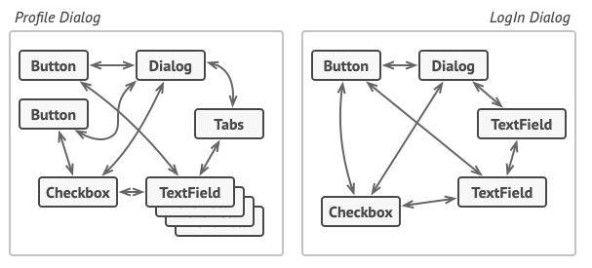

Picture 1 –Relations between elements of the user interface can become chaotic as the application evolves.

Some of the form elements may interact with others. For instance, selecting the “I have a dog” checkbox may reveal a hidden text field for entering the dog’s name. Another example is the submit button that has to validate values of all fields before saving the data.
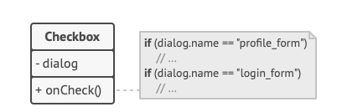

Picture 2 – Elements can have lots of relations with other elements. Hence, changes to some elements may affect the others.

By having this logic implemented directly inside the code of the form elements you make these elements’ classes much harder to reuse in other forms of the app. For example, you won’t be able to use that checkbox class inside another form, because it’s coupled to the dog’s text field. You can use either all the classes involved in rendering the profile form, or none at all.
The Mediator pattern suggests that you should cease all direct communication between the components which you want to make independent of each other. Instead, these components must collaborate indirectly, by calling a special mediator object that redirects the calls to appropriate components. As a result, the components depend only on a single mediator class instead of being coupled to dozens of their colleagues.
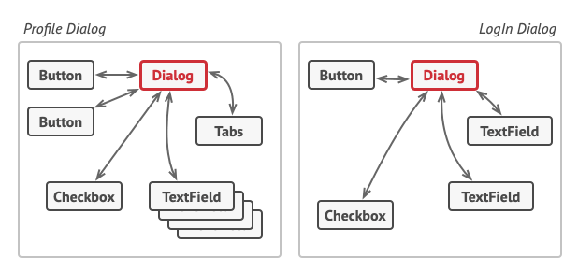
Picture 3 – UI elements should communicate indirectly, via the mediator object.

The most significant change happens to the actual form elements. Let’s consider the submit button. Previously, each time a user clicked the button, it had to validate the values of all individual form elements. Now its single job is to notify the dialog about the click. Upon receiving this notification, the dialog itself performs the validations or passes the task to the individual elements. Thus, instead of being tied to a dozen form elements, the button is only dependent on the dialog class.
You can go further and make the dependency even looser by extracting the common interface for all types of dialogs. The interface would declare the notification method which all form elements can use to notify the dialog about events happening to those elements. Thus, our submit button should now be able to work with any dialog that implements that interface.
This way, the Mediator pattern lets you encapsulate a complex web of relations between various objects inside a single mediator object. The fewer dependencies a class has, the easier it becomes to modify, extend or reuse that class.
In our example with the profile editing form, the dialog class itself may act as the mediator. Most likely, the dialog class is already aware of all of its sub-elements, so you won’t even need to introduce new dependencies into this class.
An element, triggered by a user, doesn’t communicate with other elements directly, even if it looks like it’s supposed to. Instead, the element only needs to let its mediator know about the event, passing any contextual info along with that notification.
In this example, the whole authentication dialog acts as the mediator. It knows how concrete elements are supposed to collaborate and facilitates their indirect communication. Upon receiving a notification about an event, the dialog decides what element should address the event and redirects the call accordingly.
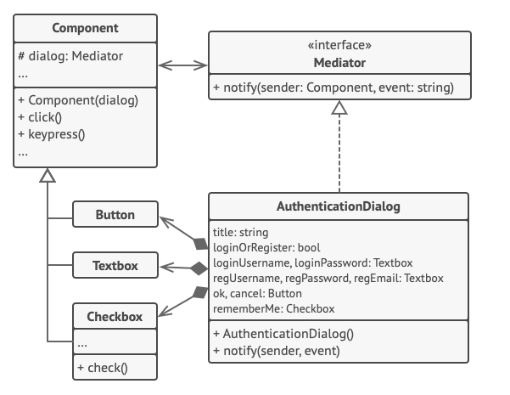
Picture 4 – Structure of the UI dialog classes.

The Mediator pattern has the following benefits and drawbacks:
- It limits subclassing. A mediator localizes behavior that otherwise would be distributed among several objects. Changing this behavior requires subclassing Mediator only; Colleague classes can be reused as is.
- It decouples colleagues. A mediator promotes loose coupling between colleagues. You can vary and reuse Colleague and Mediator classes independently.
- It simplifies object protocols. A mediator replaces many-to-many interactions with one-to-many interactions between the mediator and its colleagues. One-to-many relationships are easier to understand, maintain, and extend.
- It abstracts how objects cooperate. Making mediation an independent concept and encapsulating it in an object lets you focus on how objects interact apart from their individual behavior. That can help clarify how objects interact in a system.
- It centralizes control. The Mediator pattern trades complexity of interaction for complexity in the mediator. Because a mediator encapsulates protocols, it can become more complex than any individual colleague. This can make the mediator itself a monolith that's hard to maintain.
Sample codes and achieved results are shown in Application B.

Сommand
Command is a behavioral design pattern that turns a request into a stand-alone object that contains all information about the request. This transformation lets you parameterize methods with different requests, delay or queue a request’s execution, and support undoable operations.
Imagine that you’re working on a new text-editor app. Your current task is to create a toolbar with a bunch of buttons for various operations of the editor. You created a very neat Button class that can be used for buttons on the toolbar, as well as for generic buttons in various dialogs.
While all of these buttons look similar, they’re all supposed to do different things. Where would you put the code for the various click handlers of these buttons? The simplest solution is to create tons of subclasses for each place where the button is used. These subclasses would contain the code that would have to be executed on a button click.
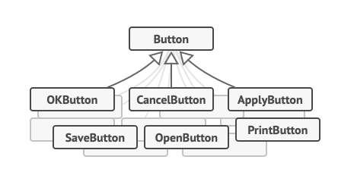
Picture 5 – Lots of button subclasses. What can go wrong?

Before long, you realize that this approach is deeply flawed. First, you have an enormous number of subclasses, and that would be okay if you weren’t risking breaking the code in these subclasses each time you modify the base Button class. Put simply, your GUI code has become awkwardly dependent on the volatile code of the business logic.
And here’s the ugliest part. Some operations, such as copying/pasting text, would need to be invoked from multiple places. For example, a user could click a small “Copy” button on the toolbar, or copy something via the context menu, or just hit Ctrl+C on the keyboard.
Initially, when our app only had the toolbar, it was okay to place the implementation of various operations into the button subclasses. In other words, having the code for copying text inside the CopyButton subclass was fine. But then, when you implement context menus, shortcuts, and other stuff, you have to either duplicate the operation’s code in many classes or make menus dependent on buttons, which is an even worse option.
Good software design is often based on the principle of separation of concerns, which usually results in breaking an app into layers. The most common example: a layer for the graphical user interface and another layer for the business logic. The GUI layer is responsible for rendering a beautiful picture on the screen, capturing any input and showing results of what the user and the app are doing. However, when it comes to doing something important, like calculating the trajectory of the moon or composing an annual report, the GUI layer delegates the work to the underlying layer of business logic.
In the code it might look like this: a GUI object calls a method of a business logic object, passing it some arguments. This process is usually described as one object sending another a request.
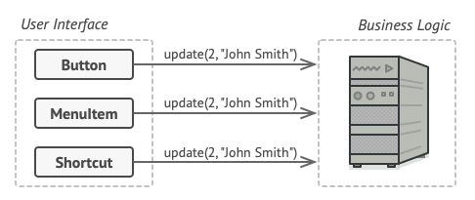
Picture 6 – The GUI objects may access the business logic objects directly.

The Command pattern suggests that GUI objects shouldn’t send these requests directly. Instead, you should extract all of the request details, such as the object being called, the name of the method and the list of arguments into a separate command class with a single method that triggers this request.
Command objects serve as links between various GUI and business logic objects. From now on, the GUI object doesn’t need to know what business logic object will receive the request and how it’ll be processed. The GUI object just triggers the command, which handles all the details.
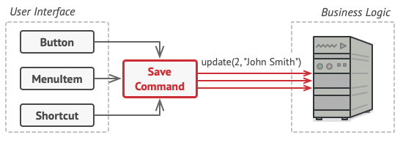
Picture 7 – Accessing the business logic layer via a command.

The next step is to make your commands implement the same interface. Usually it has just a single execution method that takes no parameters. This interface lets you use various commands with the same request sender, without coupling it to concrete classes of commands. As a bonus, now you can switch command objects linked to the sender, effectively changing the sender’s behavior at runtime.

You might have noticed one missing piece of the puzzle, which is the request parameters. A GUI object might have supplied the business-layer object with some parameters. Since the command execution method doesn’t have any parameters, how would we pass the request details to the receiver? It turns out the command should be either pre-configured with this data, or capable of getting it on its own.

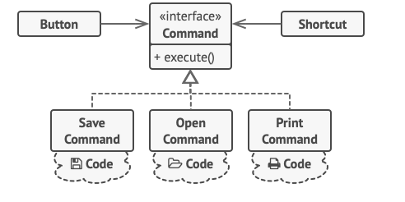

Picture 8 – The GUI objects delegate the work to commands.

Let’s get back to our text editor. After we apply the Command pattern, we no longer need all those button subclasses to implement various click behaviors. It’s enough to put a single field into the base Button class that stores a reference to a command object and make the button execute that command on a click.
You’ll implement a bunch of command classes for every possible operation and link them with particular buttons, depending on the buttons’ intended behavior.
Other GUI elements, such as menus, shortcuts or entire dialogs, can be implemented in the same way. They’ll be linked to a command which gets executed when a user interacts with the GUI element. As you’ve probably guessed by now, the elements related to the same operations will be linked to the same commands, preventing any code duplication.
As a result, commands become a convenient middle layer that reduces coupling between the GUI and business logic layers. And that’s only a fraction of the benefits that the Command pattern can offer!
Commands which result in changing the state of the editor (e.g., cutting and pasting) make a backup copy of the editor’s state before executing an operation associated with the command. After a command is executed, it’s placed into the command history (a stack of command objects) along with the backup copy of the editor’s state at that point. Later, if the user needs to revert an operation, the app can take the most recent command from the history, read the associated backup of the editor’s state, and restore it.
The client code (GUI elements, command history, etc.) isn’t coupled to concrete command classes because it works with commands via the command interface. This approach lets you introduce new commands into the app without breaking any existing code.
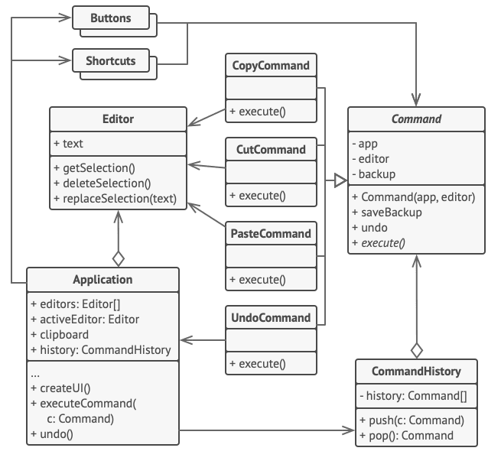

Picture 9 – Structure of the UI dialog classes.

Practical Research

Formulation of the Problem
Electricity is an important part of every person's life. Counting electricity and saving it can have a positive impact on the budget of any family. The application, created as part of the course work, allows you to solve the problem of calculating the power consumption of all household appliances in the apartment. The program allows you to calculate the energy consumption by days of the week, the total amount of energy consumption, as well as the amount of energy that can be saved depending on the characteristics of electrical appliances (energy saving, operating time). A text file is used as input data. The structure of a correct text file is a collection of lines that characterize electrical appliances and days of the week. The line characterizing electrical appliances looks like this: SIMPLE_DEVICE microwave 800 4. The first element SIMPLE_DEVICE defines which class the electrical appliance belongs to, the rest characterize its properties. The line describing the days of the week looks like this: MONDAY. The output data is a map, in which the days of the week is a key, and the electrical devices that were used on that day is a value.

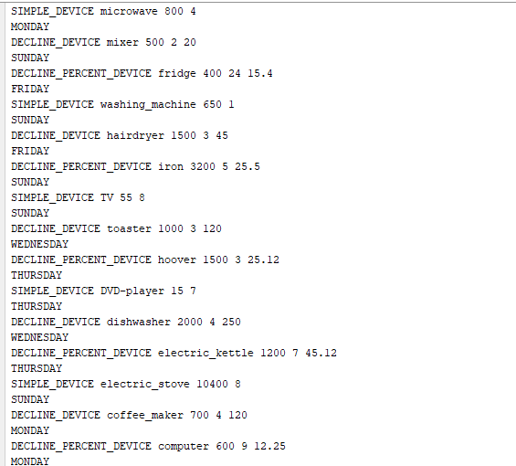
Picture 1 – Input txt file

Description of Entities

Description of SimpleDevice class
SimpleDevice class is a Java bean class located in the by.gsu.epamlab.beans package. The purpose of this class is to represent the most common electronic device in the program. Also, the class is a superclass for classes such as EnergyDeclineDevice and EnergyDeclinePercentDevice. SimpleDevice includes the following fields: name, power, workingTime. The purpose of the name field is to represent the name of electronic device. The purpose of the power is to represent the
electrical device power. The purpose of the workingTime is to represent the electric device operating time (in hours). SimpleDevice includes the following methods: getters, setters, String toString(), int hashCode(), boolean equals(Object o), String fieldsToString(), EnergyConsumption getEnergyConsumption(). The purpose of the method getEnergyConsumption() is to calculate the energy consumption based on working time and power. The purpose of the method fieldsToString() is to avoid copy-paste in the toString() method in subclasses. There are two constructors in SimpleDevice class. The first constructor is SimpleDevice (String name, int power, int workingTime). The purpose of this constructor is to initialize object. The second constructor is SimpleDevice(Scanner sc). The purpose of this constructor is to initialize object from in.txt file. The UML diagram of the class (picture 2).

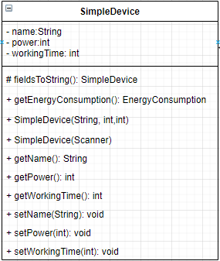

Picture 2 – SimpleDevice class UML diagram.

Description of EnergyDeclineDevice class
EnergyDeclineDevice class is a Java bean class located in the by.gsu.epamlab.beans package. The purpose of this class is to represent electrical devices in which energy consumption is reduced by a certain value in the program. Also, the class is a subclass for the SimpleDevice class. EnergyDeclineDevice includes the following fields: name, power, workingTime, decline. The purpose of the name field is to represent the name of electronic device. The purpose of the power is to represent the electrical device power. The purpose of the workingTime is to represent the electric device operating time (in hours). The purpose of the decline is to represent how much electricity an electronic device can save. EnergyDeclineDevice includes the following methods: getters, setters, String toString(), int hashCode(), boolean equals(Object o), String fieldsToString(), EnergyConsumption getEnergyConsumption(). getEnergyConsumption() method is overridden from superclass. Energy consumption is calculated in this implementation of the method as: power * waitingTime – decline * waitingTime. The purpose of the method fieldsToString() is to avoid copy-paste in the toString() method in subclasses. There are two constructors in EnergyDeclineDevice class. The first constructor is EnergyDeclineDevice (String name, int power, int workingTime, EnergyConsumption decline). The purpose of this constructor is to initialize object. The second constructor is EnergyDeclineDevice (Scanner sc). The purpose of this constructor is to initialize object from in.txt file. The UML diagram of the class (picture 3).
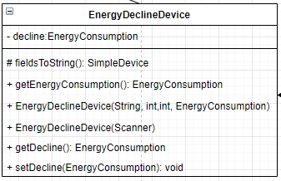

Picture 3 – EnergyDeclineDevice class UML diagram.

Description of EnergyDeclinePercentDevice class
EnergyDeclinePercentDevice class is a Java bean class located in the by.gsu.epamlab.beans package. The purpose of this class is to represent electrical devices in which energy consumption is reduced by a certain percent if device’s operation time is more than certain class constant. Also, the class is a subclass for the SimpleDevice class. EnergyDeclinePercentDevice includes the following fields: name, power, workingTime, declineRate, WORKING_LIMIT. The purpose of the name field is to represent the name of electronic device. The purpose of the power is to represent the electrical device power. The purpose of the workingTime is to represent the electric device operating time. The purpose of the declineRate is to represent the percentage reduction in the power consumption of an electrical device. The purpose of the WORKING_LIMIT is to represent the сlass constant. EnergyDeclinePercentDevice includes the following methods: getters, setters, String toString(), int hashCode(), boolean equals(Object o), String fieldsToString(), EnergyConsumption getEnergyConsumption(). getEnergyConsumption() method is overridden from superclass If WorkingTime is greater than or equal to WORKING_LIMIT then energy consumption is calculated in a special way. The purpose of the method fieldsToString() is to avoid copy-paste in the toString() method in subclasses. There are two constructors in EnergyDeclinePercentDevice class. The first constructor is EnergyDeclinePercentDevice (String name, int power, int workingTime, double declineRate). The purpose of this constructor is to initialize object. The second constructor is EnergyDeclinePercentDevice (Scanner sc). The purpose of this constructor is to initialize object from in.txt file. The UML diagram of the class (picture 4).

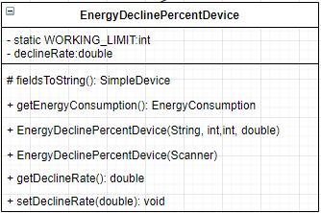

Picture 4 – EnergyDeclinePercentDevice class UML diagram.

Description of EnergyConsumption class
EnergyConsumption class is a Java immutable bean class located in the by.gsu.epamlab.beans package. The purpose of this class is to represent energy consumption value. EnergyConsumption includes the following fields: value. The purpose of the value field is to represent the amount of energy consumption. EnergyConsumption includes the following methods: String toString(), int hashCode(), boolean equals(Object o), int compareTo(EnergyConsumption energy), add(EnergyConsumption energyConsumption), sub(EnergyConsumption energyConsumption), mul(int k), mul(double k, RoundMethod roundMethod,int d), round(RoundMethod roundMethod,int d). The purpose of the methods add and sub is to calculate the sum and substraction of energy consumption. The purpose of the methods mul is to calculate multiplication by an integer or multiplication by a fractional number followed by rounding. There are three constructors in EnergyConsumption class. The first constructor is EnergyConsumption (int value). The purpose of this constructor is to initialize object. The second constructor is EnergyConsumption (EnergyConsumption energy). The purpose of this constructor is to copy objects. The third constructor is EnergyConsumption (). The purpose of this constructor is to to initialize object by default value (zero). The UML diagram of the class (picture 5).

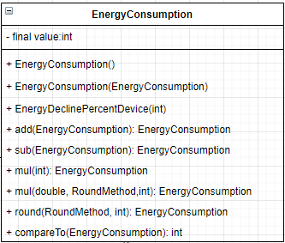

Picture 5 – EnergyConsumption class UML diagram.

Description of RoundMethod and WeekDay enums
RoundMethod and WeekDay enums are Java enums located in the by.gsu.epamlab.enums package. The purpose of the RoundMethod is to represent the set of methods that provide different ways to round energy consumption in the program. The purpose of the WeekDay is to represent the day of week. RoundMethod includes the following methods: int round(double roundedValue,int d), abstract double roundMethod(double value). The purpose of the method round is to round the value according to RoundMethod’s constant. The purpose of the abstract method roundMethod is to define the algorithm of rounding double values. The UML diagram of the enum (picture 6). The UML diagram of the enum (picture 7).
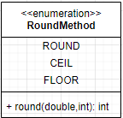

Picture 6 – RoundMethod enum UML diagram.

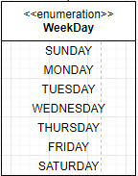
Picture 7 – WeekDay enum UML diagram.

Description of EnergyFactory class
EnergyFactory class is a Java factory class located in the by.gsu.epamlab.factories package. The purpose of this class is to represent the factory method pattern in the program. EnergyFactory includes the nested enum DeviceKind. The purpose of the DeviceKind enum is to represent the factory method pattern. EnergyFactory includes the following method: SimpleDevice getDeviceFromFactory (Scanner sc). The purpose of the method getDeviceFromFactory() is to return a class hierarchy object based on the value of the elements in the in.txt file. The UML diagram of the class (picture 8).

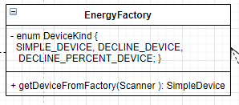

Picture 8 – EnergyFactory class UML diagram.

Description of Constants class
Constants class is a Java utility class located in the by.gsu.epamlab package. The purpose of this class is to represent the set of constants in the program. The UML diagram of the class (picture 9).
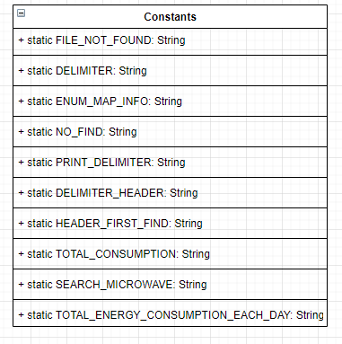
Picture 9 – Constants class UML diagram.

Description of EnergyChecker interface
EnergyChecker interface is a generic java interface located in the by.gsu.epamlab.interfaces package. The purpose of this interface is to provide a method that specifies the conditions for selecting or removing elements in the data structure. EnergyChecker includes the following methods: boolean check(Map.Entry<K,V> devices). The purpose of the method check(Map.Entry<K,V> devices) is to define an algorithm for removing or finding elements in a Map. Thanks to the interface EnergyChecker, the pattern Strategy is implemented. The UML diagram of the class (picture 10).

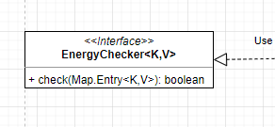

Picture 10 – EnergyChecker interface UML diagram.

Description of Runner class
Runner class is a Java class located in the default package. The purpose of this class is to represent the main algorithm of the program. The main algorithm consists of the following parts:
- Load the content of the in.txt file into the the enumerated map, where a week day is a key and devices list for this weekday is a value;
- Load the content of the in.txt file into the list;
- Print the map by for-each cycle;
- Print the total energy consumption of all purchases for each weekday;
- Print the total energy consumption of the device’s list;
- Remove all entries from the enumerated map where the weekday is Monday;
- Remove all entries from the enumerated map where the device’s name is mixer;
- Cover all code with junit tests;
Runner includes the following methods: printMap(), outputAllEnergyConsumption(), printTotalConsumption(), loadEnumeratedMap(), loadEnergyDeclineList(), findAndShow(), removeEntities(). The purpose of the method printMap() is to print the map on console. The purpose of outputAllEnergyConsumption() method is to print the total energy consumption according to weekday. The purpose of the printTotalConsumption() is to print the total energy consumption of the List< EnergyDeclineDevice>. The purpose of the loadEnumeratedMap() is to load information into the enumerated map from in.txt file. The purpose of the loadEnergyDeclineList() is to load information into the list from in.txt. The purpose of the findAndShow() is to find the current element of the enumerated map according to the searching algorithm. The search algorithm is created using the EntryChecker interface. The purpose of the method removeEntities is to delete elements from the enumerated map according to the deleting algorithm. The delete algorithm is сreated using the EntryChecker interface. The UML diagram of the class (picture 11).
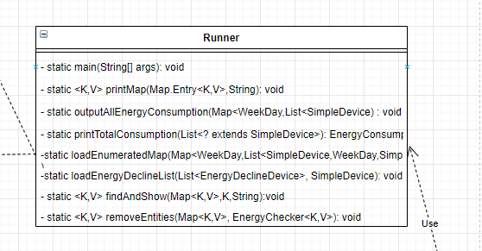

Picture 11 – Runner class UML diagram

UML diagram
The picture eleven shows UML classes diagram of the program.

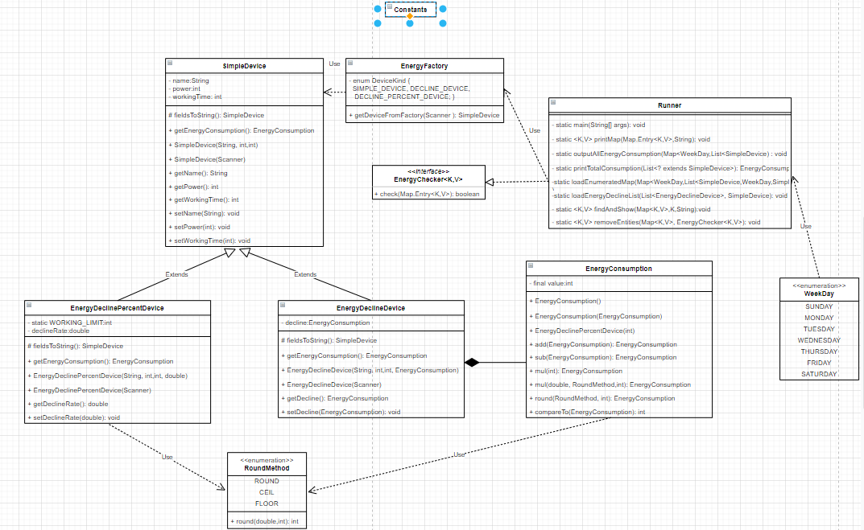
Picture 12 – UML classes diagram

Implementation of Design Patterns
In this course work, two design patterns were used:
1. Factory method;
2. Strategy.
A factory method is an ancestral design pattern that defines a common interface for creating objects in a superclass, allowing subclasses to change the type of objects they create.
Problem
There is Java code, which counts the consumption of electricity. Initially, this code considers the energy consumption of simple devices, so the code only works with the Simple devices class.
At some point, this code will have to calculate the energy consumption of energy-saving devices, since the calculation changes radically from the original one and the code was rigidly tied to the Simple devices class. To add the counting of energy-saving devices to the code, you need to completely redo this code.
The result is terrifying code filled with conditional statements that perform one action or another, depending on the class of the device.
Decision
The Factory Method pattern suggests creating objects not directly using the new operator, but by calling a special factory method.
Now this code will have an enumeration and, depending on what implementation the program will need, that implementation will give this enumeration(Picture 12).
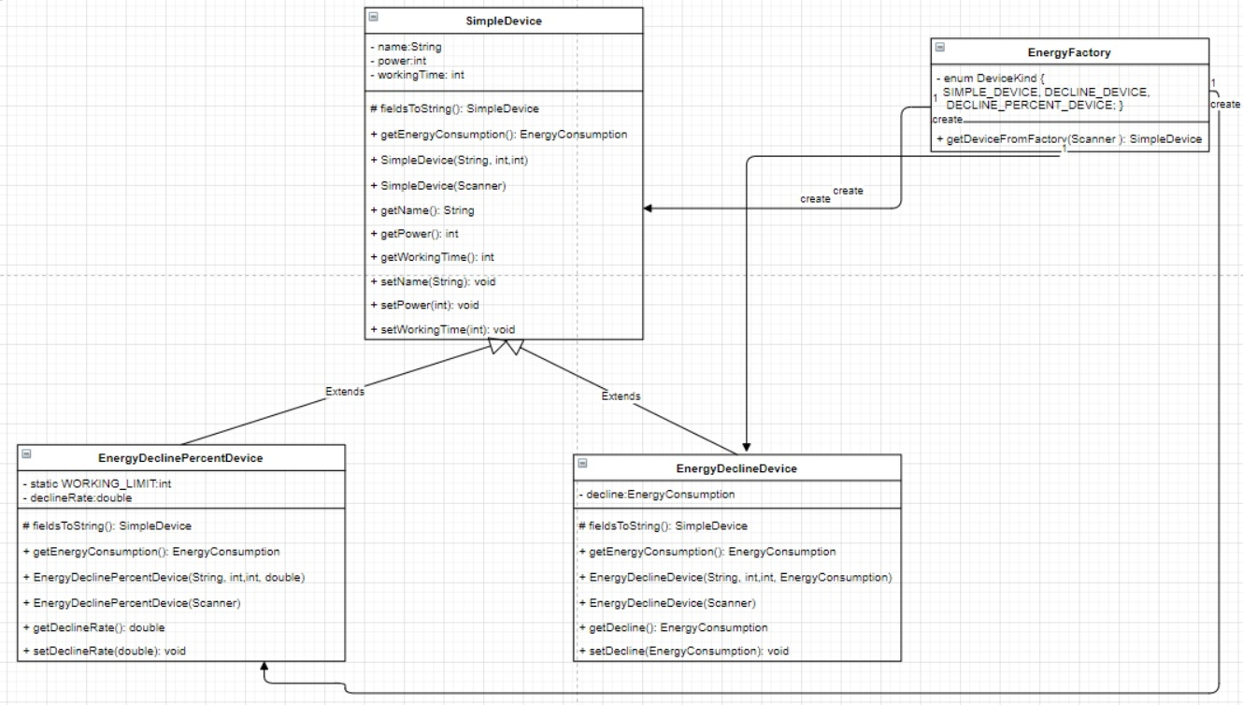
Picture 12 – UML factory method diagram

Code listing

public class EnergyFactory {
private enum DeviceKind {
SIMPLE_DEVICE {
SimpleDevice getDevice(Scanner sc) throws EmptyArgumentException, NonpositiveArgumentException {
return new SimpleDevice(sc);
}
}, DECLINE_DEVICE{
SimpleDevice getDevice(Scanner sc) throws EmptyArgumentException, NonpositiveArgumentException{
return new EnergyDeclineDevice(sc);
}
}, DECLINE_PERCENT_DEVICE{
SimpleDevice getDevice(Scanner sc) throws EmptyArgumentException, NonpositiveArgumentException{
return new EnergyDeclinePercentDevice(sc);
}
};
abstract SimpleDevice getDevice(Scanner sc) throws EmptyArgumentException, NonpositiveArgumentException;

}
public static SimpleDevice getDeviceFromFactory(Scanner sc) {
String id = sc.next();
DeviceKind kind = DeviceKind.valueOf(id);
return kind.getDevice(sc);
}
}
As we can see, this class has one enum and one method that the Scanner takes. Next, the string is parsed and the variable is assigned the first value of the string. In this file, the first line contains the information that you need to select the implementation for each device.
Next, the following pattern will be considered.
Strategy - it is a behavioral design pattern that defines a family of similar algorithms and puts each of them in its own class, after which the algorithms can be interchanged right at runtime.
Problem
There is a code that removes any value by a certain condition from the Map. Removing a value from Map has been moved to a separate method or class. After some time, apply the same request to remove any element from the Map, but according to a different condition. For this, a new method or class will be created to remove an element from the Map, after a while a new request is received to remove an element from the Map and also with a new condition, and so on. It turns out that the class will have many methods or classes that will remove elements from the Map. The class is piling up.
Decision
The Strategy pattern proposes to define a family of similar algorithms that are often changed or extended, and move them into their own classes or interface called strategies.
Instead of adding a new class or method, you can simply create a generic interface and use it to remove items from the Map. Also one of the important advantages is that there is no cluttering of method names. Only one method will be used, which is written in the interface(Picture 12).

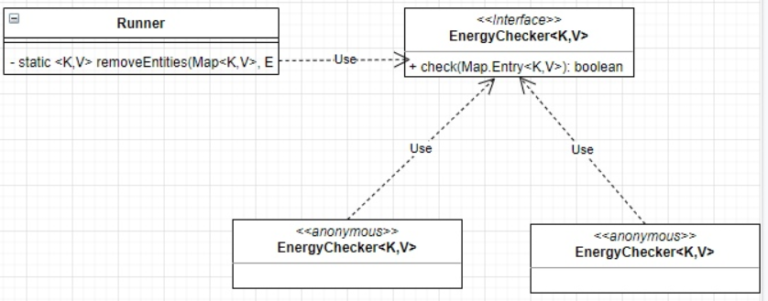
Picture 12 – UML strategy diagram

Code listing.

public interface EnergyChecker<K,V> {
boolean check(Map.Entry<K,V> devices);
}

removeEntities(dayDeviceMap, new EnergyChecker<WeekDay, List<SimpleDevice>>() {
@Override
public boolean check(Map.Entry<WeekDay, List<SimpleDevice>> devices) {
boolean isName = false;
for(SimpleDevice device: devices.getValue()){
if(device.getName().equals(Constants.SEARCH_MICROWAVE)){
isName = true;
}
break;
}
return isName;
}
});

removeEntities(dayDeviceMap, new EnergyChecker<WeekDay, List<SimpleDevice>>() {
@Override
public boolean check(Map.Entry<WeekDay, List<SimpleDevice>> devices) {
return devices.getKey() == WeekDay.MONDAY;
}
});

This code uses a common interface to remove items from a Map. Also in this code there are anonymous classes in which the logic for removing elements from the Map is implemented, each new anonymous class has its own logic for removing an element from the Map.

Testing the Application
This course project has tests. Every method in the classes has been tested. Testing data is presented in the table below.

Class | Method | Expected | Actually
SimpleDevice | getEnergyConsumption | 20.00 Byn | 20.00 Byn
EnergyConsumption | add | 15.00 Byn | 15.00 Byn
EnergyConsumption | sub | 10.00 Byn | 10.00 Byn
EnergyConsumption | mul | 50.00 Byn | 50.00 Byn
EnergyConsumption | getEnergyConsumption | 20.00 Byn | 20.00 Byn
EnergyDeclinePercentDevice | getEnergyConsumption | 20.00 Byn | 20.00 Byn
Runner | main | File empty | Filer empty
Runner | main | File doesn’t exist | File doesn’t exist

Description of the table.
Let's start with the method of the main Runner class. If the program has a file and it is not empty, then the program will work completely, but, suppose we have an empty file, then the program will throw an exception that the file is empty and an inscription will be displayed in the console stating that the file is empty, if the program does not have a file at all, then the program will throw an exception stating that the file is not present and a message will be displayed in the console stating that the file is empty.
The SimpleDevice class was tested. Only one getEnergyConsumption method has been tested in this class, since other methods in this class do not need to be tested. The expected result of this method was 20 Byn and in the end we got the same 20 Byn.
Also, in the EnergyConsumption and EnergyDeclinePercentDevice classes, only one method was tested, since testing other methods does not make sense. For the first class the expected result was 20.00 Byn and the final result was also 20.00 Byn. For the second class, the expected result was 20.00 Byn and the final result was also 20.00 Byn.
The last class that has been tested is the EnergyConsumption class. Three methods were tested in it: add, sub, mul. For the first add method, the expected value was 15.00 Byn, and the actual value was also 15.00 Byn. For the sub method, the expected value was 10.00 Byn, and 10.00 Byn was also obtained. For the mul method, the expected value was 50.00 Byn, and we got 50.00 Byn as well.
Conclusion about testing
This program passed all tests and the results were in line with expected. Also, in the absence of a file, this application does not break, but gives an error that there is no file. The situation was also processed that the file was empty, the application also does not break, but gives an error that the file is empty.

Conclusion
As a result of this course project, a program was created and tested to collect information from the energy devices. The program implements functions that allow you to determine the energy consumption of electrical devices, find a list of working electrical appliances by day of the week and delete electrical appliances according to certain criteria.
Functions of the software complex, implement the following tasks:
- Load the content of the in.txt file into the the enumerated map, where a week day is a key and devices list for this weekday is a value;
- Load the content of the in.txt file into the list;
- Print the map by for-each cycle;
- Print the total energy consumption of all purchases for each weekday;
- Print the total energy consumption of the device’s list;
- Remove all entries from the enumerated map where the weekday is Monday;
- Remove all entries from the enumerated map where the device’s name is mixer;
- Cover all code with junit tests;
The success of the work confirms the verification of all information obtained from the created software package, as well as testing the program for errors on various dataset.

List of sources used

- Blinov, I., Romanchik, V. Programming methods / I. Blinov. V. Romanchik. - Minsk: Four Quarters, 2013 .-- 896 p.
- Savitch, W. The Java Language. Programming Course / W. Savitch. - M .: Williams, 2015 .-- 928 p.
- Khabibullin, I. Self-Study Guide Java / I. Khabibullin. - M.: BHV-Petersburg, 2014 .-- 768 p.
- Schildt, H. Java 8. A Beginner's Guide / H. Schildt. - M .: Williams, 2015 .-- 720 p.
- Eckel, Bruce Java Philosophy / Bruce Eckel. - M .: St. Petersburg, 2016 .-- 809 p.

Application А
The listing of the main method algorithm

public static void main(String[] args){
final String FILE_NAME = "src/in.txt";
try(Scanner sc = new Scanner(new FileReader(FILE_NAME))) {
sc.useLocale(Locale.US);
Map<WeekDay, List<SimpleDevice>> dayDeviceMap = new EnumMap<WeekDay, List<SimpleDevice>>(WeekDay.class);
List<EnergyDeclineDevice> declineDevices = new ArrayList<>();
while (sc.hasNext()){
SimpleDevice device = EnergyFactory.getDeviceFromFactory(sc);
WeekDay dayOfWeek = WeekDay.valueOf(sc.next());
loadEnumeratedMap(dayDeviceMap,dayOfWeek,device);
loadEnergyDeclineList(declineDevices,device);
}
if (declineDevices.isEmpty()){
throw new DaoException(Constants.FILE_IS_EMPTY);
}
printMap(dayDeviceMap, Constants.ENUM_MAP_INFO);
findAndShow(dayDeviceMap,WeekDay.MONDAY,Constants.HEADER_FIRST_FIND);
outputAllEnergyConsumption(dayDeviceMap);
System.out.println(Constants.TOTAL_CONSUMPTION + printTotalConsumption(declineDevices));
removeEntities(dayDeviceMap, new EnergyChecker<WeekDay, List<SimpleDevice>>() {
@Override
public boolean check(Map.Entry<WeekDay, List<SimpleDevice>> devices) {
boolean isName = false;
for(SimpleDevice device: devices.getValue()){
if(device.getName().equals(Constants.SEARCH_MICROWAVE)){
isName = true;
}
break;
}
return isName;
}
});
removeEntities(dayDeviceMap, new EnergyChecker<WeekDay, List<SimpleDevice>>() {
@Override
public boolean check(Map.Entry<WeekDay, List<SimpleDevice>> devices) {
return devices.getKey() == WeekDay.MONDAY;
}
});
printMap(dayDeviceMap,Constants.ENUM_MAP_INFO);

} catch (FileNotFoundException e){
throw new DaoException(Constants.FILE_NOT_FOUND);
} }

Application B
The listing of the Mediator pattern code

First, let's introduce the code without Mediator:

public class Button {
private Fan fan;

// constructor, getters and setters

public void press(){
if(fan.isOn()){
fan.turnOff();
} else {
fan.turnOn();
}
}
}
public class Fan {
private Button button;
private PowerSupplier powerSupplier;
private boolean isOn = false;

// constructor, getters and setters

public void turnOn() {
powerSupplier.turnOn();
isOn = true;
}

public void turnOff() {
isOn = false;
powerSupplier.turnOff();
}
}
public class PowerSupplier {
public void turnOn() {
// implementation
}

public void turnOff() {
// implementation
}
}

First, let's introduce the Mediator class:

public class Mediator {
private Button button;
private Fan fan;
private PowerSupplier powerSupplier;

// constructor, getters and setters

public void press() {
if (fan.isOn()) {
fan.turnOff();
} else {
fan.turnOn();
}
}

public void start() {
powerSupplier.turnOn();
}

public void stop() {
powerSupplier.turnOff();
}
}
Next, let's modify the remaining classes:

public class Button {
private Mediator mediator;

// constructor, getters and setters

public void press() {
mediator.press();
}
}
public class Fan {
private Mediator mediator;
private boolean isOn = false;

// constructor, getters and setters

public void turnOn() {
mediator.start();
isOn = true;
}

public void turnOff() {
isOn = false;
mediator.stop();
}
}

