Content
Introduction 3
1 Advantages of Design Patterns 4
1.1 Bridge pattern 4
1.1.1 Problem and its obvious implementation 4
1.1.2 Fixing drawbacks with the Facade pattern 6
1.2 Template method 8
1.2.1 Problem and its obvious implementation 8
1.2.2 Fixing drawbacks with the Template method pattern 10
2 Practical Research 12
2.1 Formulation of the Problem 12
2.2 Description of Entities 13
2.2.1 Student class 13
2.2.2 Achievement class 14
2.2.3 Course class 15
2.2.4 Progress class 16
2.2.5 DatabaseConnection and DatabaseInteraction classes 17
2.2.6 Graphic class 18
2.2.7 Histogram, DotPlot and PieChart classes 18
2.2.8 GraphicStrategy interface 18
2.2.9 HistogramStrategy, PieChartStrategy, DotPlotStrategy classes 18
2.3 Implementation of Design Patterns 19
2.3.1 Builder 19
2.3.2 Factory Method with Builder 21
2.3.3 Singleton 25
2.3.4 Strategy 26
2.4 Testing the Application 28
Conclusion 29
List of sources 30

Introduction
This coursework involves the using of Java programming language to create a program that uses Design Patterns. We have created an application that implements the possibilities of playing Chess in player versus player mode.
The coursework contains two chapters. The first chapter describes the benefits of design patterns. It includes descriptions of two design patterns that we did not use in the developed application. The description includes short formulation of the problem and its obvious implementation with described drawbacks, the idea of their fixing with the illustrative java code and class diagram, and achieved results.
The second chapter is divided into four parts. The first part includes a problem statement, which describes in detail the statement of the problem that we are going to solve. The second part includes a description of entities, where we describe all our classes and interfaces of the developed application and the relationships between them. The third part includes a description of the design patterns that we used in the developed application, where we need to describe their purpose, a class diagram with our entities, illustrative Java code and the results achieved. The last part includes information about testing the application. In this part, we describe the tests performed and their results.

Advantages of Design Patterns

Bridge pattern

Problem and its obvious implementation
Suppose we have some kind of complex framework that, for example, provides us with a set of video conversion classes. We need to use this set of classes to convert the file to mp4 format.
The obvious code implementation is presented below.

class VideoFile {
private String name;
private String codecType;

public VideoFile(String name) {
this.name = name;
this.codecType = name.substring(name.indexOf(".") + 1);
}

public String getCodecType() {
return codecType;
}

public String getName() {
return name;
}
}

public interface Codec {
}

public class MPEG4CompressionCodec implements Codec {
public String type = "mp4";

}

public class OggCompressionCodec implements Codec {
public String type = "ogg";
}

public class CodecFactory {
public static Codec extract(VideoFile file) {
String type = file.getCodecType();
if (type.equals("mp4")) {
System.out.println("CodecFactory: extracting mpeg audio...");
return new MPEG4CompressionCodec();
}
else {
System.out.println("CodecFactory: extracting ogg audio...");
return new OggCompressionCodec();
}
}
}

public class BitrateReader {
public static VideoFile read(VideoFile file, Codec codec) {
System.out.println("BitrateReader: reading file...");
return file;
}

public static VideoFile convert(VideoFile buffer, Codec codec) {
System.out.println("BitrateReader: writing file...");
return buffer;
}
}

public class AudioMixer {
public File fix(VideoFile result){
System.out.println("AudioMixer: fixing audio...");
return new File("tmp");
}
}

public class Application {
public static void main(String[] args) {
VideoFile file = new VideoFile(fileName);
Codec sourceCodec = CodecFactory.extract(file);
Codec destinationCodec;
if (format.equals("mp4")) {
destinationCodec = new OggCompressionCodec();
} else {
destinationCodec = new MPEG4CompressionCodec();
}
VideoFile buffer = BitrateReader.read(file, sourceCodec);
VideoFile intermediateResult = BitrateReader.convert(buffer, destinationCodec);
File result = (new AudioMixer()).fix(intermediateResult);
}
}
This code has some drawbacks:
- The code has to work with a large number of objects of some complex library or framework. You have to create these objects yourself, keep the dependencies in the correct order, and so on..
- As a result, the logic of your classes is tightly intertwined with the implementation details of third-party classes. Such code is quite difficult to understand and maintain.

However, all these drawbacks can be fixed. The Bridge pattern can help to optimize the code.

Fixing drawbacks with the Facade pattern
The facade pattern is a software-design pattern commonly used in object-oriented programming. Analogous to a facade in architecture, a facade is an object that serves as a front-facing interface masking more complex underlying or structural code. A facade can:
- improve the readability and usability of a software library by masking interaction with more complex components behind a single (and often simplified) API.
- provide a context-specific interface to more generic functionality (complete with context-specific input validation)
- serve as a launching point for a broader refactor of monolithic or tightly-coupled systems in favor of more loosely-coupled code.
Figure 1 represents class diagram for the code with the Facade pattern.

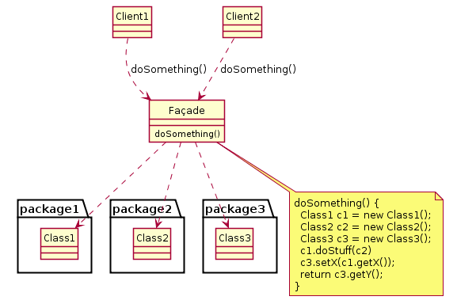
Figure 1 – Class diagram of the Facade pattern

The implementation of the code with the Bridge pattern is presented below.

class VideoFile {
private String name;
private String codecType;

public VideoFile(String name) {
this.name = name;
this.codecType = name.substring(name.indexOf(".") + 1);
}

public String getCodecType() {
return codecType;
}

public String getName() {
return name;
}
}

public interface Codec {
}

public class MPEG4CompressionCodec implements Codec {
public String type = "mp4";

}

public class OggCompressionCodec implements Codec {
public String type = "ogg";
}

public class CodecFactory {
public static Codec extract(VideoFile file) {
String type = file.getCodecType();
if (type.equals("mp4")) {
System.out.println("CodecFactory: extracting mpeg audio...");
return new MPEG4CompressionCodec();
}
else {
System.out.println("CodecFactory: extracting ogg audio...");
return new OggCompressionCodec();
}
}
}

public class BitrateReader {
public static VideoFile read(VideoFile file, Codec codec) {
System.out.println("BitrateReader: reading file...");
return file;
}

public static VideoFile convert(VideoFile buffer, Codec codec) {
System.out.println("BitrateReader: writing file...");
return buffer;
}
}

public class AudioMixer {
public File fix(VideoFile result){
System.out.println("AudioMixer: fixing audio...");
return new File("tmp");
}
}

public class VideoConversionFacade {
public File convertVideo(String fileName, String format) {
System.out.println("VideoConversionFacade: conversion started.");
VideoFile file = new VideoFile(fileName);
Codec sourceCodec = CodecFactory.extract(file);
Codec destinationCodec;
if (format.equals("mp4")) {
destinationCodec = new OggCompressionCodec();
} else {
destinationCodec = new MPEG4CompressionCodec();
}
VideoFile buffer = BitrateReader.read(file, sourceCodec);
VideoFile intermediateResult = BitrateReader.convert(buffer, destinationCodec);
File result = (new AudioMixer()).fix(intermediateResult);
System.out.println("VideoConversionFacade: conversion completed.");
return result;
}
}

public class Application {
public static void main(String[] args) {
VideoConversionFacade converter = new VideoConversionFacade();
File mp4Video = converter.convertVideo("youtubevideo.ogg", "mp4");
// ...
}
}
Implementation with the Facade pattern has one main advantage: the user of the system hides his device. Instead of working with several classes, one single method is provided, which itself takes care of correctly configuring the necessary objects of a complex system and getting the required result.

Template method

Problem and its obvious implementation
Suppose that say we are developing AI for a strategy game. For each race, we can create a separate class that will determine the behavior of the units.The obvious implementation is presented below:

class ElvesAI{
void takeTurn() {
//realizaion
}
void collectResources() {

}
void buildStructures() {
//realizaion
}
void buildUnits() {
//realizaion
}
void attack() {
//realizaion
}
void sendScouts() {
//realizaion
}
void sendWaarriors() {
//realizaion
}
}

class HumanityAI{
void takeTurn() {
//realizaion
}
void collectResources() {
//realizaion
}
void buildStructures() {
//realizaion
}
void buildUnits() {
//realizaion
}
void attack() {
//realizaion
}
void sendScouts() {
//realizaion
}
void sendWaarriors() {
//realizaion
}
}
This solution has several disadvantages:
- classes can contain exactly the same methods, which leads to copy-paste of the code.
- when changing some mechanics common to all classes, you will need to make changes to each of the classes.
- when creating a new entity (in this example, a race), all methods must be rewritten.

These problems can be solved if you create a general abstract superclass, which will allow you to implement mechanics common to all entities in one place, the rest of the subclasses can inherit the abstract class and override some or all of the methods if necessary.

Fixing drawbacks with the Template method pattern
The template method is one of the behavioral design patterns identified in the book Design Patterns. The template method is a method in a superclass, usually an abstract superclass, and defines the skeleton of an operation in terms of a number of high-level steps. These steps are themselves implemented by additional helper methods in the same class as the template method.
Figure 2 shows the structure of the Composite pattern.
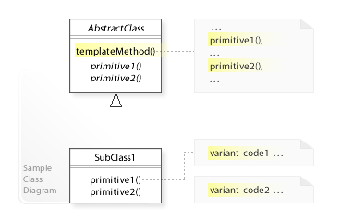
Figure 2 – The structure of the Template method

In this example, all races will have the same set of actions, buildings and units, but will have different implementations of these actions. For example, humans will attack better, elves will build buildings faster, and monsters will not build buildings and gather resources. You can create a generic abstract GameAI class that will contain a set of primitive actions to be overridden by descendants, if necessary, and also create a template method that will use these primitive actions. In addition, a superclass can contain several templated methods.
The implementation of the code with the Template method is presented below:
class GameAI {

method turn() {
collectResources()
buildNewStructures()
buildUnits()
attack()

}
void collectResources() {
//do something
}

abstract void buildStructures();
abstract void buildUnits();

void attack() {
enemy = closestEnemy()
if (enemy == null)
sendScouts(map.center)
else
sendWarriors(enemy.position)
}

abstract void sendScouts(position);
abstract void sendWarriors(position);
}

class ElvesAI extends GameAI {
void buildStructures() {
//do something
}

method buildUnits(){
//do something
}
}

class MonstersAI extends GameAI {
void collectResources() {
//nothing to do
}

void buildStructures() {
//nothing to do
}
}
The implementation with the Composite pattern has a number of advantages:
- there is no need to rewrite the entire code when adding new races
- no need to make changes to all classes when changing general mechanics

Practical Research

Formulation of the Problem
Student performance tracking system allows receiving various information about the learning outcomes of students. The application has the following features:
- Getting information about students.
- Display histogram with minimum, average and maximum points by gender.
- Display pie chart with information about students who passed, passed with honors or did not passed courses.
- Display dot plot with student results on control points of courses.
- Getting information about students and their courses.
- Getting information about student’s achievements.
The system has four course categories. There are programming, math, biology and physics categories.
Each course has five control points for which the student receives points. These points are taken into account when calculating the total points. The student needs to get a certain number of points to pass the course. This number of points differs from course to course. The formula for calculating the total points is also different for each course category.
The application receives data from MySQL database, which contains Students, Courses, Progress and Achievements tables:
The Students table contains information about students. This table contains id, nickname, country, age and gender fields. The id field is primary key. This field contains the student code by which the Progress table refers to this table. The nickname and country field of the type VARCHAR(45) contains the student’s nickname and country where this student lives. The age field of the type INT contains the student’s age. The gender field of the type ENUM(‘F’, ‘M’) contains information about the student’s gender.
The Courses table contains information about courses. This table contains id, name, threshold_points, points_to_honors and category fields. The id fields is primary key. This field contains the course code by which the Progress table refers to this table. The name field of the type VARCHAR(45) contains the course’s name. The threshold_points and points_to_honors fields of the type INT contain information about points, which the student should get to just pass the course or pass with honors. The category field of the type VARCHAR(45) contains information about the course category.
The Progress table contains information about the student’s progress on the course. The table contains student_id, course_id and control_point[1-5] fields. The student_id and course_id fields are foreign keys, which refer to the id fields of the Student and Courses tables. These fields form a composite key. The control_point[1-5] fields of the type INT contain information about points, which the student received at the control points of the course.
The Achievements table contains information about achievements that the student can get by taking courses. These achievements are common for all courses. The table contains id, name, required_points, testNo and earned_points fields. The id fields is primary key. This field contains the achievement code. The name field of the type VARCHAR(45) contains the name of the achievement. The required_points field of the type INT contains information about points that the student need to get on the control point to get this achievement. The test number is stored in the testNo field of the INT type. The earned_points field of the INT type contains points that the student receives for the achievement.
Figure 3 shows a data scheme of the tables.
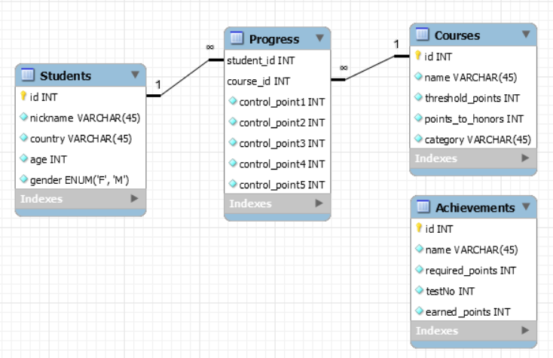
Figure 3 – Database scheme
The application has a console interface. There is a seven-item menu. You need to enter the numerical value to select the desired menu item. If the entered numerical value does not match the menu items, the application will display the message and ask to enter a new value.

Description of Entities

Student class
Public class Student stores information about the student. It contains five private fields. There are integer id field, string nickname, country fields, and gender field of the Gender type. Gender is enumeration, which contains constants M and F and their string implementations. These implementations are stored by string gender field. In addition, Gender enumeration contains public constructor and toString method that has no parameters and returns string representation of student’s gender.
The id field contains the student identifier; the nickname, country fields store the student’s name and country; the gender and age fields contain the student’s gender and age.
The class content is initialized using the Builder pattern. Inner static class Builder represents this pattern. The Builder class contains private student field of the Student type that is initialized by a public constructor without parameters. In addition, class Builder contains public methods that initialize fields of the Student class instance and return the instance of the Builder class. There are setId method with integer id parameter, setNickname and setCountry methods with string nickname and country parameters, setGender method with gender parameter of the Gender type and setAge method with integer age parameter. Public build method has no parameters and returns initialized instance of the Student class.
The Student class also contains public methods that work with its private fields. These methods include getters and overridden equals, hashCode and toString methods. Getters are represented by methods getId, getNickame, getCountry, getGender, getAge that return the values of the fields. The equals and hashCode methods are used to compare instances of the Student class and return Boolean and integer values, the toString method returns string representation of the Student class as a csv-string.

Achievement class
Public class Achievement stores information about achievements that student can get for high results on control points of different courses. These achievements are common for all courses. The Achievement class contains five private fields. There are integer id field, string name field and integer requiredPoints, testNo, earnedPoints fields.
The id field contains the achievement identifier; the name field stores the name of the achievement; the requiredPoints field contains points which student should receive on the control point to get this achievement; the control point number is stored in the testNo field; the earnedPoints field contains points the student gets for the achievement.
The class content is initialized using the Builder pattern. Inner static class Builder represents this pattern. The Builder class contains private achievement field of the Achievement type that is initialized by a public constructor without parameters. In addition, class Builder contains public methods that initialize fields of the Achievement class instance and return the instance of the Builder class. There are setId method with integer id parameter, setName method with string name parameter, setRequiredPoints method with integer requiredPoints parameter, setTestNo method with integer testNo parameter and setEarnedPoints method with integer earnedPoints parameter. Public build method has no parameters and returns initialized instance of the Achievement class.
The Achievement class also contains public methods that work with its private fields. These methods include getters and overridden toString method. Getters are represented by methods getId, getName, getRequiredPoints, getTestNo, getEarnedPoints that return the values of the class fields. The toString method return string representation of the Achievement class as a csv-string.

Course class
Public abstract class Course stores information about different courses. This class contains five private fields. These fields are final. There are integer id field, string name field, integer thresholdPoints and pointsToHonors fields and achievements field of the List<Achievement> type.
The id field contains the course identifier; the name field stores name of the course; the thresholdPoints and pointsToHonors fields contain points that the student should receive to pass the course or pass with honors; the achievements field contains the list of achievements that the student can get for good results on the course.
Public constructor initializes the class content. This constructor has parameters that are equivalent to the class fields.
The Course class also contains public getters and overridden equals, hashCode, toString methods. There are getId, getName, getThresholdPoints, getPointsToHonors, getAchievements that return the values of the class fields. The equals and hashCode methods are used to compare class instances. The toString method return string representation of the Course class fields as a csv-string.
The Course class is abstract, so it does not imply creating its own instances. This class is the parent class of ProgrammingCourse, MathCourse, BiologyCourse and PhysicsCourse classes. The Course class also contains the abstract method calculateTotalPoints with integer summaryPoints and achievedPoints parameters. This method calculates the total points of the student for the course. All inherited classes will implement the calculateTotalPoints method.
The factory method will be used to create instances of course classes. There are also CourseFactory class and CourseCategories enumeration, which are used in the factory method implementation.
Public class CourseFactory is used to create instances of the courses. It contains inner class Builder. This inner class is public and static because we need to be able to call it without creating the instance of the class CourseFactory. The Builder class contains six private fields. There are fields that the Course class contains and category field of the CourseCategories type. The category field contains information about the course category.
The CourseCategories is an enumeration that contains constants of the available courses. There are PROGRAMMING, MATH, BIOLOGY, PHYSICS constants. Their implementations are stored by string field. In addition, this enumeration contains public constructor and toString method that has no parameters and returns string representation of the course category. The CourseCategories defines a createCourse method for invidual constants. This method creates an instance of the course in accordance with its category. The createCourse method gets parameters equivalent to fields of the Course class and returns the desired course instance.
The Builder class also contains public constructor with parameter of the CourseCategories type. This constructor initializes the category field. There are public setId, setName, setThresholdPoints, setPointsToHonors and setAchievements methods that initialize other fields and return the instance of the Builder class. Public method build return the course instance that returns the course instance using the createCourse method of the CourseCategories enumeration.

Progress class
Public class Progress stores information about the student’s progress on the course. The Achievement class contains three private fields. There are student field of the Student type, course field of the Course type and controlPoints that represents array of integers.
The student field contains information about the student; the course field contains information about the course; the controlPoints field contains information about the points received at the control points.
The class content is initialized using the Builder pattern. Inner static class Builder represents this pattern. The Builder class contains private progress field of the Progress type that is initialized by a public constructor without parameters. In addition, class Builder contains public methods that initialize fields of the Progress class instance and return the instance of the Builder class. There are setStudent method with student parameter of the Student type, setCourse method with course parameter of the Course type and setControlPoints parameter of the array type. Public build method has no parameters and returns initialized instance of the Progress class.
The Progress class also contains public and private methods that work with its private fields. Public methods include getters, getAveragePoint, getMinPoint, getMaxPoint, printEarnedAchievements, getTotalPoints, isPassed, isPassedWithHonors methods and overridden toString method. Private methods include getSummaryPoints and getAchievedPoints methods.
Getters are represented by methods getStudent, getCourse, getControlPoints methods that return the values of the class fields. The getAveragePoint, getMinPoint and getMaxPoint methods return average, minimum and maximum points, which the student received for the control points. These methods have no parameters and return integer value. Private getSummaryPoints and getAchievedPoints are used to calculate summary points for the control points and obtained achievements. These methods return the values that are used to calculate total points for the course. These methods has no parameters and return integer value. The getTotalPoints method return the total points that the student received for the course. The method has no parameters and returns integer value. The isPassed method returns Boolean value that indicates whether the student passed the course or not. The isPassedWithHonors method also returns Boolean value that indicates whether the student passed the course with honors or not. The printEarnedAchievements method prints names of the earned achievements and points that student received for these achievements. The toString method return string representation of the Progress class as a csv-string.
Figure 4 represents the UML-diagram of all described classes.
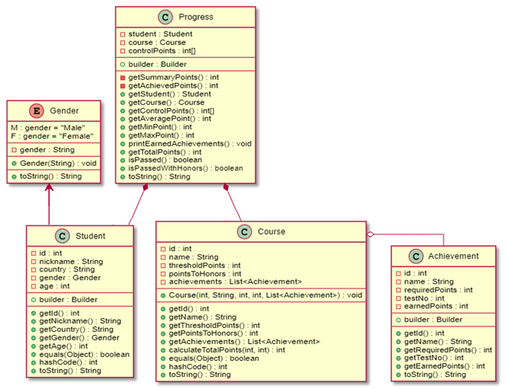
Figure 4 – Class diagram of all described classes

DatabaseConnection and DatabaseInteraction classes
Public class DatabaseConnection created a database connection. The database connection will be created once. This feature is implemented using the Singleton pattern. This pattern will be described in the next chapter. The DatabaseConnection class contains six private fields. The instance field is static. It contains the instance of the DataConnection class. The connection field of the Connection type contains the connection to the database. The string DRIVER, URL, USERNAME, PASSWORD fields are static final fields because they are constant. They contain driver name, database url, name and password of the database user.
The constructor of the DatabaseConnection class is private. It will create the database connection if the driver exists. If the driver does not exist, ClassNotFoundException will be raised. If this exception occurs, we will throw SQLException with the message “JDBC driver not found”. Further, this exception will be handled in the Main class. This method also will throw the SQLException if we have problems with connection to the database.
Public static getInstance method returns the instance of the DatabaseConnection class. It will create new instance of the DatabaseConnection class if the instance field is null or the connection was closed. This method will throw the SQLException if we have problems with the instance. The exception will be handled in the Main class. Public method getConnection returns the database connection.
Public class DatabaseInteraction reads data about students, courses, achievements and student’s progress from the database. It stores the cn field of the Connection type. The public constructor initializes this field.
This class contains four public methods for reading data from the database. There are readStudentsFromDb, readAchievementsFromDb, readCoursesFromDb and readProgressFromDb methods. They return lists of Student, Achievement, Course and Progress types. The readStudentsFromDb and readAchievementsFromDb methods has no parameters; the readCoursesFromDb method has achievements parameter of List<Achievement> type; the readProgressFromDb method has courses and students parameters of List<Course> and List<Student> types.
The DatabaseInteraction class also contains two private methods. There are getCourseById and getStudentById. These methods get parameters courses and students of List<Course> and List<Student> types and return Map<Integer, Course> and Map<Integer, Student>, which contains the instance of the Course and Student class and its identifier.

Graphic class
The public abstract class Graphic is the parent of the PieChart, Histogram, and DotPlot classes. This class, like its child classes, is part of the implementation of the Strategy pattern and is intended for plotting charts based on data from a database.
Because a class is abstract and not instantiated in the application, the class constructor is the default constructor.
The only field of the class is the protected GraphicStrategy graphicStrategy, which is intended to store the object that implements the plotting.
Public void create method is designed to create a window for the chart and display information on it. The class method applies the method of the same name to the GraphicStrategy class object.

Histogram, DotPlot and PieChart classes
These classes inherit from the Graphic class and are identical in their implementation. Each of the classes contains only a constructor that initializes the inherited graphicStrategy field. The object that is created depends on the class in which it is created. This can be DotPlotStrategy, HistogramStrategy or PieChartStrategy.

GraphicStrategy interface
This interface describes a single void create() method that uses an array of integers int[] data and a String name as arguments. This method is implemented in the DotPlotStrategy, HistogramStrategy, and PieChartStrategy classes.

HistogramStrategy, PieChartStrategy, DotPlotStrategy classes
These classes are identical in implementation and implement the graphicStrategy interface. The classes contain two integer fields X and Y that store the size of the window that is created when building graphs and histograms. These fields are constants, so there is no need to initialize them with the constructor. For this reason, all three classes use the default constructor.
The create () method is intended for graphing. Its implementation depends on the class in which this method is implemented. In general, the method uses int [] data as the data array for plotting the chart, and String name for setting the title of the chart window. Further, using the Swing and AWT libraries, the method creates a window object and draws a chart on it, the appearance of which depends on the class in which the method is implemented. After rendering, the method sets the title of the window and then exits.

Implementation of Design Patterns

Builder
Builder is a creational design pattern that helps to solve the issue with large number of optional parameters by providing a way to build the object step-by-step.
This pattern helps to create the class instances with many parameters and not confuse them especially when there are many fields of the same type in the class. The Builder pattern is also allows not filling in all the fields of the object and we do not need to create a large number of constructors for this feature. In addition, this pattern makes the code more readable.
The application includes two implementation of the Builder pattern. The first implementation creates an instance of the external class in the constructor of the Builder class. This implementation is applied in Student, Progress and Achievement classes. The second implementation used with the Factory method and contains all the fields of the Course class in the Builder class. The constructor of the Builder class initializes the category field that is responsible for the category to which the course belongs.
Figure 5 represents the UML-diagram of the Student class that implements the Builder pattern.
The code with the implementation of the Builder pattern in the Student class is presented below.

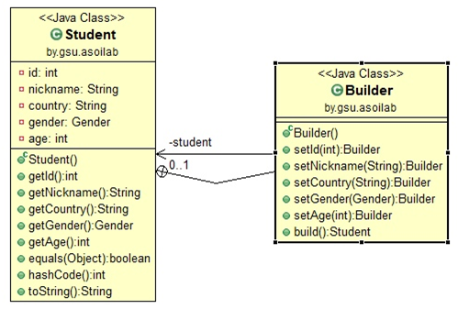
Figure 5 – Class diagram of the Builder pattern
public class Student {
private int id;
private String nickname;
private String country;
private Gender gender;
private int age;
public static class Builder {
private Student student;
public Builder() {
student = new Student();
}
public Builder setId(int id) {
student.id = id;
return this;
}
public Builder setNickname(String nickname) {
student.nickname = nickname;
return this;
}
public Builder setCountry(String country) {
student.country = country;
return this;
}
public Builder setGender(Gender gender) {
student.gender = gender;
return this;
}
public Builder setAge(int age) {
student.age = age;
return this;
}
public Student build() {
return student;
}
}
// getters and other methods
}
}
The Builder pattern made the procedure of creating an instance of a class more convenient. Now it looks like this:

Student student = new Student.Builder()
.setId(1)
.setNickname("Paul")
.setCountry("USA")
.setGender(Gender.M)
.setAge(20)
.build();

Factory Method with Builder
Factory method is a creational pattern that uses factory methods to deal with the problem of creating objects without having to specify the exact class of the object that will be created. We just create objects by calling a factory method.
The Factory Method pattern allows making the code for creating objects more flexible, without being tied to specific classes but operating only the general interface.
The application uses Factory Method to create instances of classes with different course categories.
Figure 6 represents the UML-diagram of Factory Method with Builder.
The illustrative code that implements Factory Method with Builder is shown below:

public abstract class Course {
private final int id;
private final String name;
private final int thresholdPoints;
private final int pointsToHonors;
private final List<Achievement> achievements;
// constructor, getters and equals, hashCode, toString methods
public abstract int calculateTotalPoints(int summaryPoints, int achievedPoints);
}

public class ProgrammingCourse extends Course {
// constructor
public int calculateTotalPoints(int summaryPoints, int achievedPoints) {
double result = summaryPoints + achievedPoints;
return (int)Math.round(result);
}
}

public class BiologyCourse extends Course {
// constructor
public int calculateTotalPoints(int summaryPoints, int achievedPoints) {
double result = summaryPoints + 0.75 * achievedPoints;
return (int)Math.round(result);
}
}

public class MathCourse extends Course {
// constructor
public int calculateTotalPoints(int summaryPoints, int achievedPoints) {
double result = 0.9 * summaryPoints + 0.8 * achievedPoints;
return (int)Math.round(result);
}
}

public class PhysicsCourse extends Course {
// constructor
public int calculateTotalPoints(int summaryPoints, int achievedPoints) {
double result = 0.85 * summaryPoints + achievedPoints;
return (int)Math.round(result);
}
}

public enum CourseCategories {
PROGRAMMING("Programming") {
public Course createCourse(int id, String name, int thresholdPoints, int pointsToHonors, List<Achievement> achievements) {
return new ProgrammingCourse(id, name, thresholdPoints, pointsToHonors, achievements);
}
},
MATH("Math") {
public Course createCourse(int id, String name, int thresholdPoints, int pointsToHonors, List<Achievement> achievements) {
return new MathCourse(id, name, thresholdPoints, pointsToHonors, achievements);
}
},
BIOLOGY("Biology") {
public Course createCourse(int id, String name, int thresholdPoints, int pointsToHonors, List<Achievement> achievements) {
return new BiologyCourse(id, name, thresholdPoints, pointsToHonors, achievements);
}
},
PHYSICS("Physics") {
public Course createCourse(int id, String name, int thresholdPoints, int pointsToHonors, List<Achievement> achievements) {
return new PhysicsCourse(id, name, thresholdPoints, pointsToHonors, achievements);
}
};
private String course;
CourseCategories(String course) {
this.course = course;
}
public abstract Course createCourse(int id, String name, int thresholdPoints, int pointsToHonors, List<Achievement> achievements);
@Override
public String toString() {
return course;
}
}

public class CourseFactory {
public static class Builder {
private int id;
private String name;
private int thresholdPoints;
private int pointsToHonors;
private CourseCategories category;
private List<Achievement> achievements;
public Builder(CourseCategories category) {
this.category = category;
}
public Builder setId(int id) {
this.id = id;
return this;
}
public Builder setName(String name) {
this.name = name;
return this;
}
public Builder setThresholdPoints(int thresholdPoints) {
this.thresholdPoints = thresholdPoints;
return this;
}
public Builder setPointsToHonors(int pointsToHonors) {
this.pointsToHonors = pointsToHonors;
return this;
}
public Builder setAchievements(List<Achievement> achievements) {
this.achievements = achievements;
return this;
}
public Course build() {
return category.createCourse(id, name, thresholdPoints, pointsToHonors, achievements);
}
}
}
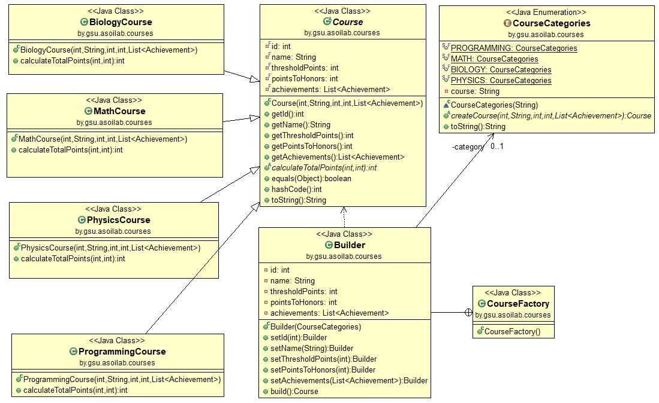
Figure 6 – Class diagram of Factory Method
Now, there is a common interface for creating instances of course classes. The instance creating process looks like this:

Course mathCourse = new CourseFactory.Builder(CourseCategories.MATH)
.setId(2)
.setName("Probability")
.setThresholdPoints(325)
.setPointsToHonors(335)
.setAchievements(achievements)
.build();

Singleton
The Singleton pattern is a design pattern that restricts the instantiation of a class to one “single” instance. This pattern is useful when exactly one object is needed to coordinate actions across the system.
The application uses the Singleton pattern to create the database connection. It helps to create a single connection for the entire program.
Figure 7 represents the UML-diagram of Singleton.
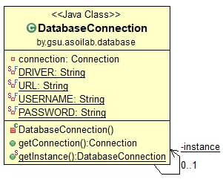
Figure 7 – Class diagram of Singleton
The code that implements the Singleton pattern is shown below:

public class DatabaseConnection {
private static DatabaseConnection instance;
private Connection connection;
private static final String DRIVER = "com.mysql.cj.jdbc.Driver";
private static final String URL = "jdbc:mysql://127.0.0.1:3306/courses_db?serverTimezone=Europe/Minsk";
private static final String USERNAME = "name";
private static final String PASSWORD = "password";
private DatabaseConnection() throws SQLException {
try {
Class.forName(DRIVER);
this.connection = DriverManager.getConnection(URL, USERNAME, PASSWORD);
} catch (ClassNotFoundException e) {
throw new SQLException("JDBC driver not found!");
}
}
public Connection getConnection() {
return connection;
}
public static DatabaseConnection getInstance() throws SQLException {
if (instance == null || instance.getConnection().isClosed()) {
instance = new DatabaseConnection();
}
return instance;
}
}

Strategy
The strategy pattern is a behavioral software design pattern that enables selecting an algorithm at runtime. Instead of implementing a single algorithm directly, code receives run-time instructions as to which in a family of algorithms to use.
Strategy lets the algorithm vary independently from clients that use it. Deferring the decision about which algorithm to use until runtime allows the calling code to be more flexible and reusable.
The application uses the Strategy for charting.
Figure 8 represents the UML-diagram of Strategy.
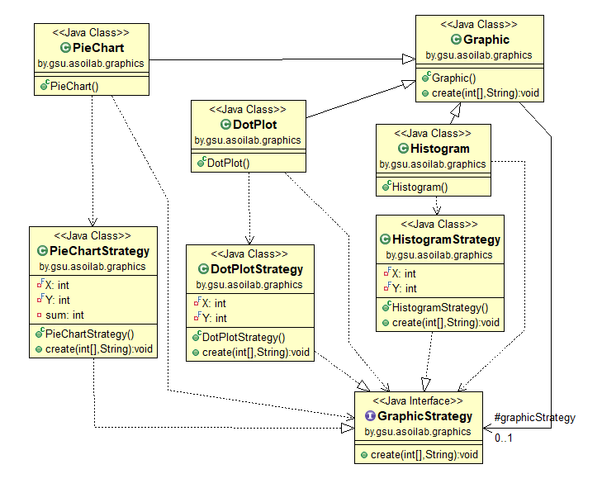
Figure 8 – Class diagram of Strategy
The code that implements the Strategy pattern is shown below:
public interface GraphicStrategy {
public void create(int[] data, String name);
}
public class DotPlotStrategy implements GraphicStrategy {
private final int X = 500;
private final int Y = 300;
@Override
public void create(int[] data, String name) {
//realization
}
}
public class HistogramStrategy implements GraphicStrategy {
private final int X = 500;
private final int Y = 300;
@Override
public void create(int[] data, String name) {
//realization
}
}
public class PieChartStrategy implements GraphicStrategy {
private final int X = 500;
private final int Y = 300;
private int sum;
@Override
public void create(int[] data, String name) {
//realization
}
}
abstract public class Graphic {
protected GraphicStrategy graphicStrategy;
public void create(int[] data, String str) {
graphicStrategy.create(data, str);
}
public class Histogram extends Graphic {
public Histogram() {
this.graphicStrategy = new HistogramStrategy();
}
}
public class DotPlot extends Graphic {
public DotPlot() {
this.graphicStrategy = new DotPlotStrategy();
}
}
public class PieChart extends Graphic {
public PieChart() {
this.graphicStrategy = new PieChartStrategy();
}
}

Testing the Application
The Student, Progress, Achievement and group of Course classes were tested using the JUnit framework. There are StudentTest, ProgressTest, AchievementTest and CourseTest classes that were created for testing.
The StudentTest class includes tests of getId, getNickname, getCountry, getGender, getAge and toString methods. These tests check if the values of the Stu-dent class are equal to the expected values.
The ProgressTest class includes tests of getStudent, getCourse, getCon-trolPoints, toString, getTotalPoints, getAveragePoint, getMaxPoint, getMinPoint, isPassed and isPassedWithHonors methods. The getStudent, getCourse, getCon-trolPoints, toString, isPassed and isPassedWithHonors tests check if the values of the Progress class methods are equal to the expected values and the getTotalPoints, getAveragePoint, getMaxPoint, getMinPoint tests check the correctness of the algo-rithms performed.
The AchievementTest class includes tests of getId, getName, getRequiredPoints, getEarnedPoints, getTestNo and toString methods. These tests check if the values of the Achievement class are equal to the expected values.
The CourseTest class includes tests of getId, getName, getThreshold, get-PointsToHonors, getAchievements, calculateTotalPoints and toString methods. These tests check if the values of the tested classes are equal to the expected values and the correctness of the calculation performed in the calculateTotalPoints method.
All described tests were passed successfully.

Conclusion

The student performance tracking system was completely finished. The appli-cation gets all needed information from the database and then can display information about student’s points, achievements and create three types of progress charts. There are pie chart, histogram and dot plot.
The application includes four design patterns:
- Builder;
- Factory Method;
- Singleton;
- Strategy.
We also tested Student, Progress, Achievement and group of Course classes with the JUnit framework. All tests were passed successfully.

List of sources

- Blinov I., Romanchik V. Java. Методы программирования / I. Blinov, V. Romanchik. – Minsk: Four quarters, 2013. – 896 pages.
- Khabibullin I. Java 7 / I. Khabibullin. – St. Petersburg: BHV-Petersburg, 2012. – 768 pages.
- Design patterns in Java [Electronic resource]. URL: https://refactoring.guru/design-patterns/java (Date of request: 17.12.2020).
- Software design patterns [Electronic resource]. URL: https://en.wikipedia.org/wiki/Software_design_pattern (Date of request: 17.12.2020).
- The Java Tutorials [Electronic resource]. URL https://docs.oracle.com/javase/tutorial/ (Date of request: 17.12.2020).

ESSAY

Course work contains 30 pages, 8 figures, 5 sources.

Key words: design patterns, builder, factory method, singleton, strategy, student performance tracking system.

Goals and objectives of the course work: the purpose of the course work is to create a student performance tracking system, which will help to get information about students’ results and achievements, and create charts reflecting learning statistics.

A summary of the course work: course work consists of an introduction, two chapters, a conclusion and a list of sources used.

Conclusions: course work performed in accordance with the assignment for course design. In the end, there is a work program that performs all the actions described.

Ministry of Education of Republic of Belarus

Educational Establishment
«Francisk Skorina Gomel State University»

Faculty of Physics and Information Technologies

Department of Automated Systems of Information Processing

Students performance tracking system

on the Discipline “Design Patterns”

Researcher
student of the group AS-36 ____________ Aliaksei Sapanovich

Research advisor
Head of the Department ASIP,
Ph.D. in Technics ____________ Viktar Liauchuk

Gomel 2020

