Content
Introduction 3
1 Advantages of Design Patterns 4
1.1 Builder pattern 4
1.2 Mediator pattern 8
2 This example shows how easily we can separate dependent objects and make our system easier to maintain.Practical Research 11
2.1 Formulation of the Problem 11
2.2 Description of Entities 11
2.2.1 Game package 11
2.2.2 Board package 13
2.2.3 Piece package 15
2.3 Implementation of Design Patterns 19
2.3.1 Factory 19
2.3.2 Template method pattern 20
Conclusion 23
List of sources used 24

Introduction
This coursework involves the using of Java programming language to create a program that uses Design Patterns. We have created an application that implements the possibilities of playing Chess in player versus player mode.
The coursework contains two chapters. The first chapter describes the benefits of design patterns. It includes descriptions of two design patterns that we did not use in the developed application. The description includes short formulation of the problem and its obvious implementation with described drawbacks, the idea of their fixing with the illustrative java code and class diagram, and achieved results.
The second chapter is divided into three parts. The first part includes a problem statement, which describes in detail the statement of the problem that we are going to solve. The second part includes a description of entities, where we describe all our classes and interfaces of the developed application and the relationships between them. The third part includes a description of the design patterns that we used in the developed application, where we need to describe their purpose, a class diagram with our entities, illustrative Java code and the results achievedAdvantages of Design Patterns.

Advantages of Design Patterns

Builder pattern
The essence of the pattern
Builder is a generative design pattern that lets you create complex objects step by step. The builder makes it possible to use the same building code to get different representations of objects.
Problem
Imagine a complex object that requires painstaking, step-by-step initialization of many fields and nested objects. The initialization code for such objects is usually hidden inside a monstrous constructor with a dozen parameters. Or even worse, it is dispersed throughout the client code.
Solution
For example, let's create a "bad" class with two required parameters and four optional parameters.

public class BadClass {
private final int reqFieldOne;
private final int reqFieldTwo;
private final int optFieldOne;
private final int optFieldTwo;
private final int optFieldThird;
private final int optFieldFour;

public BadClass(int reqFieldOne, int reqFieldTwo) {
this(reqFieldOne, reqFieldTwo, 0);
}

public BadClass(int reqFieldOne, int reqFieldTwo,
int optFieldOne) {
this(reqFieldOne, reqFieldTwo, optFieldOne, 0);
}

public BadClass(int reqFieldOne, int reqFieldTwo,
int optFieldOne, int optFieldTwo) {
this(reqFieldOne, reqFieldTwo, optFieldOne, optFieldTwo, 0);
}

public BadClass(int reqFieldOne, int reqFieldTwo,
int optFieldOne, int optFieldTwo, int optFieldThird) {
this(reqFieldOne, reqFieldTwo, optFieldOne, optFieldTwo, optFieldThird, 0);
}

public BadClass(int reqFieldOne, int reqFieldTwo,
int optFieldOne, int optFieldTwo, int optFieldThird, int optFieldFour) {
this.reqFieldOne = reqFieldOne;
this.reqFieldTwo = reqFieldTwo;
this.optFieldOne = optFieldOne;
this.optFieldTwo = optFieldTwo;
this.optFieldThird = optFieldThird;
this.optFieldFour = optFieldFour;
}
}
Instantiating a class using a constructor with an entire set of parameters.
BadClass badClass = new BadClass (3, 3, 3, 3, 4, 5);
Looking at a set of numbers is hard to understand the code. True, at the moment the studio displays a hint directly in the editor, which simplified the task. But the same code published on the site will not contain such hints, so the problem remains. In addition, increasing the number of parameters only makes the code more difficult to maintain.
Another option is to call the parameterless constructor to create the object, and then call setters to set the required and some optional parameters.

public class BadClass {
// initialize some parameters with default values
private int reqFieldOne = -1;
private int reqFieldTwo = -1;
private int optFieldOne = 0;
private int optFieldTwo = 0;
private int optFieldThird = 0;
private int optFieldFour = 0;

public BadClass() {
}

// Setters
public void setReqFieldOne(int val) {
reqFieldOne = val;
}

public void setReqFieldTwo(int val) {
reqFieldTwo = val;
}

public void setOptFieldOne(int optFieldOne) {
this.optFieldOne = optFieldOne;
}

public void setOptFieldTwo(int optFieldTwo) {
this.optFieldTwo = optFieldTwo;
}

public void setOptFieldThird(int optFieldThird) {
this.optFieldThird = optFieldThird;
}

public void setOptFieldFour(int optFieldFour) {
this.optFieldFour = optFieldFour;
}
}
The amount of code in the class increases, but the code becomes more readable when the class is instantiated.

BadClass badClass = new BadClass();
badClass.setReqFieldOne(10);
badClass.setReqFieldTwo(30);
badClass.setOptFieldOne(20);
// и т.д.
But this approach also has disadvantages. The class is in an unstable state because it depends on many separate method calls and cannot provide a check for its state.
Therefore, a third option was invented, which was called the Builder pattern. Instead of directly creating an object of the class, a constructor (or static method) is called with all the required parameters to get the Builder object. The setters are then called to set all the required parameters. Finally, the build () method is called to generate an object that is immutable. This approach is implemented through a static inner class.
An example of the pattern implementation
Let's create a "good" class using Builder.

public class GoodClass {
private final int reqFieldOne;
private final int reqFieldTwo;
private final int optFieldOne;
private final int optFieldTwo;
private final int optFieldThird;
private final int optFieldFour;

public static class Builder {
// Обязательные параметры
private final int reqFieldOne;
private final int reqFieldTwo;

// Необязательные параметры с значениями по умолчанию
private int optFieldOne = 0;
private int optFieldTwo = 0;
private int optFieldThird = 0;
private int optFieldFour = 0;

public Builder(int reqFieldOne, int reqFieldTwo) {
this.reqFieldOne = reqFieldOne;
this.reqFieldTwo = reqFieldTwo;
}

public Builder optFieldOne(int val) {
optFieldOne = val;
return this;
}

public Builder optFieldTwo(int val) {
optFieldTwo = val;
return this;
}

public Builder optFieldThird(int val) {
optFieldThird = val;
return this;
}

public Builder optFieldFour(int val) {
optFieldFour = val;
return this;
}

public GoodClass buidl() {
return new GoodClass(this);
}
}

private GoodClass(Builder builder) {
reqFieldOne = builder.reqFieldOne;
reqFieldTwo = builder.reqFieldTwo;
optFieldOne = builder.optFieldOne;
optFieldTwo = builder.optFieldTwo;
optFieldThird = builder.optFieldThird;
optFieldFour = builder.optFieldFour;
}
}
The GoodClass class is immutable and all default parameter values are in one place. Setters return a builder class, so calls can be chained.

GoodClass goodClass = new GoodClass.Builder(40, 20)
.optFieldOne(2)
.optFieldTwo(4)
.optFieldThird(23)
.optFieldFour(9)
.buidl();
This approach makes the code easier to write and easier to read. The template has other advantages, for example, multiple varags parameters can be used.

The downside to the template is the cost of creating the Builder class, but if you later extend the class, the approach pays off.

Create a Builder when there are four or more parameters. Otherwise, use the traditional approach.

Mediator pattern
The essence of the pattern
In object-oriented programming, we should always try to design the system in such a way that components are loosely coupled and reusable. This approach makes our code easier to maintain and test.
In real life, however, we often need to deal with a complex set of dependent objects. This is when the Mediator Pattern may come in handy.
The intent of the Mediator Pattern is to reduce the complexity and dependencies between tightly coupled objects communicating directly with one another. This is achieved by creating a mediator object that takes care of the interaction between dependent objects. Consequently, all the communication goes through the mediator.
This promotes loose coupling, as a set of components working together no longer have to interact directly. Instead, they only refer to the single mediator object. This way, it is also easier to reuse these objects in other parts of the system.
Problem
Imagine we're building a simple cooling system that consists of a fan, a power supply, and a button. Pressing the button will either turn on or turn off the fan. Before we turn the fan on, we need to turn on the power. Similarly, we have to turn off the power right after the fan is turned off.
Solution
Let's now take a look at the example implementation:

public class Button {
private Fan fan;

// constructor, getters and setters

public void press(){
if(fan.isOn()){
fan.turnOff();
} else {
fan.turnOn();
}
}
}
public class Fan {
private Button button;
private PowerSupplier powerSupplier;
private boolean isOn = false;

// constructor, getters and setters

public void turnOn() {
powerSupplier.turnOn();
isOn = true;
}

public void turnOff() {
isOn = false;
powerSupplier.turnOff();
}
}
public class PowerSupplier {
public void turnOn() {
// implementation
}

public void turnOff() {
// implementation
}
}

Next, let's test the functionality:

@Test
public void givenTurnedOffFan_whenPressingButtonTwice_fanShouldTurnOnAndOff() {
assertFalse(fan.isOn());

button.press();
assertTrue(fan.isOn());

button.press();
assertFalse(fan.isOn());
}
Everything seems to work fine. But notice how Button, Fan, and PowerSupplier classes are tightly coupled. The Button operates directly on the Fan and the Fan interacts with both Button and PowerSupplier.
It would be hard to reuse the Button class in other modules. Also, if we need to add a second power supply into our system, then we would have to modify the Fan class' logic.
An example of the pattern implementation
Now, let's implement the Mediator Pattern to reduce the dependencies between our classes and make the code more reusable.
First, let's introduce the Mediator class:
public class Mediator {
private Button button;
private Fan fan;
private PowerSupplier powerSupplier;

// constructor, getters and setters

public void press() {
if (fan.isOn()) {
fan.turnOff();
} else {
fan.turnOn();
}
}

Next, let's modify the remaining classes:

public class Button {
private Mediator mediator;

// constructor, getters and setters

public void press() {
mediator.press();
}
}
public class Fan {
private Mediator mediator;
private boolean isOn = false;

// constructor, getters and setters

public void turnOn() {
mediator.start();
isOn = true;
}

public void turnOff() {
isOn = false;
mediator.stop();
}
}

@Test
public void givenTurnedOffFan_whenPressingButtonTwice_fanShouldTurnOnAndOff() {
assertFalse(fan.isOn());

button.press();
assertTrue(fan.isOn());

button.press();
assertFalse(fan.isOn());
}
Our cooling system works as expected.
Now that we've implemented the Mediator Pattern, none of the Button, Fan, or PowerSupplier classes communicate directly. They only have a single reference to the Mediator.
If we need to add a second power supply in the future, all we have to do is to update Mediator's logic; Button and Fan classes remain untouched.

This example shows how easily we can separate dependent objects and make our system easier to maintain.Practical Research

Formulation of the Problem
To begin with, when creating a game Chess in the JAVA programming language, the main advantages of this choice were the following criteria:
- Ability to implement one of the most popular and challenging games in the world for two players.
- The game itself has a huge potential for working with code and algorithms later
- The ability to transfer the game to the server and, as a result, the creation of games online player against player
- Possibility of writing a player versus computer game mode through various implementations: mathematical models, script models.
- Possibility of further training of models through machine learning and generative learning
Therefore, in order to have all of the above possibilities, it is necessary to re-create the game, which we can subsequently recycle and refine.

The application currently has a console interface and a player versus player game mode. In the future, the development of the project is likely, the emergence of a server component, the emergence of a player versus computer game mode and the possibility of training models.

Description of Entities

Game package
The game package is responsible for creating the game as a whole - creating a board, initializing players, generating game pieces and fields in general. The game package contains the following classes:
- Game class;
- Game status class;
- Player class.
Figure 1 represents the UML-diagram of all described classes.
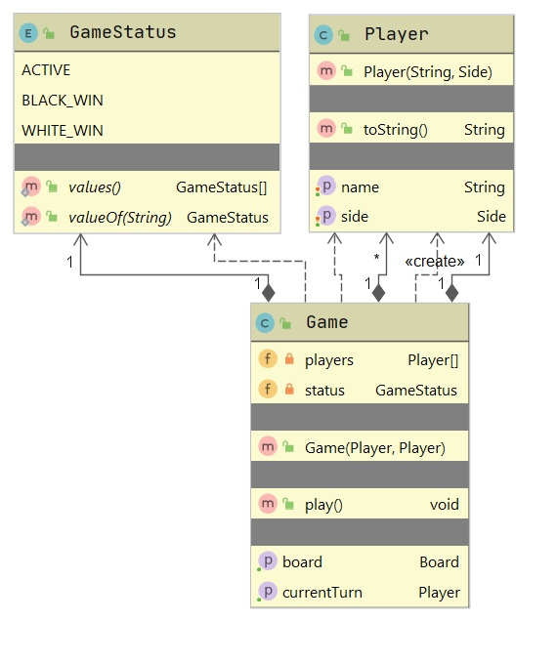
Figure 1 – Class diagram of all described classes

Game class
The game class is responsible for creating the game as a whole - creating a board, initializing players, generating game pieces and cells in general.
Class fields:
- private Player[] players – stores player data;
- private Board board – stores board information;
- private Player currentTurn – stores information whose move;
- private GameStatus status – stores information about the status of the game.

Constructors:
- public Game(Player player1, Player player2) - parameterized game constructor.
Methods:
- public void play() - method that launches the game;
- public Board getBoard() – returns board;
- public Player getCurrentTurn() – returns current turn.

Game status class
Game status class is an enumeration and contains possible game statuses.
Class fields:
- public enum GameStatus - stores various states of the game - ACTIVE, BLACK_WIN, WHITE_WIN.

Player class
Player class allows you to create a character, give him a name and side.
Class fields:
- private String name – stores players name;
- private Side side – stores players side.

Constructors:
- public Player(String name, Side side) - parameterized player constructor.

Methods:
- public String getName() – returns name;
- public Side getSide() – returns side;
- public String toString() – returns String (name (side));
- public void setName(String name) – set name;
- public void setSide(Side side) – set side.

Board package
Board package allows you to create a field, its cells, and describes the possibility of movement. Board package allows you to create a field, its cells, and describes the possibility of movement. Board package contains the following classes:
- Board class;
- Cell class;
- Move class.
Figure 2 represents the UML-diagram of all described classes.
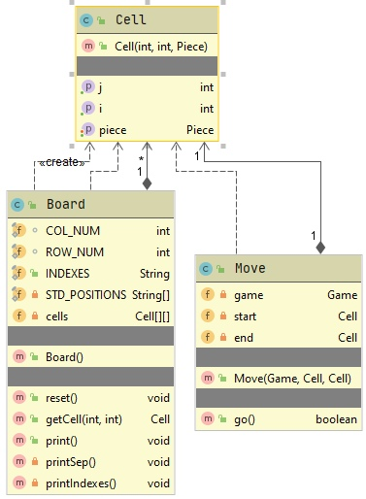
Figure 2 – Class diagram of all described classes

Board class
Board class describes the board and is responsible for displaying the board to the console.
Class fields:
- final static int COL_NUM – stores number of board columns;
- final static int ROW_NUM – stores number of board rows;
- public final static String INDEXES – stores literal indexes;
- private final static String[] STD_POSITIONS – stores standart positions of pieces on the board;
- private Cell[][] cells – representation of the board in the program as a two-dimensional array.

Methods:
- public Board() – creates board;
- public void reset() – places pieces in squares when starting a new game;
- public Cell getCell(int i, int j) – returns cell[i][j];
- public void print() – print game board to the console with separators, indexes and pieces;
- private void printSep() – print separators of the board;
- private void printIndexes() – print indexes of the board;

Cell class
Describes a cell object.
Class fields:
- private Piece piece – stores information about piece (name,side);
- private int i – stores cell position in line;
- private int j – storese cell position in column.

Constructors:
- public Cell(int i, int j, Piece piece) - parameterized cell constructor.

Methods:
- public Piece getPiece() – returns piece;
- public void setPiece(Piece p) – set piece;
- public int getI() – returns position in line;
- public int getJ() – returns position in column.

Move class
Describes the movement of figures and makes checks.
Class fields:
- private Game game – stores information about game;
- private Cell start, end – stores cell information of the initial and final position;

Constructors:
- public Move(Game game, Cell start, Cell end) - parameterized move constructor.

Methods:
- public boolean go() – checks the presence of a piece in the cell and the possibility of making a move, if possible.

Piece package
Piece package describes an object such as a shape that is inherited for a specific shape with a rank. Depending on the rank, the mathematics of the possibility of the move is calculated and a check is made. Piece package contains the following classes:
- Side class;
- Piece class;
- PieceKind class;
- PiecesFactory;
- Pawn class;
- Rock class;
- Knight class;
- Bishop class;
- Queen class;
- King class.

Figure 3 represents the UML-diagram of all described classes.
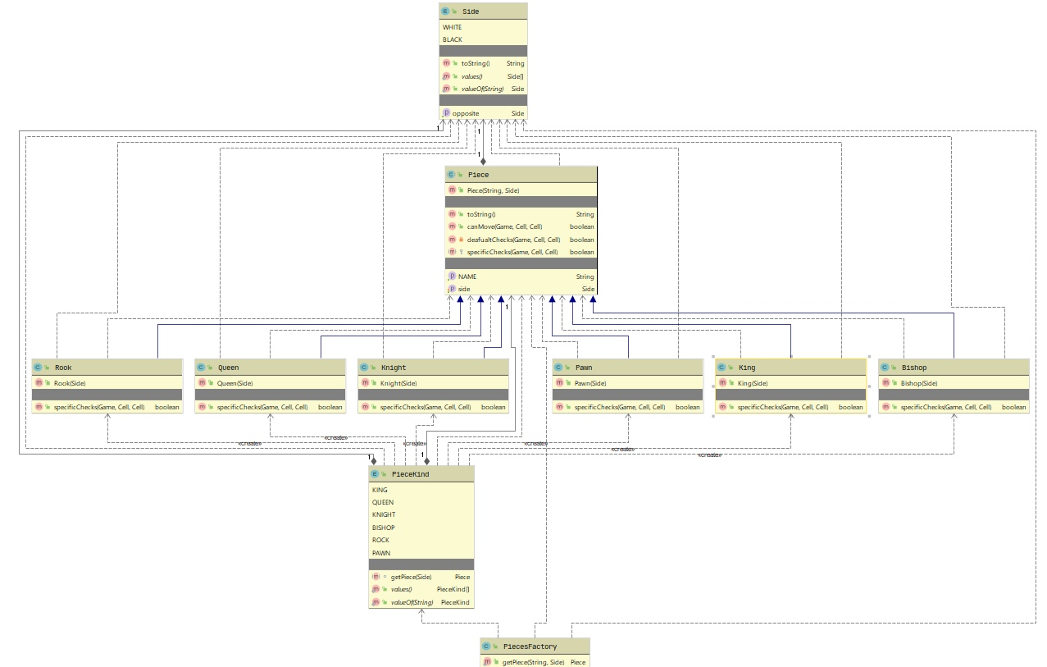
Figure 3 – Class diagram of all described classes

Side class
Side class is an enumeration that stores the side of the player.
Class fields:
- public enum Side – stores information about players and pieces side (WHITE, BLACK).
Methods:
- public Side getOpposite() – get opposite side of player or piece;
- public String toString() – get side in lower case.

Piece class
Piece class describes a piece and makes checks for the possibility of making a move. In the same class implements pattern template.
Class fields:
- private final String NAME – stores piece name;
- private Side side – stores side of piece.

Constructors:
- public Piece(String name, Side side) - parameterized piece constructor.

Methods:
- public String getNAME() – returns piece name;
- public Side getSide() – returns piece side;
- public void setSide(Side side) – set piece side;
- public String toString() – returns String in format side.name().toLowerCase().charAt(0) + NAME;
- public boolean canMove(Game game, Cell start, Cell end) – makes checks for the possibility of movement;
- private boolean deafualtChecks(Game game, Cell start, Cell end) - checks the correctness of the piece selection move before the move;
- protected abstract boolean specificChecks(Game game, Cell start, Cell end) - an abstract method for checking each figure depending on the rank of the figure.

PieceKind class
PieceKind is an enum that describes each piece's rank.
Class fields:
- public enum PieceKind – stores the titles of the figures.

Methods:
- Piece getPiece(Side side) – returns a new object of a certain title;

PiecesFactory class
Class fields:
- public static Piece getPiece(String pieceId, Side side) - a static method that returns an object based on rank.

Pawn class
Constructors:
- public Pawn(Side side) – parametrized pawn constructor.

Methods:
- public boolean specificChecks(Game game, Cell start, Cell end) - method for checking each figure depending on the rank of the figure.

Rock class
Constructors:
- public Rook(Side side) - parametrized rook constructor.

Methods:
- public boolean specificChecks(Game game, Cell start, Cell end) - method for checking each figure depending on the rank of the figure.

Knight class
Constructors:
- public Knight(Side side) - parametrized knight constructor.

Methods:
- public boolean specificChecks(Game game, Cell start, Cell end) - method for checking each figure depending on the rank of the figure.

Bishop class
Constructors:
- public Bishop(Side side) - parametrized bishop constructor.

Methods:
- public boolean specificChecks(Game game, Cell start, Cell end) - method for checking each figure depending on the rank of the figure.

Queen class
Constructors:
- public Queen(Side side) - parametrized queen constructor.

Methods:
- public boolean specificChecks(Game game, Cell start, Cell end) - method for checking each figure depending on the rank of the figure.

King class
Constructors:
- public King(Side side) - parametrized king constructor.

Methods:
- public boolean specificChecks(Game game, Cell start, Cell end) - method for checking each figure depending on the rank of the figure.

Implementation of Design Patterns

Factory
Factory Method is a creational pattern. This design pattern provides an interface for instantiating some class. At the time of creation, inheritors can determine which class to instantiate.
In other words, the Factory delegates the creation of objects to the heirs of the parent class. This allows you to use in the program code not specific classes, but to manipulate abstract objects at a higher level.
Figure 4 represents the UML-diagram of the classes, that implements factory pattern.

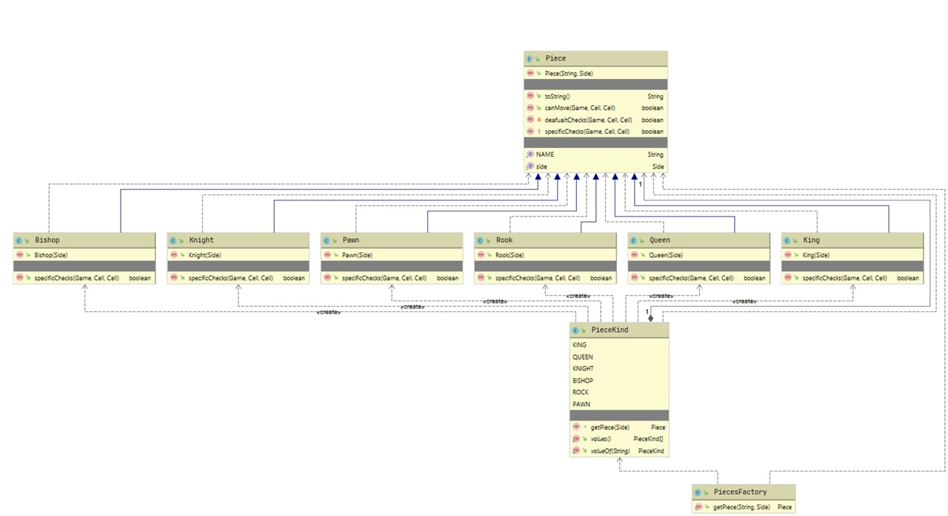
Figure 4 – Class diagram of the Factory pattern
package chess.piece;

public class PiecesFactory {

public static Piece getPiece(String pieceId, Side side) {
PieceKind kind = PieceKind.valueOf(pieceId);
return kind.getPiece(side);
}
}

package chess.piece;

public enum PieceKind {
KING {
Piece getPiece(Side side) {
return new King(side);
}
},
QUEEN {
Piece getPiece(Side side) {
return new Queen(side);
}
},
KNIGHT {
Piece getPiece(Side side) {
return new Knight(side);
}
},
BISHOP {
Piece getPiece(Side side) {
return new Bishop(side);
}
},
ROCK {
Piece getPiece(Side side) {
return new Rook(side);
}
},
PAWN {
Piece getPiece(Side side) {
return new Pawn(side);
}
};

abstract Piece getPiece(Side side);
}

Template method pattern
In Template pattern, an abstract class exposes defined way(s)/template(s) to execute its methods. Its subclasses can override the method implementation as per need but the invocation is to be in the same way as defined by an abstract class. This pattern comes under behavior pattern category.
Figure 5 represents the UML-diagram of the classes, that implements template method pattern.

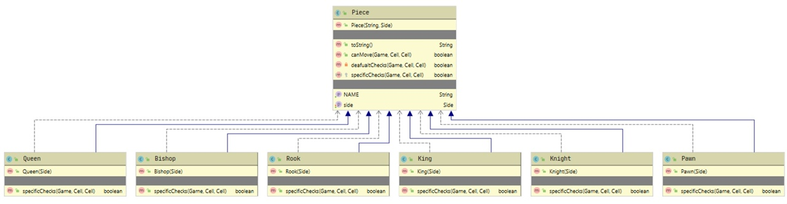
Figure 4 – Class diagram of the Template method pattern

package chess.piece;

import chess.board.Cell;
import chess.game.Game;

public abstract class Piece {
private final String NAME;
private Side side;

public Piece(String name, Side side) {
this.NAME = name;
this.side = side;
}

public String getNAME() {
return NAME;
}

public Side getSide() {
return side;
}

public void setSide(Side side) {
this.side = side;
}

@Override
public String toString() {
return side.name().toLowerCase().charAt(0) + NAME;
}

public boolean canMove(Game game, Cell start, Cell end) {
return deafualtChecks(game, start, end) & specificChecks(game, start, end);
}

private boolean deafualtChecks(Game game, Cell start, Cell end) {

if (end.getPiece() != null) {
if (end.getPiece().getSide() == this.getSide()) {
System.out.println("You cann't attact your pieces!");
return false;
}
}

if (this.getSide() != game.getCurrentTurn().getSide()) {
System.out.println("This is not your piece!");
return false;
}

return true;
};

protected abstract boolean specificChecks(Game game, Cell start, Cell end);
}

Conclusion

A completely developed game of chess in player versus player mode with a console interface in the Java programming language. Now we have the source code of the game with which we can interact later and develop various additions in the form of a server component, online games, player versus computer game modes and training models.
The app includes two design patterns:
- Factory;
- Template;
The classes were also tested. All tests passed successfully.

List of sources used
1 Romanchik, V. Java. Методы программирования / V. Romanchik, I. Blinov. – Minsk: Four Quarters, 2013. – 896 p.
2 Savitch, W. The Java Language. Programming Course / W. Savitch. – M.: Williams, 2015. – 928 p.
3 Design Patterns in Java [Electronic resource]. M., 2014 – 2020. URL: https://refactoring.guru/design-patterns/java. — Date of request: 12.12.2020.
4 Design Patterns in Java Tutorial – Tutorialspoint [Electronic resource]. M., 2016 – 2020. URL: https://www.tutorialspoint.com/design_pattern/index.htm. —Date of request: 11.12.2020.

ESSAY

Course work contains 30 pages, 8 figures, 5 sources.

Key words: design patterns, builder, factory method, singleton, strategy, student performance tracking system.

Goals and objectives of the course work: the purpose of the course work is to create a student performance tracking system, which will help to get information about students’ results and achievements, and create charts reflecting learning statistics.

A summary of the course work: course work consists of an introduction, two chapters, a conclusion and a list of sources used.

Conclusions: course work performed in accordance with the assignment for course design. In the end, there is a work program that performs all the actions described.

Ministry of Education of Republic of Belarus

Educational Establishment
«Francisk Skorina Gomel State University»

Faculty of Physics and Information Technologies

Department of Automated Systems of Information Processing

Students performance tracking system

on the Discipline “Design Patterns”

Researcher
student of the group AS-36 ____________ Aliaksei Drabysheuski

Research advisor
Head of the Department ASIP,
Ph.D. in Technics ____________ Viktar Liauchuk

Gomel 2020

