**1. What is DAM and Why Do We Use It?**

**Digital Asset Management (DAM)** in AEM is a system that allows users to store, manage, and retrieve digital assets like images, videos, and documents.

**Why Use DAM?**

1. **Centralized Storage** – All digital assets are stored in one place.
2. **Version Control** – Keeps track of different versions of assets.
3. **Metadata Management** – Stores extra information like title, description, and tags.
4. **Search and Filtering** – Easily find assets using search and filters.
5. **Renditions** – Automatically generates different image sizes for various screen resolutions.

**Path for DAM in AEM:**  
<http://localhost:4502/assets.html/content/dam>

**2. Creating a Folder & Uploading Images (10 Marks)**

**Steps to Create the Folder:**

1. Navigate to **AEM > Assets > Files**
2. Click on **Create** → **Folder**
3. Name the folder: **myTraining**
4. Inside **myTraining**, create the path:

Upload two images:

1. Click on the **Upload** button.
2. Select two images from your computer.

**Authoring Images on a Page Using Image Component:**

1. Open **AEM Sites** → Edit any page in **edit mode**.
2. Drag and drop the **Image Component** onto the page.
3. Select the **two images** uploaded in DAM.
4. Save & Publish the page.

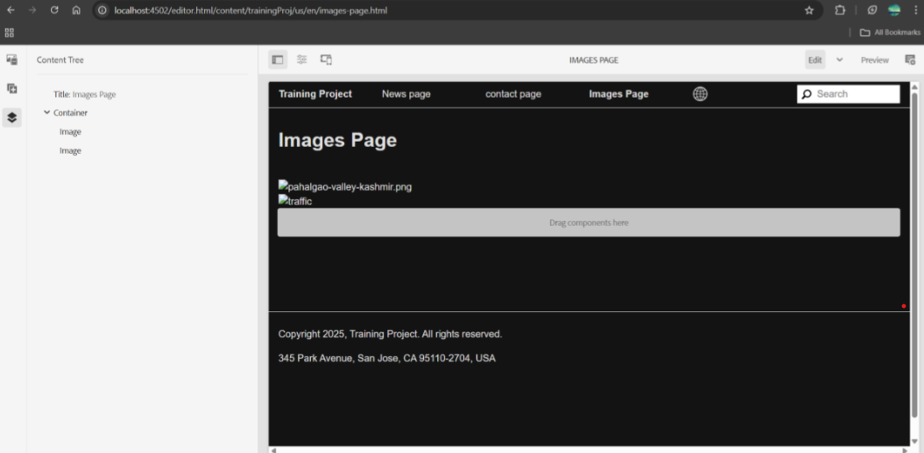

**3. What is Renditions? Check Renditions for Uploaded Images (10 Marks)**

**Renditions** are **different versions of an image** generated automatically by AEM when an image is uploaded to DAM.

**How to Check Renditions?**

1. Open **AEM Assets** and go to:/content/dam/myTraining/us/en-us
2. Select the uploaded image and click on **Renditions** in the properties panel.
3. You will see multiple versions, such as:
   * **Original** (Full-size image)
   * **Thumbnail** (cq5dam.thumbnail.48.48.png)
   * **Web Optimized** (cq5dam.web.1280.1280.png)

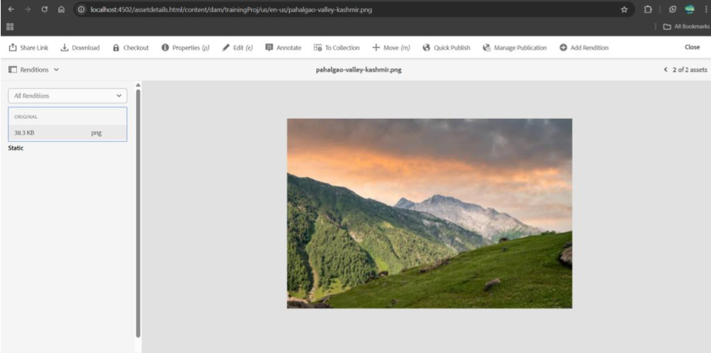

**Purpose of Renditions:**

* Used for **responsive images** on different devices.
* Improves **performance** by loading optimized images.

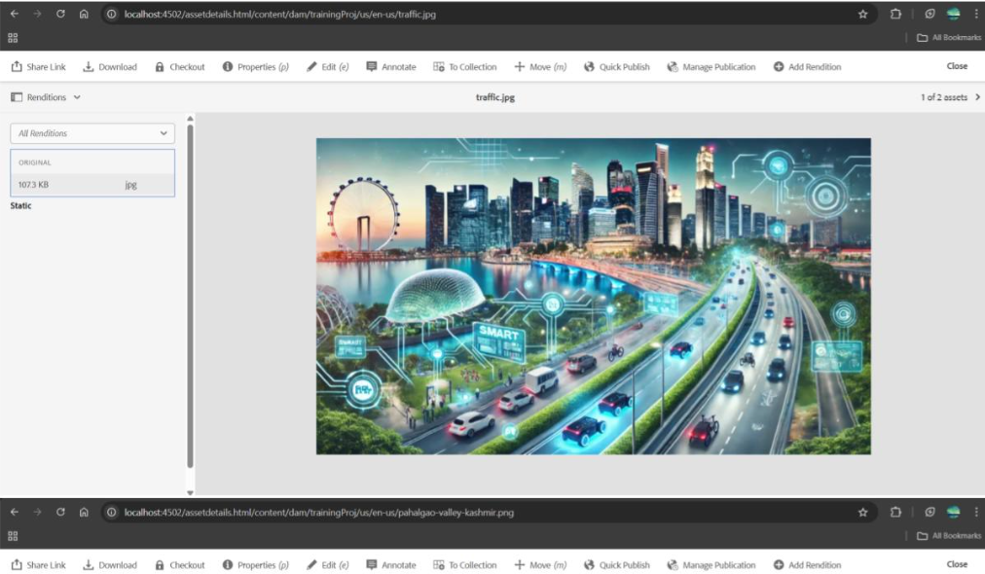

**4. Adding Two Fields (FirstName & LastName) in HelloWorld Component**

**Steps to Add Fields in cq:dialog**

1. Open helloWorld component in **CRX/DE** (/apps/myTraining/components/helloWorld).
2. Add the following fields in cq:dialog:

<items jcr:primaryType="nt:unstructured">

<firstName

jcr:primaryType="nt:unstructured"

sling:resourceType="granite/ui/components/coral/foundation/form/textfield"

fieldLabel="First Name"

name="./firstName"/>

<lastName

jcr:primaryType="nt:unstructured"

sling:resourceType="granite/ui/components/coral/foundation/form/textfield"

fieldLabel="Last Name"

name="./lastName"/>

</items>

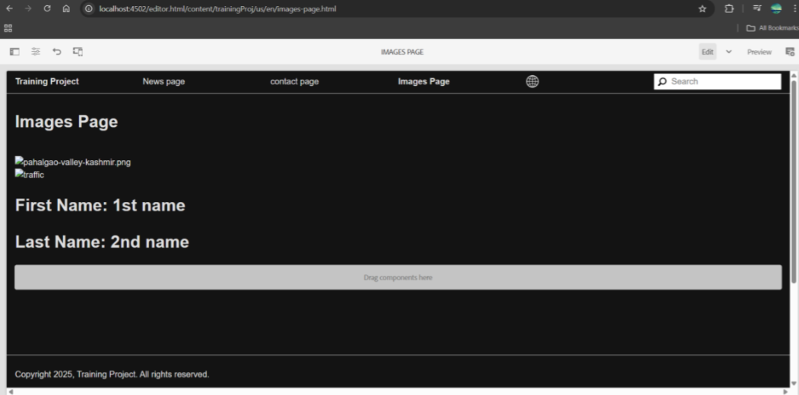

**Modify helloWorld.html to Display Values**

<div>

<h2>Hello, ${properties.firstName} ${properties.lastName}!</h2>

</div>

**5. Using @ValueMapValue in HelloWorldModel Sling Java Model (10 Marks)**

Modify HelloWorldModel.java

package com.myTraining.core.models;

import org.apache.sling.api.resource.Resource;

import org.apache.sling.models.annotations.Default;

import org.apache.sling.models.annotations.Model;

import org.apache.sling.models.annotations.injectorspecific.ValueMapValue;

@Model(adaptables = Resource.class)

public class HelloWorldModel {

@ValueMapValue

@Default(values = "John")

private String firstName;

@ValueMapValue

@Default(values = "Doe")

private String lastName;

public String getFirstName() {

return firstName;

}

public String getLastName() {

return lastName;

}

}

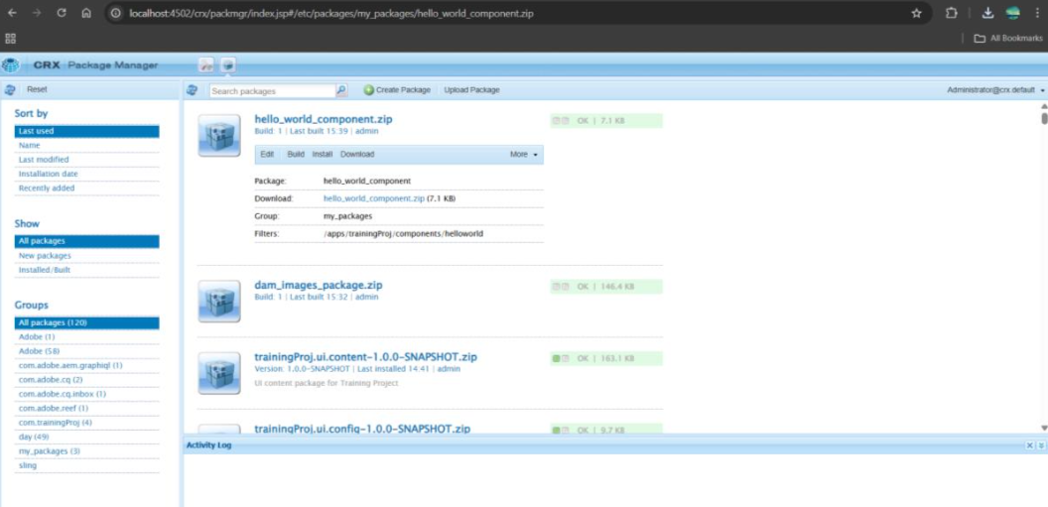

**Update helloWorld.html to Display Values from Model**

<sly data-sly-use.helloWorld="com.myTraining.core.models.HelloWorldModel" />

<div>

<h2>Hello, ${helloWorld.firstName} ${helloWorld.lastName}!</h2>

</div>

**6. Why Use Package Manager & Create Packages for HelloWorld Component & DAM Images**

Package Manager is used in AEM to export and import content, components, and configurations.

**Why Use It?**

* Transfers content between AEM instances.
* Backups components and assets.
* Moves developed code to production**.**

**Create Two Packages:**

1. Package for DAM (Images)
   * Go to AEM Package Manager (http://localhost:4502/crx/packmgr/index.jsp).
   * Click on Create Package → Name: myTraining_DAM_Package.
   * Include /content/dam/myTraining/us/en-us path.
   * Build & Download the package.
2. Package for HelloWorld Component
   * Create another package: myTraining_HelloWorld_Package.
   * Include the component path: /apps/myTraining/components/helloWorld.
   * Build & Download the package.

Now, you can install these packages on another AEM instance.

**7. Configure Replication Agent & Publish the Page from Author to Publish Environment (10 Marks)**

**Steps to Configure Replication Agent:**

1. Open AEM Web Console (http://localhost:4502/etc/replication/agents.author.html).
2. Click on "Default Agent (Publish)".
3. In Settings, set:
   * Transport URI: http://localhost:4503/bin/receive
   * Transport User: admin
   * Transport Password: admin
4. Click Test Connection (Should show "Success").
5. Save the settings.

**Publishing a Page to Publish Instance (4503):**

1. Go to AEM Sites (http://localhost:4502/sites.html).
2. Select your page.
3. Click on Publish → Activate Page.
4. The page will now be available at:

<http://localhost:4503/content/myTraining/us/en.html>

