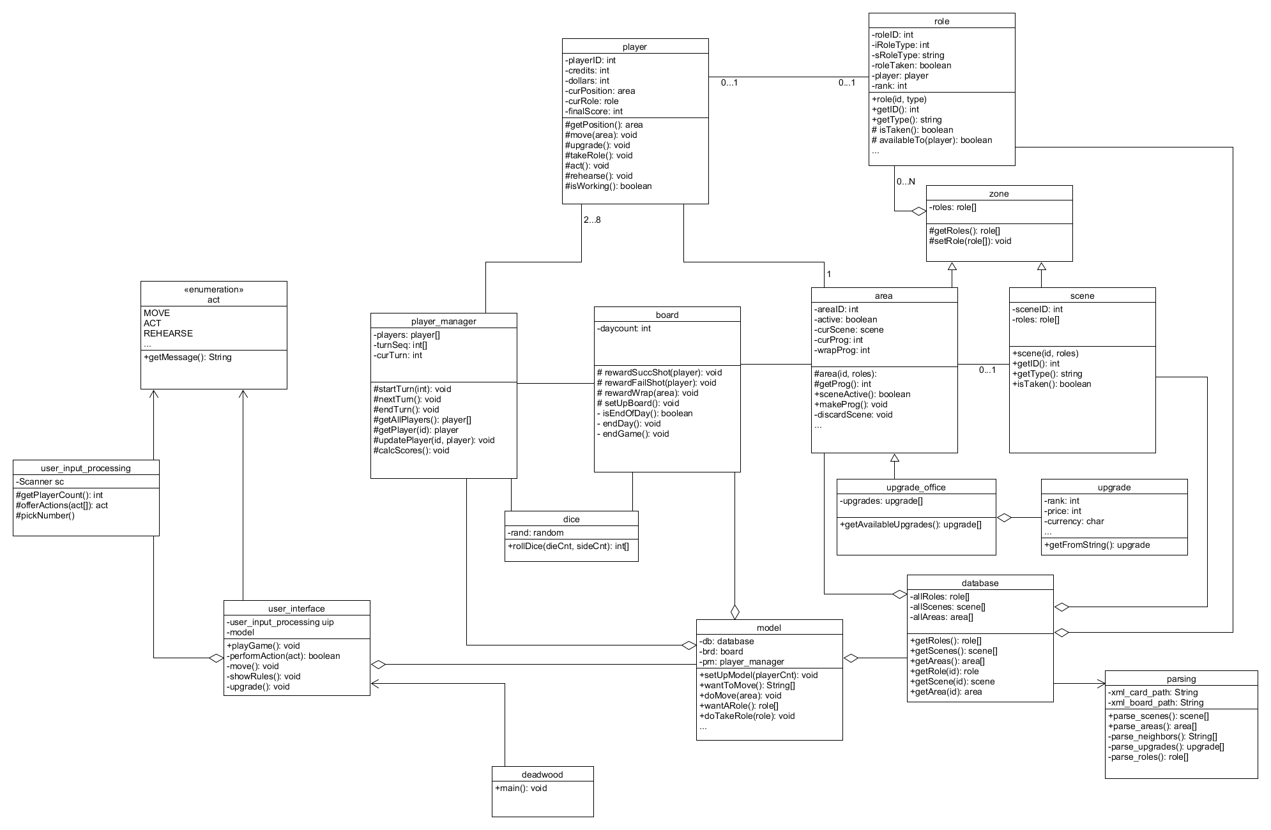

We decided to implement a Model-view-controller design pattern because of its clean and easily upgradable style. The user, when playing the game, will always only interact with the ‘user_input_processing’ class and nothing else. It communicates right with the ‘user_interface’ class (which is the controller) to show the player their progress and information about their character while playing. The ‘model’ class acts as our model, it communicates directly with the controller and receives tasks sent by the it to make the data changes to the players. This design style will be especially useful when creating a GUI because little to no changes will have to be made in the model, and only the view portion will need change.