1. Go to <https://nodejs.org/en/download> and click on below link for Windows to download Node.js:

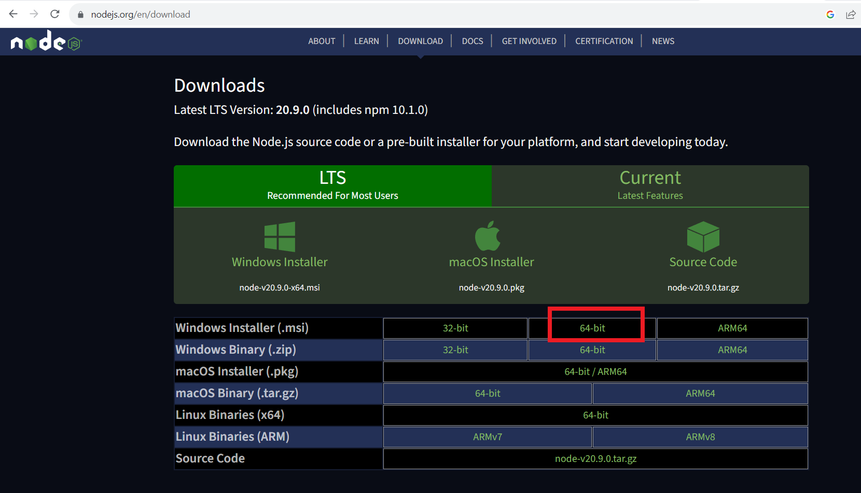

After download, install Node.js on your computer.

1. Go to <https://code.visualstudio.com/download> and download Visual Studio Code editor:

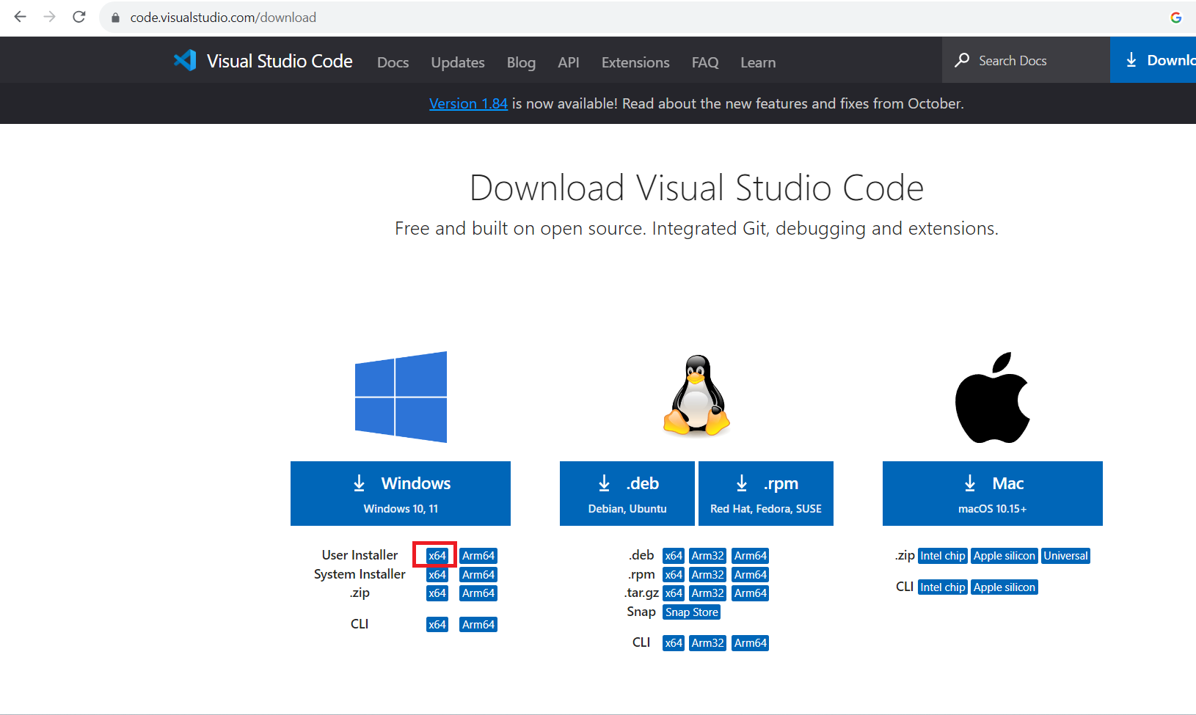

After download, install Visual Studio Code (VS Code) editor on your computer.

1. Create a new folder “Name of folder” in your drive and open it from VS Code.

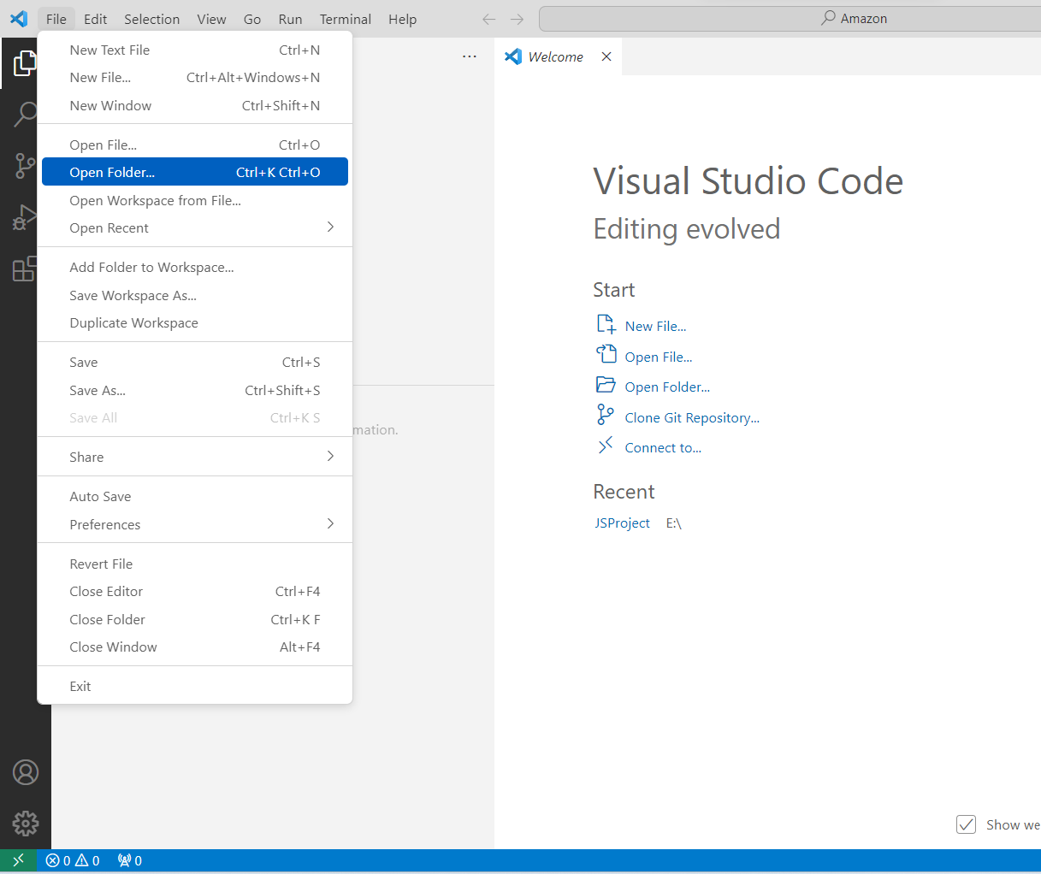

1. Go to VS Code terminal and run command *npm init playwright@latest* to install Playwright framework in your project folder.
2. Go to
   * View > Command Palette and type playwright > Select install playwright.
   * Select the browsers and click ok. It will install the libraries and create project folders.
3. Under the project folder add file called amazon.js.
4. Go to terminal and run command *npx playwright test .\tests\amazon.js*.
5. After execution, see the result playwright-report > index.html.