Tenary Plot

Mirco Brunner

FS 2019

## R Ternary Plots

All data and some Text are from (Baxter and Cool 2016) <http://www.barbicanra.co.uk/simple-r.html>.

Ternary diagrams go under a variety of names – triangular, tripolar or phase diagrams among them. They are used when p = 3 variables are available that are scaled to sum to 100% (or 1). The data may be categorical or continuous. This scaling (or compositional constraint) means the values of any two variables determine the value of the third variable. This implies that the data are exactly two-dimensional.The data can be plotted in an equilateral triangle where a point represents the relative proportions of the three variables as measured by the (perpendicular) distances to the three axes. In effect, and as previously noted, a point in a ternary diagram encapsulates the same information as a pie chart for three categories, with the considerable advantage that the distances between points are visualized. Howarth’s (1996) history of the ternary diagram traces its origins to the mid-18th century. Their use in archaeology is widespread, often occurring in the more ‘specialised’ literature. Howarth (1996: 338) notes that they are widely used ingeology, physical chemistry and metallurgy and are to be found in archaeological publications that interact with these disciplines. Recent papers in this vein that use ternary diagrams include Hughes et al. (2010) study of flint compositions, Panich (2016) of obsidian, and Chirikure et al. (2010) of slags. For data sets with more than 3 variables composite variables (i.e. linear combinations of those available) are sometimes defined to enable their representation in a ternary diagram (e.g., Hein et al. 2007: 149; Plaza and Martinón-Torres 2015: 93). Another use is in phase diagrams where a plot is ‘zoned’ in some way to identify, for example, different classes of material or manufacturing technologies corresponding to different regions of the diagram. Data are then plotted to characterize the cases beings studied (e.g., Thornton and Rehren 2009; Radivojevic et al. 2010).

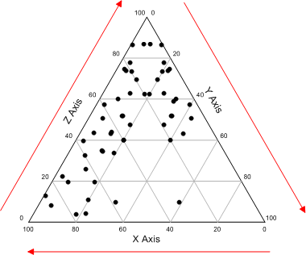

fig. 1: At the end we create this kind of diagrams

For an initial illustration, data from folder data_kasar_akil in Doran and Hodson (1975) are used. The left-hand table shows the counts of cores, blanks and stone tools found in different levels at the palaeolithic site of Ksar Akil (Lebanon); the levels are numbered from earliest (25) to latest (12). The right-hand table shows the counts converted to percentage for each level and can be represented in a ternary diagram 1b. Read the data (i.e. the headers and what follows) into a data frame Ksar – you will need to select a subset of the columns for analysis. Either Ksar[, 1:4] or Ksar[, c(1,5:7] will do it. we’ll use the former; ggtern will transform these to the percentages needed. The ternary diagram for these data, in Figure 1a, is followed by the code used.

#load libraries  
library(ggplot2);library(grid); library(ggtern)

## Warning: package 'ggplot2' was built under R version 3.5.2

## --  
## Remember to cite, run citation(package = 'ggtern') for further info.  
## --

##   
## Attaching package: 'ggtern'

## The following objects are masked from 'package:ggplot2':  
##   
## %+%, aes, annotate, calc_element, ggplot, ggplotGrob,  
## ggplot_build, ggplot_gtable, ggsave, layer_data, theme,  
## theme_bw, theme_classic, theme_dark, theme_gray, theme_light,  
## theme_linedraw, theme_minimal, theme_void

#show data  
Ksar <- read.csv("data_ksar_akil/ksar_akil.csv")  
print(Ksar)

## Levels Cores Blanks Tools  
## 1 25 21 12 70  
## 2 24 36 52 115  
## 3 23 126 650 549  
## 4 22 159 2342 1633  
## 5 21 75 487 511  
## 6 20 176 1090 912  
## 7 19 132 713 578  
## 8 18 46 374 266  
## 9 17 550 6182 1541  
## 10 16 76 846 349  
## 11 15 17 182 51  
## 12 14 4 21 14  
## 13 13 29 228 130  
## 14 12 133 2227 729

Table 1: To the left, counts of cores, blanks and tools from middle levels of the palaeolithic site at Ksar Akil (Lebanon). This is Table 9.12 from Doran and Hodson (1975).

###Ternery diagram 1a

#ternary diagram with dots fig. 1a  
ggtern(data=Ksar[,1:4],aes(Cores, Blanks, Tools, label=Levels)) +  
 geom_point(size = 3) + theme_showarrows()

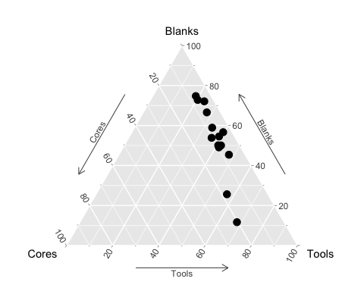 fig. 1a: Ternery diagram 1a

###Ternary diagram 1b

#ternary diagram with numbers fig. 1b  
Ksar <- read.csv("data_ksar_akil/ksar_akil.csv")  
library(ggplot2);library(grid); library(ggtern)  
ggtern(data=Ksar[,1:4],aes(Cores, Blanks, Tools, label=Levels)) +  
geom_text() + theme_showarrows()

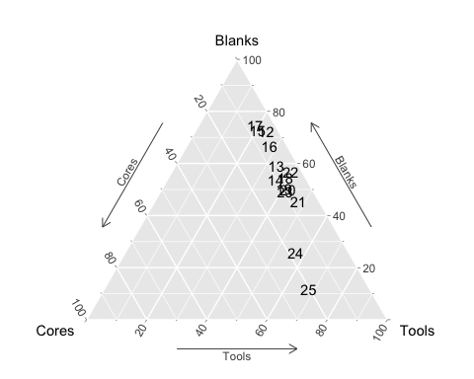

Change the dataset –> data_faunal/king

king <- read.csv("data_faunal/king.csv")  
#show data  
print(king)

## Type C P SG  
## 1 Settlement 37.0 10.4 52.6  
## 2 Vicus 37.4 13.7 48.9  
## 3 Settlement 74.4 4.7 20.9  
## 4 Settlement 62.0 10.8 27.2  
## 5 Villa 48.7 29.2 22.0  
## 6 Villa 56.2 12.9 30.9  
## 7 Villa 59.5 10.1 30.4  
## 8 Villa 71.3 8.5 20.2  
## 9 Settlement 27.0 7.8 65.1  
## 10 Vicus 87.3 2.4 10.2  
## 11 Vicus 53.0 32.1 15.0  
## 12 Villa 60.4 14.2 25.5  
## 13 Vicus 76.3 2.5 21.2  
## 14 Vicus 74.3 8.9 16.8  
## 15 Vicus 54.7 16.8 28.5  
## 16 Vicus 37.3 26.1 36.7  
## 17 Vicus 48.0 12.2 39.8  
## 18 Vicus 69.3 8.5 22.2  
## 19 Vicus 69.2 11.1 19.7  
## 20 Vicus 20.3 35.5 44.2  
## 21 Vicus 27.6 33.8 38.6  
## 22 Vicus 45.5 29.7 24.8  
## 23 Villa 57.8 18.6 23.5  
## 24 Villa 48.9 30.1 21.0  
## 25 Vicus 58.8 7.8 33.5  
## 26 Vicus 81.7 6.5 11.8  
## 27 Vicus 68.6 7.3 24.1  
## 28 Villa 70.3 4.3 25.4  
## 29 Villa 70.0 3.2 26.8  
## 30 Urban 80.7 6.1 13.2  
## 31 Urban 86.2 6.8 7.0  
## 32 Urban 47.5 23.9 28.5  
## 33 Urban 69.8 13.7 16.4  
## 34 Urban 71.9 13.3 14.8  
## 35 Urban 93.2 1.5 5.4  
## 36 Urban 82.7 7.9 9.4  
## 37 Urban 64.9 12.2 23.0  
## 38 Settlement 65.8 16.8 17.4  
## 39 Settlement 63.2 19.3 17.5  
## 40 Villa 58.9 20.6 20.6  
## 41 Villa 48.1 15.9 36.0  
## 42 Vicus 40.2 4.1 55.7  
## 43 Vicus 52.3 9.8 37.9  
## 44 Vicus 57.1 13.8 29.1  
## 45 Vicus 56.2 9.0 34.8  
## 46 Settlement 34.4 6.3 59.3  
## 47 Settlement 42.5 6.9 50.6  
## 48 Villa 57.4 4.7 37.8  
## 49 Vicus 72.8 7.7 19.5  
## 50 Urban 55.4 19.7 25.0  
## 51 Urban 39.9 25.3 34.8  
## 52 Urban 41.4 31.7 26.8  
## 53 Urban 59.7 19.9 20.4  
## 54 Settlement 28.0 2.3 69.7  
## 55 Settlement 62.6 4.9 32.5  
## 56 Villa 35.2 41.1 23.7  
## 57 Villa 42.2 32.0 25.9  
## 58 Settlement 25.7 22.6 51.6  
## 59 Settlement 48.1 11.4 40.6  
## 60 Villa 51.7 14.1 34.2  
## 61 Villa 60.0 23.4 16.6  
## 62 Urban 59.5 16.4 24.1  
## 63 Urban 62.6 12.6 24.8  
## 64 Vicus 68.0 14.8 17.2  
## 65 Vicus 74.7 16.1 9.2  
## 66 Vicus 74.1 16.6 9.3  
## 67 Vicus 73.1 15.6 11.2  
## 68 Vicus 84.4 3.0 12.6  
## 69 Settlement 28.3 11.8 59.9  
## 70 Settlement 30.3 7.2 62.5  
## 71 Settlement 33.9 7.6 58.5  
## 72 Vicus 48.3 15.8 35.8  
## 73 Vicus 69.2 7.6 23.2  
## 74 Vicus 83.5 5.6 10.9  
## 75 Vicus 62.5 16.8 20.7  
## 76 Settlement 38.2 14.1 47.7  
## 77 Settlement 36.6 11.1 52.3  
## 78 Settlement 57.0 4.1 38.9  
## 79 Settlement 49.4 5.6 44.9  
## 80 Vicus 53.7 7.7 38.6  
## 81 Vicus 48.4 5.8 45.8  
## 82 Vicus 57.1 4.3 38.6  
## 83 Vicus 88.0 2.0 10.0  
## 84 Villa 76.3 16.0 7.6  
## 85 Villa 83.6 11.9 4.6  
## 86 Settlement 35.3 6.1 58.7  
## 87 Settlement 55.1 6.1 38.8  
## 88 Urban 57.2 28.6 14.2  
## 89 Urban 46.0 38.1 15.8  
## 90 Urban 75.5 16.7 7.8  
## 91 Urban 68.7 18.2 13.1  
## 92 Urban 59.5 17.6 22.9  
## 93 Urban 44.6 26.4 28.9  
## 94 Urban 52.3 30.0 17.7  
## 95 Settlement 82.1 2.7 15.0  
## 96 Vicus 58.9 8.6 32.4  
## 97 Vicus 66.9 12.6 20.5  
## 98 Settlement 43.3 5.2 51.5  
## 99 Settlement 72.6 17.6 9.8  
## 100 Vicus 40.1 7.9 52.1  
## 101 Vicus 70.6 6.4 23.0  
## 102 Vicus 73.7 7.6 18.6  
## 103 Settlement 17.4 12.0 70.7  
## 104 Villa 54.0 10.4 35.5  
## 105 Vicus 81.0 4.8 14.2  
## 106 Vicus 83.8 8.4 7.8  
## 107 Settlement 47.7 12.5 39.5  
## 108 Settlement 57.1 4.4 38.5  
## 109 Settlement 58.3 4.4 37.4  
## 110 Villa 50.2 18.0 31.8  
## 111 Villa 31.9 17.9 50.2  
## 112 Villa 90.3 0.9 8.8  
## 113 Settlement 43.4 3.8 52.8  
## 114 Villa 22.2 17.8 60.0  
## 115 Villa 23.3 20.7 56.0  
## 116 Villa 27.5 6.2 66.3  
## 117 Vicus 27.7 10.2 62.0  
## 118 Vicus 57.3 8.8 33.8  
## 119 Villa 51.9 19.7 28.4  
## 120 Villa 53.2 19.6 27.2  
## 121 Villa 63.6 11.6 24.8  
## 122 Villa 54.3 11.9 33.8  
## 123 Settlement 23.1 34.7 42.2  
## 124 Urban 35.4 30.3 34.3  
## 125 Settlement 68.1 2.4 29.5  
## 126 Settlement 40.6 23.9 35.5  
## 127 Settlement 43.5 3.0 53.4  
## 128 Settlement 52.6 5.1 42.3  
## 129 Settlement 42.9 7.3 49.7  
## 130 Vicus 43.3 11.2 45.5  
## 131 Vicus 36.1 18.8 45.1  
## 132 Urban 77.8 10.8 11.4  
## 133 Settlement 32.6 10.5 56.8  
## 134 Settlement 44.6 12.2 43.2  
## 135 Villa 63.9 3.7 32.5  
## 136 Settlement 38.6 17.8 43.6  
## 137 Villa 56.0 8.7 35.3  
## 138 Villa 64.6 11.5 23.9  
## 139 Settlement 48.5 15.7 35.7  
## 140 Settlement 51.2 2.8 46.0  
## 141 Vicus 29.5 14.6 55.9  
## 142 Vicus 40.4 13.7 45.9  
## 143 Settlement 37.2 7.1 55.8  
## 144 Settlement 69.9 15.0 15.0  
## 145 Settlement 47.9 13.3 38.9  
## 146 Villa 55.2 6.6 38.2  
## 147 Villa 51.4 21.9 26.6  
## 148 Villa 54.6 12.5 32.9  
## 149 Settlement 32.8 22.4 44.8  
## 150 Villa 42.5 18.2 39.3  
## 151 Villa 77.4 4.9 17.7  
## 152 Villa 79.6 5.1 15.3  
## 153 Vicus 39.8 8.8 51.4  
## 154 Settlement 52.6 7.4 40.0  
## 155 Settlement 37.9 4.4 57.8  
## 156 Settlement 54.2 32.1 13.1  
## 157 Settlement 59.9 36.1 7.2  
## 158 Settlement 62.7 9.9 27.4  
## 159 Urban 65.7 17.6 16.7  
## 160 Settlement 45.1 8.7 46.2  
## 161 Settlement 54.2 5.7 40.1  
## 162 Settlement 50.6 8.3 41.0  
## 163 Settlement 36.6 8.9 54.5  
## 164 Villa 70.2 5.9 23.9  
## 165 Villa 51.9 13.6 34.6  
## 166 Villa 76.5 4.5 19.1  
## 167 Villa 79.9 3.6 16.5  
## 168 Villa 73.1 4.4 22.5  
## 169 Villa 68.0 18.3 13.7  
## 170 Vicus 39.1 12.2 48.7  
## 171 Vicus 63.4 8.4 28.3  
## 172 Vicus 83.5 3.9 12.6  
## 173 Urban 27.4 4.4 68.2  
## 174 Urban 36.4 6.9 56.7  
## 175 Urban 48.7 12.8 38.5  
## 176 Urban 22.6 24.8 52.6  
## 177 Urban 36.1 24.7 39.2  
## 178 Urban 32.0 30.0 38.0  
## 179 Urban 30.9 27.8 41.2  
## 180 Urban 37.9 27.4 34.7  
## 181 Urban 49.0 21.9 29.2  
## 182 Urban 45.9 23.5 30.7  
## 183 Settlement 27.3 13.1 59.6  
## 184 Settlement 29.2 13.1 57.8  
## 185 Settlement 24.4 12.8 62.8  
## 186 Settlement 41.1 13.2 45.7  
## 187 Settlement 32.3 12.6 55.1  
## 188 Settlement 33.6 11.5 54.9  
## 189 Settlement 50.0 25.9 24.1  
## 190 Villa 43.1 32.7 24.2  
## 191 Villa 39.8 30.4 29.8  
## 192 Villa 53.4 19.8 26.8  
## 193 Villa 44.7 19.8 35.5  
## 194 Villa 10.1 70.3 19.6  
## 195 Vicus 64.5 8.2 27.3  
## 196 Villa 53.4 9.9 36.6  
## 197 Vicus 54.8 12.3 32.9  
## 198 Vicus 48.7 16.8 34.5  
## 199 Vicus 72.8 4.6 22.6  
## 200 Vicus 44.2 15.4 40.3  
## 201 Settlement 27.3 15.6 57.1  
## 202 Settlement 23.1 7.2 69.6  
## 203 Settlement 62.4 15.5 22.1  
## 204 Urban 43.1 22.2 34.7  
## 205 Urban 61.4 16.4 22.2  
## 206 Urban 36.1 19.7 44.2  
## 207 Urban 63.8 18.4 17.8  
## 208 Urban 37.1 22.9 40.0  
## 209 Urban 61.1 14.4 24.6  
## 210 Urban 70.8 10.7 18.5  
## 211 Urban 49.7 12.6 37.7  
## 212 Urban 79.5 7.1 13.5  
## 213 Settlement 63.4 5.1 31.4  
## 214 Villa 44.8 10.1 45.1  
## 215 Settlement 69.2 6.0 24.9  
## 216 Settlement 52.1 10.2 37.7  
## 217 Settlement 59.8 2.2 38.0  
## 218 Settlement 29.3 2.6 68.1  
## 219 Villa 66.2 5.6 28.2  
## 220 Villa 67.0 2.5 30.5  
## 221 Villa 64.7 2.8 32.4  
## 222 Villa 65.1 3.7 31.1  
## 223 Settlement 21.4 50.5 28.0  
## 224 Settlement 47.3 15.1 37.6  
## 225 Villa 42.9 18.6 38.6  
## 226 Settlement 39.1 34.3 26.7  
## 227 Settlement 29.4 36.3 34.4  
## 228 Urban 35.7 31.5 32.9  
## 229 Urban 26.2 15.5 58.4  
## 230 Vicus 37.1 18.7 44.2  
## 231 Vicus 26.1 27.8 46.1  
## 232 Vicus 56.4 28.9 14.7  
## 233 Villa 49.7 3.9 46.4  
## 234 Vicus 40.2 12.2 47.6  
## 235 Vicus 44.5 11.7 43.8  
## 236 Settlement 51.7 10.7 37.6  
## 237 Settlement 55.7 17.8 26.5  
## 238 Settlement 59.8 16.5 23.8  
## 239 Settlement 82.1 2.2 15.7  
## 240 Settlement 74.8 4.3 20.9  
## 241 Settlement 82.3 1.8 16.0  
## 242 Settlement 78.6 2.7 18.7  
## 243 Settlement 59.4 18.8 21.7  
## 244 Villa 38.2 5.6 56.2  
## 245 Vicus 30.7 8.9 60.4  
## 246 Vicus 35.2 7.6 57.2  
## 247 Settlement 66.1 2.3 31.7  
## 248 Settlement 46.4 7.2 46.4  
## 249 Settlement 63.3 6.6 30.1  
## 250 Settlement 33.5 10.3 56.2  
## 251 Vicus 66.4 15.8 17.8  
## 252 Urban 68.7 17.2 14.1  
## 253 Urban 69.0 13.9 17.2  
## 254 Urban 65.5 17.1 17.4

king <- read.csv("data_faunal/king.csv")  
ggtern(data=king,aes(C, P, SG, colour=Type, shape=Type, fill = Type)) +  
geom_point() + theme_showarrows()

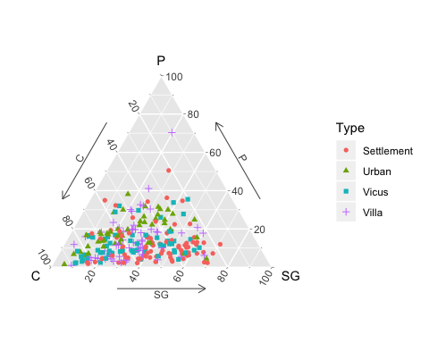

The upper plot is the ‘default’ ternary diagram for Romano-British civilian faunal assemblages using ggtern; the lower plot is a ‘modified’ version. C = Cattle, P = Pig, SG = Sheep/Goat.

fig2 <- function() {  
library(ggplot2); library(grid); library(grid); library(ggtern)  
king$Type <- factor(king$Type, labels = c("Rural settlement", "Urban site", "Vicus", "Villa"))  
p <- ggtern(data=king,aes(C, P, SG, colour=Type, shape=Type, fill=Type)) +  
geom_point(size = 3) + theme_showarrows() +  
scale_shape_manual(values=c(21,22,24,25)) +  
scale_colour_manual(values=rep("black", 4)) +  
scale_fill_manual(values=c("skyblue", "red", "yellow", "white")) +  
theme_legend_position("tl") +  
theme(legend.title=element_text(size=16),  
legend.key.height=unit(1, "cm"), legend.key.width=unit(1, "cm"))  
p  
}  
fig2 ()

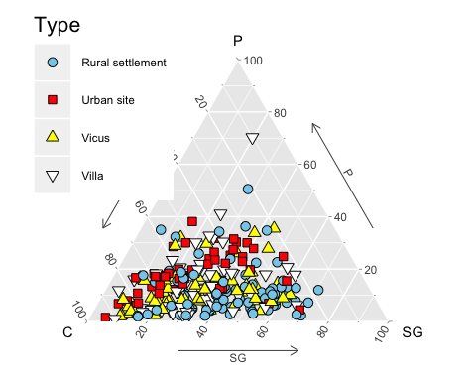

If your happy with the plot save it!

ggsave("fig2.png", dpi = 300)

## Saving 5 x 4 in image

### References

Baxter, Mike, and Hilary Cool. 2016. *Basic Statistical Graphics for Archaeology with R: Life Beyond Excel*. Nottingham: Barbican Research Associates Nottingham.