ABOUT US => OUR THOUGHT

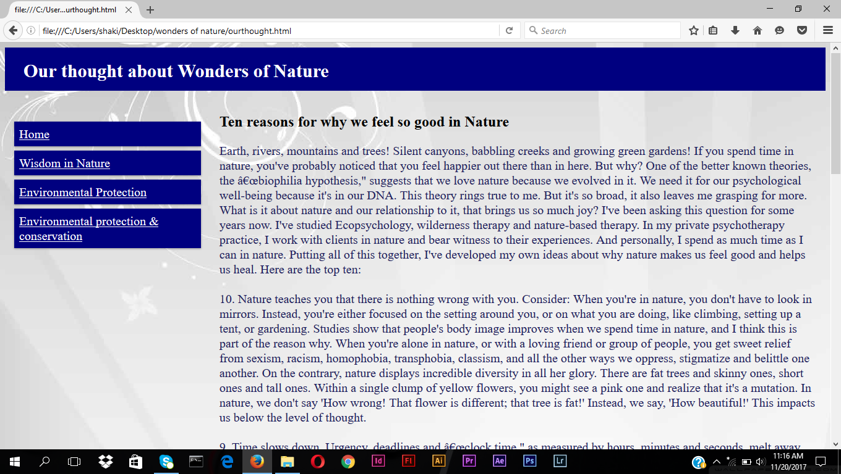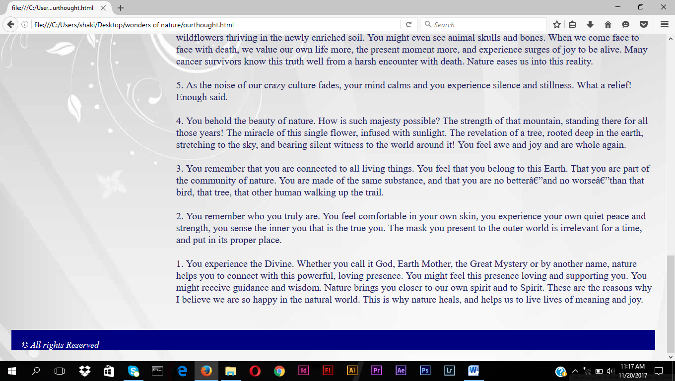

In this page has header ,content,footer secssion. Here we using CSS as internal. In this CSS style we using padding,font-style, font-size,color(font),background-color,heigth,width,marign type,box-shadow etc.

The page divide as column using CSS property. Col-12 used for header & footer secssion . col-3 used for menu list.

In the menu list has link for home page and others are online link such as how to prevent nature, why they are important about some details.