Tic-Tac-Toe inputs from the computer using random module

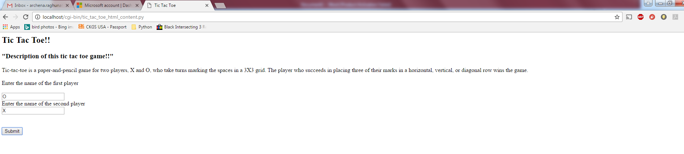

Output page:

**The first player's name is O:**

**The second player's name is X:**

**"TIC-TAC-TOE"**

**"First Player's turn"**

**"Place your move in any place from 1 to 9: "**

**('O placed in position : ', 6)**

|  |  |  |
| --- | --- | --- |
| 1 | 2 | 3 |
| 4 | 5 | O |
| 7 | 8 | 9 |

**"Second Player's turn"**

**"Place your move in any place from 1 to 9: "**

**('X placed in position : ', 6)**

**"Position already filled. Please select an unfilled position!!"**

**"Second Player's turn"**

**"Place your move in any place from 1 to 9: "**

**('X placed in position : ', 1)**

|  |  |  |
| --- | --- | --- |
| X | 2 | 3 |
| 4 | 5 | O |
| 7 | 8 | 9 |

**"First Player's turn"**

**"Place your move in any place from 1 to 9: "**

**('O placed in position : ', 6)**

**"Position already filled. Please select an unfilled position!!"**

**"First Player's turn"**

**"Place your move in any place from 1 to 9: "**

**('O placed in position : ', 3)**

|  |  |  |
| --- | --- | --- |
| X | 2 | O |
| 4 | 5 | O |
| 7 | 8 | 9 |

**"Second Player's turn"**

**"Place your move in any place from 1 to 9: "**

**('X placed in position : ', 3)**

**"Position already filled. Please select an unfilled position!!"**

**"Second Player's turn"**

**"Place your move in any place from 1 to 9: "**

**('X placed in position : ', 9)**

|  |  |  |
| --- | --- | --- |
| X | 2 | O |
| 4 | 5 | O |
| 7 | 8 | X |

**"First Player's turn"**

**"Place your move in any place from 1 to 9: "**

**('O placed in position : ', 2)**

|  |  |  |
| --- | --- | --- |
| X | O | O |
| 4 | 5 | O |
| 7 | 8 | X |

**"Second Player's turn"**

**"Place your move in any place from 1 to 9: "**

**('X placed in position : ', 7)**

|  |  |  |
| --- | --- | --- |
| X | O | O |
| 4 | 5 | O |
| X | 8 | X |

**"First Player's turn"**

**"Place your move in any place from 1 to 9: "**

**('O placed in position : ', 5)**

|  |  |  |
| --- | --- | --- |
| X | O | O |
| 4 | O | O |
| X | 8 | X |

**"Second Player's turn"**

**"Place your move in any place from 1 to 9: "**

**('X placed in position : ', 2)**

**"Position already filled. Please select an unfilled position!!"**

**"Second Player's turn"**

**"Place your move in any place from 1 to 9: "**

**('X placed in position : ', 9)**

**"Position already filled. Please select an unfilled position!!"**

**"Second Player's turn"**

**"Place your move in any place from 1 to 9: "**

**('X placed in position : ', 5)**

**"Position already filled. Please select an unfilled position!!"**

**"Second Player's turn"**

**"Place your move in any place from 1 to 9: "**

**('X placed in position : ', 2)**

**"Position already filled. Please select an unfilled position!!"**

**"Second Player's turn"**

**"Place your move in any place from 1 to 9: "**

**('X placed in position : ', 9)**

**"Position already filled. Please select an unfilled position!!"**

**"Second Player's turn"**

**"Place your move in any place from 1 to 9: "**

**('X placed in position : ', 6)**

**"Position already filled. Please select an unfilled position!!"**

**"Second Player's turn"**

**"Place your move in any place from 1 to 9: "**

**('X placed in position : ', 4)**

|  |  |  |
| --- | --- | --- |
| X | O | O |
| X | O | O |
| X | 8 | X |

**Player2 X wins!!**

Tic-Tac-Toe table positions:

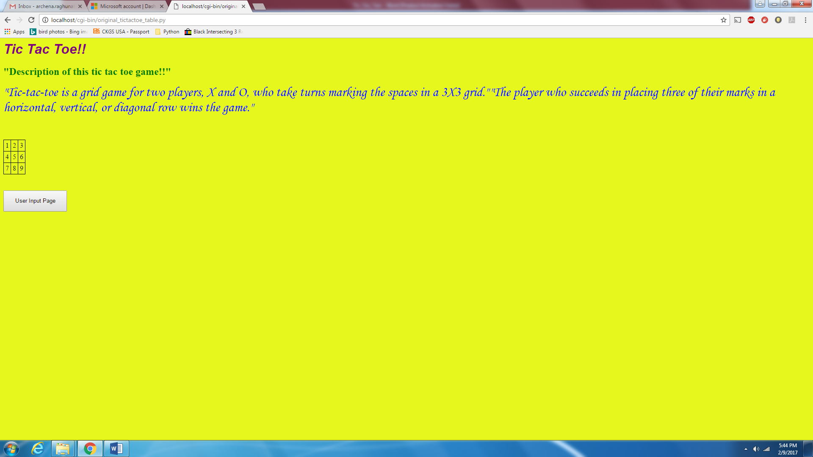

User-Input page

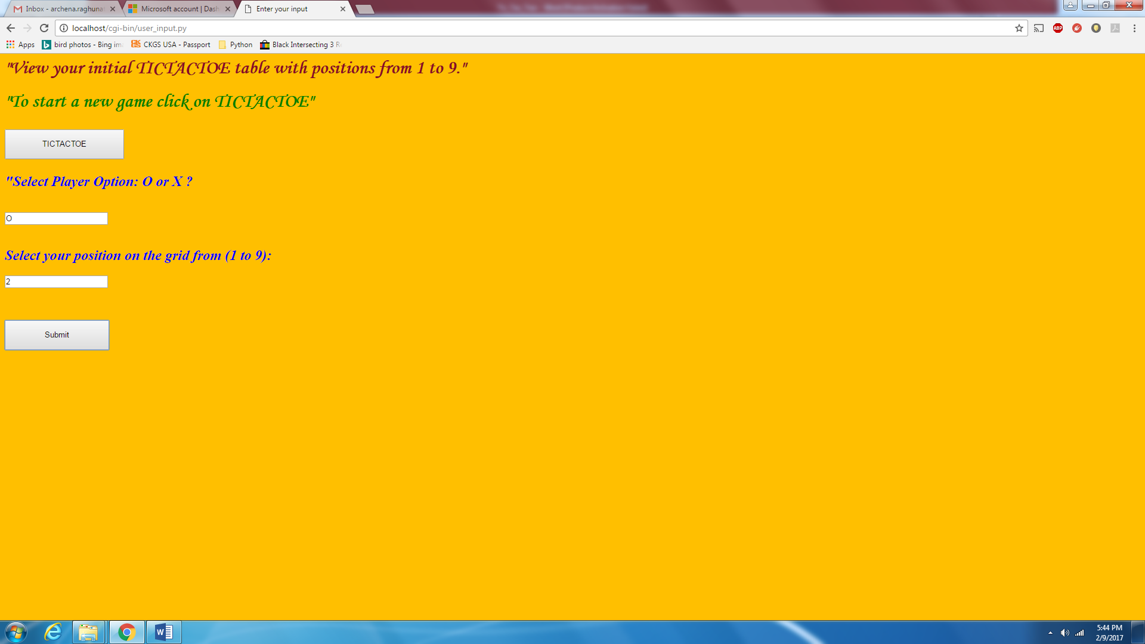

Player positions

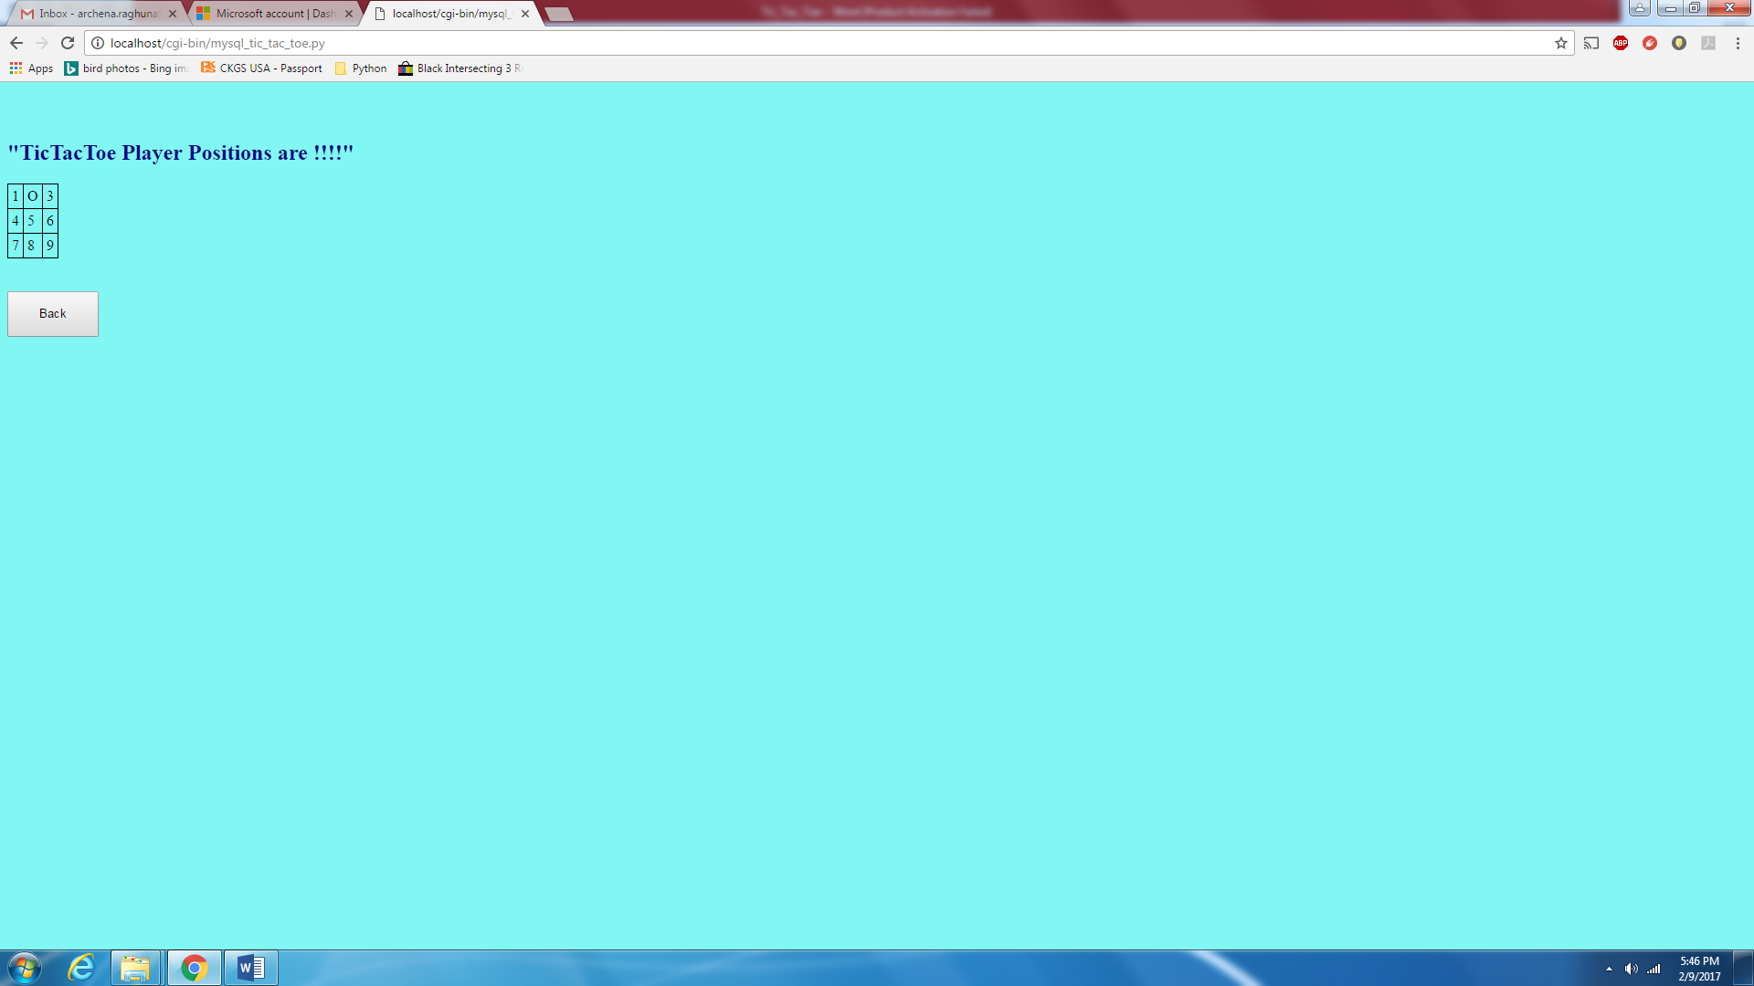

End result

