


SOA Testing Framework Guide

Author: | Ladislav Jech
Owner: | Irish Water Programme
Document Date:
Document Reference:
Version: | 0.1

Document History
Document Location
This is a snapshot of an on-line document. Paper copies are valid only on the day they are printed. Refer to the author if you are in any doubt about the currency of this document.
Most up-to-date version is available at SVN repository:
http://10.19.12.41:8080/svn/repos_int1/m2/trunk/soa_testing_framework/doc/guide
Revision History
Date of this revision: 04.11.2013 | Date of next revision 31.12.2013

Revision Number | Revision Date | Summary of Changes | Changes marked
0.1 | 04.11.2013 | Initial version
Approvals
This document requires following approvals:
Name | Title
Kieran Murphy | Integration Architect
Distribution
This document has been distributed to
Name | Title | Name | Title
Contents
1. Introduction 4
2. High Level Overview 5
2.1 Framework process flow 5
2.2 SOA Testing Framework within existing environment 5
2.3 SOA Testing Framework within future environment 5
2.4 IBM Programme Implementation Integration Patterns 5
2.4.1 OSB Patterns 5
2.4.2 SOA Patterns 5
3. Detail flow process 6
3.1 Pattern: Database -> Queue -> Queue -> Database/SOAP 6
4. Test Results Summary 7
5. Analysis and Conclusion 9
6. Test Summary Report Approval 10

Introduction
SOA Testing Framework project has been created within the Irish Water Programme as an evolutional mechanism requirement which should help to transform the software development life cycle to the way of continuous integration defined as common standard in those days. Framework itself provide atomic set of operations from the integration perspective to provide testing mechanisms for all implemented interfaces.
Another purpose is to save time of developers on interface testing as soon as this parameter counts.
Framework itself is based on Java SE implementation with Groovy scripting language based GUI based on well-known product soapUI. There is available framework configuration via XML file described by strict XSD definition.

High Level Overview
This chapter describes high level process flow and design of the framework.

High Level Framework Design
The framework itself is designed in a way to support endpoints based on multiple technologies. For each technology type there is predefined set of integration operations related strictly to one technology type. Currently supported are following technologies and operations:
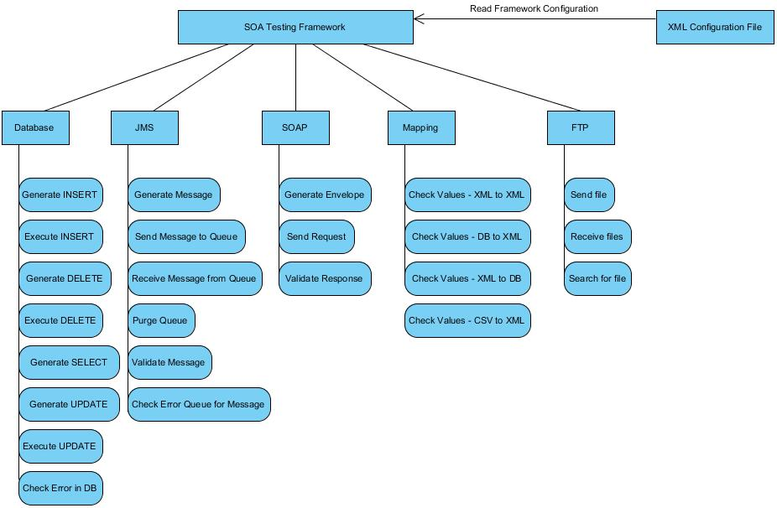
Figure 1 - High Level Framework Design

The framework is designed with idea of future usage, but the main criteria in the moment is to use the product ASAP, this fall into 2 designs of the framework flow usages:
- SOA Testing Framework within existing environment
- SOA Testing Framework within future continuous integration environment
Both of those ways of usage are more described bellow in related chapters.

High Level Framework Process Flow
asdfa

SOA Testing Framework within existing environment
asdfdsafsa

SOA Testing Framework within future environment

IBM Programme Implementation Integration Patterns

OSB Patterns
There are few of integration patterns identified within IBM Irish Water Programme implementation which are currently supported. Here they are:
- Database -> Queue -> Database/SOAP

SOA Patterns

Detail Process Flow
In this chapter I am going to describe detailed step-by-step process of the configuration and execution of the framework.

Pattern: Database -> Queue -> Queue -> Database/SOAP

Pattern: CSV File -> Queue -> Database/SOAP

