


SOA Testing Framework User's Guide

Author: | Ladislav Jech
Owner: | Irish Water Programme
Document Date:
Document Reference:
Version: | 0.1

Document History
Document Location
This is a snapshot of an on-line document. Paper copies are valid only on the day they are printed. Refer to the author if you are in any doubt about the currency of this document.
Most up-to-date version is available at SVN repository:
http://10.19.12.41:8080/svn/repos_int1/m2/trunk/soa_testing_framework/doc/user-guide
Revision History
Date of this revision: 04.11.2013 | Date of next revision 31.12.2013

Revision Number | Revision Date | Summary of Changes | Changes marked
0.1 | 04.11.2013 | Initial version
0.2 | 28.12.2013 | Extension by new features
0.3 | 07.01.2014 | Extension by new features, validation
Approvals
This document requires following approvals:
Name | Title
Kieran Murphy | Integration Architect
Distribution
This document has been distributed to
Name | Title | Name | Title
Contents
1. Introduction 4
2. General Configuration 5
2.1 Java Environment 5
2.1.1 SOATF_JAVA_HOME 5
2.2 Operating System Environment 5
2.2.1 SOA_TEST_HOME 5
2.2.2 SOATF_HOME 5
2.3 Framework Configuration 5
2.3.1 Master Configuration XML File 6
2.3.1.1 Element 'frameworkGlobalConfiguration' 6
2.3.1.2 Element 'interfaces' 6
2.3.1.3 Element 'environments' 7
2.3.1.3.1 Element 'fusionMiddleware' 7
2.3.1.3.2 Element 'databases' 8
2.3.1.3.3 Element 'ftpServers' 9
2.3.1.3.4 Element 'osbDatabaseReporting' 10
2.3.1.4 Element 'fileSystemStructure' 10
2.3.1.5 Element 'flowPatterns' 10
2.3.2 Interface Configuration XML File 10
2.4 SOA Testing Framework within existing environment 11
2.5 SOA Testing Framework within future environment 11
2.6 IBM Programme Implementation Integration Patterns 11
2.6.1 OSB Patterns 11
2.6.2 SOA Patterns 11
3. Detail Process Flow 12
3.1 Pattern: Database -> Queue -> Queue -> Database/SOAP 12
3.2 Pattern: CSV File -> Queue -> Database/SOAP 12

Introduction
SOA Testing Framework project has been created within the Irish Water Programme as an evolutional mechanism requirement which should help to transform the software development life cycle to the way of continuous integration and delivery, both becoming standards in those days. Framework itself provides mechanisms to test defined interfaces and create testing reports.
The biggest purpose is probably to save time of developers/testers on interface testing phases.
Framework is fully implemented in Java Standard Edition 7 and supports XML based configuration with 2 runtime access modes:
- Graphical User Interface
Used from developer/tester private laptop to provide user friendly control interface
- Command Line
Used by Hudson server for automatic execution of tests
This document's purpose is to help the user configure framework for new interface usage.

General Configuration
This chapter describes basic steps to configure operating system environment for framework usage.

Java Environment
Framework source code is compatible with Java 7 and therefore JRE 7 or JDK 7 are required to execute it.
You can download it at:
http://www.oracle.com/technetwork/java/javase/downloads/index.html
If your environment variable is referencing Java 6 or older for your purposes, there is workaround. Framework comes with its own Java runtime location variable:

SOATF_JAVA_HOME
Set variable 'SOATF_JAVA_HOME' value to reference path to JDK 7 or JRE 7 location on your computer.

Operating System Environment
To put framework in operation mode, there is required to configure 2 environment variables:

SOA_TEST_HOME
'SOA_TEST_HOME' variable is system path to place where are located all testing configuration and result data files. Variable should point to following SVN repository directory:
http://10.19.12.41:8080/svn/repos_int1/m2/trunk/soa_test
This will let framework know where all the necessary data are located.

SOATF_HOME
'SOATF_HOME' variable is system path to binary distribution of the framework. This should point to following SVN repository directory:
http://10.19.12.41:8080/svn/repos_int1/m2/trunk/soa_testing_framework_bin
This will let framework starting scrripts know about binary data required for execution.

Framework Configuration
Framework configuration is based on XML technology files. There currently 2 types of configuration files:
- Master configuration file
File named 'master-config.xml' located in root of directory defined in 'SOA_TEST_HOME' environment variable. As its name predicts it is the main and single file used for storing information which can be used in general by multiple interfaces.
- Interface configuration file
File named in generic way 'config.xml' is located always its generated folder created for each interface under directory defined in 'SOA_TEST_HOME' environment variable. Directory structure of SOATF itself is described later.

Master Configuration XML File
This configuration file keeps all configuration data which can be used for multiple interfaces, or by one interface on multiple environments. Schema of this file is well documented for every single element and located at:
http://10.19.12.41:8080/svn/repos_int1/m2/trunk/soa_testing_framework/schema/SOATFMasterConfig/SOATFMasterConfig.xsd
Master configuration is set of 5 main elements:
- frameworkGlobalConfiguration
- interfaces
- environments
- fileSystemStructure
- flowPatterns

Element 'frameworkGlobalConfiguration'
This element configure all framework-wide information which can be seen as constants within SOATF world.
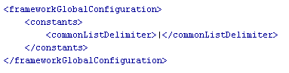
Figure 1 - Element 'frameworkGlobalConfiguration'

Element 'interfaces'
This element masters all interfaces which are meant to be tested by framework within execution. It defines all interfaces in the scope and their child elements.
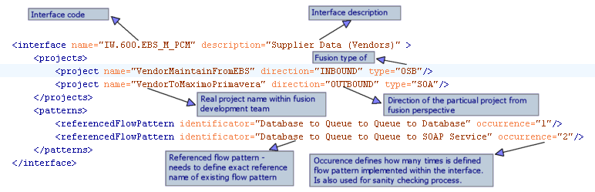
Figure 2 - Element 'interfaces'
This element is as well used to participate in file system structure generation process later.

Element 'environments'
This element defines all technology environments and their metadata used to connect to particular endpoint. Currently supports following child technology definitions:
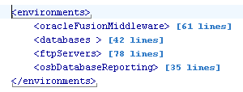
Figure 3 - Element 'environment'

Element 'fusionMiddleware'
This element defines every information related and required to work with Oracle Fusion Middleware application servers including Admin server, OSB & SOA & WSM clusters. On top of this it defines as well SSH related information required currently by framework FILE component which needs to access remotelly storage available within fusion linux servers.
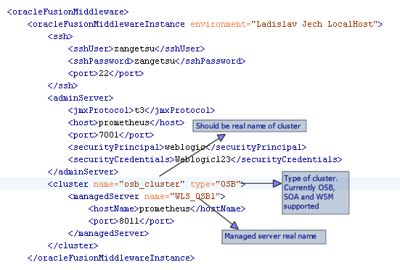
Figure 4 - Element 'fusionMiddleware'

Element 'databases'
Element store information required for connect to all database endpoints used for testing purposes.
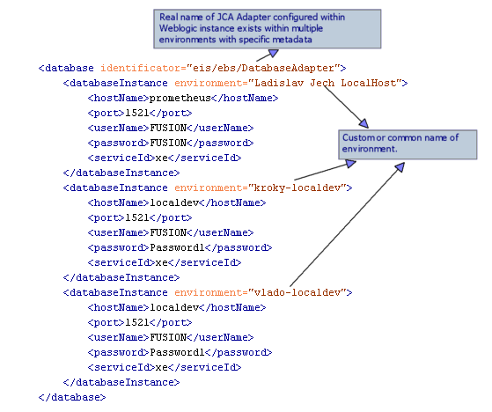
Figure 5 - Element 'databases'

Element 'ftpServers'
Element storing all FTP server instance data required to connect environment wide.
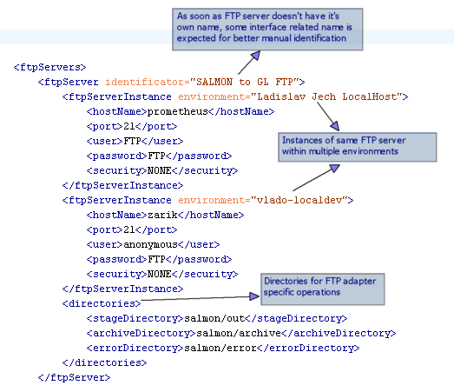

Element 'osbDatabaseReporting'
Element stores Irish Water project specific metadata of OSB reporting framework where should be available all interface events reported. In case of error occured there are more detailed provided. OSB reporting framework reports trough OSB JMS subsystem to customized databaze tables. These tables are accessed and checked if expected report exists after interface activation.

Element 'fileSystemStructure'

Element 'flowPatterns'

Interface Configuration XML File

SOA Testing Framework within existing environment
asdfdsafsa

SOA Testing Framework within future environment

IBM Programme Implementation Integration Patterns

OSB Patterns
There are few of integration patterns identified within IBM Irish Water Programme implementation which are currently supported. Here they are:
- Database -> Queue -> Database/SOAP

SOA Patterns

Detail Process Flow
In this chapter I am going to describe detailed step-by-step process of the configuration and execution of the framework.

Pattern: Database -> Queue -> Queue -> Database/SOAP

Pattern: CSV File -> Queue -> Database/SOAP

