Company Shop Admin Area
Docked Domain into Corporate Central Admin App

Document Type: Concept / Requirements / Design
Version: 1.1
Status: Draft
Owner: IT Service Management
Last Updated: 2026-01-18
Change History:
- v1.0 – Initial concept definition
- v1.1 – Removes overlaps with Central Admin App Concept

Management Summary
The Company Shop Admin Area is the application-specific administrative domain for the Company Marketing, Merchandising, and Clothing Shop.
It is docked into the Corporate Central Admin App, which provides identity, organizational master data, role assignment, auditability, and governance mechanics.
The Shop Admin Area does not manage global users, legal entities, cost centers, or core access governance. Instead, it consumes these centrally governed primitives and focuses exclusively on shop-domain administration, including:
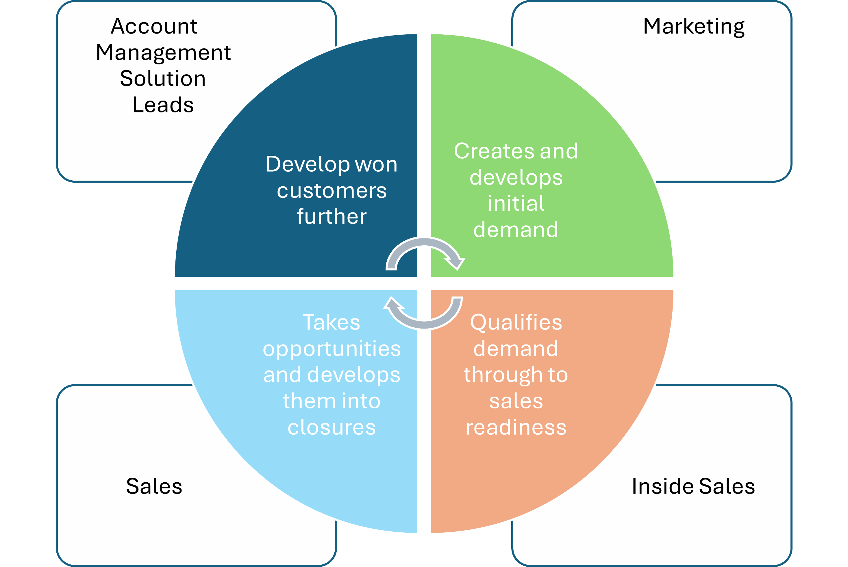
- Marketing purchase request approvals
- Employee allowance configuration
- Order and fulfillment tracking
- Delivery and logistics configuration
- Shop content management (Markdown-based)
- Shop-specific notifications
- Integration monitoring and operational stability
This separation ensures:
- Clear ownership boundaries
- Strong governance and auditability
- Independent evolution of the Shop domain
- Seamless onboarding into the Central Admin ecosystem

1) Positioning within the Corporate Central Admin App

1.1 Docking Context
The Shop Admin Area appears in the Corporate Central Admin App under:
Applications → Merchandise Shop
The Central Admin App provides:
- Identity & access governance
- Cost center and legal entity master data
- Role assignment and activation
- Unified audit trail and lifecycle metadata
- Shared notification and integration health primitives
The Shop Admin Area:
- Registers via the Application Docking Contract
- Declares its own admin navigation and role catalog
- Fully owns all shop-specific configuration and workflows

2) Purpose and Scope of the Shop Admin Area

2.1 Purpose
The Shop Admin Area is the central operational and governance interface for all shop modes:
- Marketing materials & merchandise
- Employee clothing & merchandise
- Public merchandise shop
It enables authorized administrators to govern, operate, and monitor the shop without exposing complexity to end users.

2.2 Explicit Non-Goals
The Shop Admin Area does not:
- Create or manage global users
- Maintain legal entities or cost centers
- Define authentication or SSO logic
- Implement global RBAC mechanics
- Replace the Corporate Central Admin App

3) Admin Personas and Roles (Shop Domain)
Roles are assigned in Central Admin, but interpreted and enforced within the Shop Admin Area.

3.1 Shop-Specific Admin Roles
Role | Responsibility
SHOP_Admin | Full access to all shop admin functions
SHOP_UserRole_Manager | Assign shop roles to users within allowed scopes
SHOP_Marketing_Approver | Approve marketing purchase requests
SHOP_Content_Manager | Manage shop content and Markdown pages
SHOP_Operations_Manager | Order tracking, logistics, bulk orders
SHOP_Finance_Admin | Employee allowances and internal budgets
SHOP_Technical_Admin | Integration monitoring and error handling
Scope bindings (e.g. cost center) are provided by Central Admin and respected by the Shop Admin Area.

4) Core Functional Domains of the Shop Admin Area

4.1 Shop Role & Scope Interpretation
Consumed from Central Admin:
- User identity (read-only)
- Assigned shop roles
- Cost center assignments
- Legal entity and country context
Shop Admin capabilities:
- Interpret roles for shop behavior
- Enforce scope-based visibility and approval authority
- Display effective role context in admin views

4.2 Marketing Purchase Request & Approval Management
Scope: Marketing shop mode only
Capabilities:
- Central overview of all marketing purchase requests
- Filtering by:
  - Status
  - Cost center
  - Campaign / event
  - Date range
  - Requester
Request detail includes:
- Items and quantities
- Total cost
- Delivery details
- Campaign/event context
- Approval history and comments
- Attachments (artwork, briefs)
Approval logic:
- Single or multi-level approvals (by amount)
- Substitute approvers
- Full audit trail (via Central Admin)

4.3 Orders & Fulfillment Tracking (All Shop Modes)
Unified order view covering:
- Marketing orders
- Employee orders
- Public orders
Capabilities:
- Status tracking across lifecycle stages
- Carrier and tracking information
- Fulfillment partner visibility
- Highlighted exceptions and delays
The Shop Admin Area monitors and visualizes, but does not execute fulfillment.

4.4 Delivery & Logistics Configuration (Marketing Focus)
Capabilities:
- Central repository of delivery addresses
- Tagging (office, event, warehouse)
- Validity periods for temporary addresses
Delivery scheduling:
- Campaign- or event-based delivery windows
- Bulk shipment planning
- Restock and production cycle configuration

4.5 Employee Allowance Management
Capabilities:
- Define allowance rules:
  - Amount per period
  - Reset cycle
  - Eligible product categories
- Configuration by:
  - Employee group
  - Location
  - Role
Monitoring:
- Per-employee allowance usage
- Remaining balance
- Expiration dates
Manual adjustments:
- Credits
- Deductions
- Exceptional grants

4.6 Content Management (Markdown-Based)
Capabilities:
- Separate content per shop mode:
  - Marketing
  - Employee
  - Public
- Markdown editor with preview
- Image and link management
Governance:
- Draft vs published states
- Optional approval workflow
- Version history and rollback
Content affects:
- Start pages
- Category pages
- Editorial highlights

4.7 Notification Configuration (Shop-Specific)
Capabilities:
- Manage notification triggers:
  - Request submission
  - Approval outcome
  - Shipment updates
  - Allowance thresholds
- Channels:
  - Email
  - In-app
  - Optional webhooks
Templates:
- Editable per notification type
- Mode-specific language
- Preview and test-send

4.8 Integration Monitoring & System Logs
Capabilities:
- Central log of shop-related integrations:
  - ERP
  - Fulfillment partners
  - Payment providers
Logged data:
- Timestamp
- Source / target system
- Payload summary
- Status
Error handling:
- Highlight failures
- Retry mechanisms
- Correlation IDs for support

5) UX Principles for the Shop Admin Area
- Clear separation between:
  - Configuration
  - Daily operations
  - Exception handling
- Role-aware navigation
- Strong filtering and search
- No technical knowledge required for business admins
- Full auditability via Central Admin

6) Relationship to the Corporate Central Admin App
Aspect | Central Admin | Shop Admin Area
Identity | Owns | Consumes
Cost centers | Owns | Consumes
Role assignment | Owns | Interprets
Audit trail | Owns | Uses
Shop approvals | – | Owns
Allowances | – | Owns
Orders & logistics | – | Owns
Content | – | Owns
Central Admin governs.
Shop Admin administers.

7) Outcome
With this aligned architecture:
- Governance is centralized and consistent
- Shop-specific complexity is isolated and manageable
- The Shop Admin Area evolves independently
- Future admin domains can be added without redesign
The Company Shop Admin Area becomes a clean, docked, and scalable admin domain within the Corporate Central Admin ecosystem.

