Strategy
for Sales/Marketing
  - 04.2026
Andreas Eisner / Anja Eisner

Management Summary
Our RCIM Sales & Marketing strategy combines market positioning, demand generation, qualification, value selling, and customer development in an integrated revenue funnel.
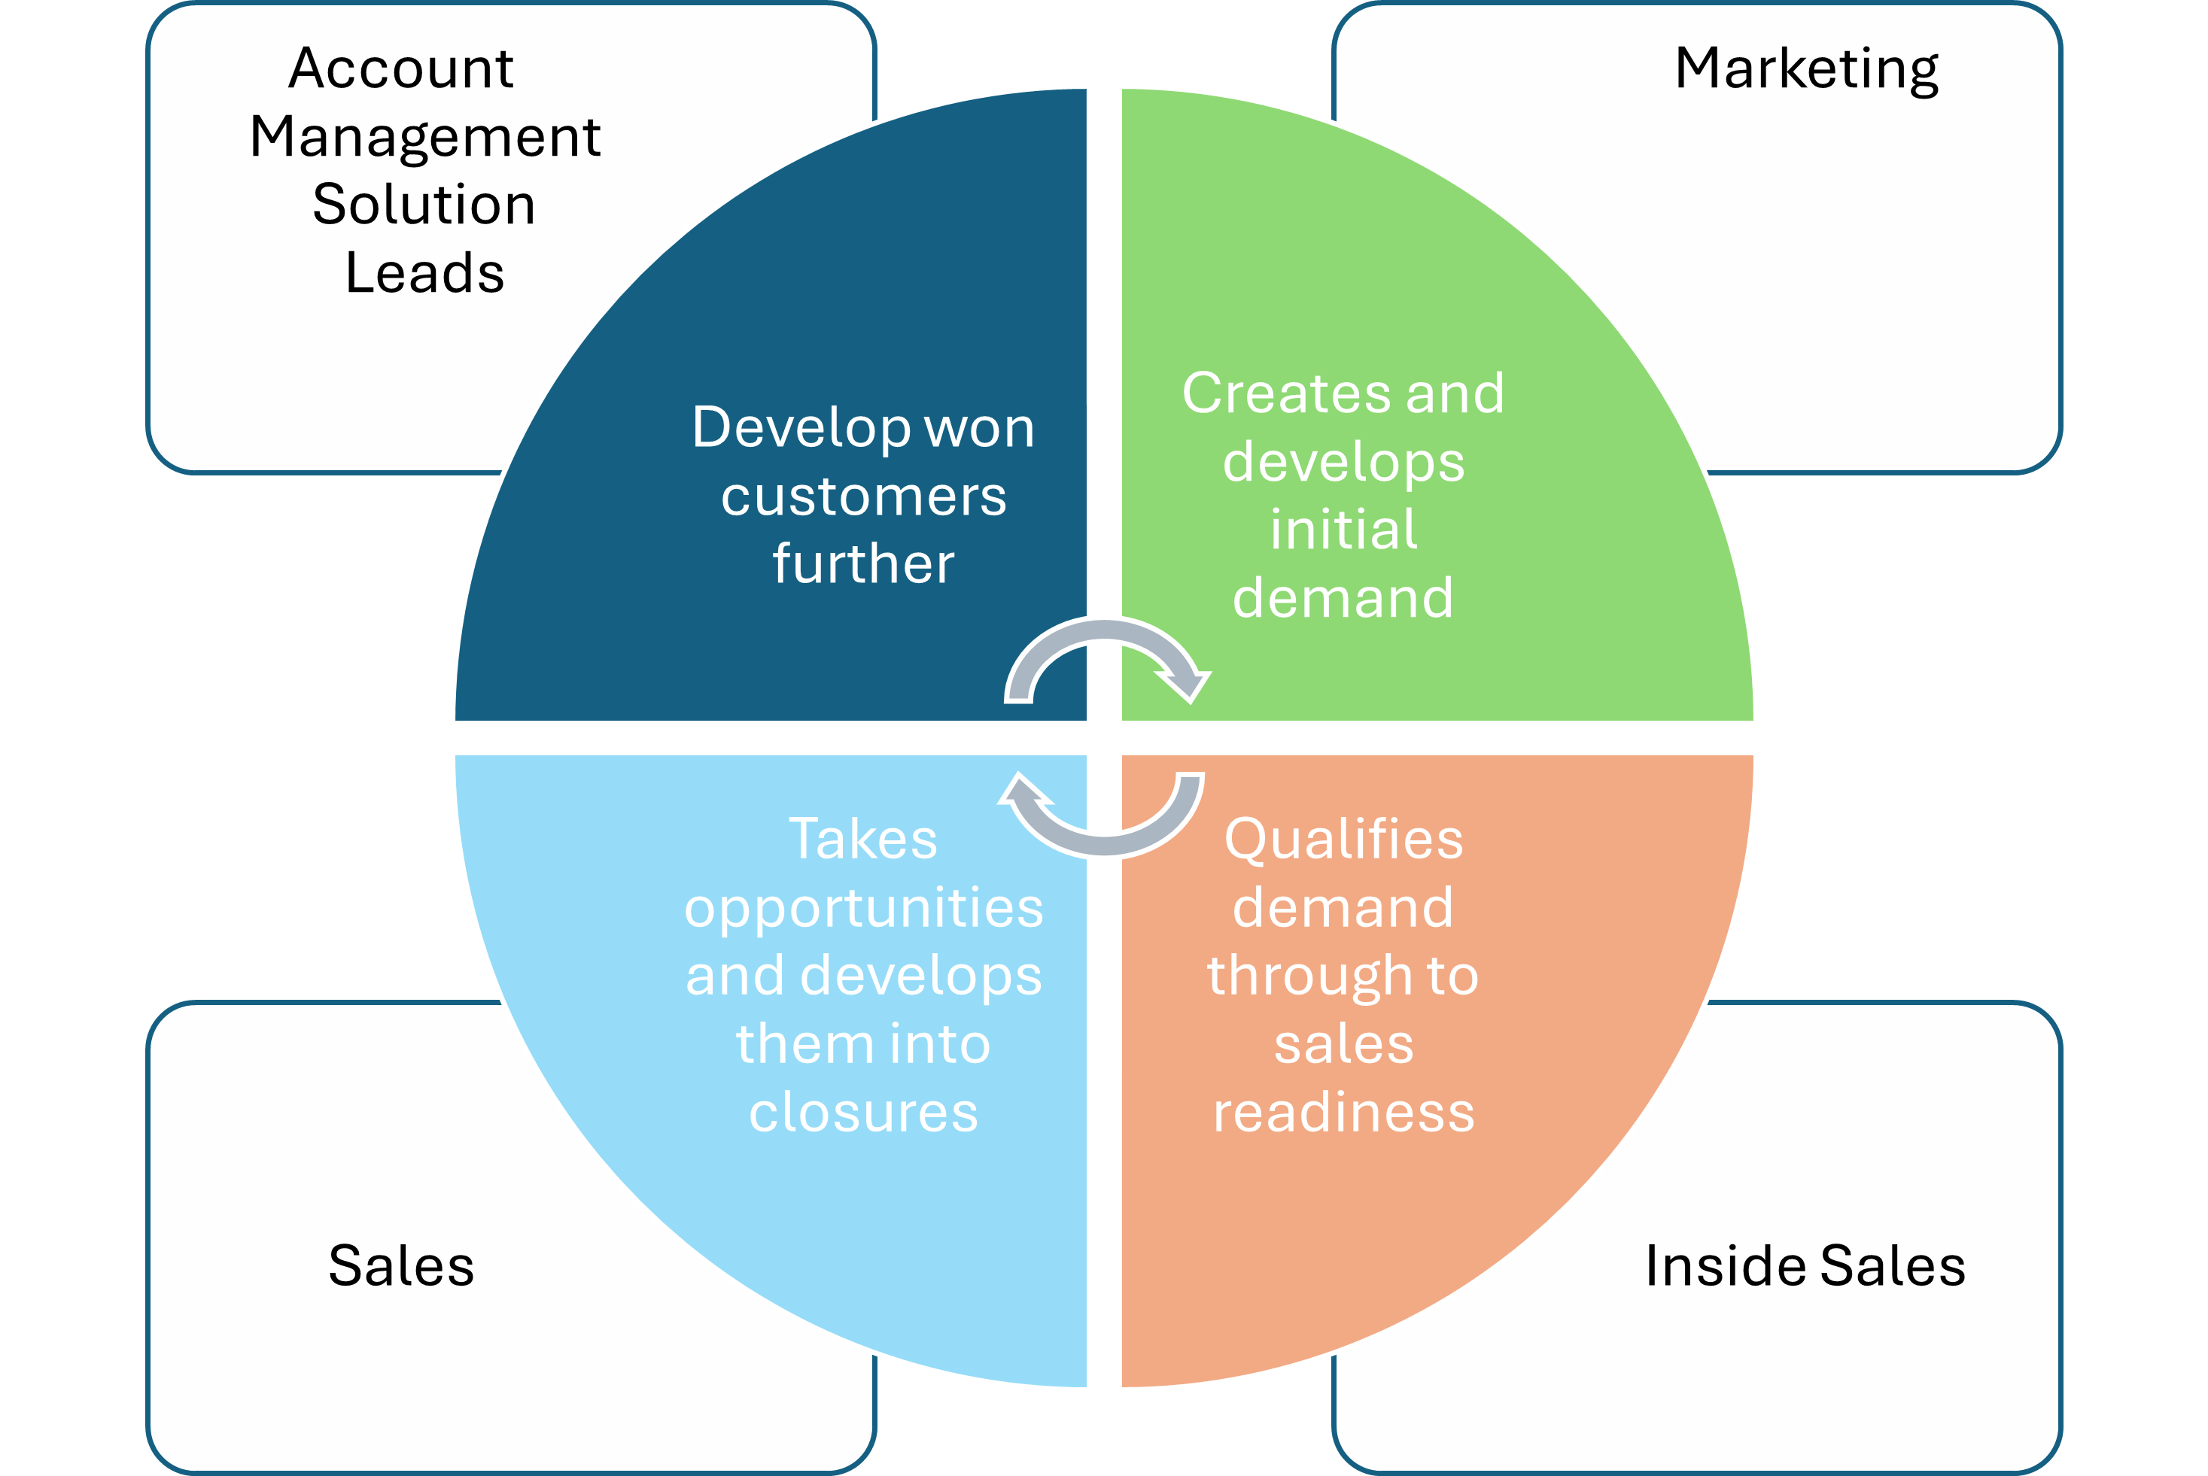
Image: Responsibility of Roles
The strategic logic is:
- Marketing creates and develops relevant demand.
- Inside Sales consistently qualifies this demand through to sales readiness.
- Sales takes over only robust, documented, and strategically suitable opportunities and develops them into closures together with the Solution Leads.
- Solution Leads and Account Management systematically develop won customers further.
The key sharpening point of this strategy is the clear handover logic between Marketing, Inside Sales, and Sales. Not interest alone, but robust qualification determines the move into the active sales cycle.
This enables:
- higher efficiency in the use of sales resources,
- better forecast quality,
- clear responsibilities,
- stronger conversion along the funnel,
and a robust foundation for profitable, recurring growth.

1. Strategic Vision & Financial Targets (2030)

Vision
Our CORE is to simplify the future by adapting digital technologies into smart solutions that leave you with a smile.

Financial Targets
- Total revenue: EUR 31.0m
- Solution revenue: 5 successful solutions generating EUR 5.0m each
- Team size: 180 FTE
- Profitability: EUR 2m EBIT

2. Strategic Framework: Integrated Revenue Funnel
Our go-to-market approach follows an integrated revenue funnel that connects market outreach, qualification, sales execution, and customer development in an end-to-end model. The goal is to systematically build demand, reliably qualify relevant purchase intent, close with a value-oriented approach, and expand profitable customer relationships over the long term.
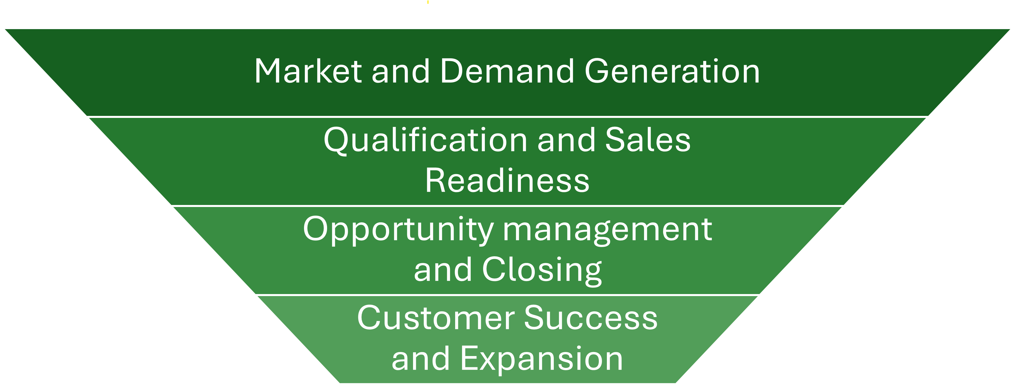
Image: Revenue Funnel
The go-to-market is managed along a four-phase revenue funnel. Each phase has a clear objective, an unambiguous leadership responsibility, defined handover criteria, and measurable success metrics.

3. Phase 1: Market & Demand Generation

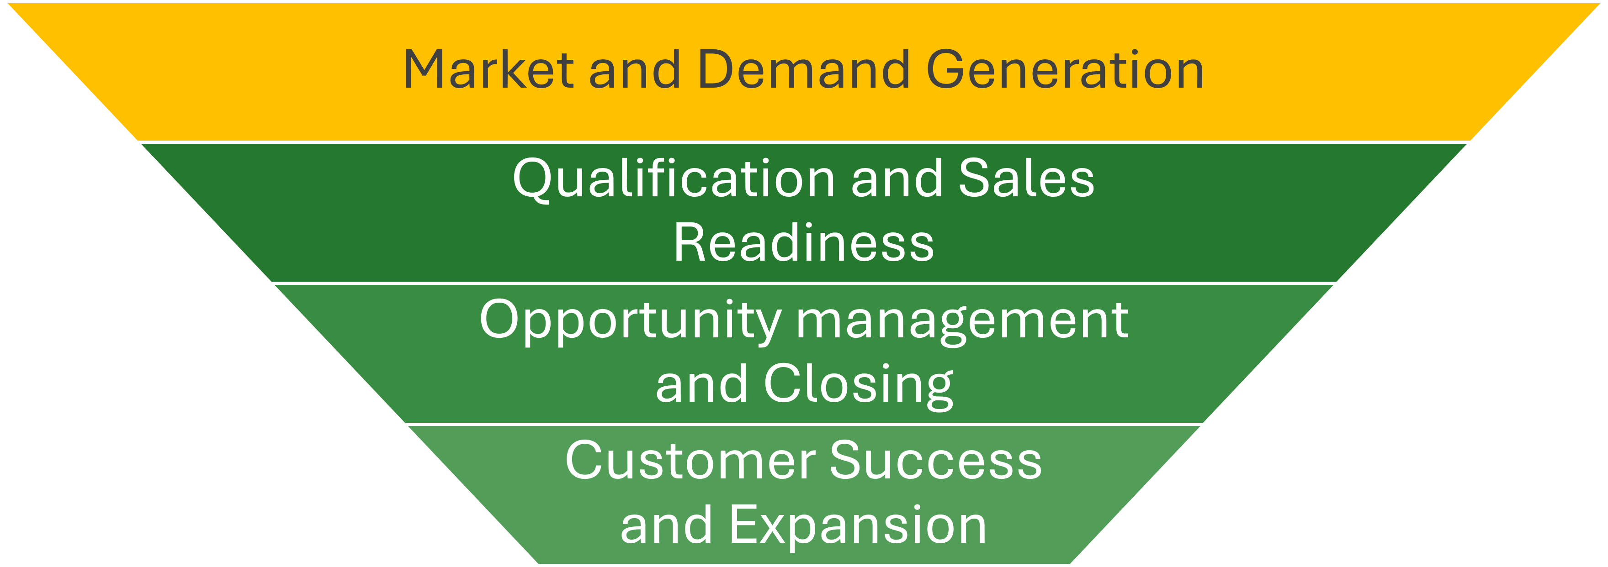
Image: Phase 1 - Revenue Funnel

Objective
Build brand awareness in the defined target segments and generate a continuous stream of relevant interested parties, contacts, and accounts.

Strategic Focus Areas
“Inbound/outbound are channel or initiative logics; touchpoints are described channel-agnostically in operations and the functional concept.”
- Inbound Marketing: Positioning as a thought leader through high-quality content along the challenges of our target customers
- Outbound & Account-Based Marketing: targeted outreach to defined target accounts via networking, partner channels, events, and topic-specific campaigns
- Lead Nurturing: systematic development of prospects who are generally relevant but do not yet have a robust project trigger
- Segment-oriented market development: steering of messages, offers, and campaigns along defined target segments and buying-center roles

Responsibility
Marketing is fully responsible for Phase 1.
Marketing is responsible for:
- brand positioning
- topic and campaign planning
- content strategy and thought leadership
- inbound channels, website, landing pages, and conversion architecture
- campaign management and demand generation
- nurturing logic for leads that are not yet sales-ready
- signal detection and preparation of qualified handovers

Campaign Governance
- Campaigns are a repeatable steering mechanism for pipeline development (not ad-hoc one-off measures).
- Campaigns are executed along strategic segments and buying-center roles.
- Steering is done via a binding review cadence with clear decisions: Stop / Adjust / Scale.
Binding operational implementation (DoD, templates, cadence, SLA, KPI definitions): See Sales Marketing Operations & Functional Concept and the Campaign Playbook.

Outcome of Phase 1
Phase 1 is successful when robust, documented demand emerges from market outreach and identifiable contacts or accounts can be transferred into a structured qualification process.

4. Phase 2: Qualification & Sales Readiness
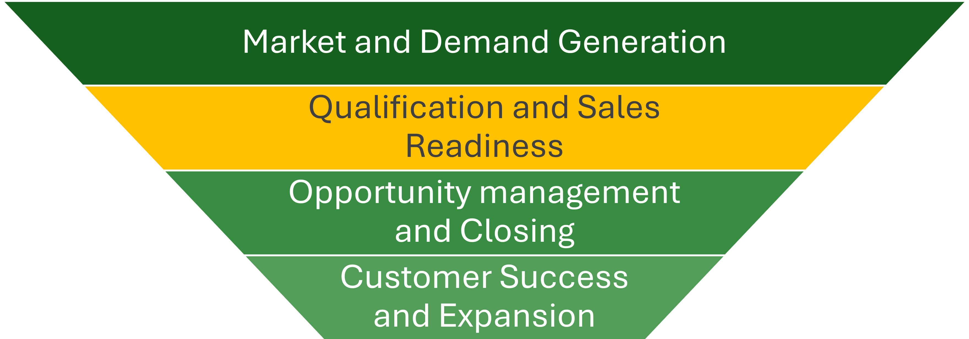
Image: Phase 2 - Revenue Funnel

Objective
Efficient identification of serious purchase intent so that valuable sales resources focus exclusively on robust, strategically suitable opportunities.

Strategic Logic
Not every interested contact is already a sales-ready lead. Between initial interest and an active opportunity lies a qualification phase in which relevance, need, timing, and strategic fit are assessed.
The aim of this phase is not to maximize volume, but to reliably distinguish between:
- general interest,
- relevant but not yet sales-ready need,
- and a robust sales opportunity.

Leadership Responsibility
Marketing and Inside Sales are jointly responsible for this phase with a clear separation of roles:
- Marketing generates demand, continues to develop leads, and provides signals, context, and content relevance. Leads/signals can arise via various touchpoints (incl. events/trade fairs, network, partners, inbound) – including via sales.
- Inside Sales qualifies this demand further personally or semi-scalably and decides on handover, return to nurturing, or exclusion.

Strategy for Transition from Marketing to Inside Sales
Marketing and Inside Sales ensure a quality-based handover.
The detailed signal logic (signal types, thresholds/scoring, triggers by channel, rules for return or exclusion) is bindingly described in the Operations & Functional Concept.

Target Picture for Qualification
The goal of qualification is the reliable separation between general interest, relevant but not yet sales-ready need, and a robust sales opportunity. Qualification ensures that the transition into Active Sales is quality-based and traceable.
Principles: - Qualification assesses strategic fit, need/use case, timing/pressure to act, and the stakeholder context (buying center). - Immature cases remain in nurturing/further qualification or are excluded to protect sales resources.
Details on the operational implementation (activities, decision logics, criteria catalogs, artifacts/handover package, role RACI) are bindingly described in the Operations & Functional Concept.

Outcome of Phase 2
Phase 2 ends with “Sales Ready” and triggers opportunity creation/handover into Phase 3; immature leads consistently remain in nurturing.

5. Phase 3: Opportunity Management & Closing

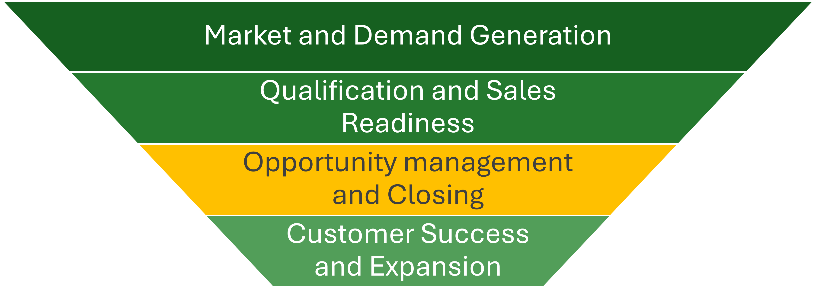
Image: Phase 3 - Revenue Funnel

Objective
Win new business through a consultative, value-oriented sales approach with clear customer benefit and a robust business case.

Strategic Sales Approach
Our standard in Phase 3 is value selling. The focus is not on selling individual services in isolation, but on developing a compelling solution perspective for the customer.
Sales works in a tandem:
- (Local) Sales Representative: responsible for the customer relationship, access, political navigation, and management of the active sales cycle
- (Global) Solution Lead: responsible for solution strategy, value proposition, architecture and delivery proximity, and a commercially robust proposal logic

Shared Objective of the Tandem
- act as a trusted advisor,
- sharpen the customer’s problem statement and target picture,
- develop a robust value proposition,
- substantiate the business case argumentatively,
- and lead the opportunity in a controlled way to closure.

Core Principles of Opportunity Steering
- active steering only for qualified and accepted opportunities
- clear owner responsibility
- robust forecasting capability
- transparent status logic
- documented next steps
- tight integration of customer relationship and solution expertise

Responsibility
Sales is responsible for Phase 3, specifically:
- (Local) Sales Representative
- (Global) Solution Lead
Marketing supports as needed with:
- references,
- content for sales enablement,
- proposal support,
- customer-specific communication building blocks,
- and thematic reinforcement in strategic accounts.

Outcome of Phase 3
Phase 3 is successful when qualified opportunities result in profitable new business with high forecast quality and professional handover readiness.

6. Phase 4: Customer Success & Expansion
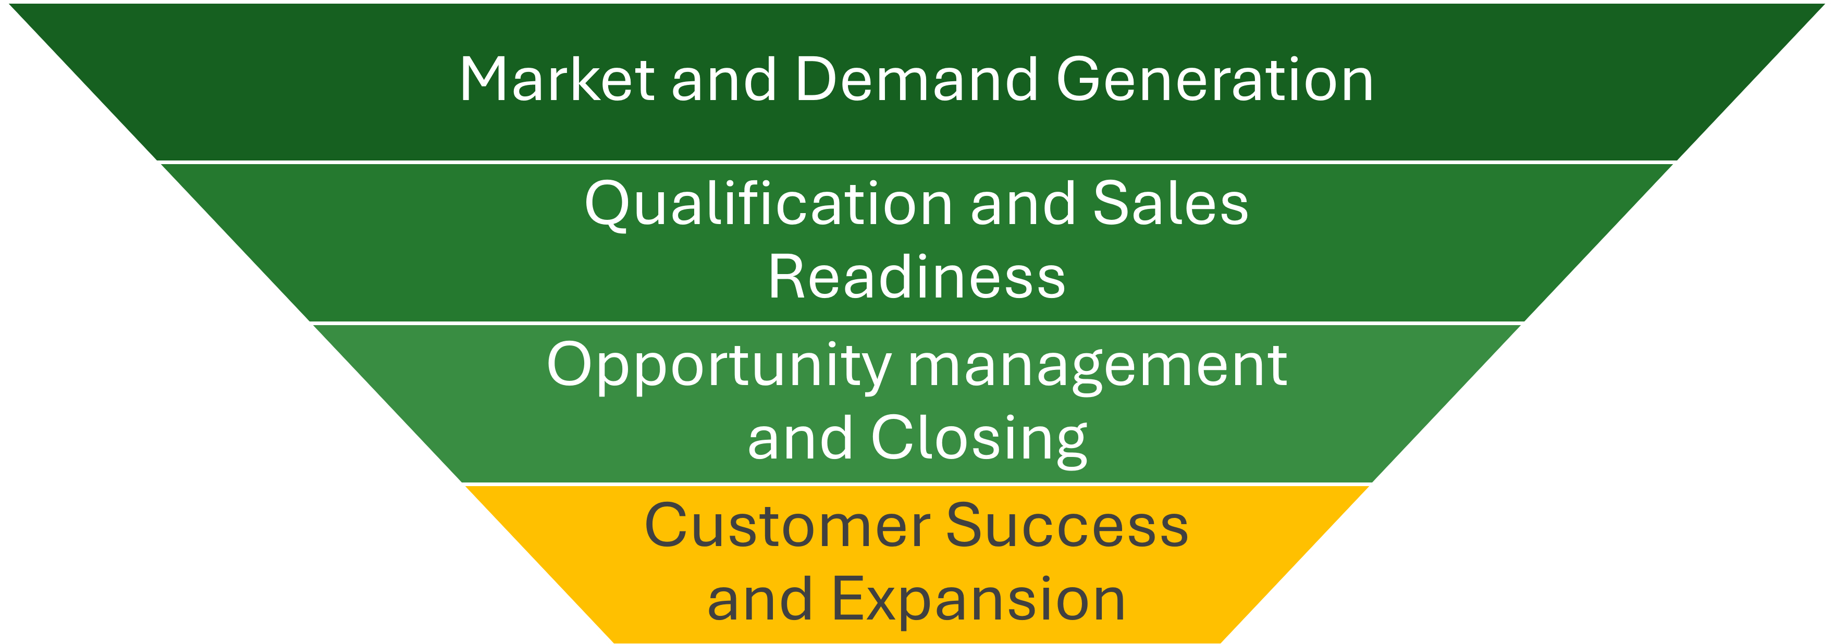
Image: Phase 4 - Revenue Funnel

Objective
Maximize customer lifetime value through high customer satisfaction, structured customer management, and systematic cross- and upselling.

Strategic Logic
Closing an initial project is not the end of the revenue funnel, but the beginning of a long-term, strategically managed customer relationship.
Phase 4 follows the Land & Expand principle:
- Land: The first project establishes trust, delivery capability, and strategic relevance.
- Expand: On this basis, additional value creation potentials are identified and developed.

Growth Levers in Phase 4
- additional solutions and follow-on projects
- automation and optimization initiatives
- expansion toward AMS
- expansion into further areas, plants, countries, or legal entities
- structured strategic reviews with the customer

Leadership Responsibility
Solution Leads and Account Management are responsible for Phase 4.
Their tasks are:
- strategic customer development
- identification of cross- and upselling potentials
- long-term positioning as a trusted advisor
- management of QBRs and strategic development discussions
- ensuring clean feedback loops into new demand and new opportunities

Role of Marketing in Phase 4
Marketing provides targeted support through:
- existing-customer communications
- thought leadership for existing customers
- segment- and account-related content
- support for QBRs and expansion initiatives
- reference development, case stories, and brand strengthening in the customer environment

Outcome of Phase 4
Phase 4 is successful when won customers yield sustainable, profitable, and recurring revenue potentials.

7. Strategic Positioning by Segment
Market development is oriented toward clearly defined strategic segments. Positioning, messaging, prioritization, offer logic, and next best actions are steered by segment.
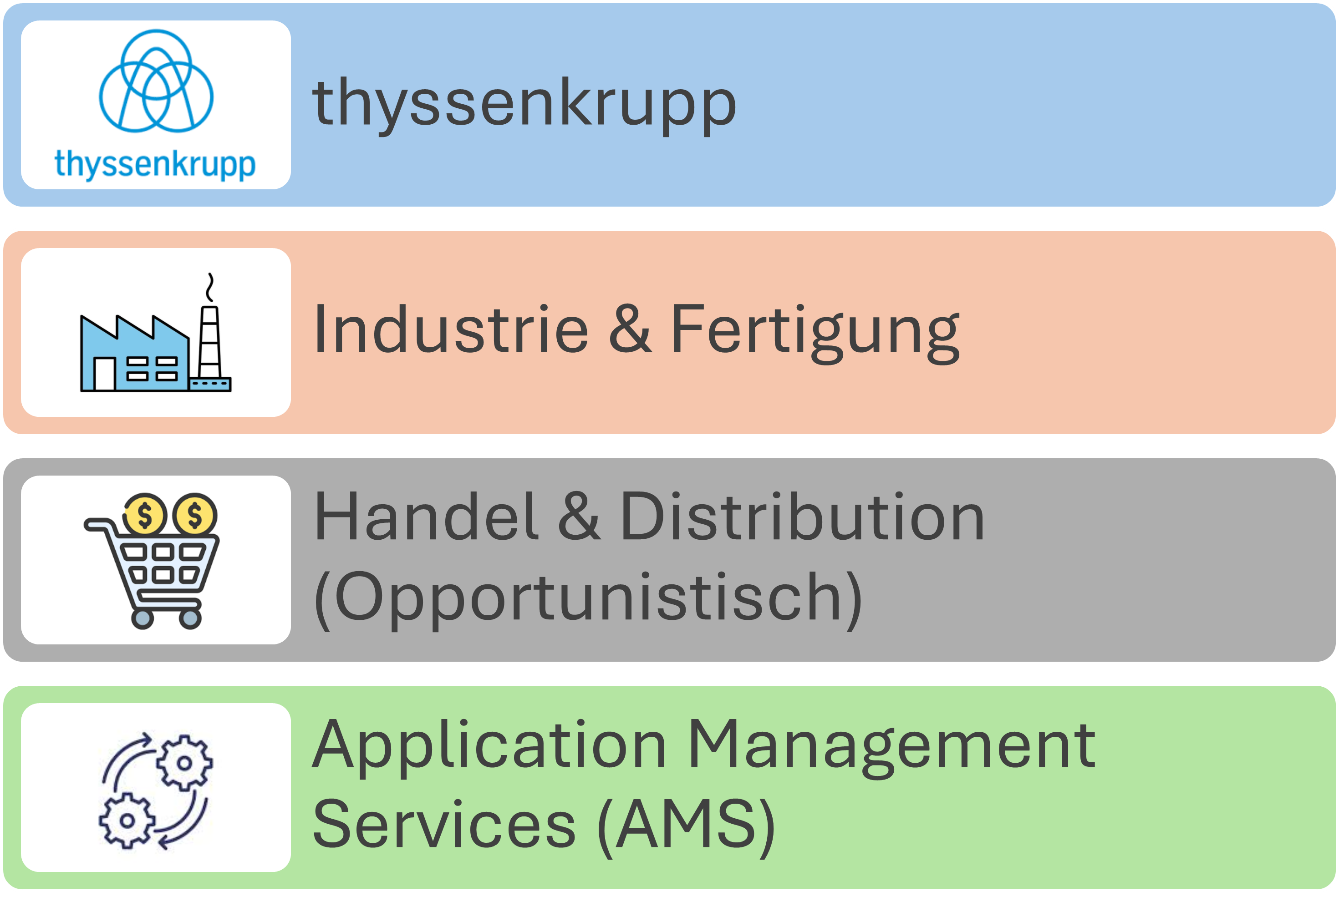
Image: Strategic Segments

7.1 thyssenkrupp (Major Key Account)
Positioning as an indispensable strategic partner who combines internal knowledge, robust delivery competence, and external innovative strength.

7.2 Industry & Manufacturing
Positioning as a field-proven industry specialist who implements SAP solutions with real understanding of shopfloor, processes, and industrial value creation.

7.3 Retail & Distribution (Opportunistic)
Positioning as a specialist who, through strong functional and technical expertise and experience combined with logistics and process competence, unlocks optimization potential for the customer and minimizes risks.

7.4 Application Management Services (AMS)
Positioning as a proactive value driver who, by relieving internal employees through automation, continuous improvement, and added value beyond classic support, creates benefits.

7.5 Segment Prioritization & Review
Objective: Segment and focus changes are rare, justified, and traceable (no ad-hoc drifts).
- Strategic prioritization criteria:
  - portfolio fit & referenceability
  - revenue/recurring potential (CLV)
  - access/relationship (entry points in the buying center)
  - delivery capability & scalability (templates, repeatability)
  - partner levers (speed/trust/access)
- Review cadence: quarterly (internal QBR) or in the event of a strategic event (M&A, portfolio shift).
- Output (mandatory): updated segment list + 3-sentence rationale per segment + date/version.
- Operational implementation: segment playbooks and implementation priorities are maintained in the Marketing Implementation Concept.

8. Strategic Role Model in the Go-to-Market

Marketing
Responsible for brand positioning, demand generation, campaigns, content, nurturing, and the preparation of qualified handovers.

Inside Sales
Responsible for qualification, follow-up, initiating conversations, relevance assessment, and handover of sales-ready leads into the active sales cycle.

Sales Representative (Local)
Responsible for new customer acquisition, customer relationship, opportunity leadership, and commercial management in the active sales process.

Solution Lead (Global)
Responsible for solution strategy, value proposition, functional sharpening, proposal logic, and customer development in the sense of expand.

Head of Industry Sales (≙ Executive Director Sales & Operations / ED S&O)
Responsible for overarching revenue steering, GTM alignment, prioritization, governance, and overall commercial development.
Commercial ownership (pricing/margins/contract submission): lies with the Solution Lead; Sales supports relationship management and the signing process. The Management Board has final authority for special conditions (special pricing) and commercial exceptions.

9. Governance Principles for the Revenue Funnel

Principles
To ensure the funnel can be managed effectively, the following strategic guardrails apply:
- quality over volume as a leadership principle
- review/steering cadences at management level
- escalation and decision principles
- trade-offs

Strategic Trade-offs (“What we do NOT do”)
To safeguard positioning and avoid commoditization, the following strategic guardrails apply:
- We do not act as a pure body leasing/staffing provider; body leasing is only complementary and not identity-defining.
- We pursue no generic, “relationship-free” RFPs without access to the requester/buying center.
- We accept no price-only deals without a robust value/outcome case (commoditization).
- We avoid very small projects without a strategic logic – except as a deliberate PoC or strategic door opener.
- We do not do projects where we enable competitors and leave them know-how or IP.
These trade-offs are strategic guardrails and apply to all go-to-market activities.

10. Strategic Steering & KPIs
Commercial success is managed via consistent, strategic metrics along the revenue funnel.

Core Steering KPIs
- Pipeline Velocity: Measures how quickly and in what volume qualified pipeline turns into revenue.
- Conversion rates per funnel phase: Show the percentage transition from leads/signals to the next phase and make bottlenecks in the funnel visible.
- Customer Acquisition Cost (CAC): Indicates how much marketing and sales cost is needed on average to acquire a new customer.
- Customer Lifetime Value (CLV): Estimates the expected contribution margin/revenue of a customer over the entire customer relationship.
- Share of recurring revenue: Describes what percentage of total revenue comes from recurring income.
- Forecast Accuracy: Measures how far the forecast revenue/closure development deviates from the actually realized results.
- Win/Loss rate: Shows the share of won versus lost/declined opportunities, often supplemented by loss/decline reasons.

Additional Management Perspectives
- share of strategic solutions in revenue
- contribution of marketing to pipeline development
- share of sales-ready leads from marketing and inside sales
- time to qualification
- quality of handovers to sales
- expansion rate of existing customers

