KT-SPD I/O-Expander (MAX10)
Hardware Specification

Document No.:
Project Code: |  | Project Name: | KT-SPD MAX10 FPGA
Brian Kleen | 0.1 | 12/05/19 |  |  | First Run
Prepared By | Revision | Date | Approved By | Date | Remark
Remarks | This document contains information confidential and proprietary to King Tiger Technology, Inc., and may not be distributed outside the company without the prior written consent of the Board of Directors.
King Tiger Technology, Inc.
12001 W. Parmer Ln #250, Cedar Park, TX 78613
R&D Confidential Document, All Rights Reserved. Tel: (512) 401-8775 www.kingtigertech.com

Table of Contents
1 Introduction 3
2 Hardware 3
3 Microcontroller Interface 4
3.1.1 Write/Read Operations 4
3.1.2 Main FPGA Operation 4
3.1.3 FPGA Microcontroller Register Map 4
3.1.3.1 General Purpose R/W Register (Address 0x005) 5
3.1.3.2 STATUS (Address 0x006) 5
3.1.3.3 SAEvent_0 (Address 0x007) 5
3.1.3.4 CLK_0 (Address 0x008) 5
3.1.3.5 CTRL_0 (Address 0x009) 6

Table of Figures
Figure 1. Simplified FPGA Block Diagram 3

KT-SPD I/O-Expander

Introduction

The MAX10 FPGA on the KT-SPD programmer is provided as an ‘I/O Expander’ for the primary STM32 microcontroller. The microcontroller performs most of the control and operational features of the tester, but needs some extra I/O controls. This document will expound upon the access to, and use of, those features.

Hardware

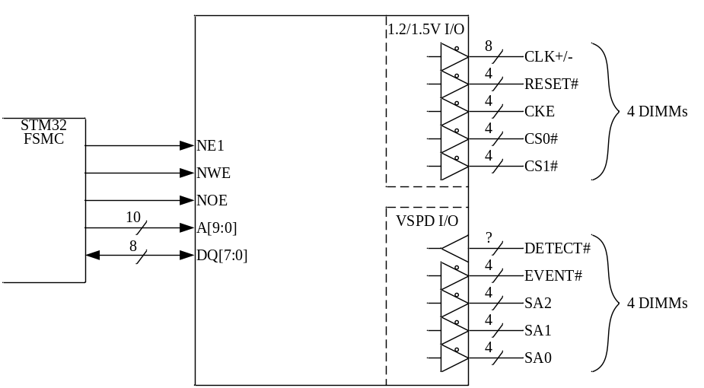
Figure 1. Simplified FPGA Block Diagram

The MAX10 FPGA is accessed by the STM32 microcontroller through the microcontroller’s FSMC (Flexible Static Memory Controller) interface. For our implementation, we use no more than a 1024-Byte address space.

The register space accessed by the STM32 controls DUT-voltage signals needed to achieve I²C access of support devices on DIMMs (RCD, TS, etc.) over and above the basic SPD EEPROM(s). There are separate controls, per-signal and per-DIMM, for up to 4 DIMM sockets.

In addition, there are VSPD-voltage level signals needed to detect DIMM insertion as well as setting the serial device addresses per-DIMM for up to 4 DIMM sockets. The serial address signals are also used to set the non-victim levels for PMU testing of the SPD EEPROM.

Microcontroller Interface

Write/Read Operations
The microcontroller (MCU) interface is basically the same as that used by the KT-3MA StratixV FPGA.

Main FPGA Operation
1. If the FPGA has been freshly powered-up or configured, all DUT signals are in a tristate condition.
2. Poll register 0x006 bits [3:0] to see when a DUT insertion is detected. ‘1’ = inserted. If bit [7] is ever ‘0’, it means the FPGA’s PLL has lost lock, and there may be a hardware failure. Try resetting the FPGA, to see if the condition changes.
3. Upon detecting a module insertion, it will be necessary to set up that DIMM’s SA[2:0] levels.
4. Set the DIMM’s RESET# and CKE to each drive a ‘0’.
5. Wait 200us.
6. Set the DIMM’s RESET# and CS[1:0]# to each drive a ‘1’, and turn the CLK on (toggling).
7. Wait 500us.
8. Set the DIMM’s CKE to drive a ‘1’.
9. Wait 50us.
10. Proceed with I²C operations to the target DIMM.
11. When finished, reverse steps 3-8 to restore all DIMM signals to Tristate.
12. Make sure the DIMM loses ‘detection’ before starting a new run.

FPGA Microcontroller Register Map
Please note that this assumes NE(1). These are 8-bit addresses. When the STM32F is in 8-bit mode, its HADDR[?:?] → FSMC_A[9:0]. Tigerclaw Address 0x??000xxx.
MCU_HADDR | FSMC Address | Register Name | Description
0x00000000 | 0x000 | VERSION | Version[7:0]. RO
0x00000000 | 0x001 | TYPE | RFU, 0x12. RO
0x00000000 | 0x002 | DAY | Day[7:0]. RO
0x00000000 | 0x003 | MONTH | Month[7:0]. RO
0x00000000 | 0x004 | YEAR[7:0] | Last 2 digits of year. RO
0x00000000 | 0x005 | GPRWREG[7:0] | R/W, default = 0x5C
0x00000000 | 0x006 | STATUS | PLL Lock and DIMM detect status. RO
0x00000000 | 0x007 | SAEvent_0[7:0] | DIMM0 SA and Event# controls. R/W
0x00000000 | 0x008 | CLK_0[2:0] | DIMM0 Clock controls. R/W
0x00000000 | 0x009 | CTRL_0[7:0] | DIMM0 Cmd/Ctrl controls. R/W
0x00000000 | 0x00A | SAEvent_1[7:0] | DIMM1 SA and Event# controls. R/W
0x00000000 | 0x00B | CLK_1[2:0] | DIMM1 Clock controls. R/W
0x00000000 | 0x00C | CTRL_1[7:0] | DIMM1 Cmd/Ctrl controls. R/W
0x00000000 | 0x00D | SAEvent_2[7:0] | DIMM2 SA and Event# controls. R/W
0x00000000 | 0x00E | CLK_2[2:0] | DIMM2 Clock controls. R/W
0x00000000 | 0x00F | CTRL_2[7:0] | DIMM2 Cmd/Ctrl controls. R/W
0x00000000 | 0x010 | SAEvent_3[7:0] | DIMM3 SA and Event# controls. R/W
0x00000000 | 0x011 | CLK_3[2:0] | DIMM3 Clock controls. R/W
0x00000000 | 0x012 | CTRL_3[7:0] | DIMM3 Cmd/Ctrl controls. R/W
0x00000000 – 0x00000000 | 0x013 – 0x3FF | --- | Not Implemented
* : R/W = microcontroller can Write and Read; R/O = microcontroller can only Read.

General Purpose R/W Register (Address 0x005)
This is an 8-bit register which is both readable and writable by the microcontroller. It does not control anything inside the FPGA, and is strictly for microcontroller testing/debug.

STATUS (Address 0x006)
Register for determining state of PLL lock and detecting the insertion of DIMMs in sockets.
Bit | Name | Description
0 | Detect[0] | 1=DIMM0 inserted, 0=No DIMM0.
1 | Detect[1] | 1=DIMM1 inserted, 0=No DIMM1.
2 | Detect[2] | 1=DIMM2 inserted, 0=No DIMM2.
3 | Detect[3] | 1=DIMM3 inserted, 0=No DIMM3.
6:4 | --- | ‘000’, Not Implemented
7 | PLL_LCK0 | 1=PLL0 locked

SAEvent_0 (Address 0x007)
Registers SAEvent_[3:0] operate exactly the same, just for the different DIMMs. Only DIMM0 (SAEvent_0) is documented here for brevity.
Bit | Name | Description
1:0 | SA0 | ‘00’(Default)=Tristate, ‘10’=Low, ‘11’=High.
3:2 | SA1 | ‘00’(Default)=Tristate, ‘10’=Low, ‘11’=High.
5:4 | SA2 | ‘00’(Default)=Tristate, ‘10’=Low, ‘11’=High.
7:6 | EVENT# | ‘00’(Default)=Tristate, ‘10’=Low, ‘11’=High.

CLK_0 (Address 0x008)
Registers CLK_[3:0] operate exactly the same, just for different DIMMs. Only DIMM0 (CLK_0) is documented here for brevity.
When fully enabled, the output clock is a differential 300MHz SSTL clock to the DIMM. To maximize Ctrl/Cmd setup time, it is recommended to use Din[1:0] = ‘10’.
Bit | Name | Description
1:0 | Clk_Din[1:0] | Waveform: ‘00’=DiffLo, ‘11’=DiffHi, ‘01’=AlignedToggle, ‘10’=InvertToggle.
2 | Drive/Tri# | ‘0’(Default)=Tristate, ‘1’=Drive.
7:3 | --- | Not Implemented.

CTRL_0 (Address 0x009)
Registers CTRL_[3:0] operate exactly the same, just for different DIMMs. Only DIMM0 (CTRL_0) is documented here for brevity.
Bit | Name | Description
1:0 | RESET# | ‘00’(Default)=Tristate, ‘10’=Low, ‘11’=High.
3:2 | CS0# | ‘00’(Default)=Tristate, ‘10’=Low, ‘11’=High.
5:4 | CS1# | ‘00’(Default)=Tristate, ‘10’=Low, ‘11’=High.
7:6 | CKE | ‘00’(Default)=Tristate, ‘10’=Low, ‘11’=High.

