EX-5 Turtle World

아래 지시대로 프로그램을 작성하고, 이를 실행시킨 결과 화면도 제출하라

1. Write a void function to draw a star, where the length of each side is 100 units. (Hint: You should turn the turtle by 144 degrees at each point.)   
void function이란 결과를 return 하지 않는 function



[Codes are here]

import turtle

turtle.setup(width=1920,height=1061)

turtle.speed(2)

turtle.hideturtle()

turtle.pensize(3) #색은 RGB 16진수 코드로 찾았으나, 두께를 구하지 못함.

def draw_a_star():

for i in range (5):

turtle.fd(100)

turtle.rt(144)

draw_a_star()

실행 결과 화면:

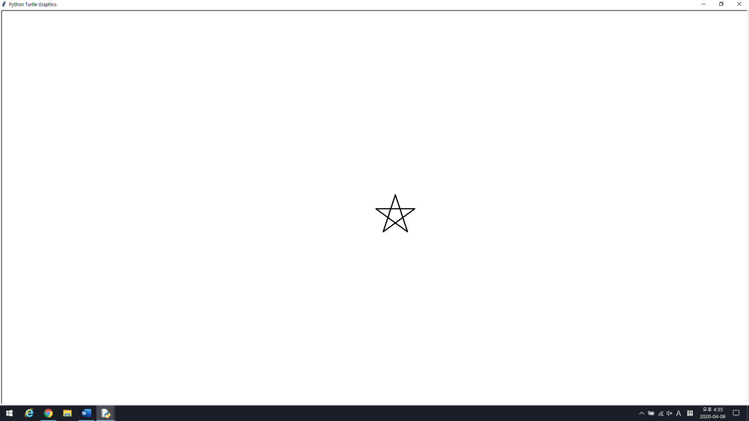

2. Extend your program above. Draw five stars, but between each, pick up the pen, move forward by 350 units, turn right by 144, put the pen down, and draw the next star. You’ll get something like this:



[Codes are here]

import turtle

turtle.setup(width=1920,height=1061)

turtle.speed(2)

#turtle.hideturtle()

turtle.pensize(3) #색은 RGB 16진수 코드로 찾았으나, 두께를 구하지 못함.

turtle.pencolor("#FF69B4")

turtle.fillcolor("#FF69B4")

turtle.bgcolor("#90EE90")

def draw_a_star():

for i in range (5):

turtle.fd(100)

turtle.rt(144)

def move_forward():

turtle.pu()

turtle.fd(350)

turtle.pd()

def turn_right():

turtle.rt(144)

for i in range(5):

draw_a_star()

move_forward()

turn_right()

실행 결과 화면:

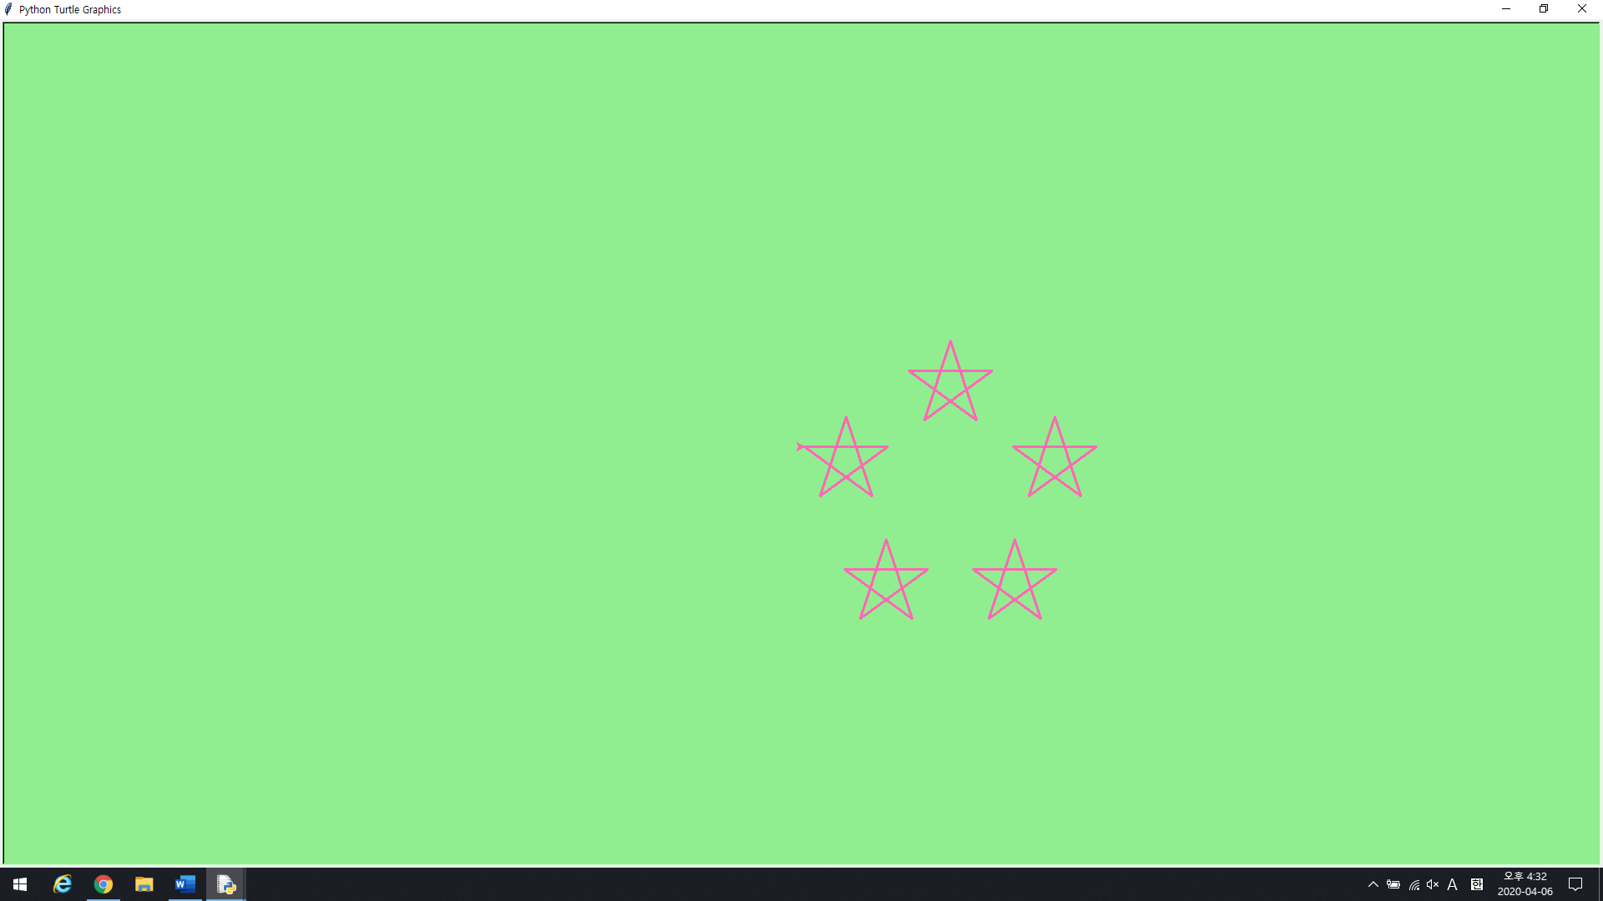

(두께가 3인지 4인지 확신이 들지 않아서 3으로 했습니다…)

3. Write a program to draw a face of a clock that looks something like this.

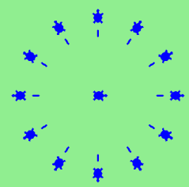

[Codes are here]

import turtle

turtle.shape("turtle")

turtle.pencolor("#0000FF")

turtle.fillcolor("#0000FF")

turtle.bgcolor("#90EE90")

turtle.pensize(3)

def clock():

turtle.pu()

turtle.fd(100)

turtle.pd()

turtle.fd(10)

turtle.pu()

turtle.fd(20)

turtle.stamp()

turtle.stamp()

for i in range(12):

clock()

turtle.setpos(0,0)

turtle.rt(30)

실행 결과 화면:

