Archer Ouyang

**Planetary Motion Activity**

**Introduction**

In this lab we use solar system data from <http://nssdc.gsfc.nasa.gov/planetary/factsheet/> so that we explore Kepler’s equation and confirm it is correct.We use the data about solar system to make linear graphs to clearly and visually compare circular motion in the solar system under the presence of gravity from the sun.We choose the data of orbital periods, orbital velocities, and the masses of planets and the sun from all the materials to better understand orbits and circular motion.

**Procedure:**

**Part A**

1. Go to the website <http://nssdc.gsfc.nasa.gov/planetary/factsheet/> to get the data
2. Create your own data table where you record the necessary information. We want to linearize 3 equations: surface gravity, orbital period, orbital velocity.
3. Record the variables you will need for these calculations. Confirm with me that you have all the correct data collected.

|  |  |  |  |  |  |  |  |  |  |
| --- | --- | --- | --- | --- | --- | --- | --- | --- | --- |
| planet | period | distance | orbital speed | T^2 | r^3 | mass10^24kg | gravity | planet radius |  |
| mercury | **7603200** | 5.79E+04 | 47400 | 57808650240000 | 1.94E+32 | 0.33 | 3.7 | 2439.5 |  |
| venus | **19414080** | 1.08E+05 | 35000 | 376906502246400 | 1.27E+33 | 4.87 | 8.9 | 6052 |  |
| earth | **31553280** | 1.50E+05 | 29800 | 995609478758400 | 3.35E+33 | 5.97 | 9.8 | 6378 |  |
| mars | **59356800** | 2.28E+05 | 24100 | 3.52323E+15 | 1.18E+34 | 0.642 | 3.7 | 3396 |  |
| jupiter | **374198400** | 7.79E+05 | 13100 | 1.40024E+17 | 4.72E+35 | 1898 | 23.1 | 71492 |  |
| saturn | **928540800** | 1.43E+06 | 9700 | 8.62188E+17 | 2.95E+36 | 568 | 9 | 60268 |  |
| uranus | **2642889600** | 2.87E+06 | 6800 | 6.98487E+18 | 2.37E+37 | 86.8 | 8.7 | 25559 |  |
| nepture | **5166720000** | 4.50E+06 | 5400 | 2.6695E+19 | 9.08E+37 | 102 | 11 | 24764 |  |
| pluto | **7824384000** | 5.91E+06 | 4700 | 6.1221E+19 | 2.06E+38 | 0.0146 | 0.7 | 1185 |  |
|  |  |  |  |  |  |  |  |  |  |

**Part B: Orbital Radius vs Period**

1. Write down the equation involving the radius of orbit and the period of orbit. (Kepler Law Equation).

T^2=(4π^2/GM)x r^3

1. What is the mass that is represented in this equation? Remember, M in this equation is the mass being orbited.

M= (4π^2 x r^3)/G x T^2.

1. Linearize this equation so you can plot the data for radius and orbital period of each planet around the Sun. You have to establish what you are graphing on the x and y axes.

The linearized equation for radius and orbital period is T^2/r^3=4π^2/GM and for x-axis is r^3, y-axis: T^2.

1. Manipulate your data if necessary. This is where you might have to have to add columns to your data tables.
2. Make a plot based on your linearized equation.

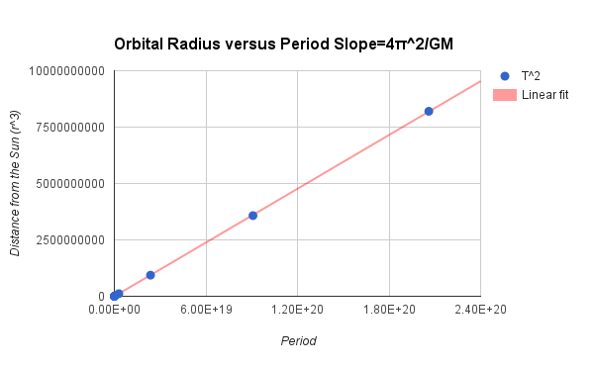

1. Graph a best fit line and use the slope to calculate the mass of the Sun.

By using our slope, we can find or calculate the mass of the Sun.

|  |  |  |
| --- | --- | --- |
| **planet** | period | distance |
| **mercury** | 7603200 | 5.79E+04 |
| **venus** | 19414080 | 1.08E+05 |
| **earth** | 31553280 | 1.50E+05 |
| **mars** | 59356800 | 2.28E+05 |
| **jupiter** | 374198400 | 7.79E+05 |
| **saturn** | 928540800 | 1.43E+06 |
| **uranus** | 2642889600 | 2.87E+06 |
| **nepture** | 5166720000 | 4.50E+06 |
| **pluto** | 7824384000 | 5.91E+06 |

According to Kepler’s Third law, Mass of suns=(4π^2 x r^3)/(G x T^3).

Mercury is 2.0 x 10^30 kg, (Venus is 2.0 x 10^30 kg, ( Earth is 2.0 x 10^30 kg , Mars is 2.0 x 10^30 kg, Jupiter is 2.0 x 10^30 kg, Saturn is 2.0 x 10^30 kg, Uranus is 2.0 x 10^30 kg , Neptune is 2.0 x 10^30 kg,Pluto is 2.0 x 10^30 kg.

By plugging in the given information, we can find that the mass of sun is 2.0 x 10^30kg.

1. Compare your experimental value for the mass of the Sun to 1.99x1030 kg by a percent error.

In order to find percent error, we need to use the formula, which is :

((**Experimental Number - Theoretical Number**)/**Theoretical Number)**x **100**.

If we plug in the number and we get 0.5 :

((**2.0 x 10^30 - 1.99 x 10^30)/2.0 x 10^30**) x **100**=**0.5**

So it’s only 0.5%

**Part C: Orbital Radius vs Speed**

1. Write the equation used to calculate an orbital velocity/speed.

**V= √(GM/r)**

1. Linearize this equation to show the relationship between radius and orbital velocity.

**V^2 x r=GM.**

1. Manipulate the data in order to make a linear plot.

1. Make a plot based on your linearized equation.

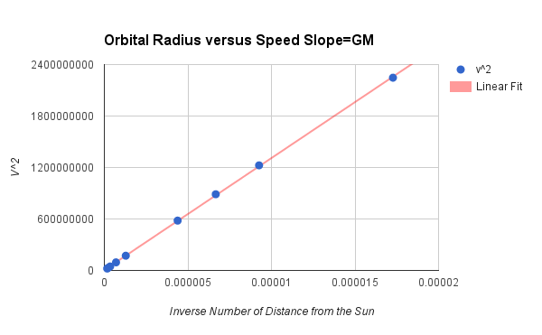

1. Graph a best fit line and used the slope to find the mass of the Sun, again.

|  |  |  |
| --- | --- | --- |
| planet | orbital speed | distance |
| mercury | 47400 | 5.79E+04 |
| venus | 35000 | 1.08E+05 |
| earth | 29800 | 1.50E+05 |
| mars | 24100 | 2.28E+05 |
| jupiter | 13100 | 7.79E+05 |
| saturn | 9700 | 1.43E+06 |
| uranus | 6800 | 2.87E+06 |
| nepture | 5400 | 4.50E+06 |
| pluto | 4700 | 5.91E+06 |

In order to find mass of sun, we need to use orbital speed and distance.

Mercury=1.95 x 10^30 kg , Venus=1.95 x 10^30 kg, Earth=1.95 x 10^30 kg, Mars=1.95 x 10^30 kg, Jupiter=1.95*10^30 kg, Saturn=1.95*10^30 kg, Uranus=1.95*10^30 kg, Neptune=1.95*10^30 kg, Pluto=1.95*10^30 kg

1. Calculate a percent error.

- For percent error **(V^2 )x (r/G)= 1.95 x 10 ^30 kg**. From these results we can find the percent error is **0.021%**. ((1.95 x 10^30-1.99 x 10^30)/1.95 x 10^30)) x 100= 0.021%.

**Part D: Surface Gravity**

1. Write the equation used to calculate the surface gravity near a spherical object.

**g=(GM)/r^2**.

1. You will notice that there are 3 variables that are changing in this part: radius, mass and gravity for each planet.

Yes we do notice.

1. Linear the surface gravity equation. You might have more than one variable on the x or y axis.

If we linear the surface gravity equation, we get G=(g x r^2)/(M), x axis equal to Mass of planet, y-axis equal g of planet x r^2.

1. What is the constant for this part of the procedure?

Gravity is constant for this part which is :

**6.67 x 10^ -11 (Nm^2)/(kg^2)**.

1. Manipulate the data accordingly and create a linear plot to exhibit the data.

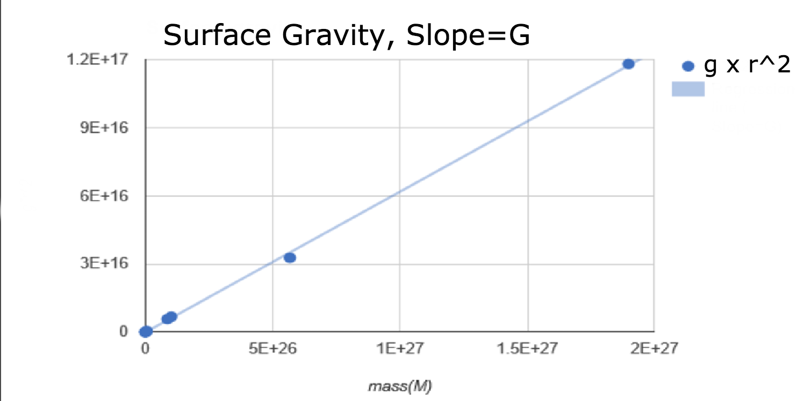

1. Use the slope to calculate the Gravitational constant, G.

|  |  |  |  |
| --- | --- | --- | --- |
| planet | gravity(m/s^2) | mass(kg) | plenetary radius(m) |
| mercury | 3.7 | 3.3E+23 | 2439500 |
| venus | 8.9 | 4.87E+24 | 6052000 |
| earth | 9.8 | 5.97E+24 | 6378000 |
| mars | 3.7 | 6.42E+23 | 3396000 |
| jupiter | 23.1 | 1.898E+27 | 71492000 |
| saturn | 9 | 5.68E+26 | 60268000 |
| uranus | 8.7 | 8.68E+25 | 25559000 |
| nepture | 11 | 1.02E+26 | 24764000 |
| pluto | 0.7 | 1.46E+22 | 1185000 |

We can tel**l G=(g x r^2)/M,** by manipulating the formula of G=g x r^2/M.

Mercury: 6.678*10^-11 , Venus: 6.678*10^-11, Earth: 6.678*10^-11 ,Mars: 6.678*10^-11,

Jupiter: 6.678*10^-11, Saturn: 6.678*10^-11 ,Uranus: 6.678*10^-11 , Neptune: 6.678*10^-11,Pluto: 6.678*10^-11

1. Find your percent error.

In order to find percent error, we need to use the formula, which is :

((**Experimental Number - Theoretical Number**)/**Theoretical Number)**x **100**

If we plug in the numbers we get 0.12% and it is really close : **((6.678 x 10^ -11-6.67 x 10^ -11)/6.678 x 10^ -11) x 100=0.12**

**Reflection:**

In this lab we use solar system data from <http://nssdc.gsfc.nasa.gov/planetary/factsheet/> so that we explore Kepler’s equation and confirm it is correct.We use the data about solar system to make linear graphs to clearly and visually compare circular motion in the solar system under the presence of gravity from the sun.We choose the data of orbital periods, orbital velocities, and the masses of planets and the sun from all the materials to better understand orbits and circular motion. We also learned a lot of things in this lab.This time we were not used to recording the data and calculating the percent error of the data , but we get used method.It’s the first lab that we get data on the website not by recording.It was pretty interesting to watch how things are working.