AP Bio Pre-Lab Outline

Scientific Name:Armadillidiidae

Classification Key:Turtles, gynecology, rat gynecology

Physical description of rolly-polly：

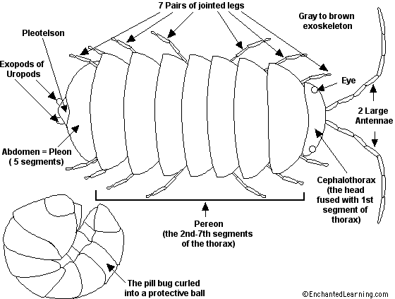

Ecosystem / Habitat：

Unlike insects and spiders, pill bugs do not have good waterproofing cuticle wax. For this reason, they must live in damp locations or they will easily dry out. For example, according to Northern State University, woodlice would dehydrate and die within a day if kept in an environment with less than 50 percent humidity.

Role / Niche in the food chain, and… any ecosystem services:

Pill bugs play a role in decomposition. After feeding on decomposing plants, they return the organic material to the soil so it can be further digested into nutrients for growing plants. They're also able to remove toxic metals from the soil during the digestion process. Pill bugs are not known to carry or transmit disease and cause minimal, if any, damage to live plants.

Characteristics of rolly-polly :

(a)K-selection

(b)Logarithmic growth

(c)Type 3

Behaviors

(a)predator

(b)A. vulgare reproduce on land as opposed to in water. Eggs develop in a brood pouch filled with fluid, from which fully developed young are released. They produce between one and two broods. The number produced depends on the size and condition of the female, who may cease to grow under stress due to excessive hydration, which reduces the chance of a second reproduction. Ironically, when the food supply is short, the offspring grow larger.

(c)One of the most notable behaviors of pillbugs is they way that they roll up into a ball. This is called conglobation. Rolling into a ball is why many people call them 'roly-polies'. When pillbugs are threatened or bothered, they roll into a ball, likely to protect their soft inner body. Rolling into a ball could also limit water loss. Preventing water loss is important for pillbugs.

(d)In drier environments, they spend more time taking shelter, rather than feeding or other activities. They are also more active at night when it is cooler. Often they will gather in groups. When moving, they alternate between gradual right and left turns so that they end up moving straight forward.

Interesting Facts

Pillbugs have the senses of sight, smell, and touch. They have eyes that can detect light, but have poor vision otherwise. They can use their sense of smell to find food and identify mates and other pillbugs. They have hairs called setae on their antennae and mouthparts that are used for touch, and can detect objects that they brush against. They can also detect chemicals with their antennae. They produce a chemical called an aggregate pheromone, which other pillbugs can detect. They often mark their trails with this pheromone, which lets pillbugs find each other by following these markings. It may also be involved in mating. The presence of this pheromone also shows other pillbugs that this habitat is desirable, as other pillbugs are clearly able to survive there.