Alpha Wolf Wrap Studio — MVP Investor Handoff
  - Verification package · prepared 2026-06-10
Table of Contents

Alpha Wolf Wrap Studio — MVP Handoff
Prepared: 2026-06-10 · Environment: production (https://alphawolfedecals-app-web.vercel.app) · Status: MVP, pre-public-launch.
This package is the independent verification of the Alpha Wolf Wrap Studio MVP: what it does, how it’s built, its security and production posture, an honest list of launch blockers, and a screenshot walk-through of the working product. Everything below was verified against the live production system this session, not from documentation.

1. What the MVP does
Alpha Wolf Wrap Studio is a web app that turns a vehicle-wrap order from a back-and- forth email thread into a self-serve design-and-submit flow.
- Customer browses a catalogue of vehicle templates, opens one in an in-browser design editor (place artwork, shapes and text on accurate, wrap-safe vehicle panels; recolor; autosave), and submits the design for production, which creates an order. No payment in the MVP.
- Wrap shop sees orders routed to it in a production queue, opens an order, and moves it through the lifecycle (submitted → in production → fulfilled).
- Email notifications fire at each step (4 PII-safe templates); errors go to Sentry; product analytics to PostHog.
The end-to-end loop — sign in → design → submit → shop receives → fulfil — is proven working on production (automated smoke, see §5 and §7).

2. Architecture snapshot
Layer | Technology
Web app | Next.js 15 (App Router, React 19) on Vercel (region sfo1), Tailwind v4 + shadcn/ui, Konva canvas editor
Auth | Custom @alphawolf/auth on Auth.js v5 — argon2id passwords, email OTP, double-submit CSRF, DB-backed login lockout
Data | Postgres (Supabase, us-west-1) via Prisma; row-level security (RLS) forced on every table
Security boundary | Two-connection split — an app_user (non-superuser) connection with RLS enforced for all customer/shop queries; a privileged connection only for unauthenticated bootstrap
Storage | Supabase Storage — public bucket for vehicle templates, private bucket for customer artwork (signed-URL, ownership-checked)
Email / errors / analytics | Resend · Sentry (server+edge, PII-scrubbed) · PostHog
Background workers | apps/api (email-retry, asset parse) on Render
Monorepo | Turborepo + pnpm
The architecture decisions are recorded as ADRs (docs/adr/); the deploy contract is locked under ADR-0013 (amended this session — see §6).

3. Security & production posture
A full security audit and production-readiness audit were run against production this session (reports in docs/deployment/audits/2026-06-09-goal-4/).
Security: PASS — no High/critical live failure. Verified live, not from code:
- RLS is forced on all 14 tables; the orders table’s customer/shop policy triple was confirmed live (a customer sees only their orders; a shop sees only orders routed to it; cross-tenant access returns nothing).
- 6 security headers + a comprehensive CSP, byte-identical between source and the live response (HSTS 2 yr, X-Frame DENY, hardened __Host- session cookies).
- Zero secrets in client-shipped code. Dev/admin backdoor endpoints are hard-404 in production (verified). Every state-changing action enforces authentication + authorization + CSRF + RLS. Hardened file-upload path. No XSS sinks. argon2id + DB-backed brute-force lockout.
- Supabase database advisors: 2 low warnings, down from 4 after this session’s fix (no new warnings introduced).
Production-readiness: functionally launch-ready for a demo, with a standard pre-public-launch hardening list (§6). Health endpoint live; CI/CD auto-deploys main; clean dependency + lockfile hygiene.
Performance (Lighthouse, prod): Performance ~88–89, Accessibility 100, Best-Practices 92, all stable vs the prior baseline. (SEO reads low only because the site intentionally blocks crawlers pre-launch; it reverts at launch. Details in docs/deployment/lighthouse-2026-06-10/.)

4. What was found and fixed this session
A verification goal’s job is to surface what’s actually true. Two significant issues were found; one was fixed under full review, one is a data gap flagged for launch.
- FIXED — production RLS recursion bug (was High). The membership policy referenced itself, so reading any order routed to a shop threw an infinite- recursion error — the entire shop-order path (submit-routed, dashboard read, status transitions) was broken. It was dormant only because no order had ever been routed to a shop. No data was ever exposed (it failed closed — an error, never over-broad visibility). Fixed with a security-definer helper, reviewed (independent + advisor), verified live across six gates, and merged (PR #116). The same change also closed two pre-existing database advisor warnings.
- FLAGGED — the design editor has no design surface on the catalogue templates (High launch blocker; data gap, not a code gap). The 3 curated Alpha Wolf catalogue templates (BMW X3, Bass Boat, Crown Coach) have no panel geometry, so the editor opens but you can’t place artwork on them. The editor itself works end-to-end — proven on the Ford Transit template (6 panels): place, color, save, submit all function (see §7). What’s missing is the per-template panel data. See §6 for the remediation spec.

5. Verification performed (evidence)
- End-to-end smoke on production — PASS (customer + shop loops). Two pre-seeded, verified accounts (created through the app’s real argon2id + HMAC code path) drive: sign-in → browse → editor → submit → order created (customer); sign-in → queue → accept → fulfil (shop). Both green.
- RLS isolation proven from a second identity: a shop member reads only their routed order; a non-member sees zero; the customer (owner) sees their own. No recursion, no leak.
- Two audits + Lighthouse + database advisors run live (reports in docs/).
- 12-screenshot demo set captured from production (§7).

6. Known gaps & launch blockers (ranked)
# | Item | Severity | Owner / remediation
1 | Catalogue templates have no panel geometry — editor non-functional on the 3 AW templates | High | Author a panel set per flagship template: a structured SVG with per-panel/per-view classes + wrap-safe zones (the schema the editor reads). Must be authored in-house or from licensed sources — never from the PVO outlines (Goal 1 license verdict is RESTRICTIVE; hard legal boundary). Est. modest effort per vehicle. The B2C roadmap’s guided-design zone-selector (B2C-003) depends on the same data — fixing this unblocks both.
2 | Edge rate-limiting not active on prod | Med | Set UPSTASH_REDIS_REST_URL/TOKEN on Vercel + redeploy (runbook: docs/deployment/runbooks/enable-edge-rate-limiting.md). Credential brute-force is already guarded by the DB lockout; this adds the edge throttle.
3 | Artwork-upload Server Action returns 500 | Med | A 500 on the upload path surfaced in testing (cause hidden by Next’s prod error-digest). Resolve the digest in Sentry or repro locally; root-cause before relying on uploads in a demo.
4 | Email deliverability (GH-016) | Med | Resend domain verified 2026-06-09; do one real end-to-end send + confirm in the Resend dashboard.
5 | Legal: /terms + /privacy are stubs; no cookie consent | Med | Replace stub copy with reviewed legal text before public launch.
6 | No uptime monitor; Dependabot just added; no backup restore-drill | Med | Wire an uptime monitor on /health; let Dependabot run; perform one restore drill before the first real signup.
7 | Verify DATABASE_URL_APP is set on Vercel prod | Verify | A missing value silently disables RLS. The live cross-tenant test passed, which proves it is set today — re-confirm before launch.
Deferred to v1.1 (tracked): editor testids for the uploaded-image place/color smoke asserts; customer→shop order routing in the UI (today orders are seeded-routed for the shop loop); CI durability for the shop smoke (per-run order seeding); the CSP nonce migration; disabling the unused PostgREST data API.

7. Demo walk-through
All captured from production against seeded accounts. Editor shots use the Ford Transit (the panel-bearing template) per §4/§6.
1. Catalogue gallery — the curated template gallery.
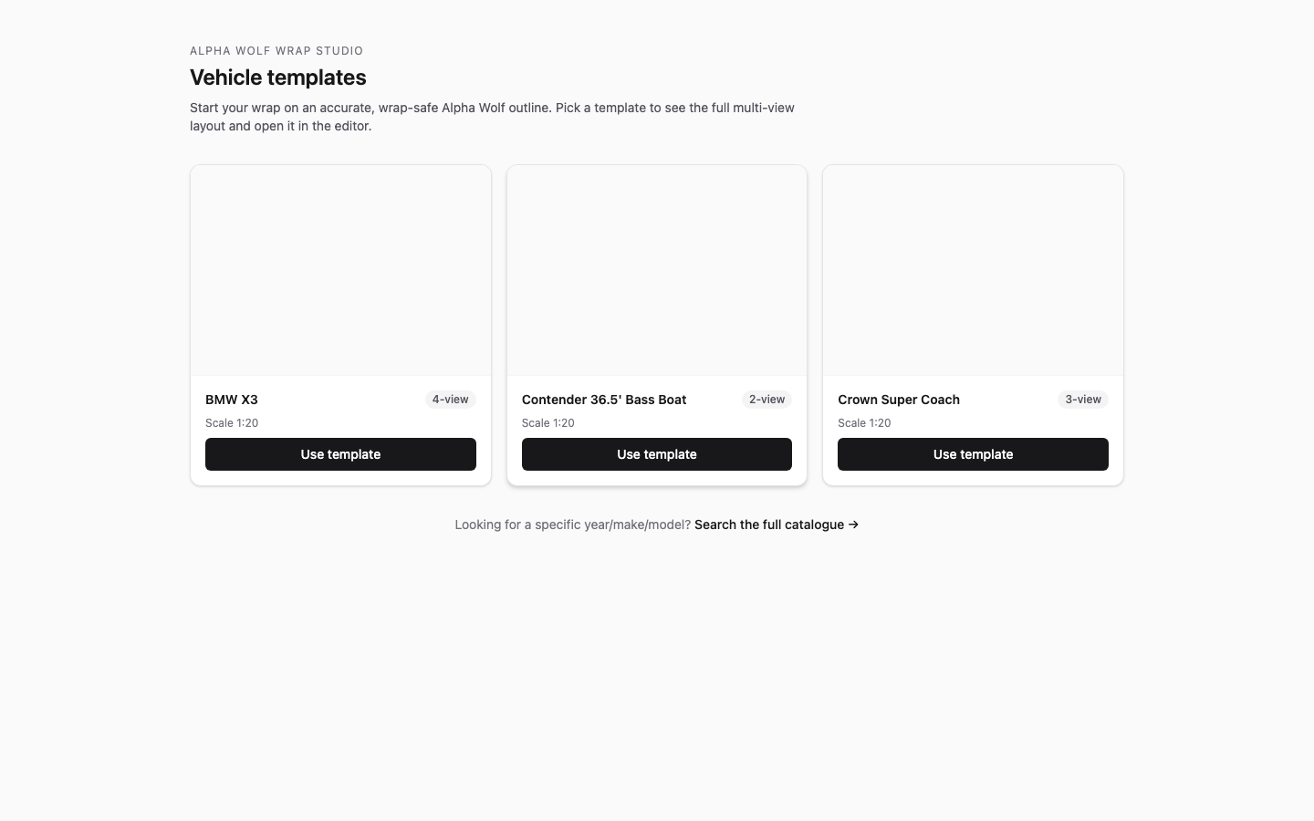
Catalogue gallery
2. Template detail — the design call-to-action.
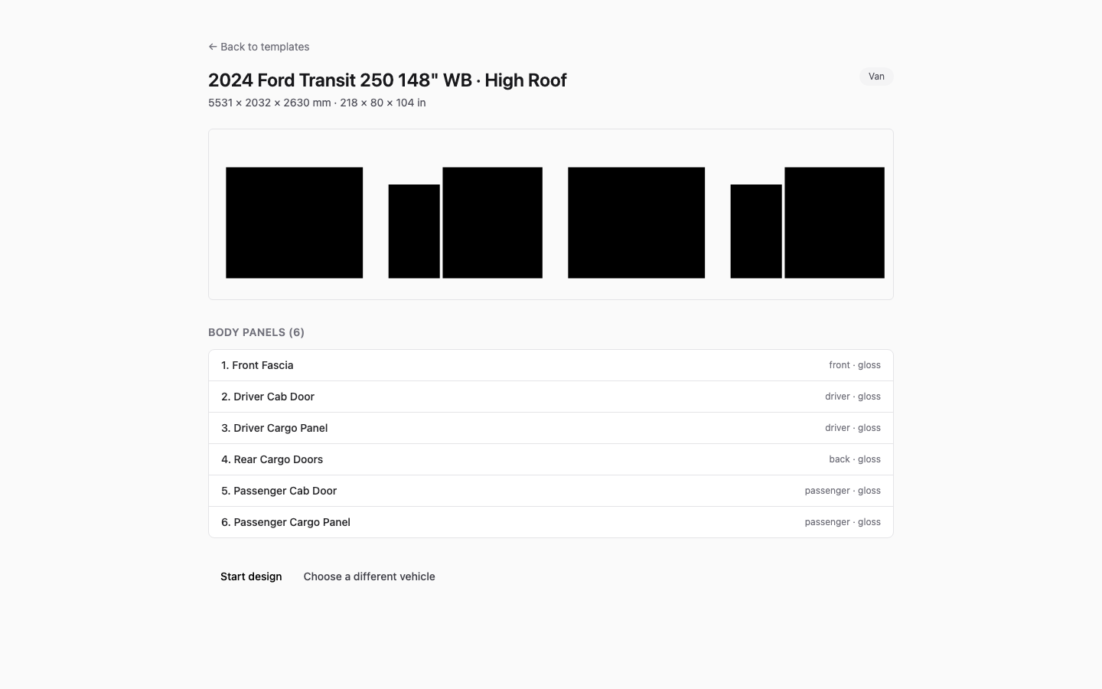
Template detail
3. Editor (empty) — the Ford Transit’s 6 panels render.
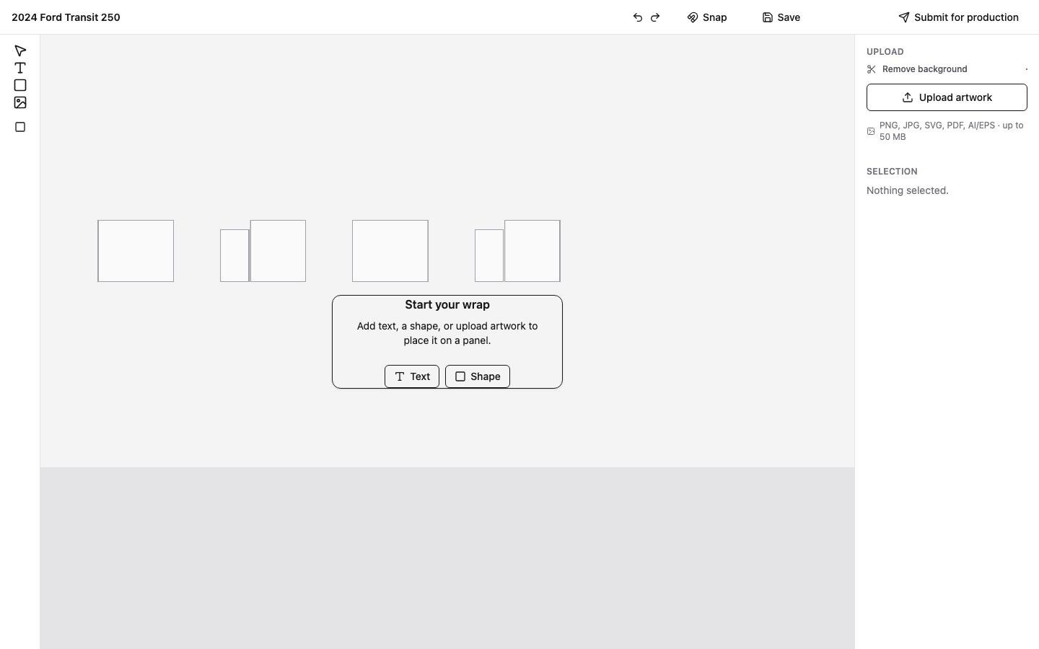
Editor empty
4. Shape placed — a shape on the Front Fascia panel (the placement engine works).
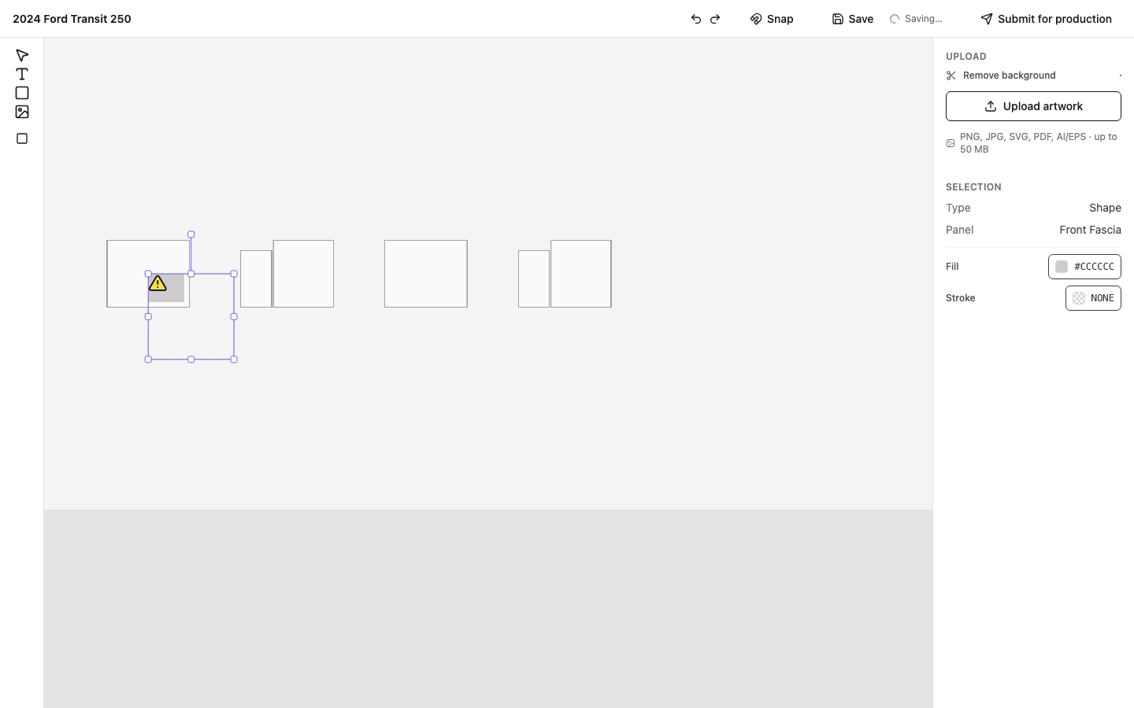
Shape placed
5. Recolored — the shape set to red via the inspector (place + color both work).
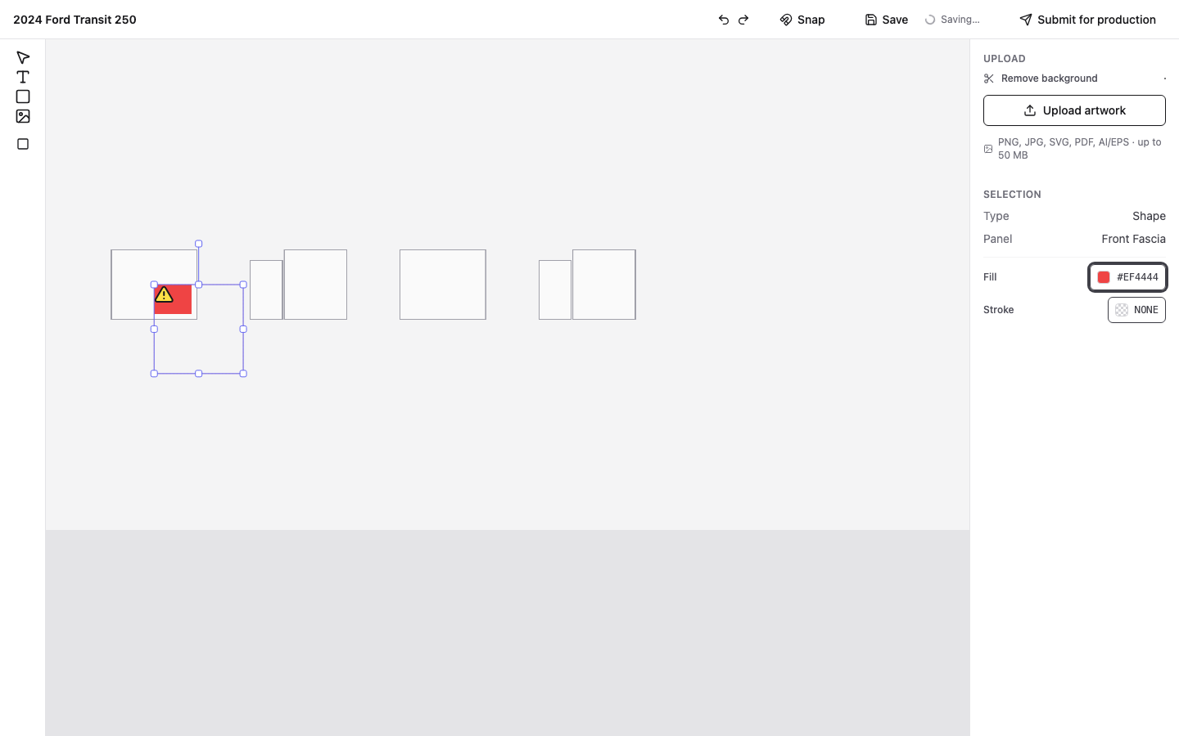
Recolored
6. Saved — manual save / autosave flush.
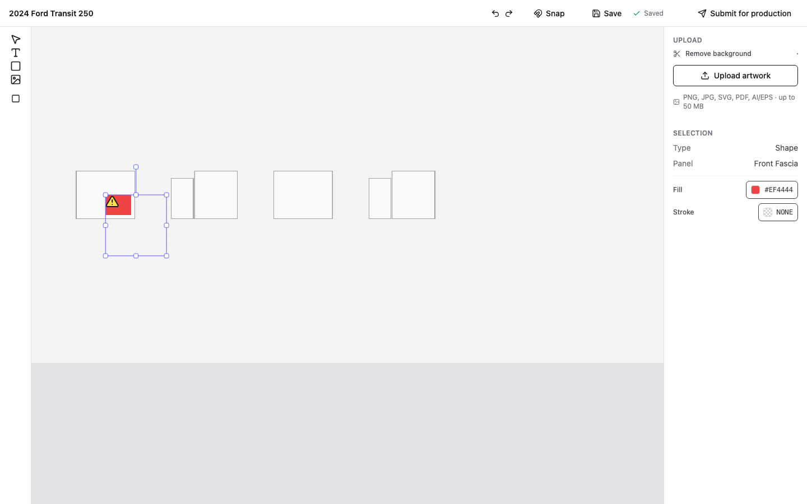
Saved
7. Submit dialog — contact details; no payment in the MVP.
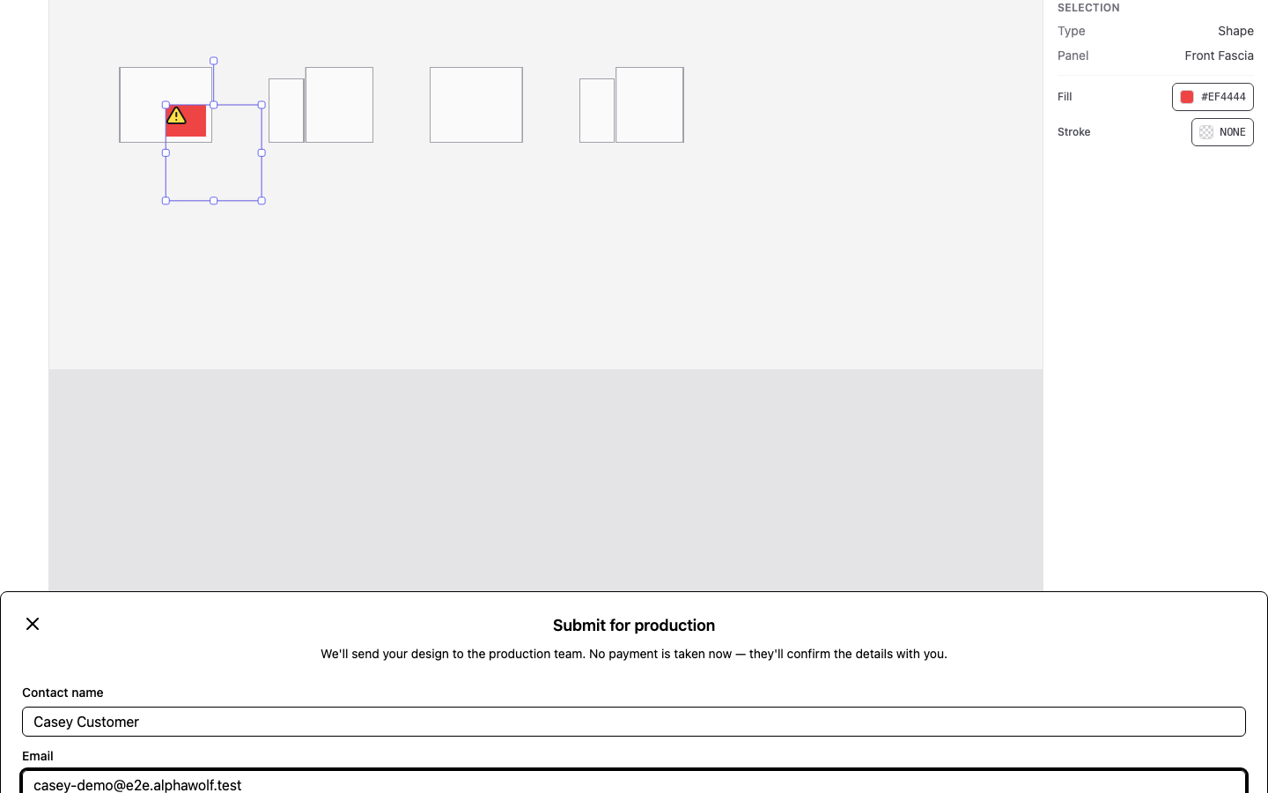
Submit dialog
8. Order confirmed — the order is created.
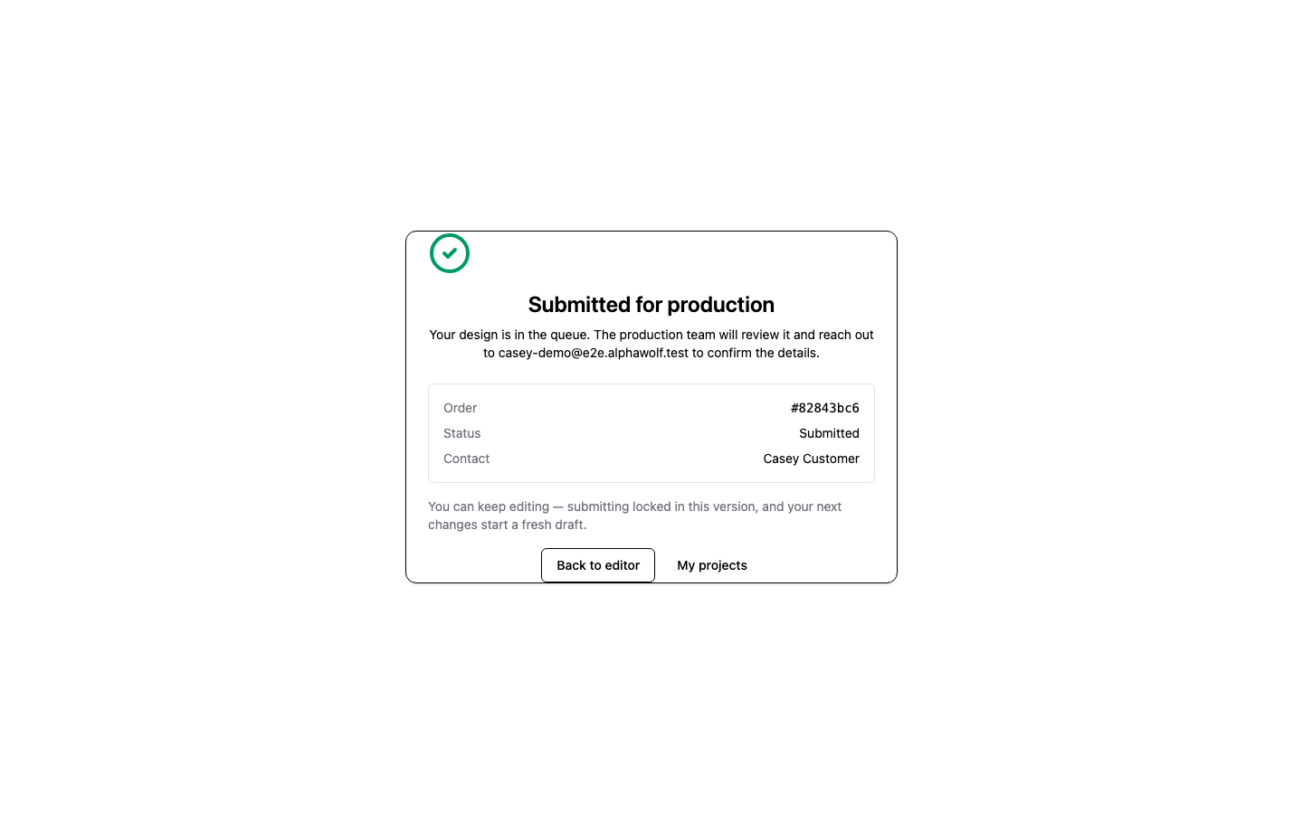
Order confirmed
9. Shop queue — the routed order appears, RLS-scoped to the shop.
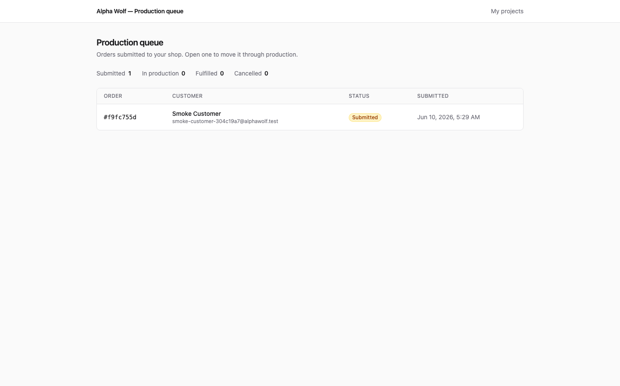
Shop queue
10. Order detail — the shop’s view of the order.
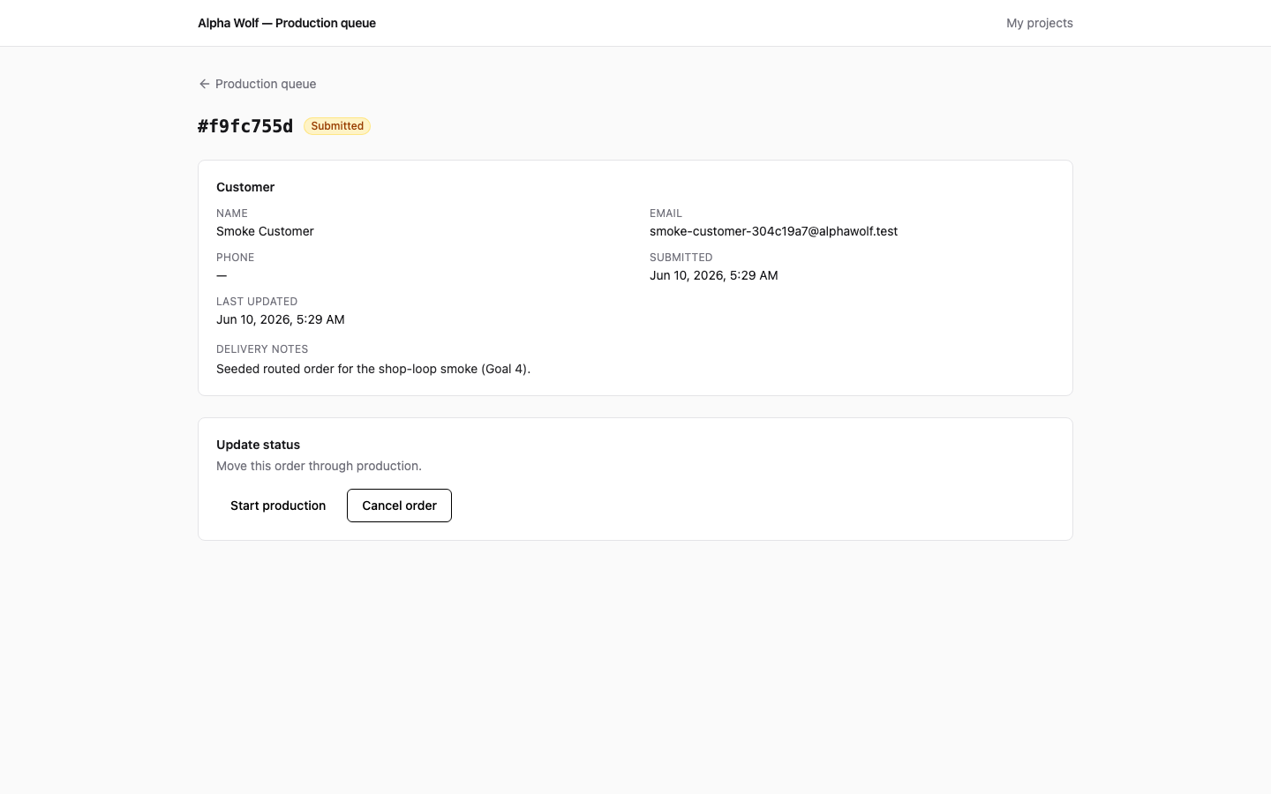
Order detail
11. In production — after the shop accepts.
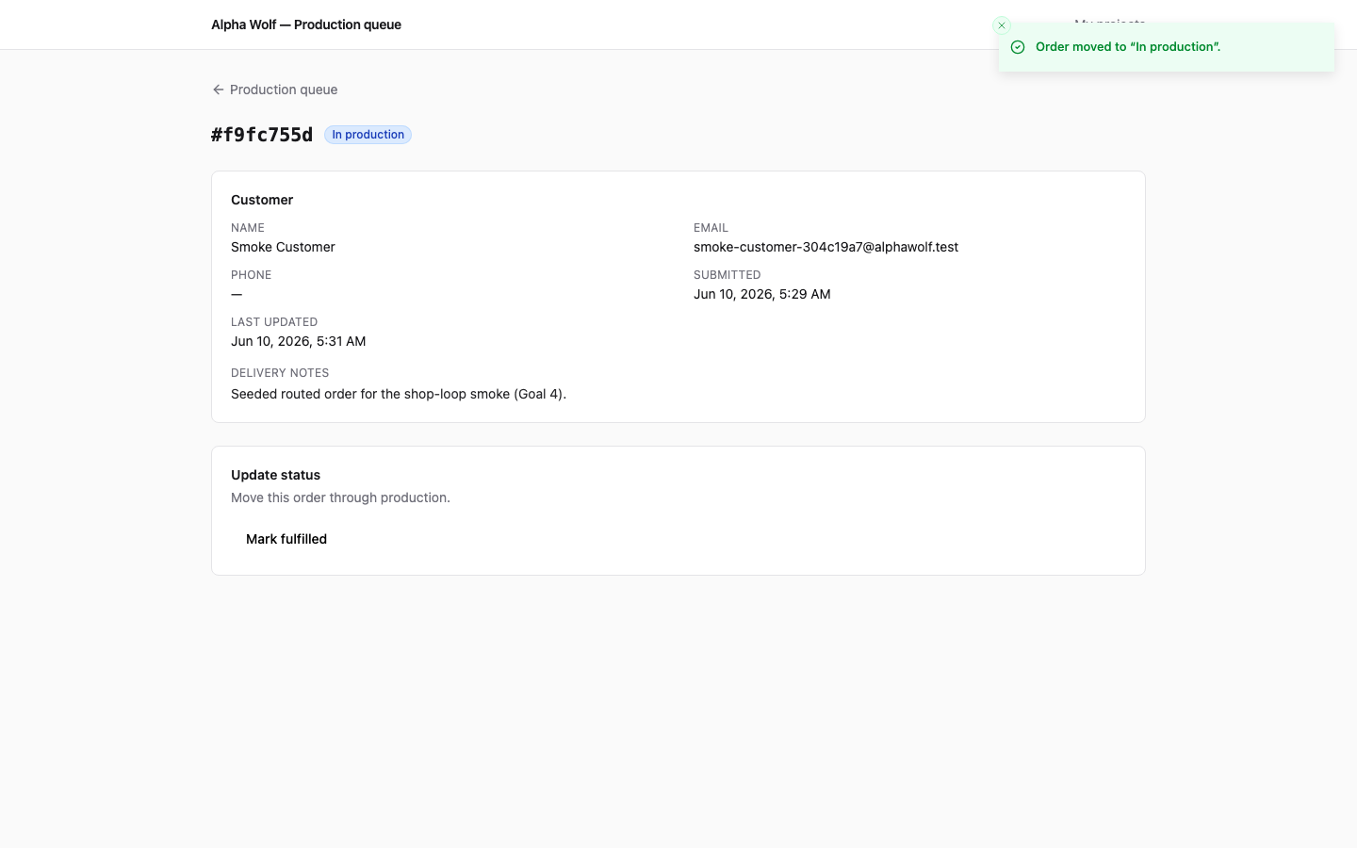
In production
12. Fulfilled — after the shop marks it complete.
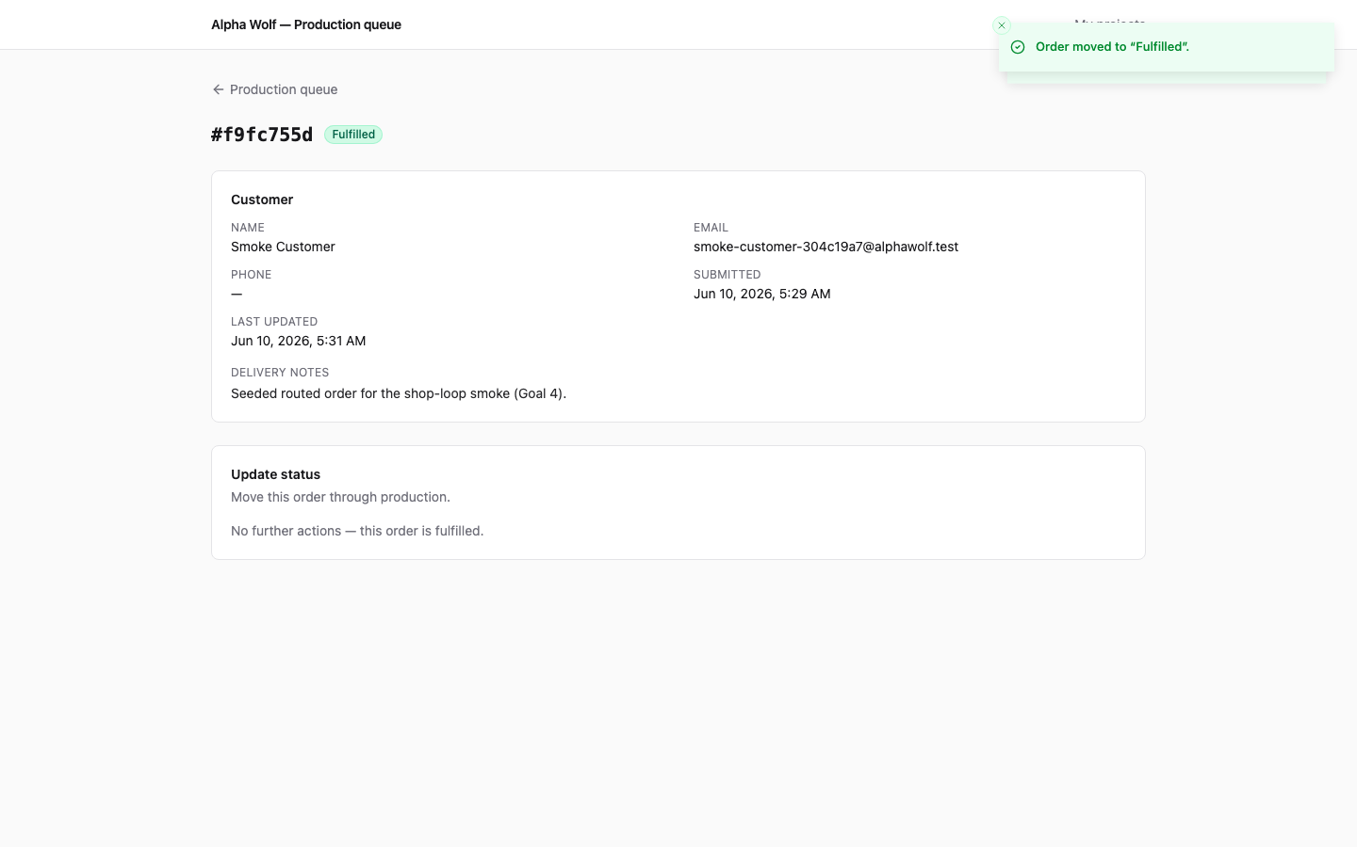
Fulfilled

8. Bottom line
The MVP’s spine is real and verified on production: secure-by-construction auth and data isolation, a working design editor, and a complete customer→shop order lifecycle. The single thing standing between this and a compelling end-to-end demo on the flagship catalogue is panel data for the 3 Alpha Wolf templates (gap #1) — an authoring task, not an engineering rebuild. The remaining items are the normal pre-public-launch hardening checklist.

