ACROPOLIS INSTITUTE OF TECHNOLOGY AND RESEARCH

Department of Information Technology

Synopsis On

DSA Visualizer Pro with Agentic AI Code Review System

INTRODUCTION

1.1 Overview
Data Structures and Algorithms (DSA) are fundamental components of computer science and software engineering. Understanding the internal behavior of algorithms and data structures is often challenging for students because traditional learning methods rely heavily on theoretical explanations and static examples. Similarly, conventional Integrated Development Environments (IDEs) provide code execution facilities but do not offer detailed insights into algorithm execution, runtime behavior, or optimization opportunities.
The proposed system, DSA Visualizer Pro with Agentic AI Code Review System, is a full-stack educational and development platform that combines an online Python IDE, interactive algorithm visualization, execution tracing, and Agentic AI-powered code analysis into a unified environment.
The system enables users to write Python code, execute programs online, visualize algorithm operations step-by-step, monitor variable changes during execution, and receive AI-generated code reviews. By integrating visualization with intelligent code analysis, the platform helps users better understand algorithm behavior, improve code quality, and learn efficient programming practices.
The proposed solution transforms traditional algorithm visualization tools into an intelligent educational platform capable of both demonstrating algorithm execution and providing personalized software engineering guidance.

Purpose
The primary purpose of the proposed system is to provide an integrated learning and development environment that enhances algorithm understanding through visualization and intelligent analysis.
The system aims to:
- Provide interactive visualizations for various data structures and algorithms.
- Enable browser-based Python code execution without local installation.
- Capture and display runtime execution traces and variable states.
- Improve algorithm understanding through step-by-step animations.
- Integrate Agentic AI for automated code review and analysis.
- Identify inefficiencies, vulnerabilities, and coding issues.
- Suggest optimized algorithms and improved code implementations.
- Assist students in learning programming concepts more effectively.

LITERATURE SURVEY

2.1 Existing Problem
Data Structures and Algorithms (DSA) are among the most fundamental subjects in computer science and software engineering. However, understanding the internal working of algorithms remains a significant challenge for students and beginner programmers. Traditional teaching methods often rely on textbooks, static diagrams, and theoretical explanations that fail to effectively demonstrate how data structures evolve during execution. As a result, learners frequently struggle to visualize operations such as sorting, searching, insertion, deletion, and traversal.
Although several DSA visualization tools have been developed to assist learning, most existing solutions focus only on graphical animation and lack deeper insights into program execution. These systems generally do not provide detailed runtime information such as variable states, execution flow, comparisons, swaps, or operation statistics. Consequently, users can observe algorithm behavior but cannot fully understand the underlying execution process.
Another major limitation of existing educational platforms is the absence of intelligent feedback mechanisms. Conventional IDEs and online coding platforms allow users to write and execute code but do not analyze the quality, efficiency, or security of the implemented solution. Students often remain unaware of inefficient algorithms, poor coding practices, unnecessary complexity, or potential vulnerabilities present in their code.
Furthermore, learning programming concepts usually requires multiple disconnected tools for coding, debugging, visualization, performance analysis, and code review. This fragmented approach increases complexity and reduces learning efficiency. With the growing adoption of Artificial Intelligence in software development, there is a need for intelligent educational systems that can combine visualization, execution analysis, and automated code review within a unified environment.

• Difficulty in Understanding Algorithm Execution
Many students find it difficult to understand how algorithms manipulate data internally because conventional teaching methods often lack dynamic visual representations.

• Limited Educational Visualization Tools
Existing DSA visualization tools mainly focus on animations and do not provide detailed execution tracing or runtime analysis.

• Lack of Integrated Development Features
Most visualization platforms do not include code editing, execution, debugging, and learning capabilities within a single environment.

• Absence of Intelligent Code Review
Traditional IDEs and visualizers generally do not provide automated code quality assessment, optimization recommendations, or vulnerability detection.

• Inadequate Runtime Analysis
Current learning tools rarely monitor variable changes, execution flow, operation counts, or algorithm performance during runtime.

• Fragmented Learning Process
Students often switch between multiple applications for coding, visualization, debugging, and code review, resulting in an inefficient learning experience.
2.2 Proposed Solution
To overcome the limitations of existing systems, the proposed project, DSA Visualizer Pro with Agentic AI Code Review System, introduces an integrated platform that combines an online Python IDE, algorithm visualization engine, execution tracing system, and Agentic AI-powered code analysis framework. The system enables users to write and execute Python programs directly within the browser while simultaneously visualizing the behavior of various data structures and algorithms through interactive animations.
Unlike traditional visualizers, the proposed platform captures detailed execution traces, including variable changes, array modifications, comparisons, swaps, and runtime events. This information is utilized not only for generating visualizations but also for providing deeper insights into algorithm behavior and performance. Such runtime analysis allows users to understand how an algorithm operates internally rather than simply observing its final output.
A key innovation of the proposed system is the integration of an Agentic AI Review Engine. The AI agent analyzes source code along with execution traces and employs multiple analysis tools to evaluate code quality, estimate time and space complexity, detect vulnerabilities, identify inefficient logic, and recommend optimized solutions. By combining tool-based analysis with Large Language Models (LLMs), the system can generate comprehensive code review reports and suggest best practices for improvement.
The proposed solution aims to create a unified educational and development environment that not only helps users learn Data Structures and Algorithms through visualization but also assists them in developing better programming skills through intelligent code analysis and optimization recommendations. This integration of visualization, execution intelligence, and Agentic AI makes the platform a modern and effective learning tool for students, educators, and aspiring software developers

• Unified Learning Platform
The proposed system integrates coding, execution, visualization, tracing, and AI-based code review into a single web-based platform.

• Interactive Algorithm Visualization
The platform provides real-time visualizations for sorting algorithms, stacks, queues, linked lists, trees, graphs, and matrix operations.

• Runtime Execution Tracing
Execution tracing mechanisms capture variable values, array modifications, comparisons, swaps, and execution flow information.

• Agentic AI Review Engine
An intelligent AI agent analyzes source code and runtime traces to generate detailed code reviews.

• Complexity Analysis
The system evaluates algorithm performance and provides time complexity and space complexity assessments.

• Security and Quality Assessment
The AI-powered review system identifies vulnerabilities, code smells, and poor coding practices using static analysis tools and LLM reasoning.

• Optimization Recommendations
The platform suggests alternative algorithms, improved approaches, and optimized code implementations

3. THEORITICAL ANALYSIS

Block Diagram

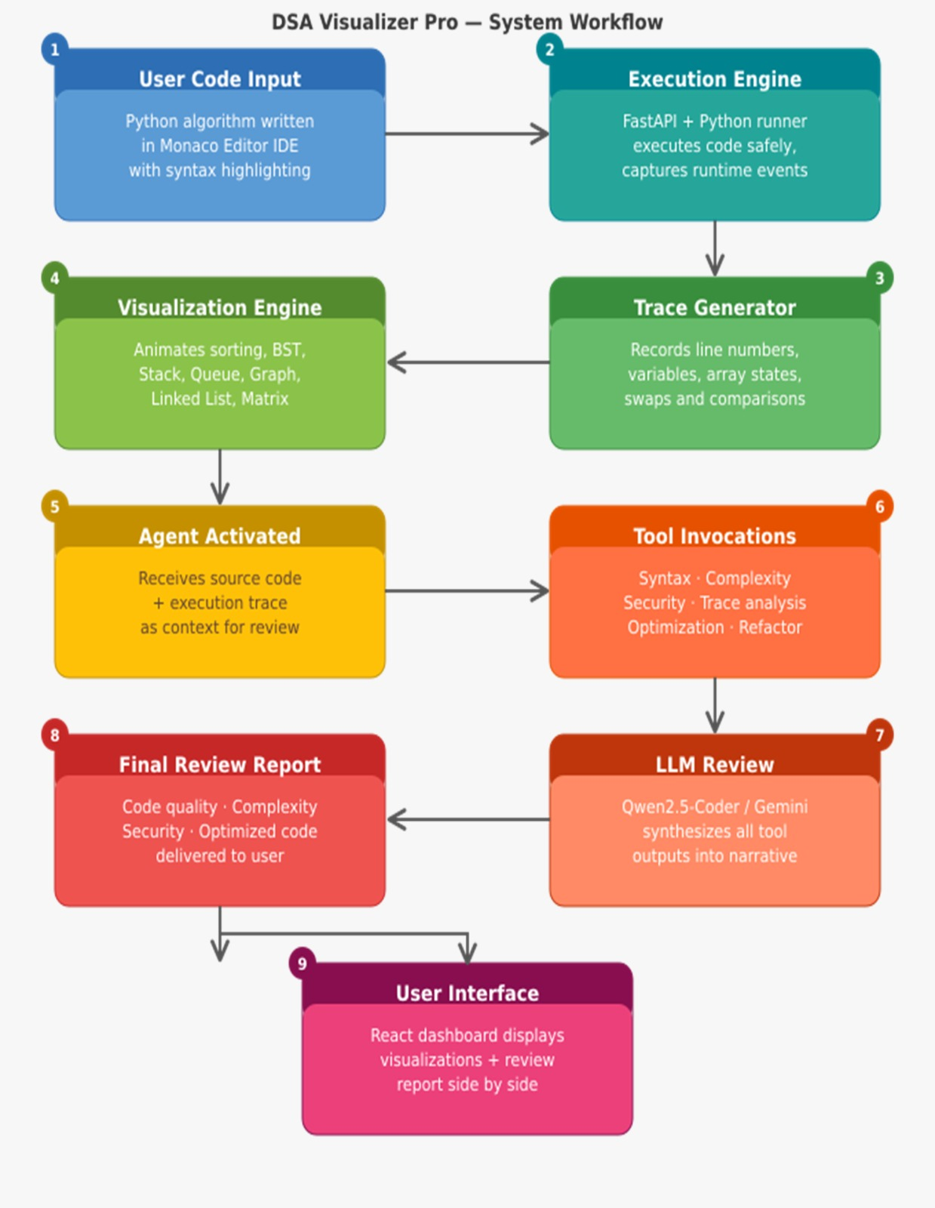

3.2 Software Designing

• Frontend: React.js, Vite, Monaco Editor

The frontend is designed using React.js and Vite to provide a fast, responsive, and interactive user experience. Monaco Editor serves as the online Python IDE, allowing users to write, edit, and manage code efficiently with features such as syntax highlighting, auto-completion, and error detection. The frontend also handles the visualization of algorithms and displays AI-generated analysis reports

.

• Backend: FastAPI

The backend is implemented using FastAPI, which manages communication between the frontend, execution engine, visualization modules, and AI review system. It processes user requests, executes code securely, generates execution traces, and provides APIs for visualization and analysis functionalities.

• Programming Languages: Python, JavaScript, HTML, CSS

Python is used for code execution, runtime tracing, and AI integration, while JavaScript, HTML, and CSS are used to develop the frontend interface and interactive visualization components

.

• Execution Tracing Engine

The tracing engine captures runtime information such as executed lines, variable updates, comparisons, swaps, and array modifications. This information is utilized to generate step-by-step visualizations and provide deeper insights into algorithm behavior.

• Visualization Modules

Dedicated visualization modules are implemented for sorting algorithms, stacks, queues, linked lists, trees, graphs, and matrix operations. These modules transform execution data into animated visual representations that help users understand internal algorithm operations

.

• AI Technologies: Gemini API / Qwen2.5-Coder

The system integrates Large Language Models such as Gemini or Qwen to perform intelligent code analysis. These models review source code, analyze execution traces, identify inefficiencies, estimate complexity, and suggest optimized solutions.

• Analysis Tools: Bandit, Ruff, AST Analyzer

Static analysis tools are used to evaluate code quality and security. Bandit identifies potential security vulnerabilities, Ruff detects coding standard violations, and Python's AST module assists in understanding code structure for complexity analysis.

• Version Control: Git and GitHub

Git and GitHub are used for source code management, collaboration, version tracking, and project maintenance throughout the development lifecycle.

• Database: SQLite (Optional)

SQLite may be used to store user data, execution history, generated reports, and future learning progress information while maintaining a lightweight architecture.

• Deployment

The system can be deployed locally or on cloud platforms, making it accessible to students, educators, and developers from different environments.

4. APPLICATION

• DSA Education and Learning
The platform provides interactive visualizations that help students understand the working of data structures and algorithms more effectively than traditional classroom methods. Step-by-step animations make abstract concepts easier to grasp and retain.

• Programming Laboratories
Educational institutions can use the system during practical sessions and laboratory courses to demonstrate algorithm execution, data structure operations, and complexity analysis in a visual manner.

• Coding Interview Preparation
The platform assists students preparing for technical interviews by helping them analyze algorithm efficiency, compare alternative solutions, and understand optimization techniques commonly asked in coding assessments.

• AI-Assisted Code Review
The integrated Agentic AI system provides automated feedback on user code, identifies inefficiencies and vulnerabilities, and recommends improvements. This helps users learn best coding practices while improving solution quality.

• Software Development Training
Beginner programmers can use the platform to understand software engineering concepts such as code quality, maintainability, optimization, and performance analysis through AI-generated recommendations.

• Academic Research and Innovation
The project can serve as a research platform for studies related to algorithm visualization, program comprehension, intelligent tutoring systems, and AI-assisted software engineering.

• Self-Learning and Online Education
The system can be integrated into e-learning platforms and online programming courses, allowing learners to experiment with algorithms and receive intelligent guidance without requiring instructor intervention.

• Performance and Complexity Analysis
Students and developers can use the platform to study time complexity and space complexity, compare different approaches, and understand the performance implications of algorithm design choices.

• Future AI-Driven Development Environments
The project lays the foundation for advanced intelligent development platforms that combine code execution, visualization, automated debugging, optimization, and AI-powered software engineering assistance.
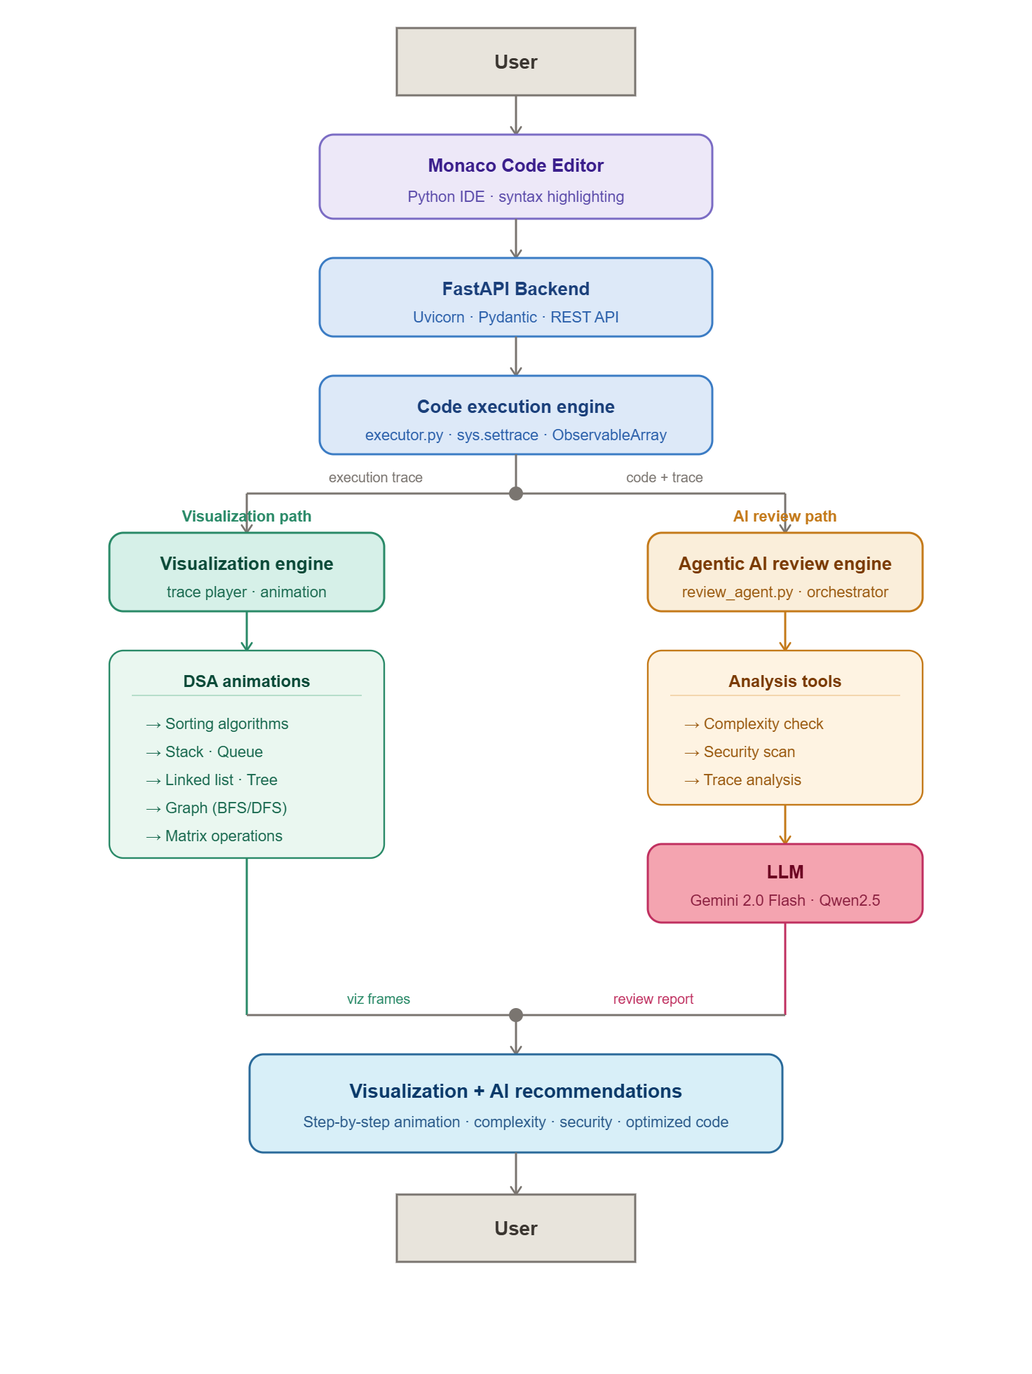

5. REFERENCES
i. Cormen, T. H., Leiserson, C. E., Rivest, R. L., & Stein, C., Introduction to Algorithms (4th Edition), MIT Press, 2022.
ii. Hundhausen, C. D., Douglas, S. A., & Stasko, J. T., A Meta-Study of Algorithm Visualization Effectiveness, Journal of Visual Languages and Computing, 2002.
iii. Vaswani, A., et al., Attention Is All You Need, NeurIPS, 2017.
iv. Yao, S., et al., ReAct: Synergizing Reasoning and Acting in Language Models, 2022.
v. Qian, C., et al., ChatDev: Communicative Agents for Software Development, 2023.
vi. React Documentation – https://react.dev/
vii. FastAPI Documentation – https://fastapi.tiangolo.com/
viii. Monaco Editor Documentation – https://microsoft.github.io/monaco-editor/
ix. Bandit Documentation – https://bandit.readthedocs.io/
x. Ruff Documentation – https://docs.astral.sh/ruff/

Internal Guide: Group Members:
Prof. (Dr) Manish Vyas Abhinav Patidar (0827IT231004)
Aditya Trivedi (0827IT231014)
External Guide: Akshat Yadav (0827IT231020)
Mr. Aditya Yadav Archesh Shrivas (0827IT231029)
Aryan Singh (0827IT231033)

