**ELECTRONIC DEVICE**

An electronic device is a gadget that manipulates the flow of electrons to process information or control systems, typically using semiconductor materials like transistors and diodes within integrated circuits.

**#TYPE OF ELECTRONIC DEVICE**

**1) Active**

**2) Passive**

**(1) ACTICE DEVICE**

Active electronic devices are components that require a power source to operate and can control or amplify electrical signals, enabling complex functions like signal amplification, switching, and energy conversion. Key types include Diodes, Transistors, Integrated Circuits (ICs), Thyristors, Vacuum Tubes, and Power Sources like batteries.

**~ Examples of Active Device Types**

**# Transistors :** Semiconductor devices that amplify or switch electronic signals.

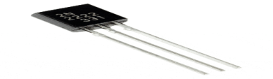

**Bipolar Junction Transistors (BJTs) :** Current-controlled devices used in amplifiers and switches.

**Field-Effect Transistors (FETs) :** Voltage-controlled devices, including MOSFETs and JFETs.

**# Integrated Circuits (ICs) :** Complex assemblies of transistors, resistors, and capacitors on a single chip, performing various functions.

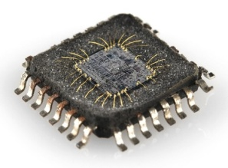

# [**Diodes**](https://www.google.com/search?sca_esv=2f32eac133bcd00b&cs=0&q=Diodes&sa=X&ved=2ahUKEwj4-fq6yeGPAxW42TgGHW_wME4QxccNegQIMRAB&mstk=AUtExfAzk34sPdQtZKDl7UCDDL3MouiVVnx1Fyxd6u0_8zspfCtHveIetcZvRSe7zC8mSKeTotoSN7BUaE7X4FaH_iMRFIrmjXQYR-88rRvu3ww3fO2IU9ODf4dOJ79Hv8naqUg&csui=3) **:**  Devices like light-emitting diodes (LEDs) and Zener diodes are active components that control the direction of current flow or are used for voltage regulation.

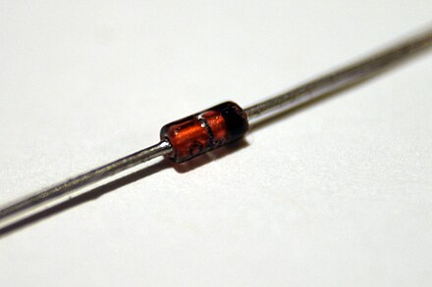

**# Vacuum Tubes:** Although older, vacuum tubes are a classic example of an active device that uses electricity to control the flow of electrons.

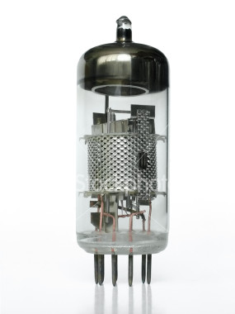

**(2) PASSIVE DEVICE**

Passive electronic devices, which do not control current with another electrical signal or introduce energy into a circuit, include fundamental components like resistors, capacitors, and inductors. Other common passive devices are transformers, ferrite beads, thermistors, and varistors, all of which dissipate, store, or regulate energy without amplification.

**~ Types of Passive Devices**

**# Resistors :** Limit the flow of electrical current and dissipate energy, often used for controlling voltage and current levels.

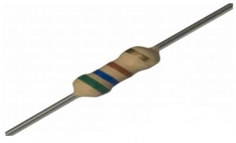

**# Capacitors :** Store and release electrical energy in an electric field, finding use in filtering, coupling, and timing applications.

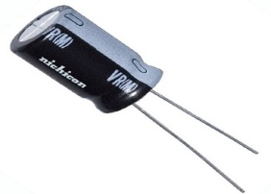

**# Inductors :** Store energy in a magnetic field, reduce electronic spikes, and serve as chokes or in tuning circuits.

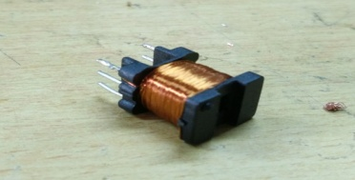

**# Transformers :** Transfer electrical energy between circuits using electromagnetic induction, primarily for voltage conversion and isolation.

