Practical - 4
Practical Title: JavaScript DOM Manipulation, Event Handling, and UI Interactivity
Problem Definition: Add dynamic UI components such as a notification banner, interactive buttons, FAQ/events controls, and a light/dark theme switcher using JavaScript. The StudentHub portal should become more interactive and easier to use.

Theory
- How are DOM elements selected and modified?
Answer: JavaScript can select HTML elements using methods like querySelector() and querySelectorAll(). After selecting an element, its text, class, style, or other properties can be changed.
- Are event listeners attached correctly?
Answer: Yes. Event listeners are used with buttons and other elements so that an action happens when the user clicks or interacts with them.
- Is localStorage used for remembering theme choice?
Answer: A theme choice can be saved in localStorage so that the selected light or dark mode can be remembered when the page is opened again.
- Does interactivity improve usability without breaking accessibility?
Answer: Yes. Simple buttons, clear messages, and a light/dark mode make the website easier to use. The controls should also have readable text and proper labels.

Work Done
  - Used JavaScript to handle button click events.
  - Added interactive notification/message behaviour on the home page.
  - Added a light and dark theme option for the StudentHub pages.
  - Tested the interaction on different pages such as Home, About, Events, Register and FAQ.
  - Used HTML, CSS and JavaScript together to make the static pages interactive.

Result
The StudentHub website became more interactive using JavaScript. Buttons respond to user actions, the notification can be interacted with, and the light/dark theme can be changed. The pages were tested in the browser and the required UI interactions were visible.

Evidence of Work (Screenshots)

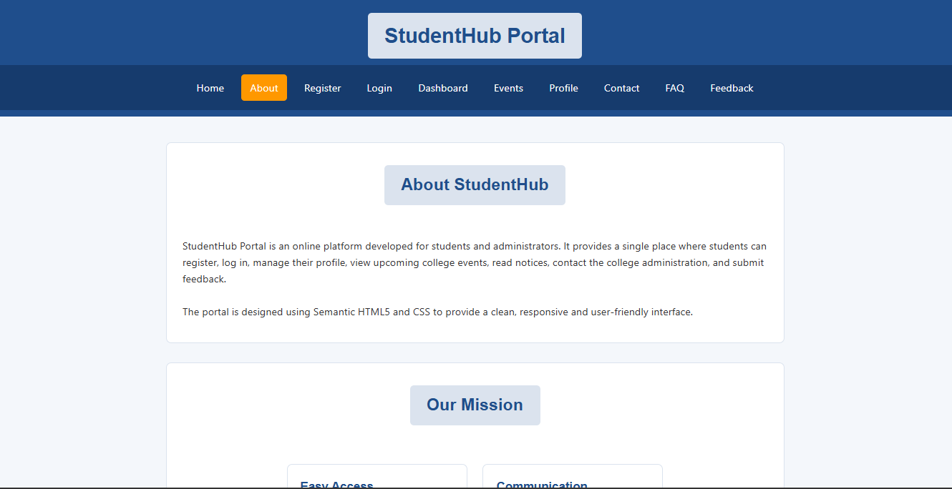
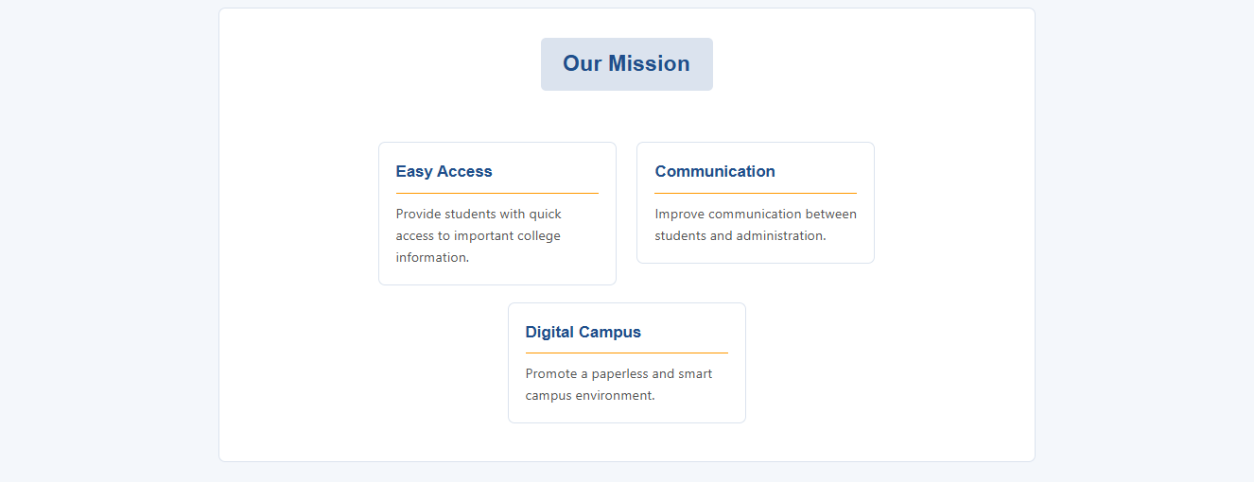
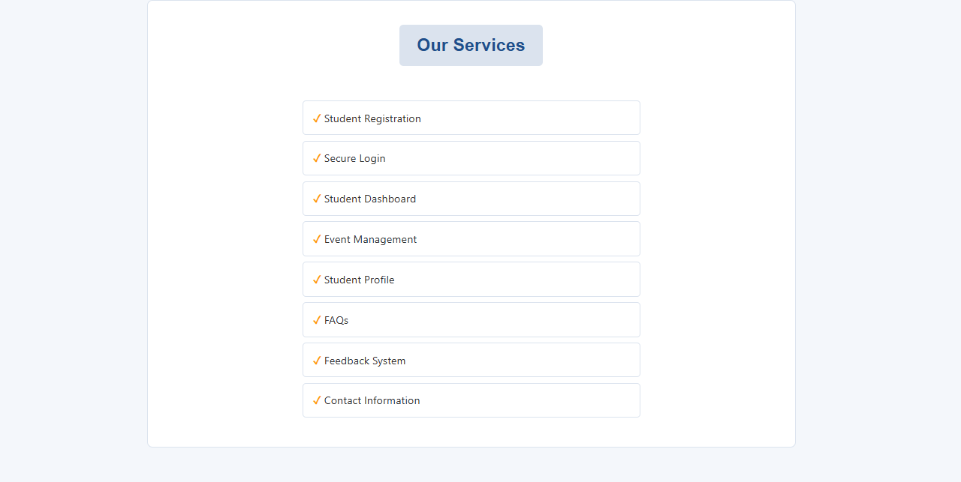
REGISTER PAGE

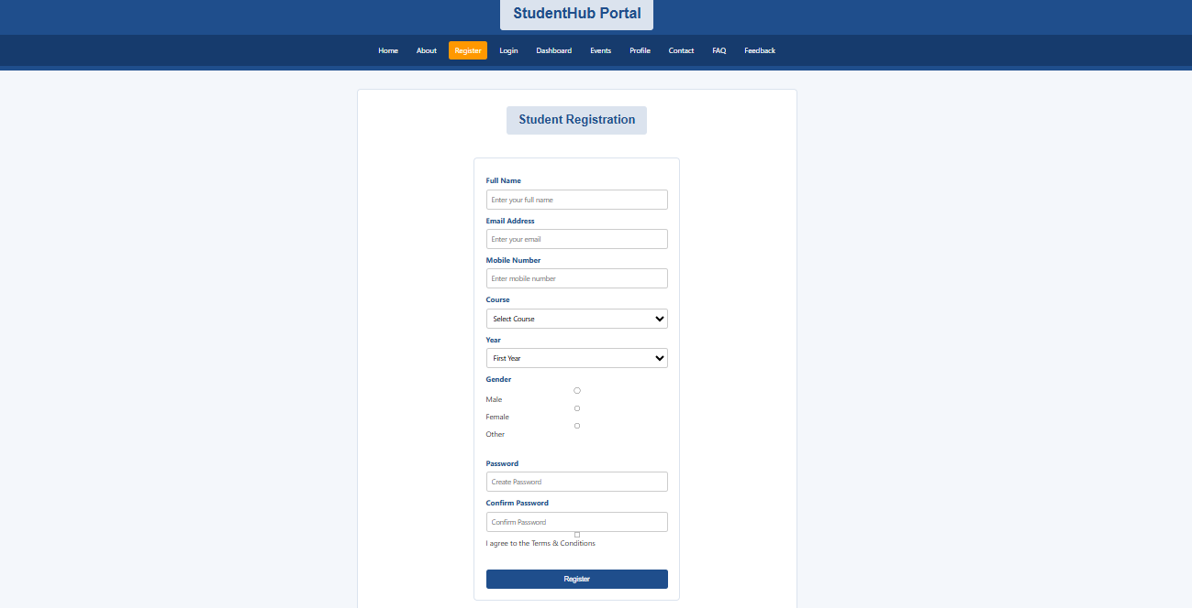

Home page in dark mode

LOGIN PAGE

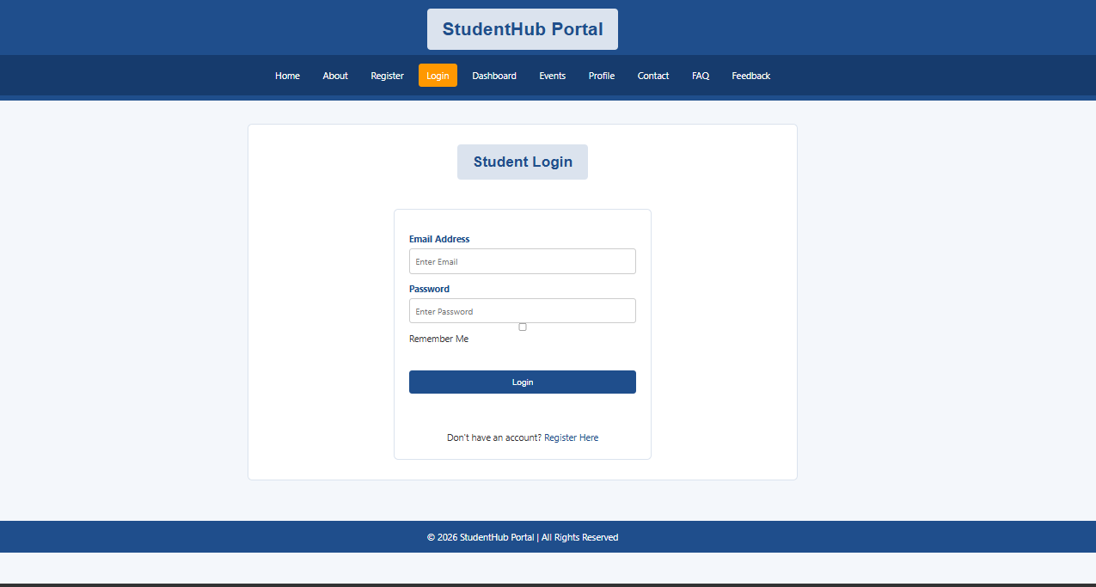

LOGIN PAGE

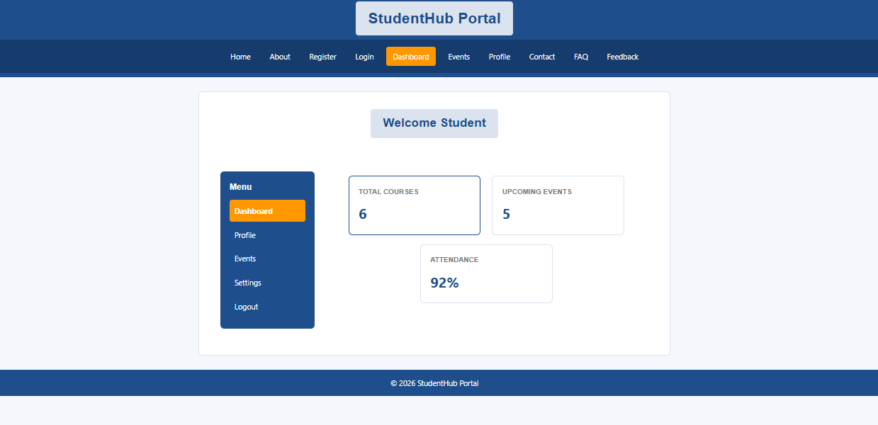

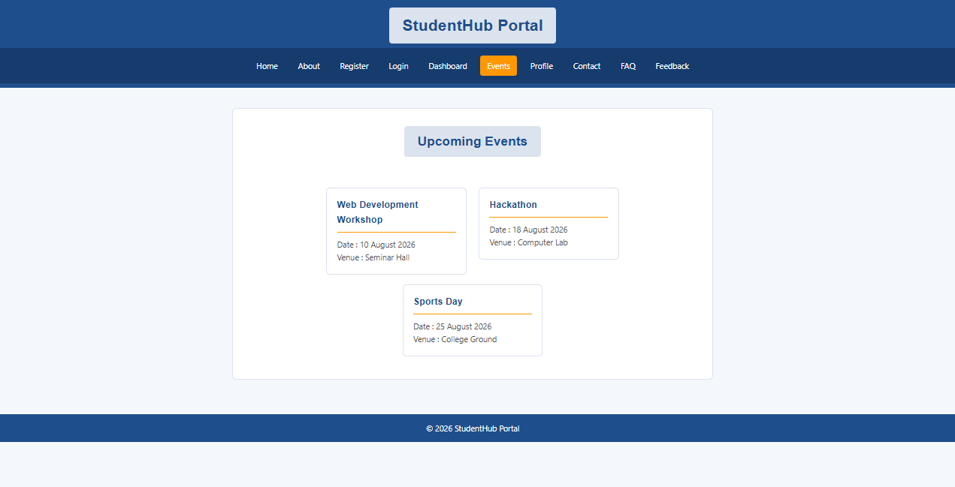

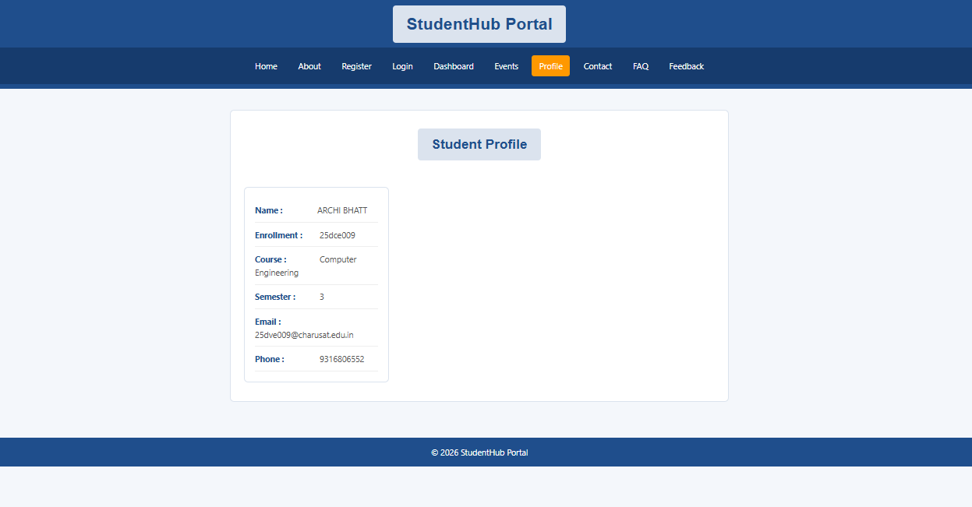

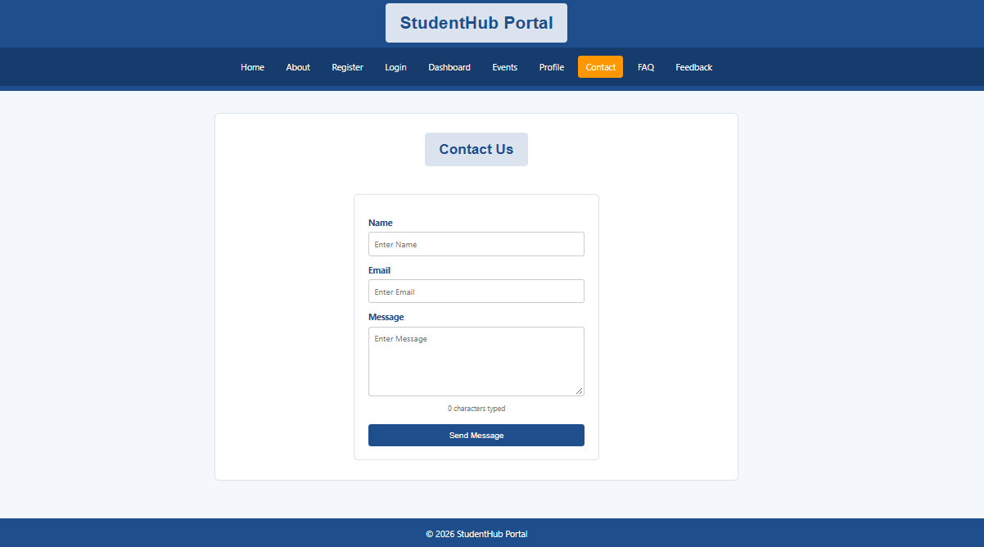
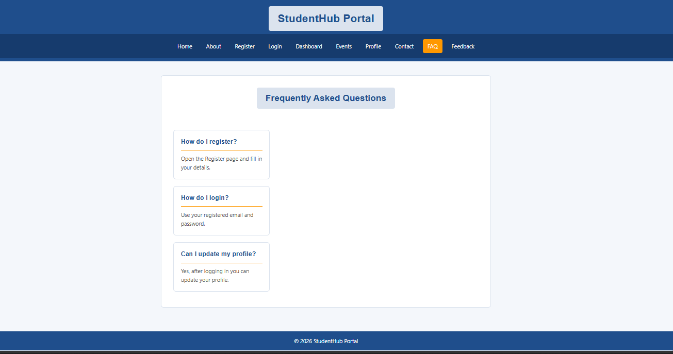

Events page - event navigation

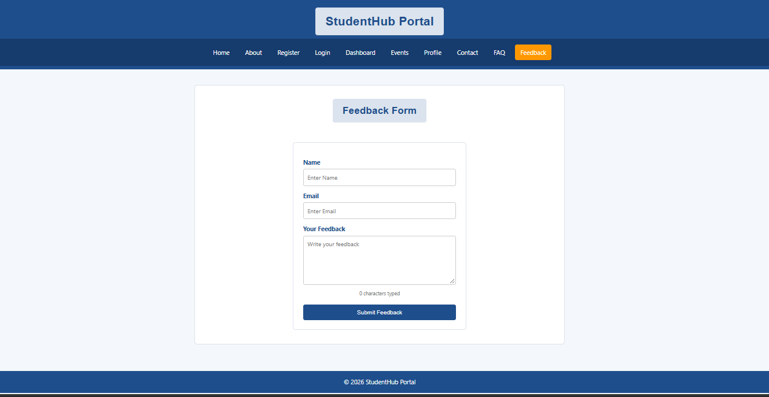

GitHub Repository Link:

https://github.com/archibhatt091601

Challenges Faced:
I faced some difficulty in connecting JavaScript with the HTML elements and making the theme change work on the pages. I also had to check the buttons and page navigation again after adding the interactive features. Testing the website in the browser helped me find and correct these small problems.

Learning Outcomes:
- I learned how to use JavaScript to select and change HTML elements.
- I learned how to use click events to make buttons interactive.
- I learned how JavaScript can be used with HTML and CSS to improve a website.
- I learned how a light/dark theme can be changed using JavaScript and CSS.
- I learned how to test interactive web pages in a browser and fix simple errors.
Faculty Remarks:

