**CHEMICAL BONDING**

**A chemical bond** is an attraction between atoms. This attraction may be seen as the result of different behaviors of the outermost or valence electrons.

An example is the **sodium chloride**, which is made up of a cation (Na +) and an anion (Cl –). The two ions of sodium chloride are held together by an ionic bond. A **covalent bond** is a type of a chemical bond wherein electrons are shared between atoms. The bond between hydrogen and oxygen atoms to form water is an example of a covalent bond. The hydrogen bond is a low-energy electrostatic bond wherein hydrogen serves as a bridge between two atoms.

A chemical bond is an attraction between atoms that allows the covalent bond normally forms between:

1. A non-metal and non- metal
2. A non-metal and metalloid
3. A metalloid and a metalloid

In polyatomic ions that contain metals and in a few other instances, covalent bonds can form between metals and non- metals. However, binary compound containing a metal and a non- metal is always ionic.

Types of Chemical Bond

1. Primary (strong) Bonds
2. Secondary (weak) Bonds

Types of Primaries (strong) Bonds

1. Ionic Bonds
2. Covalent Bonds
3. Metallic Bonds

Types of Secondary (Weak) Bonds

1. Hydrogen Bonds
2. Vander Waal’s Bonds

**IONIC BOND**

Ionic bond is a type of electrostatic interaction between atoms which have a large electronegativity. There is no precise value that distinguishes ionic from covalent bonding, but a difference of electronegativity of over 1.7 is likely to be ionic, and the difference is less than 1.7 is likely ionic to be covalent. Ionic charges are commonly between -3 to +3. Ionic bonding commonly occurs in metal salts such as sodium chloride (salts)

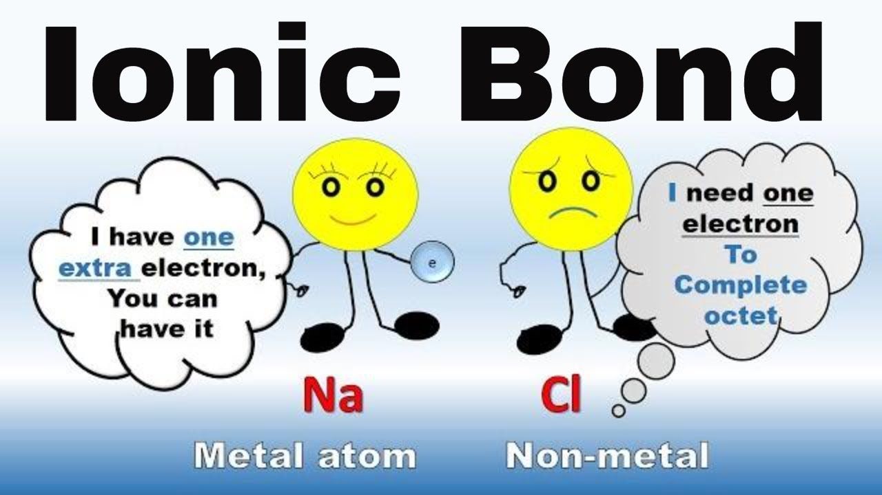

**Covalent Bond**

Covalent bonding is a common type of bonding, in which the electronegativity difference between the bonded atoms is small or nonexistent.

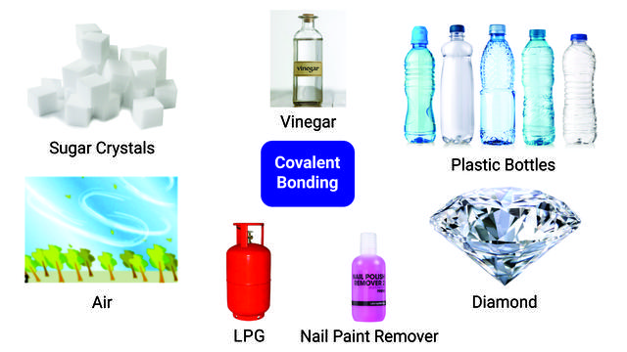

**Metallic Bond**

In Metallic, bonding electrons are delocalized over a lattice of atoms. By contrast, in ionic compounds, the locations of the binding electrons and their charges are static. the freely- moving or delocalization of bonding electrons leads to classical metallic properties such as luster (surface light reflectivity), electrical and thermal conductivity, ductility, and high tensile strength.

