**Part l : Introduction**

**What is Photography?**

**Photography** is derived from the Greek word “Photos” which means “light” and “Graphos” means “Writing”. The term, therefore means, “writing in light” (Lynch-Johnt & Perkins, 2008).

- Is the art and science of reproducing image by means of light through some sensitized material with the aid of a camera, lens and its accessories and the chemical process required in order to produce a photograph.

**Photograph**= Is the mechanical and chemical result of Photography.

• **Picture**- derived from the latin word "Pictura" meaning "a painting" or pictus which means "Painted one". It is a generic term referring to all kinds of formed image.

**Photographer** - person who take photographs.

**What is Police Photography?**

**Police Photography** = Is the application of the principles of photography in relation to the police work and in the administration of justice.

**Police photographer-** a police officer needs knowledge and skills on how a camera records visual and audio components.

**Forensic Photography -**- is the art or science of photographically documenting a crime scene and evidence for laboratory examination and analysis for purposes of court trial (Redsicker, 2001). It plays a very crucial role in criminal investigations. The photographs taken at the crime scenes create a permanent record of the scene and the evidence and there, which both investigators and prosecutors rely on and assists the courts in the admission of justice.

- refers to the recording of objects and scenes to be used for and within the legal process. These records result in forensic photographs that can be used for documentation, analysis, intelligence or court presentations. These photographs have the potential to provide information that can be used as evidence (Spring, 2007).

**Part II: History of Photography**

**Pre-Photographic History**

The early cave paintings of the Upper Paleolithic period can be considered as the earliest creation of pictorial recording. Such can be traced as far back as about 35,000 years ago. These “picture” could possibly be a record of actual hunting of the time, or they could also be religious petitions for a bountiful hunting. They could also simply be depictions of icons that serve to brighten domestic activities.These pictorial images are significant to the discussion of history because they demonstrate how human culture is inextricably linked to photography (Wright, 1999).

The history of imaging began with **camera obscura**,the first pinhole camera. Although there may be a conflict among authors as to who is the first to describe the camera obscura, Robert C. Sandersconsiders that it is most likely the Arab scholar Hassan bin al Haitham who wrote about it in 1048. These early pinhole cameras were used by scientists to observe the sun and by artists to make sketches. Two others who are credited by some authors as the first to describe the camera obscura are **Roger Bacon in 1267 and Leonardo da Vinci** in 1490 (Sanders, 2010)

The evolution of the camera obscura includes the addition of lens in 1550 by **Girolamo Cardano,** the further addition of lenses and curved mirrors to produce an upright image in 1558 by **Giovanni Battista della Porta,** and the invention of a diaphragm in 1568 by **Daniele Babaro.Jean Hellot** may have been the first one to use the word “photography”, which means writing with light. He was reported to have used a photographic process to make secret writings visible by exposure to light in 1737. In 1795, **Thomas Wedgwood** made the first known attempt to use photographic process to take a photograph with a camera obscura. However, his attempt failed due to a combination of under exposure and his inability to fix image.The editors of the Focal Encyclopedia of Photography define photography as beginning when the recording of images “could-be-made-permanent.” The book provides the following dates to outline important pre-photographic events in history (Peres, 2007)

**Advances in Photographic Technology**

The first half of the nineteenth century highlights several attempts to perfect photography through the invention of different processes and techniques. These attempts aimed at producing the most realistic and detailed pictures by fixing the image created inside a camera. The creation of the first photographs required a lot of skill and knowledge and they were regarded as miraculous and praised for their beauty and detail. In 1826, **Joseph Niepce** successfully made the first known photograph, a reproduction of a 17th century Dutch engraving showing a man leading a horse. For the reason, he has been credited as being the inventor of photography.

In 1839, **Louis Jacques Mande Daguerre**  invented the daguerreo type, the first commercially successfully photographic process. It used a silver nitrite light-sensitive emulsion that was developed with a mercury vapor and fixed with a strong salt solution to produce a positive photographic image. The latent image and user of silver combined with iodine (silver iodine) that were introduced by Daguerre became the bases of every major camera process of the 19th century until the introduction of gelatin bromide emulsions used in the manufacture of dry plates and developing-out papers (sanders, 2010).

In 1839, **William Henry Fox Talbot** invented the Calotype, a silver chloride-coated light-sensitive paper that was fixed with strong salt solution. The calotype (from the Greek kalos,meaning “beautiful”) was later patented by Talbot in 1841. In 1844, he improved the calotype paper negative process using a gallic acid and silver nitrate solution with a hypo fixer. This is the process that eventually evolved into the photographic negative printing process that is in use today (Peres, 2007).

In 1841, the Paris police department became the first agency to use daguerreotype mug shots. By the late 1840s, the daguerreo type process was being used commercially in every industrialized nation of the world.

**Persons Involved in the Development of Photography.**

**Joseph Nicephore Niepce**

**-**He is the first man to develop photograph using camera obscura. He then called his camera as **“Heliograph”** which means **sun drawing.**

**Louis Jacques Mande Daguerre**

-Daguerre is the **Father of Photography**.

-called his camera as “DAGUERRIOTYPE”

**William Henry Fox Talbot**

-invented a process called calotype, a photographic process by which a large number of prints could be produced from a paper negative**.**

**-**He introduced the “negative to positive” system

**John F.W Herschel**

**-**He is the one who coined the term “**Photography”.** He also discovered the new chemical used in fixing images, Hypo or Sodium Thiosulfate and he also the one who first used the term negative and positive in photographic process.

**James Clerk Maxwell**

-He discovered the “**Color separation of light”.** He is also the first man to develop a colored photograph.

**George Eastman**

- founded the Eastman Kodak company and invented roll film, helping bring photography to the mainstream. Photography became available to all.

**Edwin H. Land**

**-** Introduced “**Polaroid**” or One step Photography.

**Alphonse M. Bertillon**

**-** invented many techniques that contributed to the field of criminology, one of which is the invention of the mug shot.

**Part lll: Photography in Police Work and Law Enforcement**

**Significance of Photography**

In law enforcement work, photography serves four primary functions:

1. As means of identification
2. As a method of discovering, recording, and preserving evidence
3. As a way to present in court room an impression of the pertinent elements of crime
4. As a training and public relations medium for police programs

**Uses of Photography in Police Work**

Below are further uses of photography in police work.

1. It serves as evidence.

2. It preserves all pieces of evidence.

3. It refreshes the mind of the investigator.

4. It records the illegal activities and identities of criminals.

5. It is useful in personal identification as well as in the identification of missing persons, wanted persons, and stolen or lost properties.

6. It records all things that an investigator may fail to notice.

7. It assists the court in understanding the case.

8. It helps reconstruct the crime scene.

9. It helps the expert witness in illustrating their findings.

10. It supplements, explains and replaces the descriptive testimony of witnesses.

11. It serves as lecture materials and illustrations during police personnel training.

12. It also serves to reproduce and copy documents.

**The PNP Forensic Laboratory Division**

The Philippine National Police (PNP) Crime Laboratory has its own Forensic Photography Division whose personnel perform the following functions/ capabilities:

1. Photograph suspects and crime victims for personal identification;

2. Photograph evidence submitted to the laboratory before examination;

3. Conduct crime scene photography;

4. Conduct crime scene sketching;

5. Conduct comparative examination and analysis of questioned photographs against known photographs;

6. Conduct lectures to different police/military training institutions, government agencies and public/private schools upon request;

7. Reproduce photographs and other printed materials;

8. Sketch facial features of suspects based on actual description by the witness or victims for identification; and

9. Attend court duties.

**Documentation of Crime Scene**

A **crime scene** can be defined as a location at which an offense was committed and where the potential evidence of that crime may exist. This may include a home, automobile or a remote location in the woods.

There are **three most common methods of documenting a crime scene**, namely note taking, sketching and photography. A detailed record of the crime scene and of the actions taken during the search can help the investigator to accurately recall events and to identify items of evidence later in a court of law.

**Note Taking**

The investigator/ photographer's notes are personal records of the search for evidence. The objective of note taking at a crime scene is to make detailed notes that will remain fully meaningful even months after the event. Oftentimes, a note that is completely clear to the writer a short time after being made later becomes unintelligible.

The notes taken should begin with the investigator's name and assignment to the case. Notes should be supplemented by sketches: and photographs of the scene. Notes should be recorded in the order. that the observations they pertain to are made, and will not necessarily be in logical order. During the initial stage of the recording process, it is important only that the notes are complete, as the investigator will later reorganize the information during the writing of the formal report.

**Essential Items of Information to Be Included During Note Taking**

1. Dates, times, and locations

2. Detailed description of the victim and his/ her clothing

3. Wounds the victim has received

4. A general description of the crime scene

5. The type of camera and film used in photographing the crime scene

6. Discovery of each significant item of evidence

7. The failure to locate items

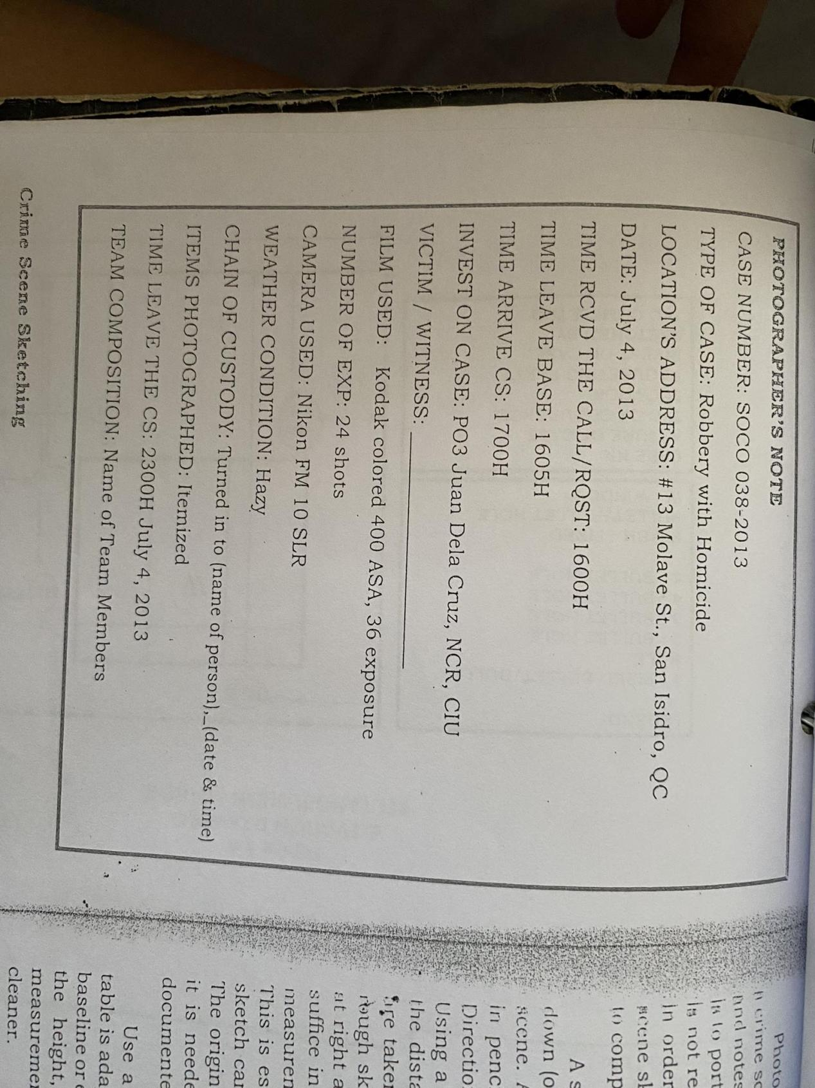

**Crime Scene Sketching**

The final phase in documenting the scene is making a crime scene sketch. Most photographs can distort the spatial relationships of the photographed objects causing items to appear closer together or farther apart than they actually are. If spatial relationships of the evidence are important or if something needs to have proportional measurements included in it for calculations (such as bullet trajectory angles, accident reconstructions, etc.) then a sketch must be made of the crime scene.

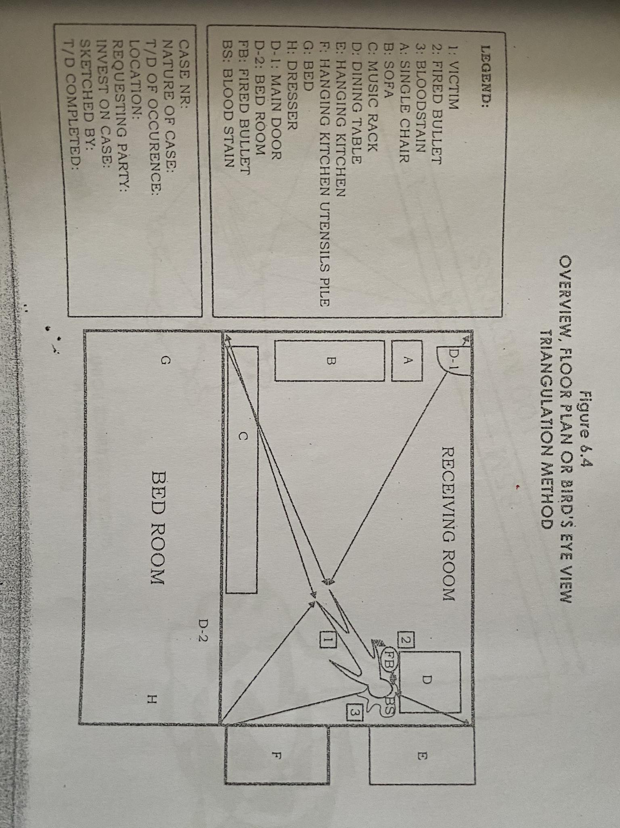

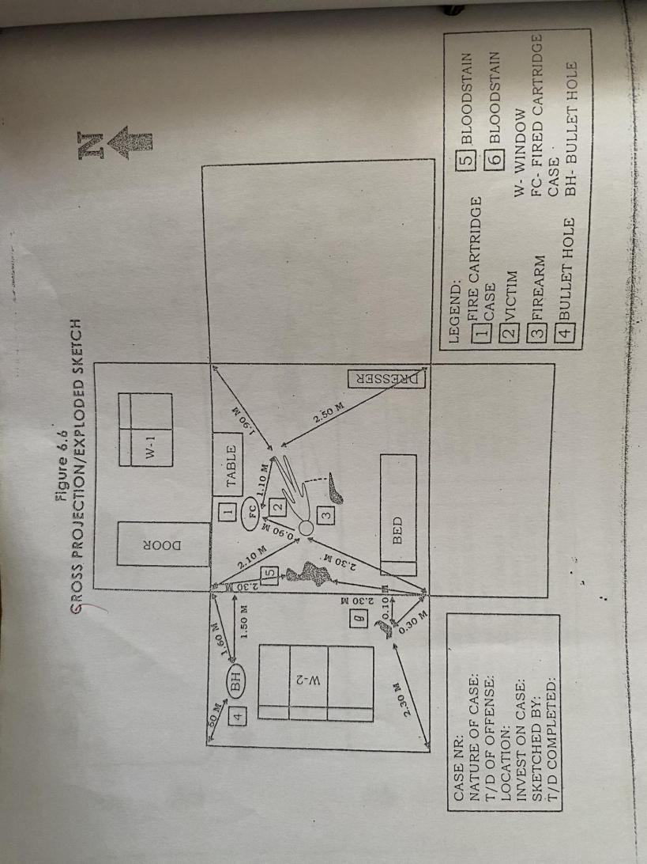

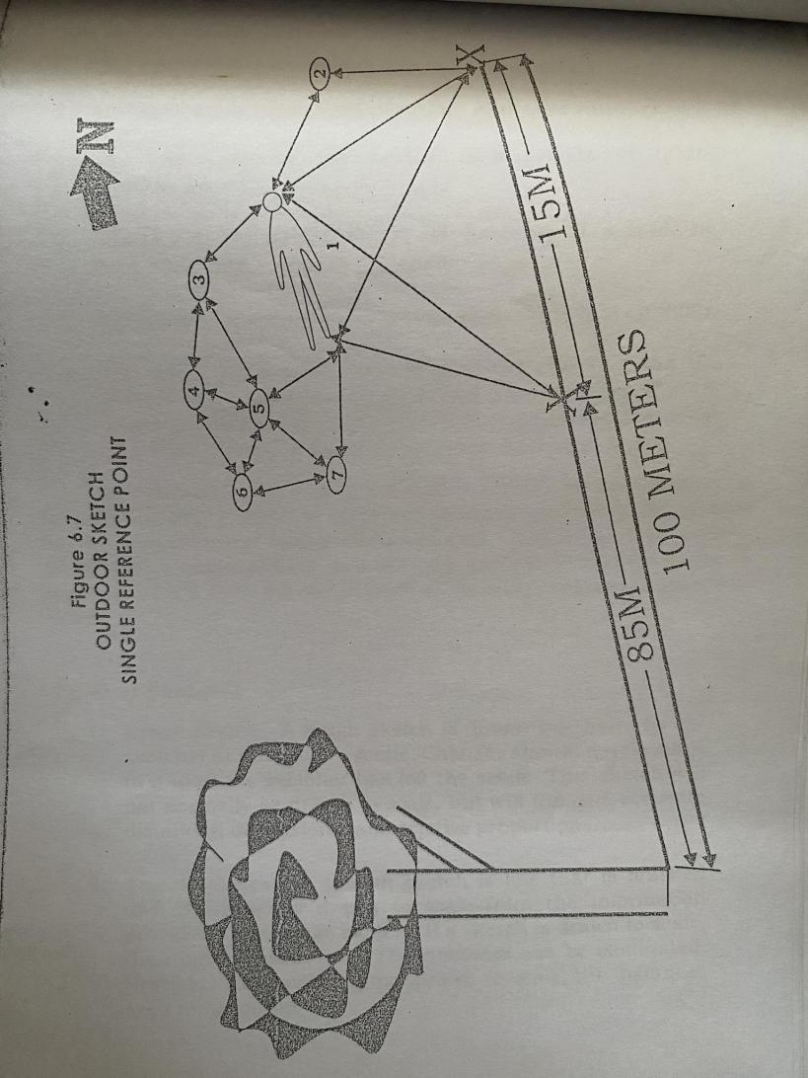

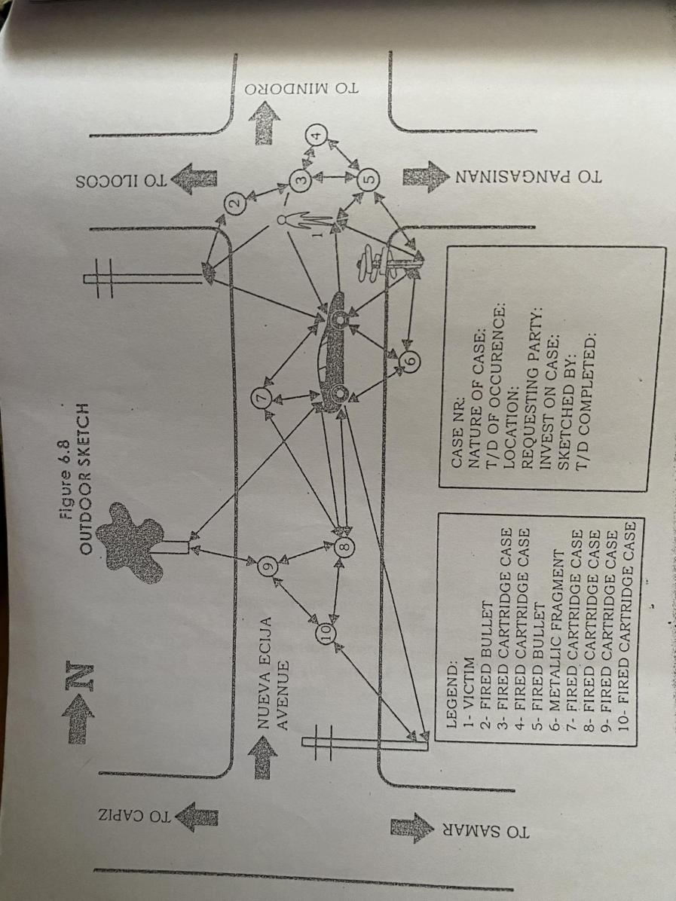

**Photographing the Crime Scene**

The purpose of crime scene photographs is to give a documented record of the scene as it is observed. The photographers should begin taking photographs of the scene as soon as possible upon arriving on the area.

The goal is to record useful information in a series of photographs which will enable the viewer to understand where and how the crime. was committed. The crime scene not only refers to the immediate locality in which the crime took place, but also to adjacent areas where important acts took place immediately before or after the crime was committed.

**Ranges of Photographs**

1. General View or Long-Range

General view or long-range photographs of the overall scene are fundamentally taken to portray the areas as if a person viewing the scene is seeing it from the standing position. To obtain this result, the photographer takes the photograph with the camera at eye level.

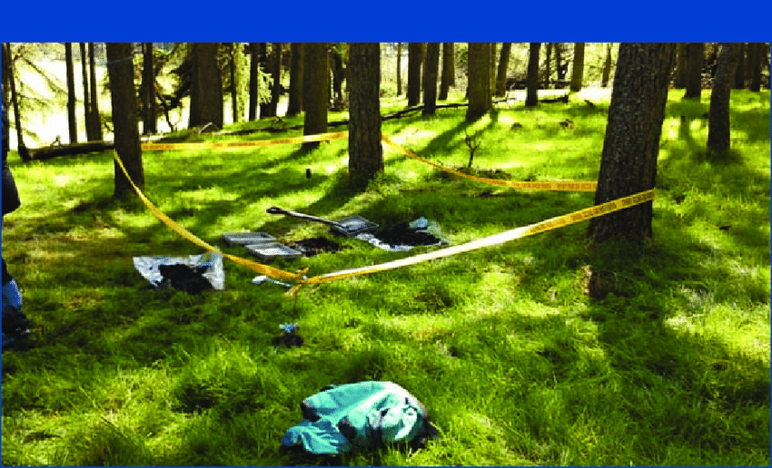2. Medium View or Mid-range

Medium view or mid-range photographs are taken in a manner which portrays the scene from approximately ten to twenty feet of distance from the subject matter. In order that the viewer be permitted to associate the crime scene with separate areas of the scene photographed, these areas should contain sufficient detail to permit the viewer this association.

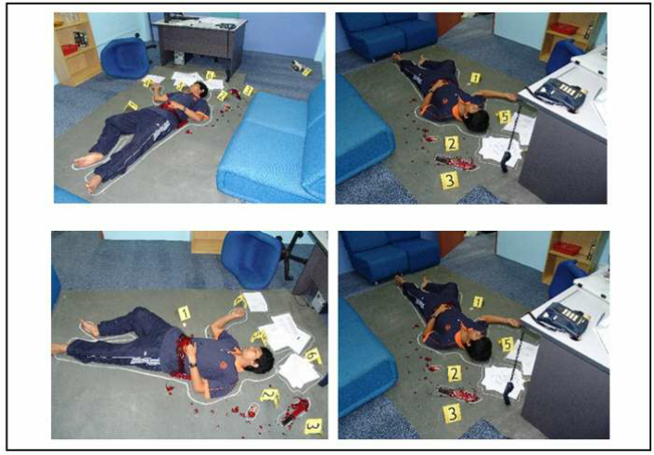

3. Close-up View/ Range

Close-up range photographs are normally taken approximately five feet or less from the subject matter. The attention of close-up photography is directed to objects which could not effectively be seen in the long-range and mid-range photographs. Take necessary extreme close-up shot of the subject to show the extent of damage.

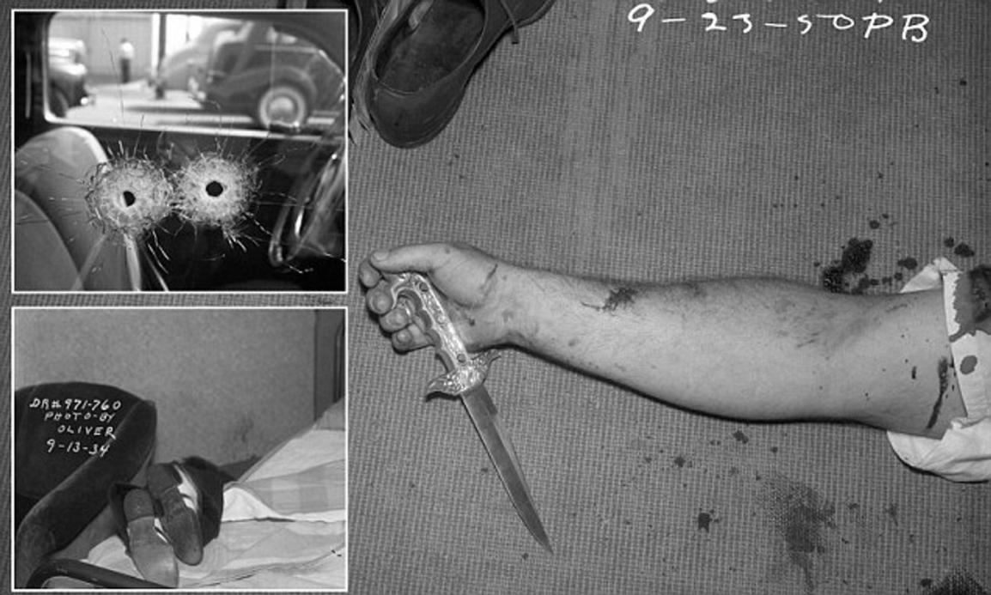

**Sequential Photographs of the Crime Scene**

The following photographs should be taken.

1. Views of the exterior of the building/vehicle, with relation to other buildings/ vehicles, roads, streets, etc.

2. Point of entry, outside and inside

3. Point of exit, outside and inside

4. Condition (s) of the crime scene

5. Area from which valuable articles were removed

6. Articles left at the scene

7. Trace evidence, such as hairs, fibers, and cigarette butts

8. Tool marks and impressions of shoes or tire tracks

9: Fingerprints and footprints, as well as articles on which these prints may be found

**Standard Operating Procedures in Photographing the Crime Scene**

The PNP's forensic photographers follow these basic rules for Scene of Crime Operation (SOCO) and Field Laboratory Work (FLW):

1. Photograph the entire scene or the general view. to include nearby surroundings pertinent to the case, indicating the case number, time, date, and initial of the photographer.

2. Take an overlapping shot of the immediate scene from four different angles.

3. Photograph the entrance and exit of the crime scene.

4. Photograph the body (victim/s or suspect/s) showing the exact location, direction where it tends. After removal of the body, take a photograph of the scene with the white outline to indicate the place where the victim was lying.

5. Take close-up photographs of the body showing the face for proper identification.

6. Take mid-range and close-up photographs of all pieces of evidence found at the crime scene with a measuring tool or scale, if necessary, including the case number, date and initial of the photographer.

7. Take close-up photographs of the bullet hole if there is any, and photograph the area showing the appropriate distance of fire by making a straight line on the direction of the bullet hole.

8. The crime scene should be sketched in the presence of the investigator or other authorized person. The investigator should sign in the rough sketch to attest the authenticity of the crime scene sketch. Record on the photographic log book the weather condition, type of lens, film and camera used

9. Negatives and photographs should be placed in a plastic holder and put inside a white mailing envelope with proper case identification such as case number, time and date before filing in a steel cabinet.

**Photographing the Evidence**

The PNP forensic photographers follow standard operating procedures in photographing evidence. Many valuable articles of evidence can be found in the scene of the crime. Each object should be photographed individually in relation to other objects at the scene.

Three purposes are served by this procedure.

1. A permanent record is made of the original appearance of the object.

2. The photographed subject can be used in place of physical evidence to supplement the case report.

3. Each article is preserved from unnecessary handling, which might cause the evidence to deteriorate or otherwise. become altered.

As a general rule, some or all of the evidence are brought to the crime laboratory for examination where photomicrography and photomacrography is available, if needed.

• For foot or shoe impressions, the imprints of shoes, foot slippers or sandals are often found at or near crime scenes.

Before and after reproductions are made by plasters casts or dental stone, the impressions should be photographed.

Evidence of all kinds must be photographed in close-up range to show details.

• The procedure for tire impression is quite similar to the described shoe impressions. A length of the tire track that shows a clear pattern should be shot several times in closeup range to give maximum detail of the pattern.

• In murder and homicide cases, it is necessary to photograph in detail the pattern and color of bloodstains. The location area and tapering of the stains may indicate the positions and action of the assailant or the victim.

Small quantities of clue materials such as glass fragments, paint flakes, soil particles, fibers, hair and other substances and small specimens are often carried unknowingly to and from the scene of the crime. Their location on the suspect's clothing and at the crime scene should be documented carefully by close-up photograph for comparison purposes.

• Conduct mug-shot photography to the victim/s and suspects while undergoing paraffin casting.

• Photograph other physical evidence submitted to the laboratory before examination such as suspected drugs, chemicals, explosive substances and others.

• Photograph vehicle/s submitted as evidence to show the trajectory of bullet holes, entrance, exit and the extent of damage, as well as the body serial number and chassis number order to show any sign of tampering.

• For firearms identification, conduct macro-photography on the serial numbers, nomenclature and other small part of the firearm/s submitted as evidence before the actual examination of the firearms examiner.

Conduct close-up photography on the firearm for identification and documentation purposes prior to the examination of the firearm examiner.

• Take other photographs with ballistics value upon request of the firearm examiner.

• For fingerprint identification, fine grain panchromatic film of medium contrast, along with some high contrast panchromatic film, may be used to photograph latent prints.

• When photographing black powdered latent prints in colored objects, the photographer must make the colored background appear as light as possible in order to provide the greatest possible contrast with the black fingerprint.

• When photographing fingerprint on wood, it is best to develop latent prints on dark stained wood with white powder and to photograph them with high contrast panchromatic film with blue filter.

• When photographing visible latent print found on glass, it must be photographed before and after applying powder on it.

• Latent prints found on paper and plastic should be treated with powders, fumes or liquid reagents to bring out the prints clearly enough to photograph.

Dusted and lifted latent prints that have been lifted should be photographed as soon as possible. The lifting material bearing the prints should be used as transparent positive to make an enlarged negative,

• When it is necessary, fingerprint should be photographed while still on the original surface.

**Issuance/ Release of Photographic Evidence**

A written request addressed to the Director, Crime Laboratory is required from the investigating units having jurisdiction over the case prior to the release/issuance of photographic evidence.

Upon receipt of the approved request, photographs and other photographic evidence should be released within minimum period of one day. Likewise, requests for court presentation should be attended without delay. Forensic Photographer subpoenaed by court should personally print the negatives as soon as possible and prepare the materials, photo log and crime scene sketch for court presentation.

**Part lV: Light and the Camera**

**Light-**is the very essence and the basic substance of photography. It is important to understand how light behaves and how lenses form it into images to gain a broader view of the possibilities of photography.

**-** is a radiant electromagnetic energy that can be seen by the eye.

**Two Main Source of Light**

1. Natural Light- This refers to the daylight coming from the sun, which is generally utilized for outdoor photography, or light that comes to existence without the intervention of man. Light produced by the sun, including direct sunlight, the soft tight in a shadow, light that bounced off a reflective surface, moonlight reflected surface, moonlight reflected from the sun, and starlight are all sources of natural light. Daylight photography depends as much on the quality of the daylight as its strength. The quality of daylight is a combination of contrast and color temperature or color of the day.

Natural light can be classified according to its intensity.

1. Bright Light- a lightning condition wherein objects in open space cast a deep uniform shadow.In bright light, the subject will produce strong shadow because the source of light is not covered by clouds. In black and white photography, the objector subject looks contrast.
2. Hazy Light- a lightning condition wherein the objects in open space cast a transparent shadow.In hazy sunlight, the sun is covered by the clouds and shadow appears bluish because of the decrease of the light falling on the subjects in open space.The shadow cast a transparent to the eye and more details are visible under these lightning conditions than in bright sunlight. When the sunlight is obscured by light clouds, the intensity of the direct light falling on subject in open space is decreased.In effect, the light coming from the sky becomes stronger that the shadows appear more bluish that in bright sunlight.
3. Dull Light- a lightning condition wherein the objects in open space cast no shadow.In dull sunlight, the sun is totally covered by thick clouds. No shadows are formed due to the uniform illumination of light around the subjects in open space.

2. Artificial Light- This refers to man-made sources of light used or utilized for indoor photography to align the hazy or dull light in outdoor photography.This includes all non-natural sources such as conditions light from incandescent and fluorescent light bulbs,electronic flashes, and studio strobes.

Sources of Artificial Light

1. Continuous Duration: Ex.•Fluorescent Lamps, Incandescent Lamps/ Tungsten Light,•Photoflood Lamps,•Infrared Lamp,•Ultraviolet Lamp
2. Short Duration: Ex. Flash bulbs (chemical flash lamp), Flash cubes,•Flash bar,•X-cube, Electronic Flash

**The Camera**

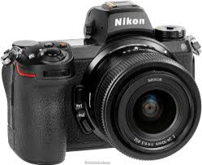

By definition, a **camera** is photographic apparatus used to expose sensitized film or plates to reflected light images formed by a lens. It can also be considered as a light tight box with means of forming the image, holding sensitized materials, and controlling the amount of light that will reach the film.

**Camera Types**

1. 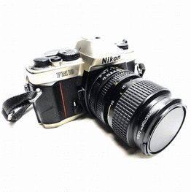SLR (single lens reflex) cameras are the most popular type for serious photography. They could be either digital or use 35mm film. An SLR camera’s unique feature lies in the design of its viewfinder system in which a system of mirrors shows the user the image precisely as the lens renders it. Thus, no matter what focal length lens is attached to the camera, the scene the photographer sees through the viewfinder corresponds exactly to that seen by the lens.
2. Compact or Point-and- shoot Cameras can be either digital or film cameras and are light and easy use. This non-SLR camera does not support interchangeable lenses and the view seen through the viewfinder is not exactly the same as that seen through the lens. This problem can result in framing errors and not seeing whether the image is correctly focused. They are called point-and-shoot because they have controls that are either very simplified or very automated (or both). Such cameras are meant to be used to record snapshots without having to learn how to use a camera

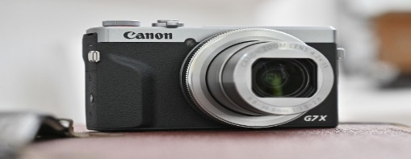

1. 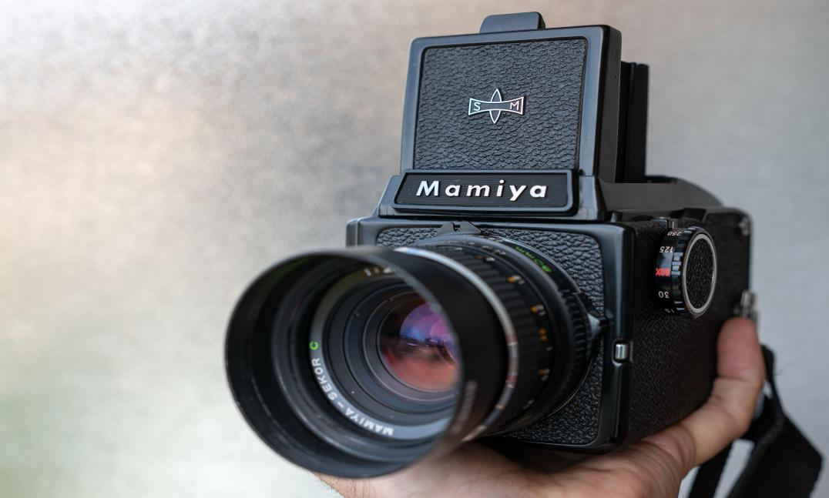Medium-format Cameras use wide rolls of film(between the 35mm and 4x5-inch formats) for better image definition. Because of the large negative size,the image resolution is higher with medium format than 35mm cameras. These cameras tend to be more expensive, and lenses tend to be large.

**Essential Parts of a Camera**

1. Light-Tight Box or Body- part of the camera that is very important because of its capability to exclude all the unwanted light that might expose the film.
2. Lens- a glass, plastic, or crystal optical element molded into a curved shape that can bend and focus rays of light;responsible for focusing the rays of light coming from the subject.
3. Film Holder- holds the film firmly inside the camera
4. Shutter- device used to control the amount of time during which light is allowed to enter the camera and register on the film or image sensor; serves as the barrier of the rays of light that will enter and affect the film inside the camera Settings the shutter at certain speeds enables the camera to determine the length of time the film is exposed. Moving the shutter speed dial to the next stop either doubles or halves exposure time. Shutter speed: B, 1, 2, 4, 8, 15, 30, 60, 125, 250,500, 1000, 2000•

-Number 1 stands for a whole second and the others are fraction of a second.•

-The shutter speed of 125 can stop the movement of the subject.•

-The shutter speed of 60, 125 and above is advisable to use when hand holding the camera with a 50mm lens but if your lens is 300, use 500/sec or higher

1. Viewfinder- an optical or electrical device used to compose and frame a scene; shows the entire scene coverage that can be recorded in the film inside the camera; also called a view system, a finder, or a viewing screen.Compact or point-and-shoot cameras have direct vision viewfinders that do not show exactly the same image that the lens sees. In SLR cameras, light is reflected by a mirror and penta prism to the viewfinder. Digital cameras usually have an LCD monitor to show the image being projected onto the sensor.

6. Film Advancer & Lever- a mechanism for moving film from one spool to another incrementally one frame at a time.

7. Shutter Speed- it will control the duration between the opening and closing of the shutter.

**WHEN TO USE SHUTTER SPEEDS?**

When to Use Slow Shutter Speeds: to shoot in the lowest light. Slow shutter speeds can also be used for still images and in creative effect, as moving subjects will become artistically blurred.

When to Use Fast Shutter Speeds: Moving subjects require you to consider using a faster shutter speed than that needed to avoid camera shake.

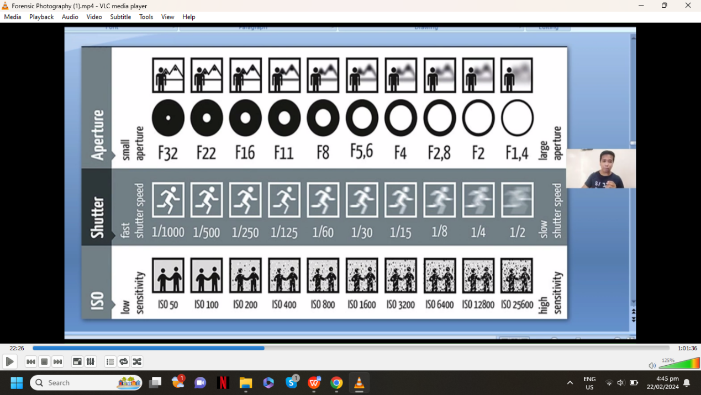

Factors to be considered in using Shutter Speed Control:

1. The light sensitivity of the film, which are determined through its ISO

2. The lighting condition

3. The motion of the subjects on different angles

4. The purpose of the photographs to be taken, etc.

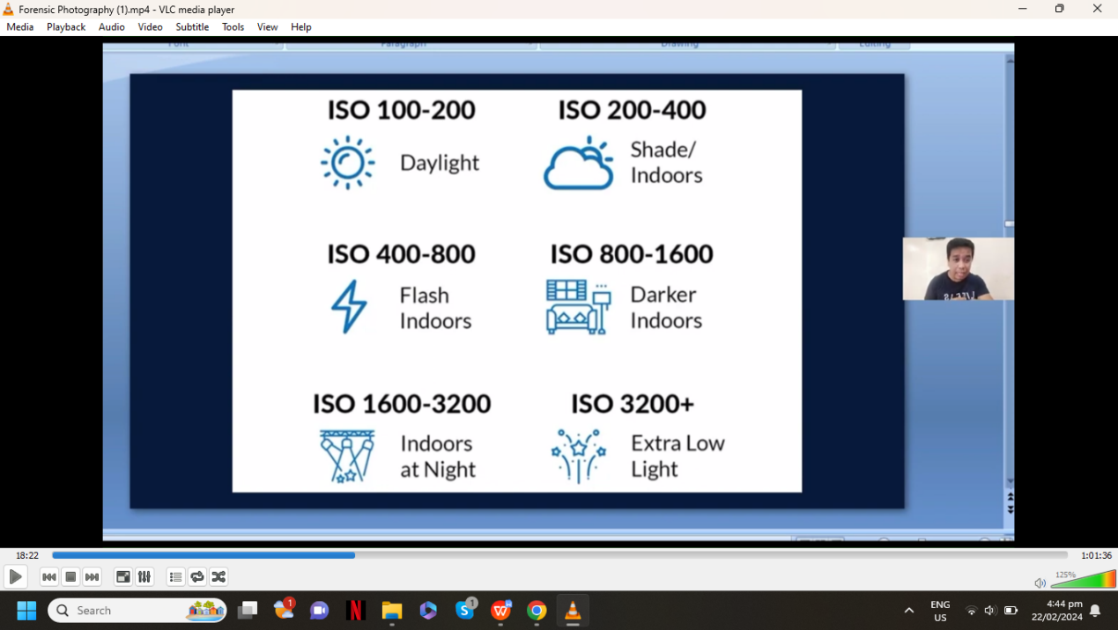

1. Lens Aperture- an opening (diaphragm) in a light-blocking plate that allows light to strike the film or image sensor; the ratio between the diameter and focal length of the lens; the light gathering power of the lens. •The diameter of the lens diaphragm can be changed by turning the aperture ring. This dictates the brightness of the image reaching the film. Moving to the next f-number either halves or doubles aperture size. Aperture size also affects depth of field.•The higher the number, the smaller the lens opening.•The smaller the lens opening, the greater the depth of field

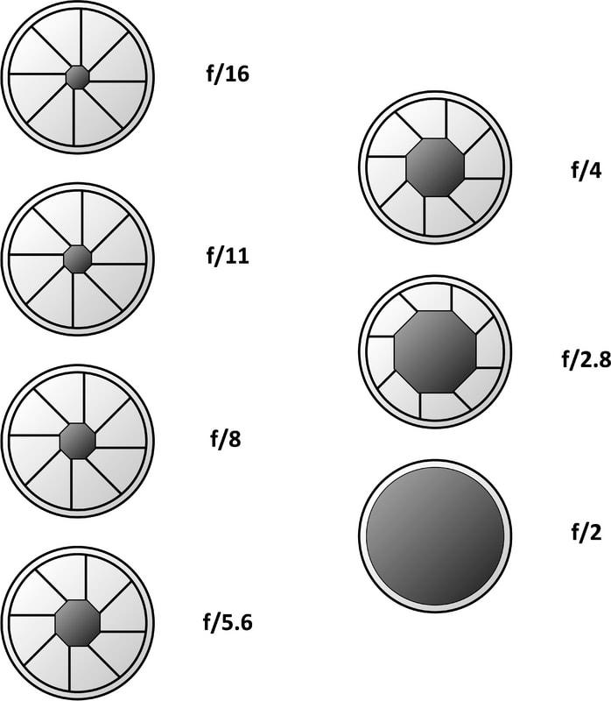

9. Focusing mechanism- the sharpness or clearness of the objects being photographed will depend upon the focusing system of the camera. The focus is the physical point at which rays and light from lens converge to form a properly defined image of the subject

**Mechanical 35mm SLR Camera**

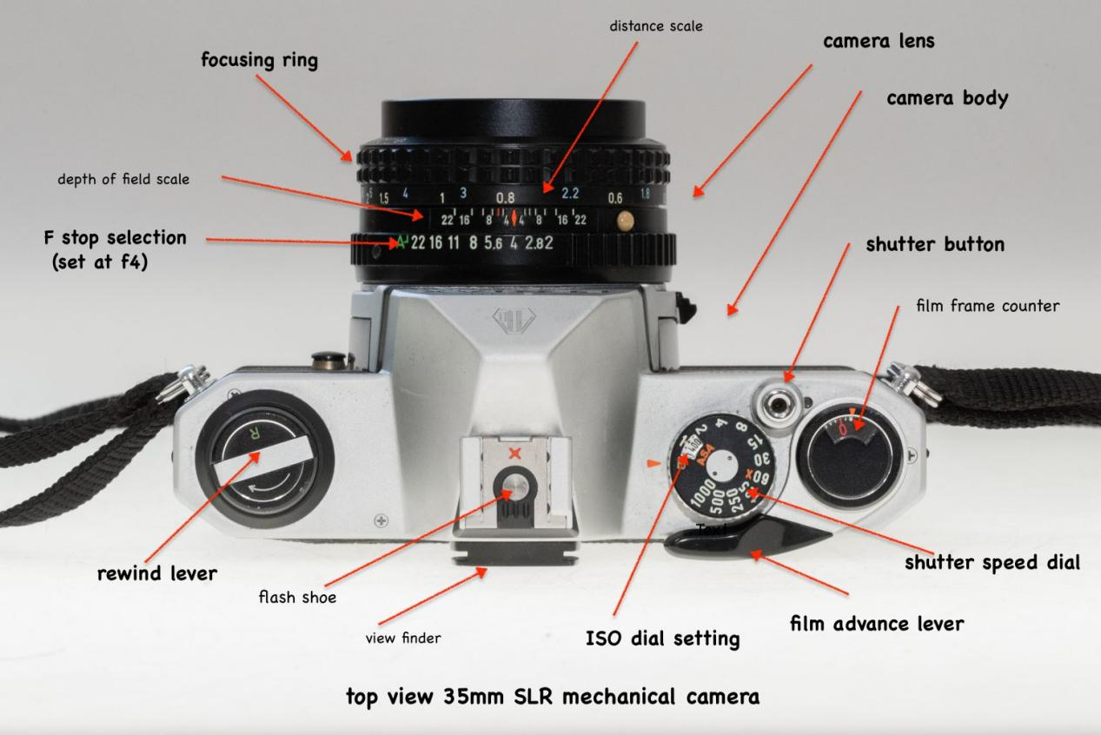

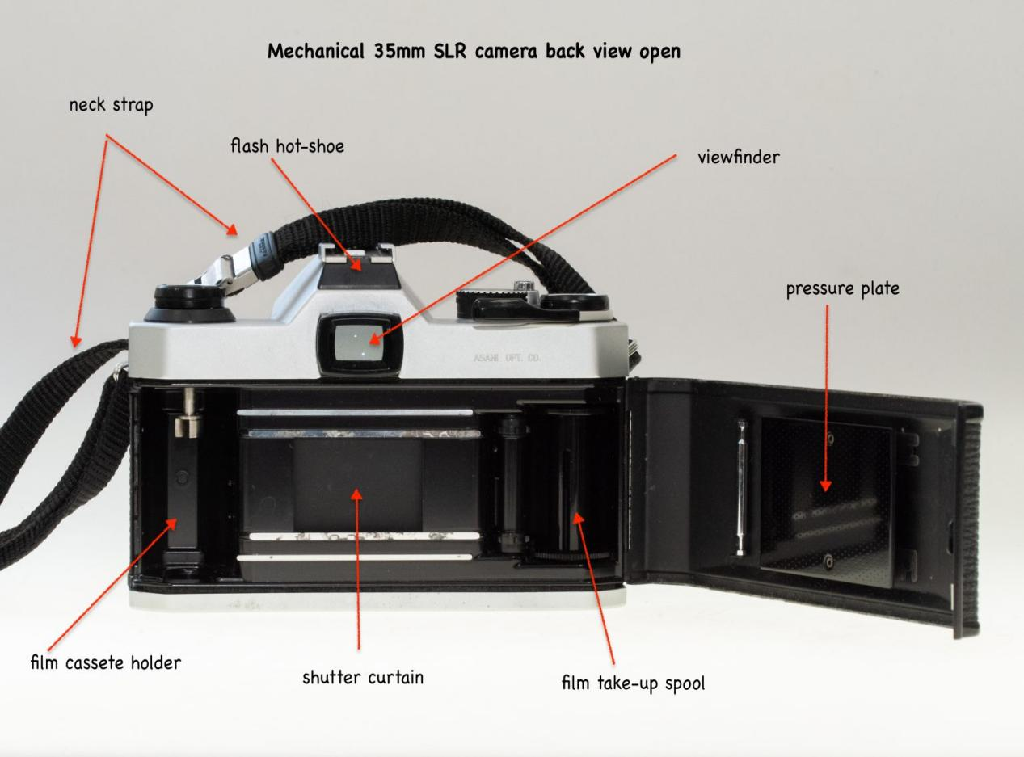

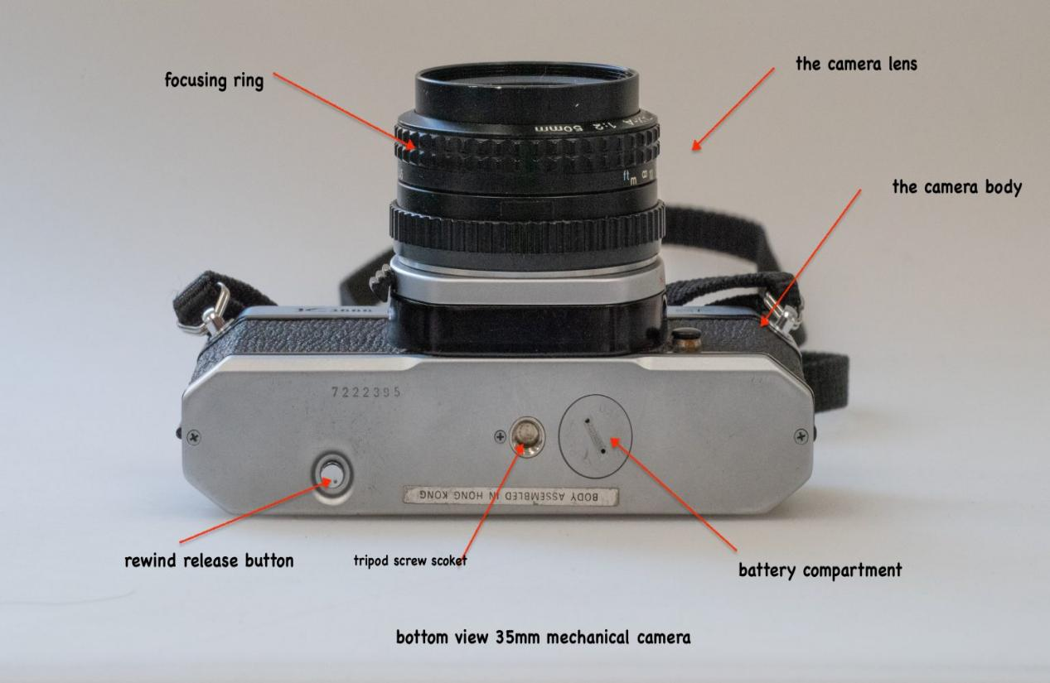

**Camera Lenses**

**Lens** is a glass, plastic, or crystal optical element molded into a curved shape that can bend and focus rays of light coming from the subject.

TYPES OF LENSES

Biconvex - both surfaces are convex.

Biconcave - A lens with two concave surfaces is biconcave (or just concave).

Plano-convex or Plano-concave - If one of the surfaces is flat, the lens is plane-convex or plane-concave depending on the curvature of the other surface.

Positive or Converging Lens - This lens is always thicker at the center and thinner at the sides.

Negative or Diverging Lens - This lens is always thinner at the center and thicker at the sides.

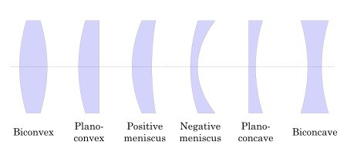

**Standard Camera Lenses**

1. Standard/Normal Lens- A standard lens or normal lens has a focal length that is roughly equivalent to the diagonal of the light-sensitive,image recording area within the camera. They usually have wide maximum apertures, making them useful in low-light situations;
2. Wide-angles Lens- A wide-angle lens has a focal length shorter than the diagonal of the film frame or image sensor. It provides broader angle of view than a standard lens and is therefore ideal for photographing a group of people or when working in confined space. However, distortion may be a problem if the lens is used too close to a subject;

A wide-angle lens is also sometimes called a short lens.These lenses can be rectilinear (straight lines are preserved)or fisheye (showing extreme barrel distortion);

1. Long- Focus Lens- A long focus lens has a focal length that is much greater than the diagonal of the film image format with which it is used. Longer focal lengths are useful for taking large images of distant subjects or when unable to move close enough to the subject to use a shorter lens; and
2. Zoom Lens- A zoom lens has a variable focal length. It allows fine-tuning of subjects framing by adjusting the focal length of the lens

**Special Camera Lenses and Zooms**

1. Ultra Wide-Angles Lens

Linearly corrected ultra-wide-angle lenses have a focal length ranging from around 21mm down to around 15mm.

2. Wide-Angle Zoom

A wide-angle zoom is likely to be slower and heavier and to show more image distortion than wide-angle fixed focal length.

1. Macro Lens

Macro lenses are designed to render a subject with 1:1 or higher magnification for very close focusing distances. They are useful in taking close-ups of small subjects or isolating details of larger subjects because they allow the camera to focus extremely close to a subject to record a detailed image.

4. Telephoto Lens

A telephoto lens has a focal length longer than the diagonal of the film frame or image sensor. Telephoto lenses make a subject appear larger on film than a normal lens at the same camera-to-subject distance.

5. Telephoto Zoom

A telephoto zoom ranging from 75-300mm encompasses about six fixed focal length lenses. This type of zoom is popular with sports and wildlife photographers . it is also useful for portraits and can be used to photograph architectural and landscape details.

**Telephotos vs Wide Angle**

Telephotos - are long focal length lenses. Telephotos are lenses with tocal lengths greater than 50mm. They range from 70mm short telephotos to

"long toms" with focal lengths of 1000mm or more.

Wide angles - are short focal lengths. A lens with a focal length of 50mm is known as a standard lens the view that it gives is similar to that of the human eye. Any lens with a shorter focal length, and wider angle of view, is known as wide-angle.

**Inherent Lens Defects or Aberrations**

1. Spherical Aberration - When light passing through near the central part of a converging lens is bended more sharply than those rays falling in the edge, thus the rays coming from the edges are focused on a plane nearer the lens than those coming from the central part.

2. Coma - This is another form of spherical aberration but is concerned with the light rays entering the lens obliquely. The defect is noticeable only on the outer edges and not on the central part of the lens. If a lens has coma, circular objects reproduced at the corners of the negative are comet-like form. Just like the spherical aberration, it is reduced by combinations of lenses of different curvatures.

3. Curvature of Field - This is a kind of defect where the image formed by a lens comes to a sharper focus in curved surface than a flat surface. The correction of this defect is similar to spherical aberration and coma. When taking a picture using a lens with field curvature, when the focus of the lens is on the center of the picture, the center is clear and the surroundings are blurred. Vice versa, when the focus of the lens is on the surroundings, the center becomes blurred.

4. Distortion - A lens with distortion is incapable of rendering straight lines correctly; either horizontal or vertical lines in an object. This is caused by the placement of the diaphragm. If the diaphragm is placed in front of the lens, straight lines near the edges of the object tends to bulge outside. This is known as the barrel distortion. If the diaphragm is placed behind the lens, straight lines near the edges tends to bend inward.

This is known as the pincushion distortion. Distortion is remedied by placing the diaphragm in between the lens component and the two opposite distortions will neutralize each other.

5. Chromatic Aberration - This defect is the inability of the lens to bring photographic rays of different wavelengths to the same focus. Ultraviolet rays are bent the most while infrared rays are bent to the least when they pass through the lens. This defect is reduced by utilizing compound lenses made up of single lens made up of glass of different curvatures.

6. Astigmatism - This defect is present when the size of image produced by photographic rays of one wavelength is different from the size produced by another. Size of the image increases as the wavelength of the rays decreases. In color photography it produces a rainbow colored fringes around the edges of objects while in black and white photography, it appears as a slight blue.

**Types of Lenses (as to degree of correction to lens aberration)**

1. Achromatic lens - corrected for chromatic aberration.

2.Rapid-rectilinear lens - corrected for distortion.

3.Anastigmatic lens - corrected for astigmatism as well as the other lens defects.

4. Process lens - also corrected for astigmatism but with higher degree of correction to color.

5. Aspherical- lens corrected for spherical aberration

**Camera accessories**

The following are among the several camera accessories that can be utilized in photographing subjects.

1. Tripod- a stand consisting of three legs and a mounting head a camera; used to support and stabilize.
2. Cable release- a cable with a button or plunger attached to a camera to prevent accidental movement and eliminate camera shake.
3. Flash unit- an artificial light source synchronized with the opening and closing of the shutter to emit a brief but very bright burst of illumination to a scene

Types of Flash Units

1. Manual flash- these flash units require you to figure out the correct exposure for your shooting conditions.
2. Automatic Flash- These flash units use automatic sensors to control light output and duration based on the distance from the camera to the subject. When you set the aperture, you want to use, the flash will automatically calculate how much light is needed to illuminate a specific distance range, such as 3 to 15feet; the flash unit will have an electric eye that reads the amount of light bouncing back from the subject.
3. Dedicated Light Unit- They are made to work with your camera in specific electronic means (hence the name). They will do all the thinking for the photographer: automatically setting then correct shutter speed and aperture and controlling the exposure by regulating flash duration.
4. Built-in Flash Unit- a flash unit built into the camera
5. Off-camera Flash- a flash unit not mounted on the camera
6. Light meter- a device used in determining the intensity of light that strikes the subjects and affects the film
7. Extension tube - a tube inserted between the lens and camera body to provide increased magnification for macrophotography; used in photographing minute objects
8. Filter- a piece of colored glass, gelatin, plastic, or other material that attaches to or over the camera or enlarger lens to selectively absorb (or otherwise alter) the light passing through it; used to enhance color or contrast, remove reflections reduce haze,soften focus, or produces variety of special effects.
9. Camera grip- a device used to hold the camera firmly to prevent vibration or movement
10. Lens hood- a plastic,metal, or rubber device that attaches to the front of a lens to shield it from extraneous light and eliminate reflection that might destroy the image cast by objects especially when the light is coming from the camera; also offers added physical protection against accidental blows; also called sun shade or lens shade

**Photographic filters**

Filters can also be classified into five ,namely:

1. Contrast filter- adjusts the tonal differences of an image.
2. Correction filter- colored filter used in black&white image capture to ensure that tones are reproduced with the same relative brightness as perceived by the human eye.
3. Haze filter- used to filter out ultraviolet (UV)radiation, which can cause a bluish fog and loss of detail in distant objects; also used to protect the front lens element from dust, moisture and scratches.
4. Sky filter- a graduated filter designed to darken the sky while leaving the foreground exposure unaltered.
5. Polarizing filter- gray filter used over light sources or camera lenses to reduce specular reflections on certain surfaces; also increases saturation of colors,especially in landscapes.

**Primary color filters** allow only that particular primary color to pass through- that is red allows red to pass through,blue allows blue, and green allows green. Complementary color filters work in the same way. Yellow is a mixture of red and green , so yellow filter allows only those two colors to pass through , and so on.

Color combination of photographic filters:

1. Yellow and Magenta= red
2. Cyan and Magenta= blue
3. Cyan and yellow=green
4. Red and green=yellow

e. Blue and red magenta

f. Blue and green= cyan

**What is exposure?**

Exposure is one of the most fundamental photography terms. Exposure is the amount of light that reaches your camera’s sensor, creating visual data over a period of time. Overexposure leads to overexposed highlights and faded-looking images. Underexposed images are dark and hard to see.

**Proper Handling of the Camera**

Camera motion can be caused by lack of sharpness. There are two prime causes of camera motion.

1. Vibration- usually caused by body movement including the beating of the heart

2. Actual camera movement- caused by the improper holding of the camera

**How to Hold a Camera?**

Camera motion can result in blurry images. To prevent this it is important to hold the camera properly by considering the following

1. Hold the camera with the right hand and place the index finger under the shutter release. The thumb should be under the film advance lever and the remaining three fingers against the front of the camera.
2. The heel of the camera must lie on the palm of the left hand.
3. The photographer’s arm should be resting against the body with legs far enough apart to be a be steady base. When taking a photograph in a kneeling position, do not rest the elbow on the knees as the bone-to-bone contact is unsteady and will be reflected in the photograph.
4. The placement of the rest of the body while taking the photograph is as important as holding the camera

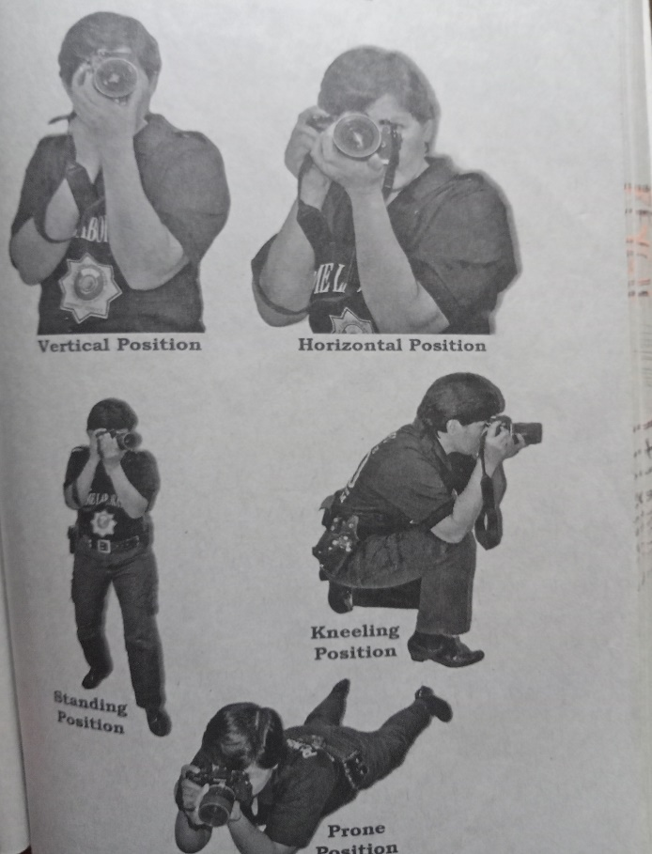

**Care and Handling of the Camera and Film**

The photographer should take care of the camera between uses by keeping it out of direct sunlight and away from heat sources. The camera should never be exposed to direct sunlight or to heat inside glove compartments or trunks of vehicles during hot weather. The photographer should also keep the film in an insulated chest or wrapped in a white reflective cloth. Exposed film should be maintained in a refrigerator or processed immediately. In cold water, the camera should be protected by keeping it under your jacket as the film may become brittle and tear or break. Salt water may also damage the camera and film so make sure the camera is fully protected. Negatives should be placed in a plastic sleeve to avoid scratch

**Part V: Photographic films and Chemical processing**

A **photographic film** is defined as thin, transparent, flexible acetate or polyester base, coated with light-sensitive emulsion used a camera to record a photographic image. They should always be kept in a cool place, out of direct sunlight, in low humidity, and away from all sources of chemical fumes.

Loading and Unloading the Film

To load the film into a 35mm camera:

1. Open the back of the camera by lifting the film rewind knob and pulling out the back.

2. With the rewind knob up, fit the film canister on the left side under the rewind knob.

3. Pull the tail of the film gently out of the canister into place.

4. Pull the tail of the film gently bout of the canister and insert it into the take-up spool.

5. Turn the rewind knob slightly to make sure that film is snug against the sprockets and advance the film once.

1. Close the camera and advance the film twice.

To unload the film into a 35mm camera:

1. Release the take-up spool by pushing the film rewind button on the bottom of the camera

2. Pull the rewind lever out and turn it slowly until it is released from the take-up spool.

3. Turn the lever a few more times and then open the back of the camera and remove canister.

The film is protected from light during loading and unloading because the film is contained in a cartridge, or a cassette having a velvet ‘light-trapped’ feed slot. Roll film is just tightly rolled up on a spool together with opaque backing paper.

**Choosing Film Types**

Taking good picture is not always easy and requires some skill and the right type of film. Films may be classified based on speed depending on their sensitivity to light. Film speed is also a factor in determining the correct exposure.

The film controller is usually located on the top of the camera or on the top left side. Film speed figures follow strict test procedures laid down by standardizing authorities. Most film manufactures use an **ISO (International Standards Organization)**, a combination of the previous U.S based ASA ratings and European Din ratings.

* Slow Film is best for scene where the light is bright. They often have a brighter detail and gave the sharpest image.
* A medium-speed film is suitable for a wide range of different subjects and lighting conditions. It can also be used in less light earlier or later in the day when the sun is much lower in the sky.
* Fast films are used for low-light situations where a less-sensitive, slower film may result in underexposure. The quality, however, is not good as the slower film speed.
* A black-and –white film records the actual intensity of light as shades of gray. The developing stage of the photographic process turns the silver halide crystals that have been exposed to light into minute grains of metallic silver.
* A color film is more complex and consists of three layers of light-sensitive emulsion—red, green or blue – with layer sensitive to a particular color

**Photographic films and Papers**

**A. Black and White Films**

1.Emulsion - a suspension of a sensitive silver salt or a mixture of silver halides in a viscous medium (as a gelatin solution) forming a coating on photographic plates, film, or paper.

2. Gray or Anti-Halation Backing - a layer found in modern photographic films. It is placed between the light-sensitive emulsion and the tough film base, or sometimes on the back of the film base. The light that passes through the emulsion and the base is absorbed by the opaque anti-halation layer. This keeps that light from reflecting off the pressure plate or anything else behind the film and re-exposing the emulsion, reducing contrast. The anti-halation layer is rendered transparent or washed from the film (as in K-14 films) during processing of the film.

3.Film Base- A film base is a transparent substrate which acts as a support medium for the photosensitive emulsion that lies atop it. The base generally accounts for the vast majority of the thickness of any given film stock. Historically there have been three major types of film base in use:

a. cellulose nitrate,

b. cellulose acetate (cellulose diacetate, cellulose acetate propionate, cellulose acetate butyrate, and cellulose triacetate),

c. and polyethylene trephthalate poyester (Kodak trade-name: ESTAR).

**Characteristics of B & W Films:**

1.Emulsion Speed

2.Spectral Sensitivity

3.Granularity or Graininess

1. Emulsion Speed

a.ASA (American Standards Association) rating. This is expressed in arithmetical value.

b.DIN (Deutsche Industrie Normen) rating, which is expressed in logarithmic value.

C.ISO (International Standards Organization) rating. This is expressed in the combined arithmetical and logarithmic values.

2. Spectral Sensitivity

a.Blue sensitive film + sensitive to UV rays and blue color only

b.Orthochromatic film , sensitive to UV rays, to blue and green color. It is not sensitive to red color.

c.Panchromatic film * sensitive to UV radiation to blue, green, and red light or all colors.

d.Infra-red film sensitive to UV rays, to blue, green, red light and infrared rays.

3. Granularity or Graininess - This refers to the size of the metallic silver grains that are formed after development of an exposed film.

Generally, the size of metallic silver grains are dependent on the emulsion speed of the film and the type of developing solution that is used in processing.

**B. Color Films**

A color film is a multi-layer emulsion coated on the same support or base.

Main types of color film in current use

1.Color negative film forms a negative (color-reversed) image when exposed, which is permanently fixed during developing. This is then exposed onto photographic paper to form a positive image.

Ex: Kodacolor

2.Color reversal film, also known as slide film, forms a negative image when exposed, which is reversed to a positive image during developing. The film can then be projected onto a screen.

• Ex: Kodachrome

**C. Photographic Papers (Black & White)**

Photographic paper is exposed to light in a controlled manner, either by placing a negative in contact with the paper directly to produce a contact print, by using an enlarger in order to create a latent image, by exposing in some types of camera to produce a photographic negative, or by placing objects upon it to produce photograms, Photographic papers are subsequently developed using the gelatin-silver process to create a visible image.

**Characteristics of a Photographic Paper**

1. Chloride paper - has a slow speed and is suited for contact printing.

2.Bromide paper - has a fast speed and is recommended for projection printing or enlarging.

3.Chloro-bromide paper - is a multi-speed and could be used in both contact printing and enlarging.

**Chemical Processing**

**Film processing begins with the loading of the film, which involves a few simple steps:**

1. Remove the film leader.

2. Cut the film into the reel

3. Cut off the end of the film

4. Place the reel in the tank.

**Next is the developing process using the stainless-steel tank and reel:**

1. Take the temperature of the developer, and determine the correct developing time (usually 68 degrees Fahrenheit or 20 degrees Celsius);

2. Pour the developer into the processing tank. Start the timer as soon as the developer is in the tank;

3. Gently tap the bottom of the tank against a table or give the tank a sharp tap with the heel of your hand to remove any air bubbles trapped in the developer;

4. Agitate the tank for the first 30 seconds of development. Agitation is a darkroom term that refers to the movement of a processing liquid over the material that is being processed (e.g., the inversion of the developing tank or the movement of the tray to ensure constant movement of the fluids) so that the fresh chemicals come in contact with the negative, film or print. To agitate, gently rotate the tank in a circular direction then invert it. A typical method is to invert the tank three times every 30 seconds. A lack of agitation can reduce the development and excessive agitation can reduce the development and excessive agitation can over develop the film.

5. At the end of the development time, open the lid of the drainage opening of the developing tank and pour the developer away and pour in a stop bath for about 30 seconds and don’t forget to agitate. A stop bath is an acid rinse used to stop development by neutralizing unwanted developer when processing black & white film or paper. This prevents carryover of one chemical into another during development.

6. After pouring the stop bath, pour the fixing solution into the tank and agitate. The fixing process usually takes 5 to 10 minutes in a regular fixer and 2 to 4 minutes in a rapid fixer. A fixer is a chemical solution that dissolves unexposed silver halide crystals, leaving the developed silver image on the film or print and making it stable in white light, fixation is the process of removing, unexposed silver halide remaining in the emulsion after first stage of development of the latent image.

7. Pour out the fixer and save it for reuse.

8. Wash the film in a clean running water for a minimum of 20 minutes (20 to 30 minutes.

9. Rinse then film in wetting agent. A wetting agent is a mild form of detergent that reduces water surface tension, thereby helping the water to flow off the surface of the film without leaving drying marks.

10. Gently wipe it through a special film squeegee or even two fingers applied with the wetting agent: and

11. Lastly, hang the film and attach a weight to prevent it from curling during drying.

**The final process involves printing, as enumerated below:**

1. Place the negative on the negative carrier then insert the negative carrier in the enlarger head. The negative should be placed side up, but with the image upside down;

2. Turn off the light inside the darkroom;

3. Adjust the height of the enlarger head to get the desired size of print by moving the adjuster up and down. As the head moves up the rail, the projected

image becomes bigger; as it moves down, image becomes smaller;

4. Focus the image by adjusting the focusing knob or focus control at the enlarger lens’ biggest aperture. This procedure not only makes the image brighter and easier to see initially, it ensures that the image will be sharp;

5. Set the appropriate diaphragm by closing down two or three stops before the exposure, or close down the aperture to smaller f-stop. (f-8 or f-11) this is to obtain the great depth of field.

6. Set the timer with appropriate enlarging time;

7. Turn off the enlarger with safe light on;

8. Take a sheet of photographic paper out of its sealed plastic bag and place it on the easel with the emulsion side facing up;

9. Align the photo paper correctly with guides of the easel mask and close the mask gently. The easel has size scale on its top, bottom or sides for setting the

image size; and

10. Lastly switch on the enlarger and expose the photographic paper at the appropriate exposure time.

**Equipment for Film Processing**

A. Tank or Tray

B. Developing Reel

C. Opener for Film Cartridge

D. Scissors

E. Thermometer

F. Timer

G. Funnel

H. Photographic Sponge

I. Film clips for Drying

J. Glass or Plastic Bottles (gallon size) for storing

mixed solutions

**Enlarger’s parts, function and enlarging procedure**

An **Enlarger** projects light when you either throw the switch or press the button on the timer.

**Basic Parts:**

1. The Lens

Forms the light passing through the negative into a sharp image. Like a camera lens, the enlarger lens has an aperture to adjust the amount of light passing through it.

1. Filter House/Colour Filter

Holds the filters, which are placed under the path of the light to alter its contrast and gray tones.

1. Negative Carrier

Holds the negative flat and level and fits into an opening between the condenser and lens

1. Lamp-house

Supplies the light to expose the printing paper. The more light, the darker to print.

1. Baseboard

Supports the whole unit. It is also where an easel is placed.

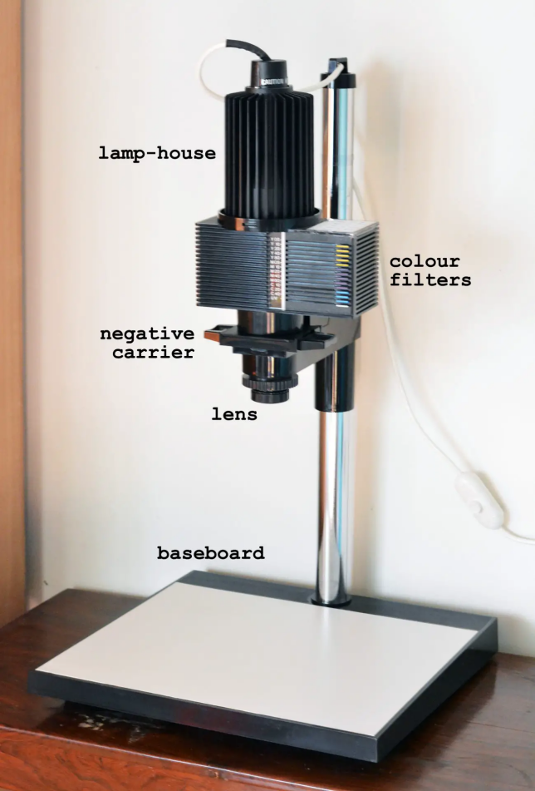

**Part Vl: Film vs. Digital Photography**

Film Advantages

* There can be a lower initial cost for a film camera than for a comparable digital camera.
* Film delivers a higher dynamic range, which makes it better at capturing detail in whites and blacks.
* Film photography is more forgiving of minor focusing issues and exposure problems.
* A film camera often has a higher resolution than what is found in most digital cameras.
* Film photographers with a limited number of exposures available on a roll of the film must think more about their images before shooting them.

(Digital photographers tend to take pictures first and think later. Depending on your viewpoint, this is either an advantage or a disadvantage. )

Film Disadvantages

Some of the disadvantages of film photography are:

* Film cameras are usually heavier than similar-sized digital cameras.
* Film storage takes up a lot of physical space.
* Purchasing and developing film is a continuing cost.
* The film must be developed before viewing, so you can end up developing poor photo captures or images taken unintentionally. Unless you have a darkroom, the photographer is dependent on a lab to develop the images.

▪

Digital Advantages

* The resolution of a point-and-shoot camera, which is often 12 to 20 megapixels, is a high enough resolution for large prints.
* ➢ A digital camera is usually lighter in weight than a film camera.
* Memory cards are tiny so they don't require much storage space. One memory card can store more images than a dozen rolls of film.
* The images from a digital camera can be viewed immediately. You can edit your images directly on the camera or on a computer with photo-editing software.
* You can choose to print only the images you like best.
* Many cameras offer built-in filters.

(There is instant gratification with a digital camera. This can be an advantage or a disadvantage, depending on your perspective. )

Digital Disadvantages

* Digital photography usually requires computer skills to manage and edit images.
* The initial cost for a digital camera is usually higher than for a comparable film camera.
* Digital images easily lose detail in whites and blacks.
* Some digital cameras are difficult to focus.
* Digital images are less subtle than film images.
* Digital cameras become obsolete much faster than film cameras.
* The digital storage can be lost; backups are absolutely necessary.
* Many digital cameras do a poorer job focusing in low light than film cameras.
* Digital cameras are bigger consumers of batteries than film cameras.
* Digital photographers need to keep extra batteries on hand to ensure the camera stays charged.