**PREFINAL EXAM**

IPT209

INTERACTIVE PROGRAMMING AND TECHNOLOGY

NAME ___________________________________ SECTION _______________ SCORE ______________

Instructions:

1. Create a form with a title Billing Statement.
2. Input the data provided in the textbox
3. Compute the current bill (present meter reading – previous meter reading)
4. The current bill is computed based on the cubic per meter is 29.42.
5. Input the number for CBU, medical and mortuary
6. Compute and display the total amount and grand total

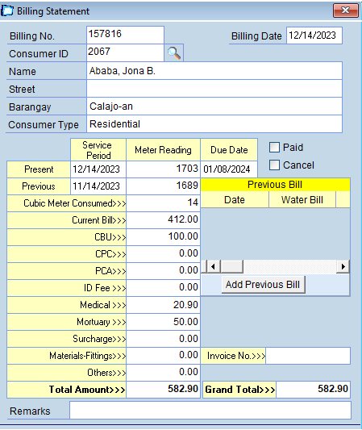

|  |  |  |  |  |
| --- | --- | --- | --- | --- |
| Form design-the form is presentable | Source code  The code is correct | Functionality  The program  Is functional. | Bug free  There should be no error during runtime | Property names  The property names are correctly labeled |
| 15 | 20 | 20 | 20 | 15 |