**The Gaseous State**

Gas- is a state of matter that has no fixed shape and no fixed volume.

* The gaseous state of matter is found between the liquid and plasma states, latter of which provides the upper temperature boundary for gases.

The air in a hot air balloon expands when it is heated. Some of the air escapes from the top of the balloon, lowering the air density inside the balloon, making the balloon buoyant.

* The atmosphere that surrounds us is composed of a mixture of gases (air)
* The air we breath consists primarily of oxygen (about 21%) nitrogen (about 78%)
* Industrial and household uses of gases:
* To purify drinking water (Chlorine)
* Welding (acetylene)
* Semiconductors (hydrogen chloride, hydrogen bromide)
* A substance that is normally in the gas state at ordinary temperature and pressure (oxygen gas)
* Vapor: the gaseous from of any substance that is a liquid or solid at normal temperature and pressure. (Water vapor or steam)
* The gas phase is the normal state for eleven of the elements (H2, N2, O2, and noble gases.
* Gases have no definite shape or volume and completely fill the container that holds them.
* Gases can be compressed to a larger volume. The behavior of gases can be described by simple quantitative relationship: **Gas Laws**
* Only behavior of gases can be described by these simple quantitative relationships.
* The gas laws are mathematical equations that predict how gases behave.
* Why do they behave in a predictable manner?

Why does a gas expand when its temperature is increased?

A model has been proposed to understand the physical properties of gases.

**Properties of Gases**

1. **Gases are fluids**. Which means they can flow, like liquids. The particles, being far apart have great freedom of movement.
2. **Gases have very low densities** as compared to liquids and solids because of the large particle separations. In fact, most of the volume occupied by a gas is empty space.
3. **Gases are highly compressible**, since the space between particles is very large compared to the volume taken up by the particles.
4. **A gas expands/contracts** to completely fill whatever closed container it is put in. this happens because the particles have great freedom of movement and are not constrained by mutually attractive interparticle forces.

* Gas laws are generalizations that describe mathematically the relationship of these four properties:

Pressure (P)

Volume (V)

Temperature(T)

Amount of gas in moles (n)

**Pressure**

* The term pressure refers to the average per unit that the gas exerts on the surface of the container.
* A gas exerts pressure as its molecules collide with the surface of the container that holds it.
* The pressure is the result of these collisions (impacts) divided by the unit area receiving the force.

Formula:

P= force/area

A= F/P

F = P x A

The pascal (Pa) is the unit of pressure or stress in the International System of Units (SI). It is named after the scientist and mathematician **Blaise Pasca**l. One pascal is equivalent to 1 newton (N) of force applied over an area of 1 square meter (m2).

* The atmosphere exerts pressure on the earth by the collisions of molecules with every surface contacts.
* Caused by air being pulled towards earth by gravity
* **Weather can change pressure** (Lows and highs on the weather map)
* **Altitude can change pressure** (atmospheric pressure is lower in Denver than is Stockton because of “thinner air” due to less collisions of gas with surface.

**Temperature**

* Is a measure of the kinetic energy of the atoms or molecules in the system.
* Discovered in 1848, British Mathematician and scientist William Thomson (also known as Lord Kelvin) proposed an absolute temperature scale.
* Anders Celsius (born November 27, 1701, Uppsala, Sweden) astronomer who invented the Celsius temperature scale (often called centigrade)
* The Fahrenheit scale is a temperature scale based on one proposed in 1724 by the physicist Daniel Fahrenheit (1686-1736)

Examples.

The water molecules in a cup of hot coffee have a higher average kinetic energy than the water molecules in a cup of iced tea.

Temperature of a gas is related the KE of the molecules. The velocity of gas particles increases as the temperature increases.

When working problems temperature is expressed in Kelvin and Celsius.

**Conversion Formulas**

Celsius to Fahrenheit: Multiply by, 9 divided by 5, then add 32

Fahrenheit to Celsius: Subtract 32, then multiply by 5, then divide by 9

Celsius to Kelvin: add 273

Kelvin to Celsius: Subtract 273

Fahrenheit to Kelvin: Subtract 32, multiply by 5, divide by 9 and then add 273.15

Kelvin to Fahrenheit: Subtract 273.15, multiply by 1.8 and then add 32.

Scale

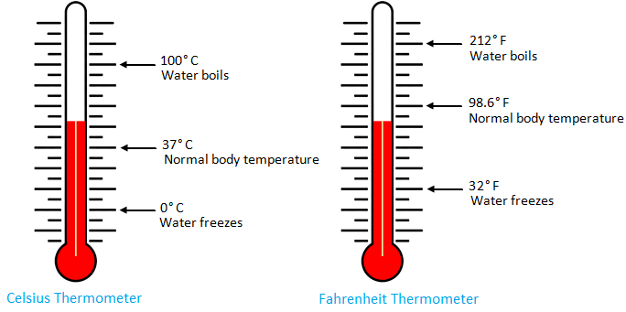

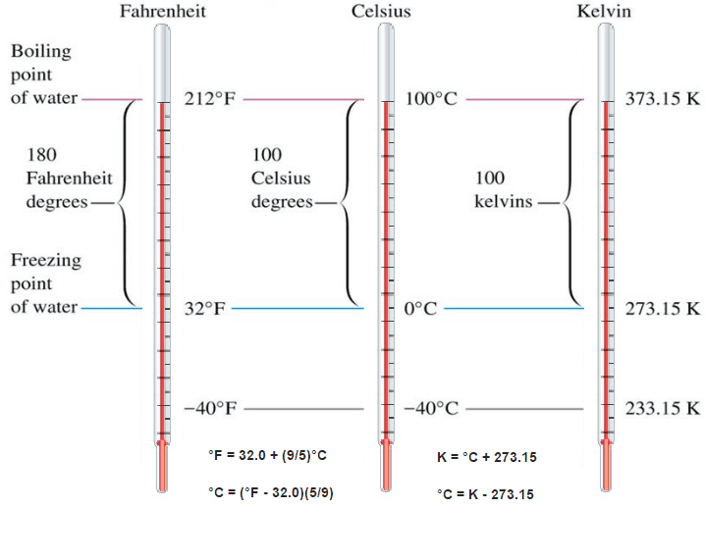

**Volume**

The volume of a gas depends on

1. The pressure of the gas
2. The temperature of the pressure
3. The number of moles of the gas

The volume of a gas is expressed in ml and L

Amount of gas

* Gases are usually measured in grams
* Gas law calculations require that the quantity of a gas is expressed in moles
* Moles of a gas represents the number of particles of a gas that are present

When working gas law problems convert mass (in grams) to moles.

Gas Pressure

* Use a device called a barometer- measures the height of Hg in a glass tube

Invented in 1643 by Torricelli, units are in mn Hg

* Common units Units

Mm Hg ot Torr (1 mm Hg= 1 Torr)

Atmosphere (atm) 1 atm = 760 Torr

Pascal (Pa) 1 atm= 101.325 Pa