Week 1: Data Science Project Planning and Strategy Design
Hypothetical Project: Predicting Customer Churn for a Subscription Service
A Python-based project plan covering problem definition, data strategy, modeling, evaluation, and delivery

1. Project Background and Motivation
The hypothetical organization is a subscription-based digital service that experiences customer cancellations (churn). The business wants to identify customers who are likely to leave early enough to take appropriate, non-intrusive retention actions. A data science approach can combine historical customer activity, subscription information, service interactions, and billing patterns to estimate churn risk and reveal the factors associated with cancellation.
Python is well suited to this project because it provides an end-to-end ecosystem for data preparation, exploratory analysis, statistical testing, machine learning, visualization, experiment tracking, and reproducible reporting. The project is therefore designed not merely as a model-building exercise, but as a repeatable analytical workflow that connects technical results to a business decision.

2. Project Objectives
- Define a clear churn prediction problem and success criteria with measurable business and technical metrics.
- Design a reliable data pipeline for collecting, validating, cleaning, and documenting customer-level data.
- Explore customer behavior and identify patterns, relationships, missingness, and potential data-quality issues.
- Develop and compare baseline and candidate classification models for estimating churn probability.
- Evaluate models using appropriate validation methods and metrics, with particular attention to class imbalance and probability quality.
- Translate model findings into interpretable insights that stakeholders can use for retention planning.
- Produce reproducible documentation so the workflow can be repeated or extended in later weeks.

3. Project Scope

In scope
- Customer-level churn definition and target-variable design.
- Planning for structured data such as customer profile, subscription, usage, support, and billing history.
- Data quality assessment, cleaning, exploratory data analysis, feature engineering, and supervised classification.
- Baseline comparison, cross-validation, model evaluation, interpretability, and communication of results.
- Python notebooks/scripts and a documented analytical workflow.

Out of scope
- Building a production-grade real-time prediction API or complete cloud deployment.
- Automatically contacting customers or executing retention campaigns.
- Collecting sensitive personal data that is not necessary for the analytical objective.
- Guaranteeing that predicted churn causes cancellation; the model identifies risk and association, not causation.
- Large-scale experimentation on actual customers during the planning phase.

4. Methodology and Strategy
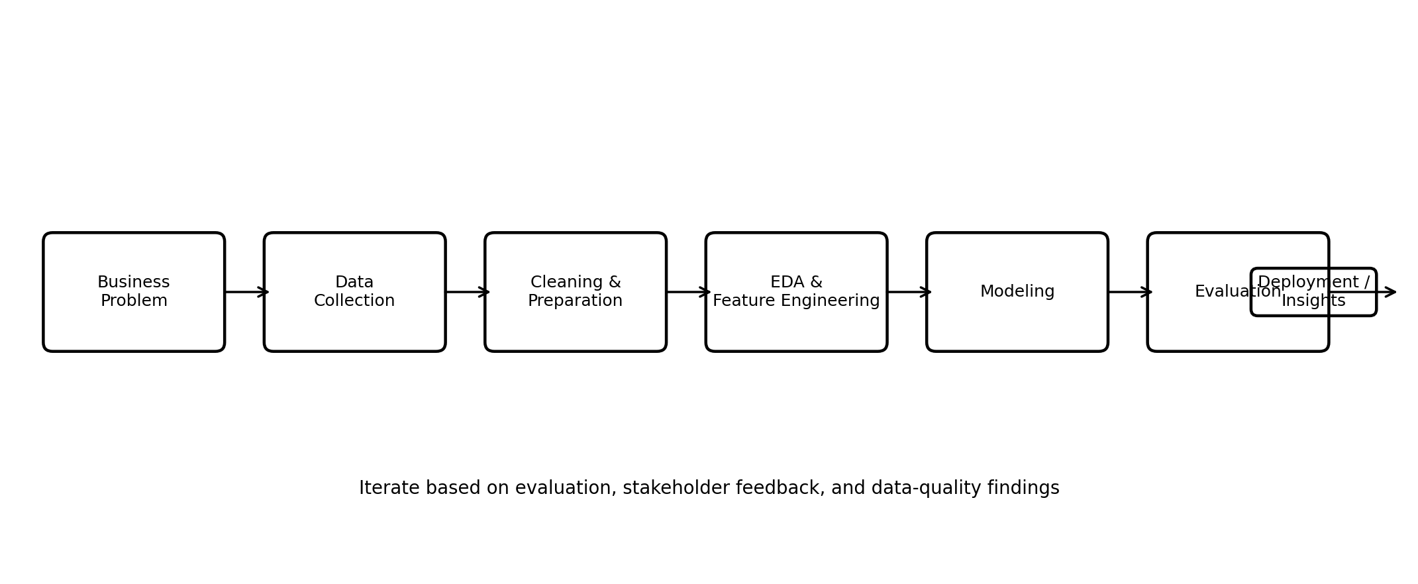
Figure 1. Planned data science lifecycle for the churn prediction project.

4.1 Problem Definition & Requirements
Define churn operationally, for example as cancellation within a specified future window. Confirm the prediction horizon, unit of analysis, decision that the prediction will support, acceptable false-positive/false-negative trade-offs, and the minimum useful performance level.

4.2 Data Collection & Data Governance
Plan source tables and fields from subscription, product-usage, customer-support, and billing systems. Establish a data dictionary, unique customer key, time windows, extraction rules, ownership, access controls, and provenance. Avoid unnecessary personal information and document assumptions.

4.3 Data Cleaning & Preparation
Profile missing values, duplicates, invalid ranges, inconsistent categories, outliers, and temporal inconsistencies. Standardize data types and categories. Separate training and test information by time where appropriate to reduce leakage. Record every transformation so the process is reproducible.

4.4 Exploratory Data Analysis (EDA)
Use descriptive statistics and visualizations to understand churn rates, customer segments, usage patterns, tenure, support interactions, and billing behavior. Check distributions, correlations, missingness patterns, and potential target leakage. EDA findings will guide feature engineering and model selection.

4.5 Feature Engineering
Create defensible features such as recent usage frequency, change in usage over time, support-contact frequency, tenure, subscription changes, and payment-behavior indicators. Features must be computable using information available before the prediction point.

4.6 Modeling
Start with a simple baseline such as majority-class prediction and logistic regression. Compare interpretable tree-based methods and, if justified, stronger ensemble models. Use pipelines to keep preprocessing and modeling consistent and reduce leakage.

4.7 Evaluation & Validation
Use stratified cross-validation for an initial comparison and a held-out test set or time-based test period for final assessment. Report precision, recall, F1, ROC-AUC, PR-AUC, confusion matrix, and probability calibration where appropriate. Select the operating threshold based on the business cost of errors rather than accuracy alone.

4.8 Interpretation & Communication
Explain important predictors using model coefficients or feature-importance/explanation methods. Present limitations clearly and distinguish predictive association from causation. Provide a concise stakeholder summary with recommended next steps.

5. Data Strategy
Data domain | Example fields | Quality checks | Potential use
Subscription | plan, start date, renewal, changes | valid dates, consistent plan codes | tenure and plan behavior
Product usage | sessions, active days, feature events | duplicate events, time ordering, impossible values | engagement trends
Support | tickets, resolution time, contact dates | duplicate tickets, missing timestamps | service-friction indicators
Billing | payment status, invoice history, price | currency, missing/late payments | payment-risk indicators
Customer profile | region, acquisition channel, segment | allowed categories, missingness | segmentation/context

6. Tools and Python Technology Stack
Tool | Purpose
Python | Core programming language and reproducible workflow
pandas / NumPy | Tabular data manipulation, numerical operations, cleaning
matplotlib / seaborn | Exploratory charts and reporting visuals
scikit-learn | Preprocessing, pipelines, baseline and classification models, cross-validation, metrics
Jupyter Notebook | Exploration, experiments, narrative documentation
Git / GitHub | Version control, collaboration, and change tracking
VS Code | Optional development environment for scripts and notebooks
Joblib | Saving fitted preprocessing/model pipelines when needed
SHAP or equivalent explanation tool | Optional model interpretability for supported models

7. Timeline and Work Allocation
The initial plan allocates 30 hours, which fits the requested 30–35 hour range. The schedule emphasizes planning, validation, and documentation rather than premature coding.
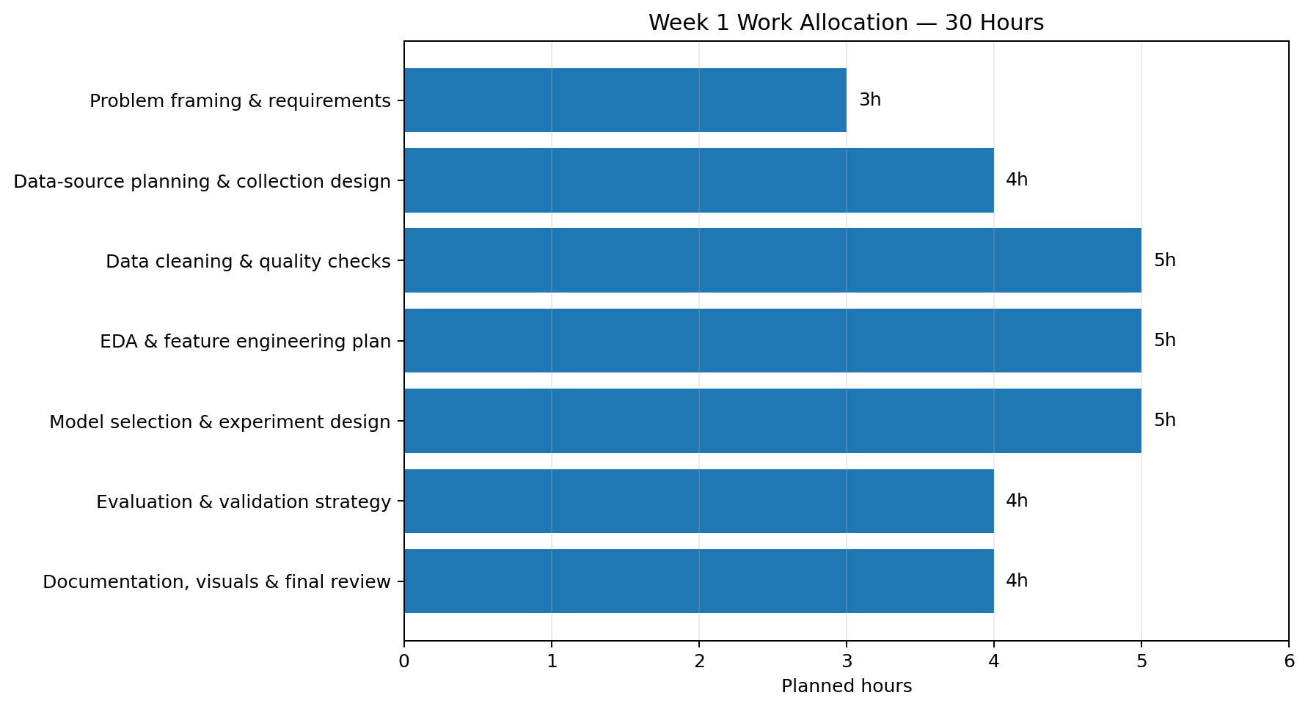
Figure 2. Planned 30-hour allocation.

8. Evaluation Strategy and Success Criteria
- Business success: the analysis should identify a usable segment of at-risk customers and provide evidence that the model can support better prioritization than a simple rule or baseline.
- Technical success: the selected model should outperform the baseline on relevant validation metrics without evidence of leakage.
- Metric balance: prioritize recall/precision and PR-AUC when churn is relatively uncommon; use ROC-AUC as a complementary ranking metric.
- Reliability: performance should be reasonably stable across validation folds or time periods, and probability estimates should be checked for calibration if probabilities will drive decisions.
- Interpretability: stakeholders should be able to understand the main drivers and important limitations of the predictions.

9. Expected Outcomes
- A documented end-to-end project architecture that can be implemented in later technical phases.
- A cleaned, well-defined analytical dataset specification and data dictionary.
- An exploratory analysis plan identifying the most relevant customer behavior patterns.
- A benchmark against simple baselines and a justified candidate model-selection strategy.
- A clear evaluation framework and stakeholder-ready reporting structure.
- A reproducible Python project structure suitable for future model development and deployment.

10. Anticipated Challenges and Mitigation
Challenge | Risk | Mitigation
Class imbalance | Accuracy may hide poor churn detection. | Use stratified validation, PR-AUC, precision/recall, threshold analysis, and appropriate class weighting.
Data leakage | Future information could make validation unrealistically strong. | Use time-aware feature definitions, pipelines, and explicit leakage checks.
Missing/inconsistent data | Biased estimates or unusable features. | Profile missingness, document rules, use robust imputation where justified, and investigate source-system causes.
Concept drift | Customer behavior may change over time. | Prefer time-based validation and plan periodic monitoring/retraining.
Overfitting | Complex models may fail on new customers. | Use cross-validation, regularization, model comparison, and a locked final test set.
Interpretability | Stakeholders may not trust opaque predictions. | Start with interpretable baselines and provide clear feature explanations and limitations.
Privacy and governance | Unnecessary data collection creates compliance and ethical risk. | Minimize fields, restrict access, document provenance, and exclude sensitive fields unless clearly justified.

11. Proposed Project Structure
- data/ — source specifications, data dictionary, and later-stage datasets (with sensitive data excluded from version control)
- notebooks/ — exploratory analysis and experiments
- src/ — reusable preprocessing, feature engineering, modeling, and evaluation code
- reports/ — figures, summaries, and final findings
- tests/ — data and pipeline validation checks
- README.md — setup, assumptions, workflow, and reproducibility instructions

12. Final Week 1 Deliverable Checklist
- Problem statement and business motivation approved.
- Objectives, scope, assumptions, and out-of-scope items documented.
- Data sources and data dictionary requirements defined.
- Cleaning, EDA, feature engineering, modeling, and evaluation strategy documented.
- 30-hour timeline and technology stack established.
- Flowchart and timeline visual integrated into the project plan.
- Expected outcomes, risks, and mitigation strategies documented.
- Plan structured so that Week 2 technical implementation can begin without redefining the project.

Conclusion
This Week 1 plan establishes a complete and practical roadmap for a hypothetical customer-churn data science project. The strategy deliberately begins with a business decision and data-quality considerations, then progresses through reproducible preparation, exploration, modeling, validation, and communication. By defining scope, success criteria, tools, time allocation, and risks before implementation, the project reduces avoidable rework and creates a strong foundation for the subsequent technical phases.

