**Archie Pape-Valdez**

Design1-Header.png

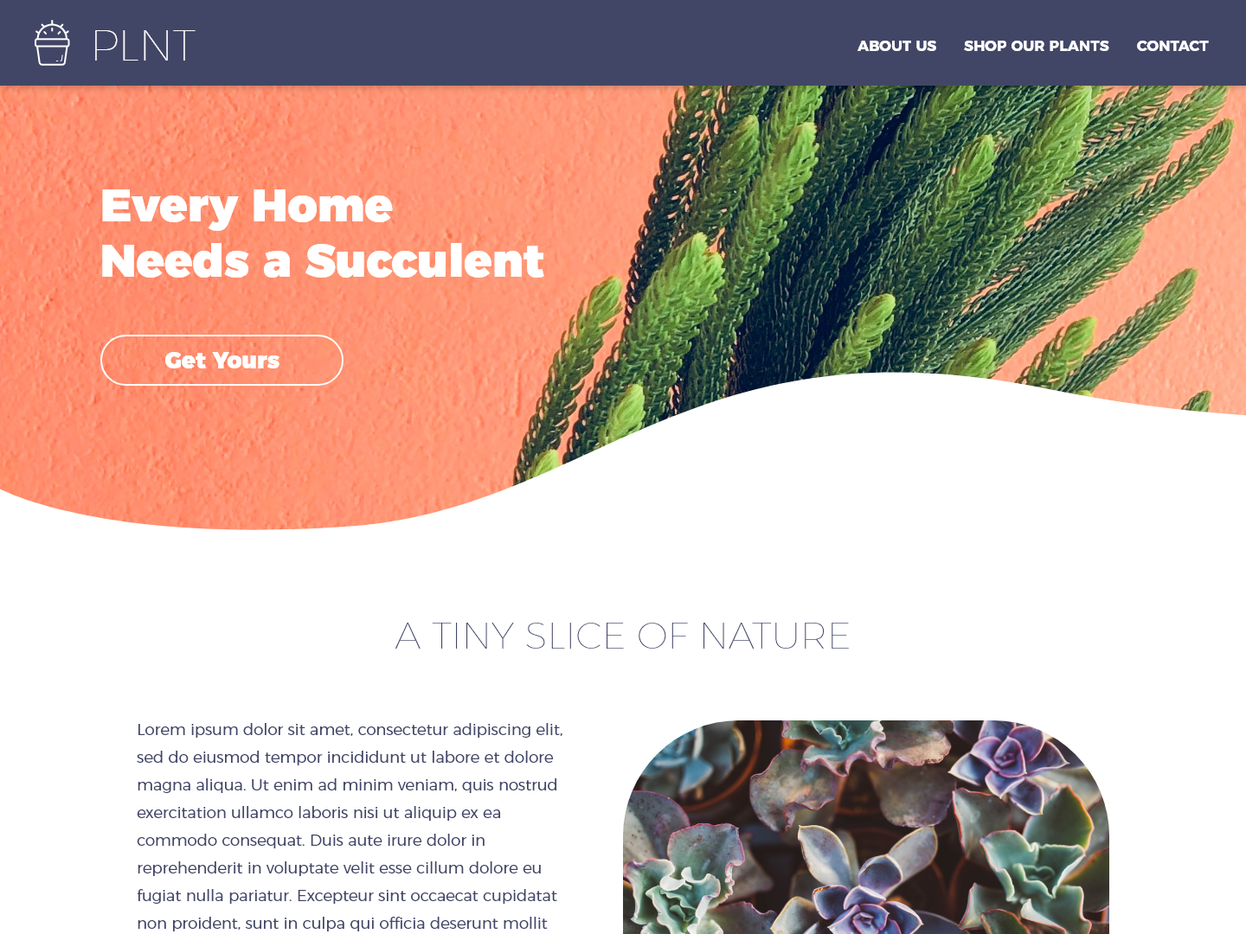

Assessment:

If the curved division is created from image, then it won’t take that much time. Either create a mask on top of the image or slice the image with curves. If it’s done through css styling, for a beginner-intermediate coder will take some time to create unless you copy and paste an existing code (which I found in codepen <https://codepen.io/anon/pen/EWpjpx>). It uses the border radius and you must create two different selectors for each curve. This

The best option is to use an image because it’s easier to make an image more responsive to different devices rather than writing different media query codes.

It’s a good design choice because the shape is playful and organic looking. It works very well with the content of the website and the curvature gives it a softer tone.

Design2-Signup01.png

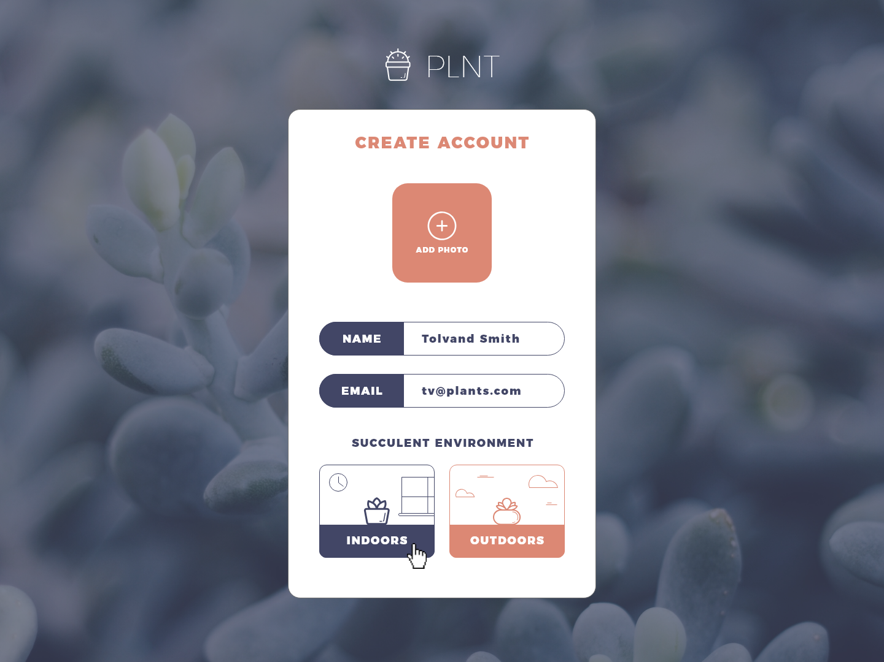

Assessment:

As a designer, depending on how fast your sketches are approved, the buttons can take from little to moderate amount of time to create. It also needs to match the brand of the product. It will take more time to create it using SVG especially adding those small details.

Another option would be to search if there are similar icon design that’s been premade from sites like fontawesome.com.

I think the design works. It’s simplistic and has good use of complementary color palette. It makes the buttons less boring and makes me want to click it. My only concern about the design is that I don’t understand why it is part of the “create an account” page. It doesn’t explain to me why it’s there and what happens if I just click on it without creating an account.

If you are creating this as an image, I would use illustrator or any similar vector base software. I would make sure that the file handling is not too big and restrict the dpi to 72 dpi.

Design3-Signup02.png

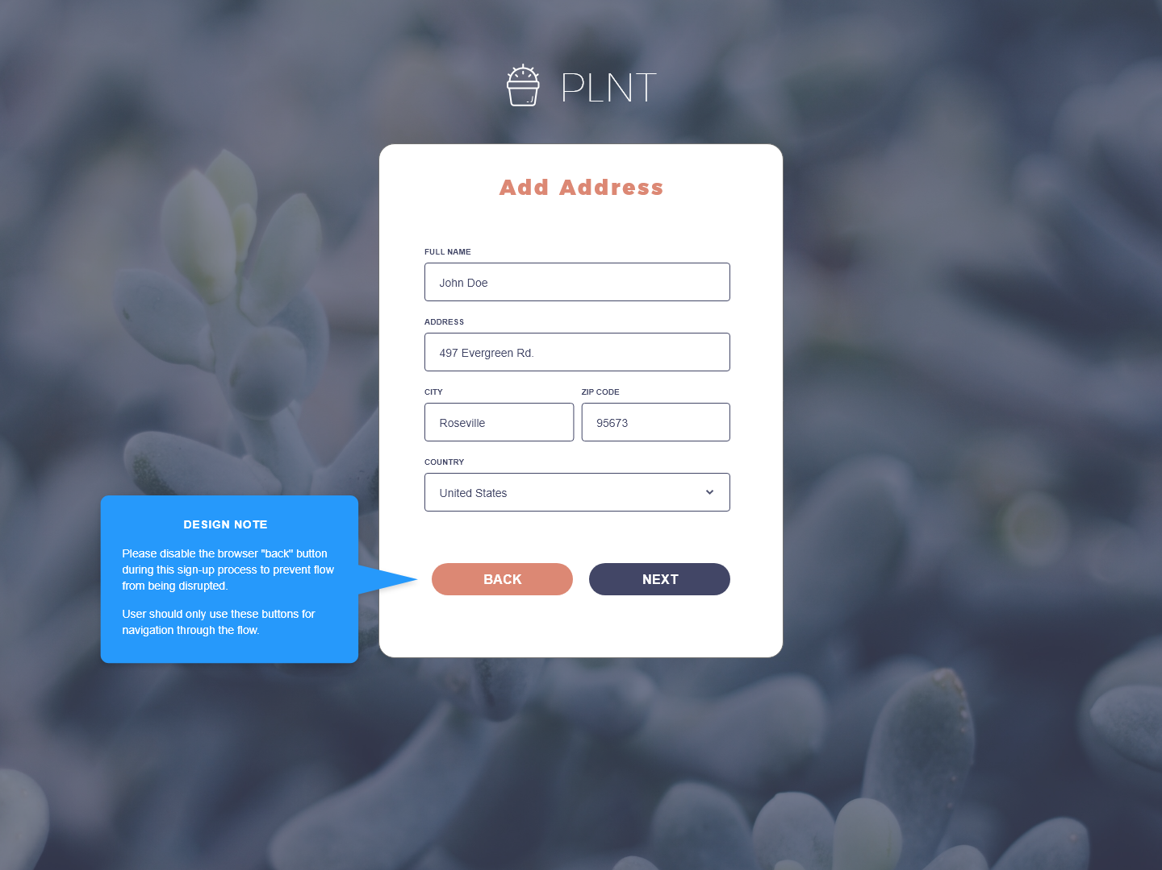

Assessment:

This design will take a little amount of time. It’s a simple button using border radius to curve the edges. The functionality of the “back” button might take some time though (if they decide to follow the “Design Note”). That means you have to create a function in javascript just for that particular use.

I would not use images on this because it is very easy to style the buttons in css. I would start using a selector and adding a declaration block with border radius declaration to curve the edges of the buttons and give it a background color.

The function of the “back” button however is a bad development choice. I would take it out at the start of the flow but keep it after the first flow. That way you don’t have to create an extra script function that will disable it at the beginning of the flow.